# Lab Exercise – 802.11

Step1

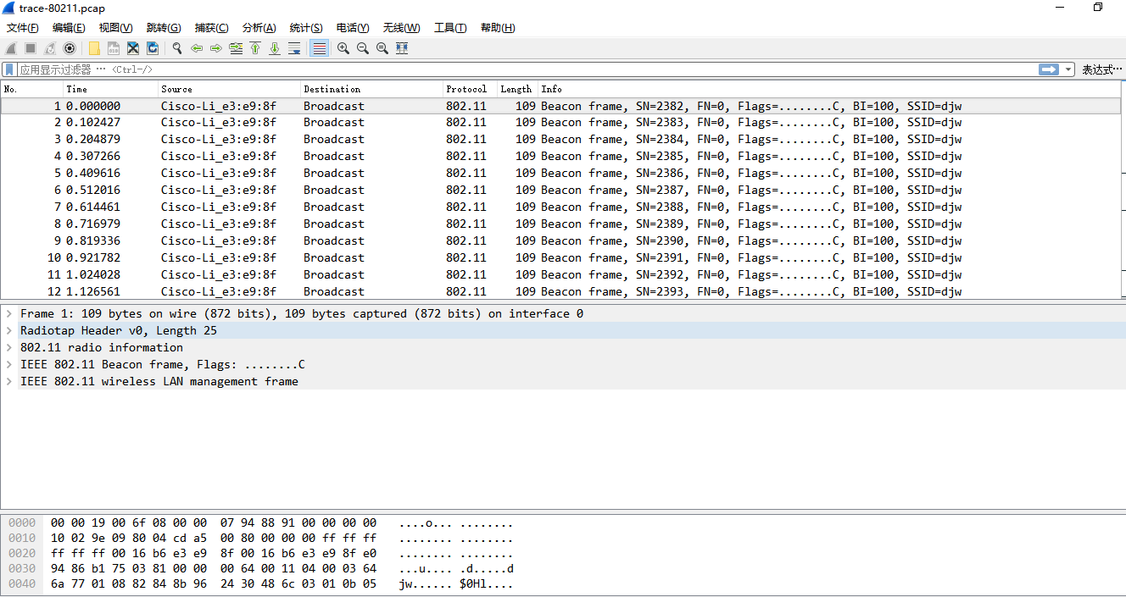

## Step 2

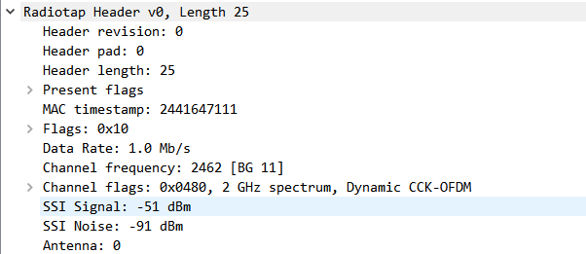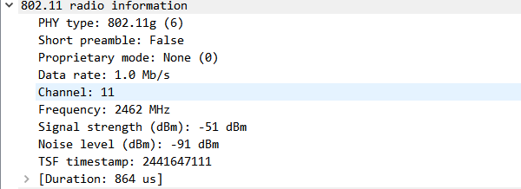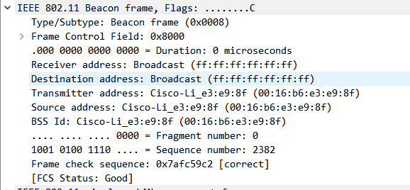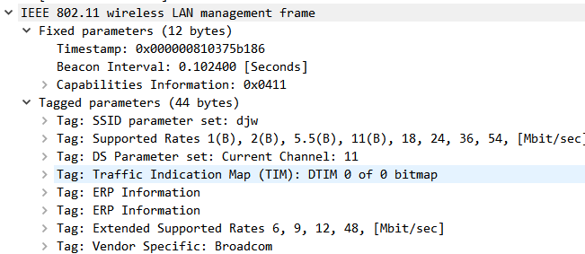

## Step 3

1.What is the channel frequency? To find the frequency, expand the Radiotap header of any frame and look for the Channel frequency.  
Answer: The Channel frequency is 2462 MHz

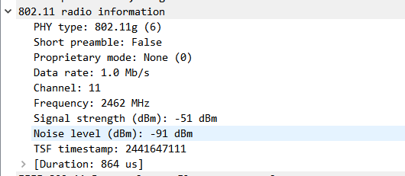

2.What rates are used? Give an ordered list of rates from lowest to highest. Hint: you can click the Rate column to sort by that value.

Answer: The rates are 1, 6, 12, 18, 24, 38, 48, and 54 Mbps.

3.What is the range of RSSI and hence variation in SNRs in the trace? Give this as the strongest and weakest RSSI and the dB difference between them.

Answer: The RSSIs range from -44 dBm (strongest) to -69 dBm (weakest signal). This is a variation of 25 dB or around a factor of 300 in the SNR

Step4 4

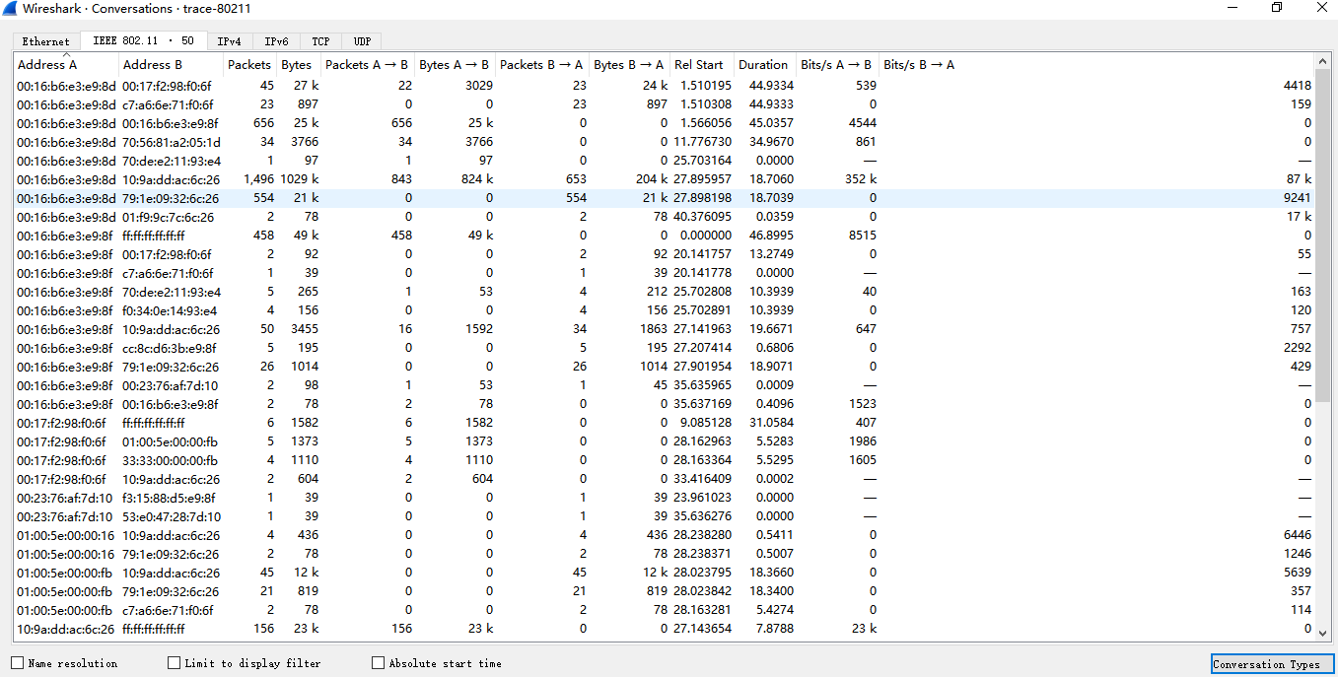

1. the AP has a BSS ID of 00:16:b6:e3:e9:8f

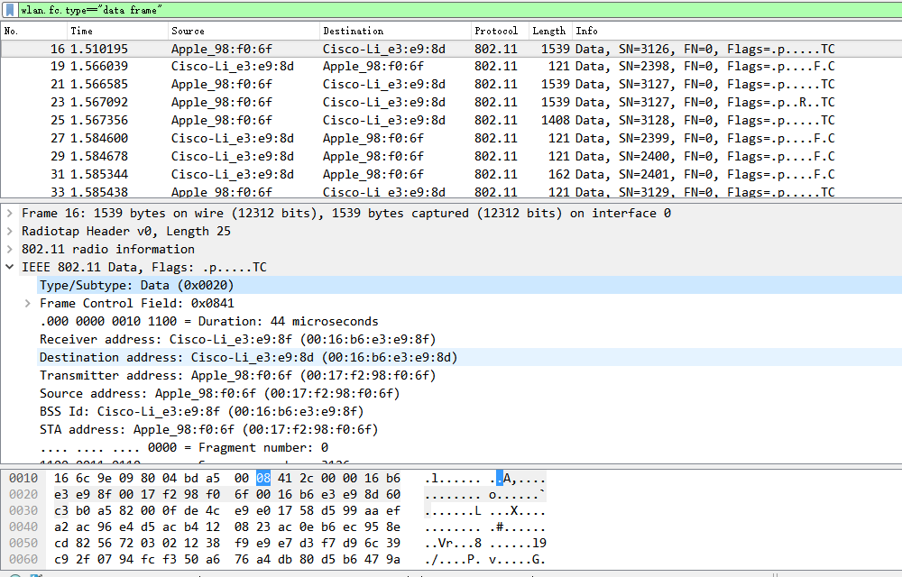

1. There are totally 1783 data frames in the trace.

The most common Data frame is  
simply called “Data” with subtype 0. The fraction of Data frames will depend heavily on whether there are active data transfers during the trace; there is a small transfer during this trace.

1. There are 1391 Control frames. The most common Control frame is the Acknowledgement frame with subtype 13.
2. There are 557 Management frames. The most common Management frame is the Beacon frame with subtype 8
3. Frame Control: 2 bytes

Receiver Address: 6 bytes

Duration: 2 bytes

Frame Check Sequence: 4 bytes

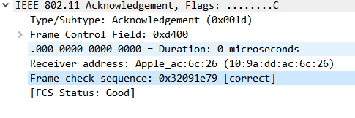

1. 353 Data frames have their Retry bit set in the Frame Control field, while  
   the number of their unset counterparts is 1430, so that the retransmission  
   rate is about 24.69%.
2. 16 out of 822 or 2% of the frames sent to the AP have their power management bit set, indicating that they are about to sleep

## Step 5

1. The SSID is “djw”.
2. beacon frames are sent by the “djw” AP every 102.4 milliseconds, or a rate of roughly  
   10/second.
3. The AP supports 1, 2, 5.5, 6, 9, 11, 12, 18, 24, 36, 48, and 54 Mbps.
4. The Beacon frames for this AP are all transmitted at a rate of 1 Mbps.
5. Request is Type 0 (Management) and Subtype 0. Response is Type 0  
   (Management) and Subtype 1
6. Probe Request is Type 0 (Management) and Subtype 4. Probe Response is Type 0 (Management) and Subtype 5.

