Xinyue Hu

Task0:

In this kmeans algorithm. I set the loss function = weight matrix * distance matrix.

For distance matrix, I used the norm2 distance.

For each element in weight matrix, I used

$$weight_{i,j}=\frac{e^{-αd_{k}}}{\sum_{k=1}^{k=n_{cluster}}{e^{-αd_{k}}}}$$

Where, $d_{k}$ means the distance from this point to the nearest center. Here I set the $α$ to 10.

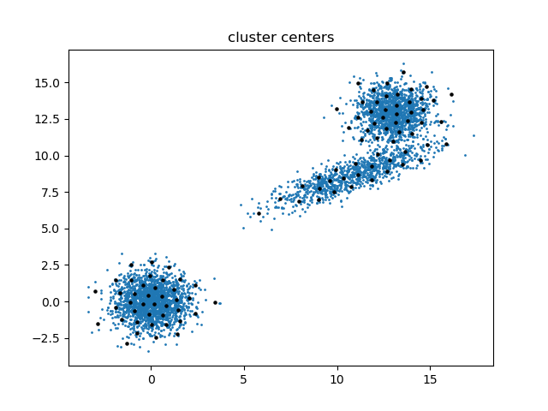

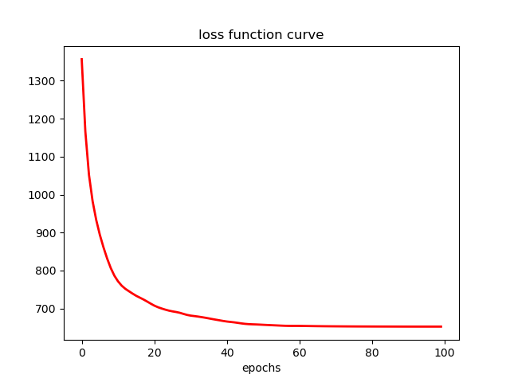

Task1:

I chose to compare 2 different loss function variants. Here are the results.

(1) Loss function with L2 norm distance

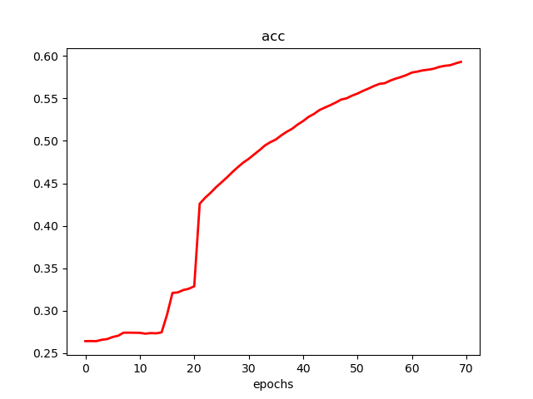

|  |  |  |  |  |  |  |  |  |  |  |
| --- | --- | --- | --- | --- | --- | --- | --- | --- | --- | --- |
| # Runs | 1 | 2 | 3 | 4 | 5 | 6 | 7 | 8 | 9 | 10 |
| Acc | 0.5539 | 0.5472 | 0.5054 | 0.5863 | 0.5107 | 0.5066 | 0.5398 | 0.5512 | 0.5930 | 0.6343 |

Average: 0.552

(2) loss function with L1 norm distance

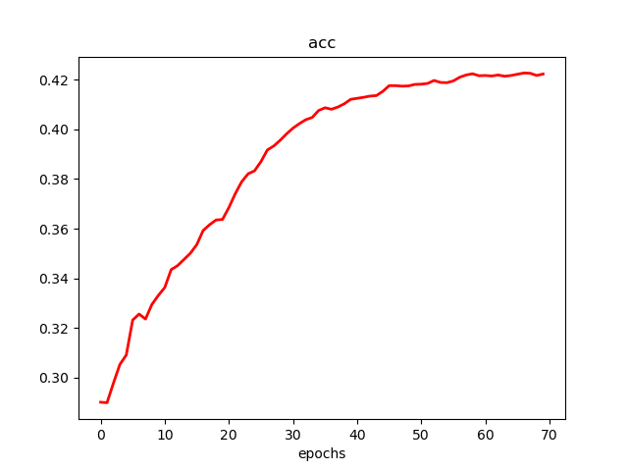

|  |  |  |  |  |  |  |  |  |  |  |
| --- | --- | --- | --- | --- | --- | --- | --- | --- | --- | --- |
| # Runs | 1 | 2 | 3 | 4 | 5 | 6 | 7 | 8 | 9 | 10 |
| Acc | 0.4019 | 0.4591 | 0.3489 | 0.4488 | 0.3140 | 0.4223 | 0.4339 | 0.5225 | 0.3775 | 0.4392 |

Average: 0.416

As we can see, the average accuracy of variant using the L2 norm is higher. It indicates that the first loss function is better.

Task2:

1. After lots of times of test. I set 3 layers for Auto Encoder.

For the dimension of each latent layers. The first layer has 50 nodes. second layer has 50 nodes, too. third layer which is also the output layer of the encoder, has 5 nodes.

For the nonlinear function, ReLu is tested to be the best. It’s worth noting that, the relu function after the third layer should be erased. Because if the meaningful output is less than zero, then they would be destroyed by relu function.

The best accuracy is 0.6891.

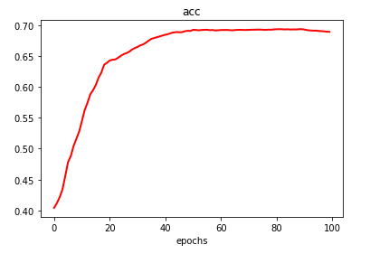

1. there is no need for me to think about diminishing problem. Because my autoencoder is not that deep.
2. Just like the figures shown below. Different color represents a different class. And each class has been shown as its number. The black points are the cluster center of each class.

Figure 1 is before the AE is involved.

Figure 2 is after the AE is involved.

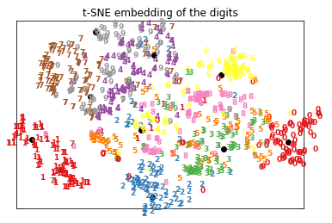

Figure1- before the AE is involved.

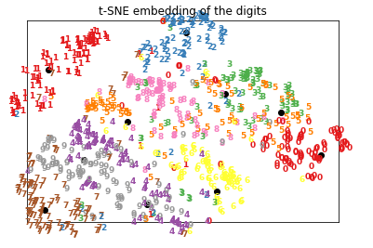

Figure2- After the AE is involved