Attention

Correlation matrix （window size 自己optimize 是否overlap

拉成一维

Query(should be optimized) -> context vector 不同的人分开算

Cross-validation. 5-fold, average

逐步加technique

1

final average accuracy: 0.5150

[tensor(0.5750), tensor(0.6000), tensor(0.4500), tensor(0.4500), tensor(0.5000)]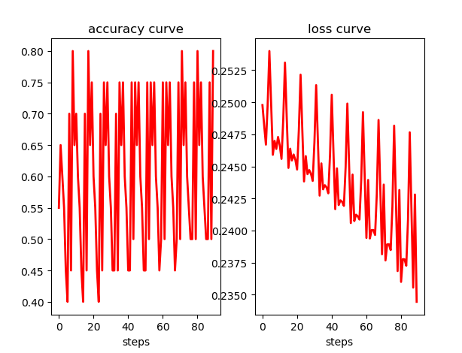

2

final average accuracy: 0.5500

[tensor(0.5000), tensor(0.5000), tensor(0.5500), tensor(0.5500), tensor(0.6500)]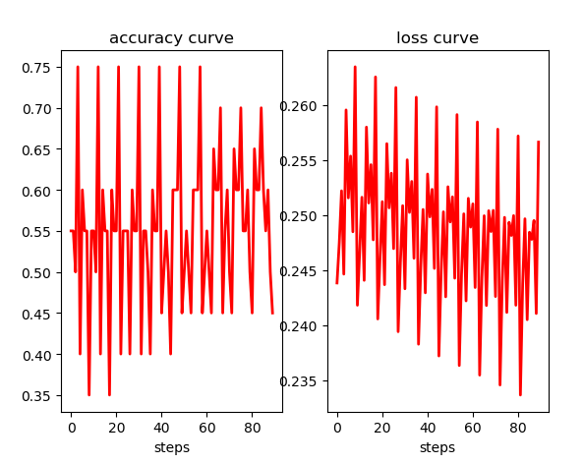

3

final average accuracy: 0.6200

[tensor(0.6750), tensor(0.6750), tensor(0.5250), tensor(0.6000), tensor(0.6250)]

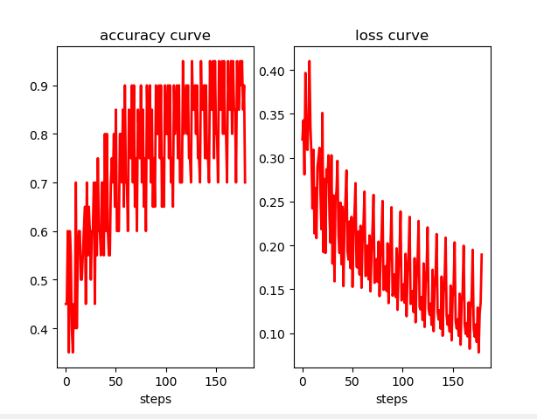

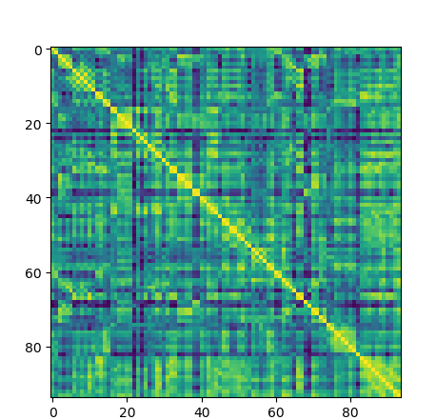

tensor([1, 1, 1, 1, 1, 1, 1, 1, 0, 1, 0, 0, 1, 1, 1, 1, 0, 1, 0, 1])

tensor([0, 1, 1, 0, 0, 1, 1, 1, 0, 1, 1, 1, 1, 0, 0, 0, 0, 0, 1, 0])