KNUST Engineering Data Analysis Report
Date: March 26, 2026
Generated by: Antigravity AI Assistant

1. Hierarchy Analysis
Overview of student performance trends across College, Faculty, and Department levels.

1.1 College-Wide Performance Trend
academic_year | avg_mark | records
2018/2019 | 63.19 | 86459
2019/2020 | 66.92 | 100220
2020/2021 | 63.31 | 123215
2021/2022 | 62.85 | 141424
2022/2023 | 63.19 | 138125
2023/2024 | 63.51 | 138924
2024/2025 | 62.68 | 132070
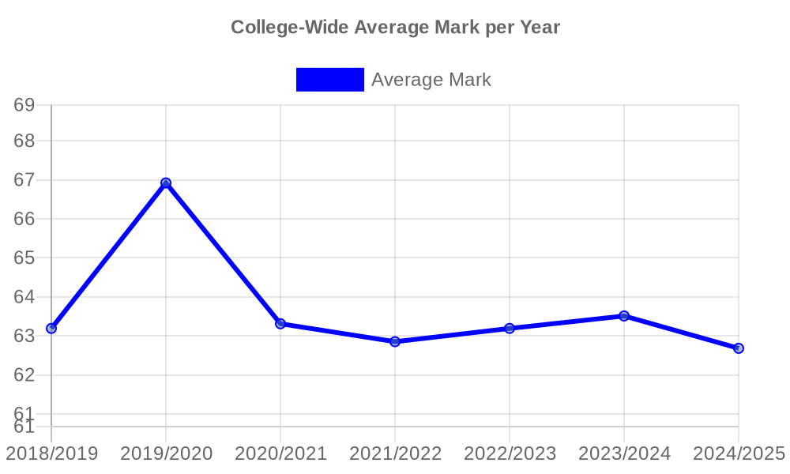

1.2 Faculty Performance (Average Mark per Year)
academic_year | faculty | avg_mark
2018/2019 | Faculty of Civil and Geo-Engineering | 64.95
2018/2019 | Faculty of Electrical and Computer Engineering | 65.36
2018/2019 | Faculty of Mechanical and Chemical Engineering | 62.88
2019/2020 | Faculty of Civil and Geo-Engineering | 68.75
2019/2020 | Faculty of Electrical and Computer Engineering | 67.14
2019/2020 | Faculty of Mechanical and Chemical Engineering | 65.66
2020/2021 | Faculty of Civil and Geo-Engineering | 64.69
2020/2021 | Faculty of Electrical and Computer Engineering | 64.76
2020/2021 | Faculty of Mechanical and Chemical Engineering | 62.93
2021/2022 | Faculty of Civil and Geo-Engineering | 60.90

1.3 Department Performance (Snapshot: 2020/2021)
department | mean_mark
ce | 67.09
aero | 67.05
pce | 66.65
che | 66.00
pe | 65.95
bme | 65.82
ee | 65.75
me | 64.57
mse | 63.84
coe | 63.77
tel | 63.71
geom | 62.66
geol | 62.38
mete | 60.10
mari | 60.00
ae | 59.25
auto | 58.96
ind | 58.76

2. Course Performance Analysis

2.1 All-Time Highest Performing Courses
code | name | all_time_avg
CEE 421 | CONCRETE STRUCTURES | 85.25
TE 498 | PROJECT II | 84.14
TE 497 | PROJECT I | 83.86
CHE 471 | PHARMACEUTICAL TECHNOLOGY | 82.67
TE 392 | TELECOMMUNICATION LAB IV | 82.29
EE 489 | INDUSTRIAL TRAINING | 82.07
COE 472 | DIGITAL SIGNAL PROCESSING | 80.21
MME 486 | SHIP SAFETY, ENVIRONMENTAL PROTECTION AND SAFE WATCH KEEPING | 80.00
MME 492 | SHIP OPERATION, REGULATION AND MANAGEMENT | 80.00
BME 498 | PROJECT II | 79.43

2.2 All-Time Lowest Performing Courses
code | name | all_time_avg
MATHS 252 | CALCULUS WITH SEVERAL VARIABLES | 42.50
ME 291 | TECHNICAL REPORT WRITING AND PRESENTATION | 43.00
CHE 255 | FLUID TRANSPORT | 46.70
PE 251 | RESERVOIR ENGINEERING I | 47.00
MSE 251 | TRANSPORT PHENOMENA IN MATERIALS PROCESSING I | 47.19
CHE 256 | HEAT TRANSPORT PROCESSES | 48.08
PE 153 | ORGANIC CHEMISTRY FOR ENGINEERS | 48.71
ME 261 | ENGINEERING MECHANICS II: DYNAMICS | 48.72
EE 368 | POWER SYSTEMS ANALYSIS | 48.89
CE 259 | ENGINEERING GEOLOGY | 49.38

3. Cohort Analysis (Focus: Class of 2018/2019)
Deep dive into the 2018/2019 cohort, analyzing the best and least performing students and the courses impacting them.

3.1 Top 10 Graduates (Class of 2018/2019)
student_id | Final_CWA | Program
3560218 | 87.04 | ee
3553218 | 84.55 | ee
3517718 | 84.17 | pe
3523318 | 83.56 | pe
3548918 | 83.29 | ee
3522418 | 82.88 | pe
3486818 | 82.49 | ce
3556718 | 81.96 | ee
3562918 | 81.88 | ee
3520618 | 81.55 | pe

3.2 Bottom 10 Graduates (Class of 2018/2019)
student_id | Final_CWA | Program
3474918 | 44.66 | ce
3605518 | 45.05 | auto
3702718 | 46.58 | mete
3618818 | 47.72 | me
3558418 | 48.08 | ee
3479018 | 48.75 | ce
3561418 | 48.93 | ee
3687518 | 48.99 | mse
3534818 | 49.02 | geol
3561218 | 49.38 | ee

3.3 Top 10 Group: Strongest Courses (Boosters)
course_code | course_name | avg_mark
CHE  250 | STRENGTH OF MATERIALS FOR CHEMICAL ENGINEERS | 95.50
TE  372 | ENGINEERING PROJECT DESIGN AND MANAGEMENT | 94.00
COE  475 | COMPUTER NETWORKING | 93.80
PETE  251 | PETROLEUM ENGINEERING CALCULATIONS | 92.25
EE  261 | ASYNCHRONOUS AND DC MACHINES | 91.80

3.4 Bottom 10 Group: Weakest Courses (Draggers)
course_code | course_name | avg_mark
EE  366 | POWER ELECTRONICS | 28.00
EE  387 | CLASSICAL CONTROL SYSTEMS | 29.00
EE  360 | HIGH VOLTAGE ENGINEERING | 29.50
CE  461 | ENGINEERING ECONOMY AND ENTREPRENEURSHIP | 32.00
CE  458 | WATER RESOURCES ENGINEERING II | 32.50

4. Retention & Attrition

4.1 Failure/Trail Rates per Year
academic_year | failure_rate
2018/2019 | 2.77
2019/2020 | 1.44
2020/2021 | 2.86
2021/2022 | 3.57
2022/2023 | 4.08
2023/2024 | 3.98
2024/2025 | 5.57

5. Demographics Analysis

5.1 Gender Performance Gap (Overall)
gender | avg_mark | avg_cwa | records
Female | 64.27 | 62.70 | 176647
Male | 63.37 | 62.64 | 677808

6. Semester Analysis

6.1 Performance by Semester (1-8)
semester | avg_mark
1.00 | 63.02
2.00 | 64.15
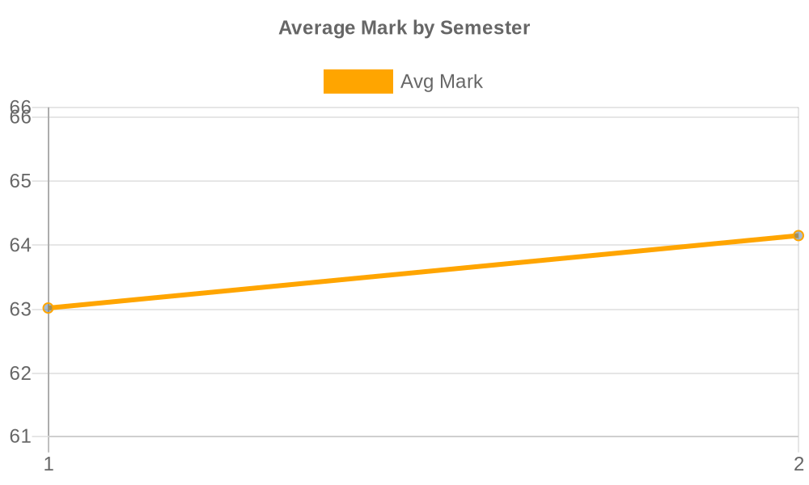

7. Year-by-Year CWA Trend
Analysis of how students' Cumulative Weighted Average (CWA) changes across their four years of study. Historically, there is often a dip in performance during the second and third years as courses become more specialized, before recovering in the final year.
level | avg_cwa
1.00 | 63.20
2.00 | 62.54
3.00 | 62.58
4.00 | 63.72
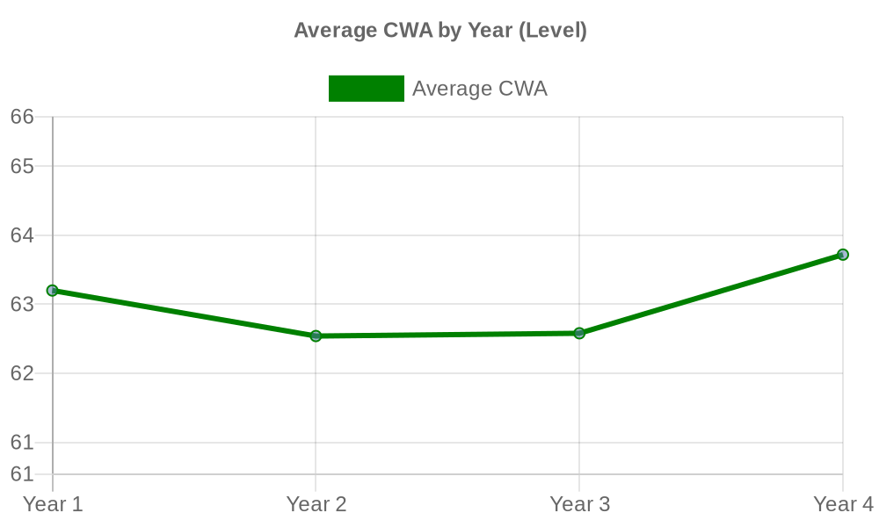

8. Trail Impact Analysis
This section analyzes the impact of trailing courses on a student's final Cumulative Weighted Average (CWA). It correlates the total number of courses a student has trailed with their ultimate academic standing.
num_trailed_courses | avg_final_cwa | num_students
0.00 | 67.68 | 8330.00
1.00 | 61.20 | 1781.00
2.00 | 58.10 | 890.00
3.00 | 56.20 | 586.00
4.00 | 54.68 | 343.00
5.00 | 53.26 | 262.00
6.00 | 52.39 | 185.00
7.00 | 51.24 | 158.00
8.00 | 51.17 | 92.00
9.00 | 49.15 | 57.00
10.00 | 49.79 | 38.00
11.00 | 48.54 | 41.00
12.00 | 47.55 | 19.00
13.00 | 46.17 | 16.00
14.00 | 46.02 | 6.00
