5-2 Encryption Coding
by Brandon Hollada
Southern New Hampshire University
CS-405-11881-M01
Submitted to Aaron Demory

Console output after run
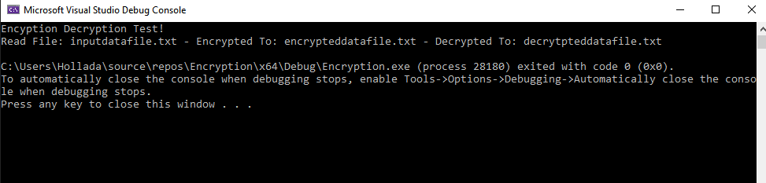
Approaching this activity, I lookied through the entire program to understand the goal of it. While walking through each function and the main calls to them, I determined that it was going to read a file, encrypt it, and than decrypt it. Because of the todo explainations and the layout of the program, I was able to work from the top to the bottom. The first step was to loop through each characher and transform it based on the given modification. For the read file, I checked through each line and added ut ti a string with a new line to ensure that each line could be determined. The save_data_file was the only one that I had dificult on. The difficulty I had with this was to be able to pull a time stamp as it is not something I have done in c++ before. I had trouble with the part where the strftime required a local time. But I was not able to pass it a localtime without having the local time applied to a variable before hand. I was able to find that I needed this varaible defined, but I am still not sure why. Saving the information was easy after this, as I have used ofstreams previosly. So besides creating a timestamp, these were all items I had done previosuly.

