Report #2

For

“Better Automobile Inventory Management”

CSCI441_VA

Software Engineering

Fall 2019

<https://github.com/gculver/SoftwareEngineering_FinalProject>

Team:

Paul Whitely

James Cox

Grant Culver

September 9, 2019

Revision History:

|  |  |
| --- | --- |
| Version No. | Date of Revision |
| V.1 | 9/15/2019 |
| V.2 | 9/30/2019 |
| V.3 | 10/01/2019 |
|  |  |

**Contents**

1. Interaction Diagrams……………………………………….……………………………………4

2. Class Diagram and Interaction Diagram

2.1 Class Diagram……….…………………………….…………………………….....7

2.2 Design Patterns.….…………………………….…………………………………..9

2.2 Data Types and Operations……………………………………………………….9

2.3 Traceability Matrix…………………………….…...……………………..............12

3. System Architecture and System Design

3.1 Architectural Style…………………………………………………………………13

3.2 Identifying Subsystems…………………...…………………….………………..14

3.3 Mapping Subsystems to Hardware…………………………...………………...14

3.4 Persistent Data Storage………………………………………...………………..14

3.5 Global Control Flow……………………………………………………………….14

3.6 Hardware Requirements………………………………………………………….15

1. **Interaction Diagrams**

**1.1 Use Case 1: InvSettings**

We decided to assign the responsibility to set initial settings for the system to the controller, as mentioned by the **Expert Doer Principle** mentioned in textbook. This will allow the system to have a short communication chain between the related objects. The controller is the principle object and the secondary object in this situation would be the database. The database would be responsible to verify and store the settings that are received. In this instance, we believe it is necessary to use the publisher-subscriber design pattern to improve and implement this use case scenario. As related to this case, the user would be the subscriber and the system would be the publisher. Once the user subscribes valid input information, the publisher releases information of concern to the subscriber. I.E. A “success” message that notifies the user that the settings are set and acceptable. If the subscriber inputs invalid metrics, the publisher shows an error message showing invalid inputs.

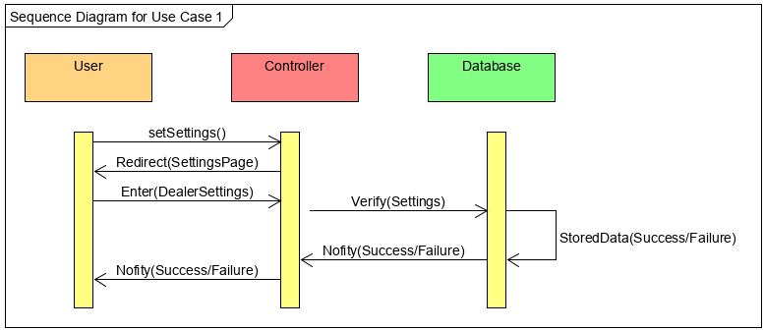

**1.2 Use Case 3: FetchData**

When a user attempts to fetch the data to calculate and display information from the user, the system attempts to verify the user authorization by querying the database for the correct account information. In this case, the databases main responsibility it to keep track of and report back to the user the relevant data. This data is retrieved by the system, which in-turn is responsible for passing information from the customer to the database and then relaying relevant information from the database to the customer based on the requests. For this interaction, we use the Publisher-Subscriber design pattern to improve this uses case’s design and functionality. When the user selects the desired data to be retrieved, they receive current inventory information that is able to correctly calculate the needed month’s supply and the inventory position. In this test case, the publisher gives the subscriber the pertinent information that the subscriber needs to make intelligent decisions.

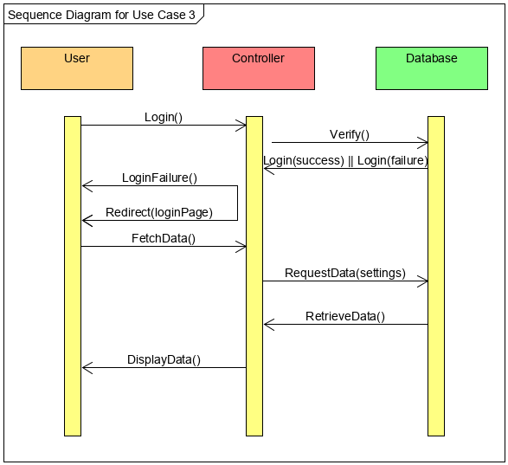

**1.3 Use Case 4: CalcSupply**

Favoring the High Cohesion design principle the controller will be responsible for receiving information from the Database to calculate and display the inventory position and then pass the rendered page to the user.

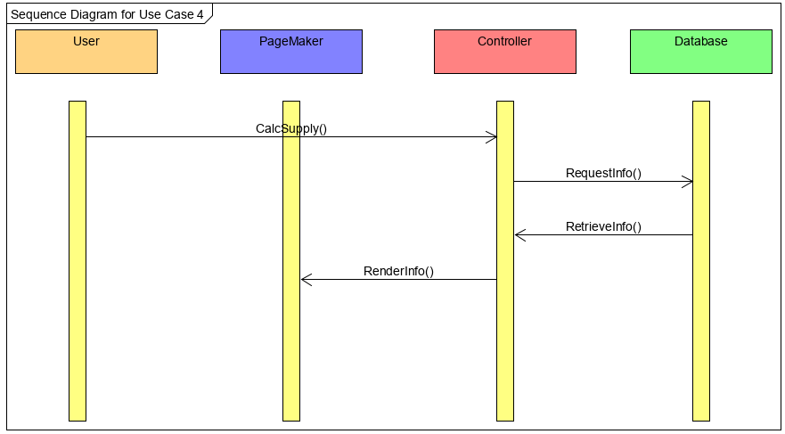

**2. Class Diagram and Design Patterns**

**2.1 Class Diagram**

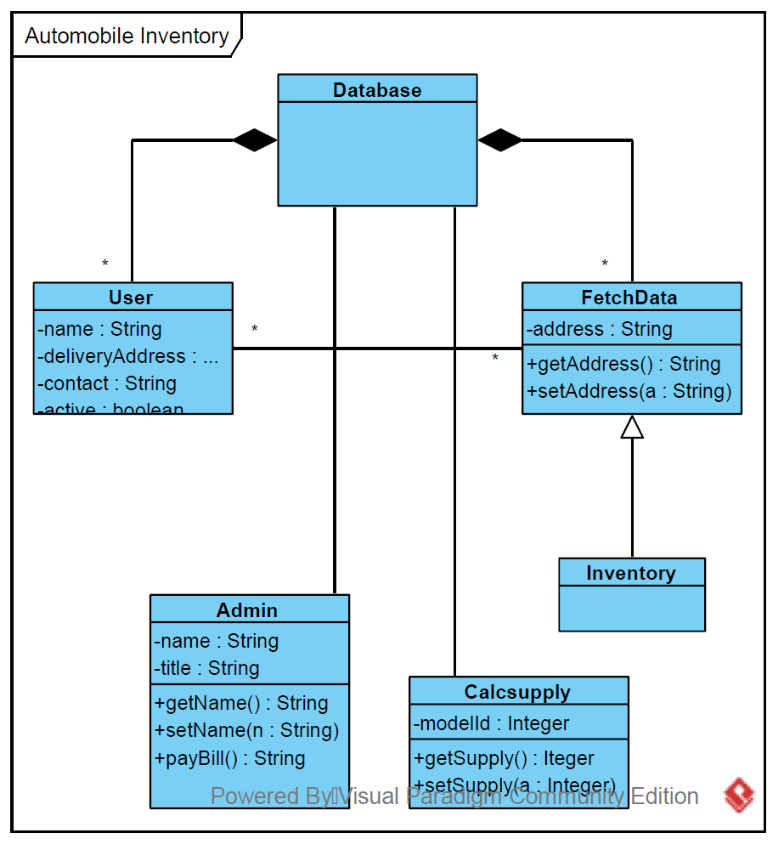

**2.2 Design Patterns**

The primary design pattern for this project will be the Model-View-Controller. The data model will be stored in a MySQL database and constraints and any necessary interface will be developed here. The Controller portion of the system will be written using PHP to interface with the database and external APIs. The system will present views of the information using HTML, JavaScript and PHP.

In a more abstract terms, hence utilizing the MVC framework, for the majority of this application we will be utilizing the Publisher-Subscriber Design Pattern. When the subscriber executes certain actions, e.g. fetching inventory from the database, the publisher will send the subscriber the relevant information via database connection and represented graphically in GUI. Utilizing the publisher-subscribed design pattern will reduce coupling within our application and will ensure that when updates or modifications are made a complete reconfiguration of the system will not be needed.

**2.3 Data Types and Operations**

1. User

(a) Attributes

* int user_id: identification number of the user

* string first_name: customer’s first name

* string last_name: customer’s last name

* string email: customer’s email address

* string username: customer’s user name for system

* string password: customer’s password for system

* boolean isActive: customer’s status in the system

(b) Operations

* signIn(): Allows the user to sign in to the system

2. FetchData

(a) Attributes

(b) Operations

*getData(): fetches data from the database

3. InvSettings

(a) Attributes

*int newCarMonthSupply: Overall new car month supply

*int newTruckSupply: Month supply by truck lineup

*int newCarSupply: Month supply by car lineup

*int newCarStock: number of new vehicles in stock

*int newTruckSupply: number of new trucks in inventory

*int newCarSupply: number of new cars in inventory

(b) Operations

*setNewCarMonthSupply(): set the desired monthly supply for new cars.

*setNewTruckSupply(): set desired supply of new trucks.

*setNewCarSupply(): set desired supply of new cars

*getNewCarMonthSupply(): return setting of new car supply

*getNewTruckSupply(): return setting of new truck supply

*getNewCarSupply(): return setting for new car supply

*storeData(): Stores settings in the database

4. CalcSupply

(a) Attributes

(b) Operations

*calcSupply(): retrieves data from inventory settings and performs calculation

*displayData(): Display calculated data to the user

5. Admin

(a) Attributes

*string user_name: username of the admin user

*string password: password of the admin user

*string name: name of the admin user

*string email: email of the admin user

*boolean isActive: status of the admin user in system

(b) Operations

*createUser(): Create a new user

*changePassword(): Change password of the user

*changeStatus(): Change the attibute of the user isActive

*deleteUser(): delete a user from the system

6. Database

(a) Attributes

* DBConnection: Connects to the database

(b) Operations

* connectDB(): Connects the database

7. Database Config

(a) Attributes

* DB_HOST: host of the database

* DB_NAME: name of database table

* DB_USER: user of the database

* DB_PASS: password to the database

(b) Operations

**2.4 Traceability Matrix**

|  |  |  |  |  |  |
| --- | --- | --- | --- | --- | --- |
| Classes | Domain Concepts | | | | |
| Database | Login | Calculate Inventory | Controller |
| User | x | x |  | x |
| FetchData | x |  |  | x |
| InvSettings | x |  |  | x |
| CalcSupply |  |  | x | x |
| Admin | x | x |  | x |
| Database | x | x |  | x |
| DB_Config | x |  |  | x |

**3. System Architecture and System Design**

**3.1 Architectural Styles**

In terms of structure for the application logic modules, the inventory system will utilize a component-based design style. Each task that must be completed within the system is performed by a module dedicated to that task (the database class handles the connection to the database, the config system handles the database configuration settings, the inventory settings module handles specifically the handling of the settings and is independent of inventory calculations).

As for memory and data sharing, the system uses a database-centric architecture. All information relating to user settings, admin settings, and inventory settings are saved in databases which are accessible to other components or modules in the system. This database design allows the various components of the system to access, view, and edit the same data, allowing for easing communication between components in many cases.

The direct communication between components in the system is also heavily based on an event-driven architecture. Each primary function in the system must happen in a predefined step during a normal use case. For example, the inventory settings must be addressed and completed before calculation and display of inventory position to the end user. Each step in the system’s process is triggered by the completion or progress of a previous step, which is the main philosophy behind an event-driven design.

**3.2 Identifying Subsystems**

**3.3 Mapping Subsystems to Hardware**

Our software application operates utilizing server client pattern of communication. The server responds to all user requests sent by the client. As mentioned previously, our solution implements the LAMP development stack. In the development environment the client and server will be located on the same computer. However, when application is deployed, it will obviously be on separate computers.

**3.4 Persistent Data Storage**

For our application, we will be utilizing a MySQL database to store the data entered by the end user. The database stores information related to the User (e.g. user_id, username, password, email, name, etc.), the admin users(e.g. user_id, isActive, etc.) and inventory settings(monthSupply, etc.).

**3.5 Network Protocol**

For communication between client and server and for the structure of the web application, our system will use the LAMP development environment. Utilizing PHP and extensive libraries will allow for many features to be developed, such as code which can securely handle and encrypt passwords or code which can be used to display visual inventory data to the end user.

**3.6 Hardware Requirements**

1. Website Hosting Server

• 33 MB disk space

• 100 Kb/s connection speed

2. Database Hosting

• 10 GB disk space

• 80 GB memory for spark processing

• 100 Kb/s connection speed

**4 Algorithms and Data Structures**

**4.1 Algorithms**

**5 User interface Design and Implementation**

**6 Design of Tests**

**7 Project Management and Plan of Work**

**8 References**