Report #1 – Part 2

For

“Better Automobile Inventory Management”

CSCI441_VA

Software Engineering

Fall 2019

<https://github.com/gculver/SoftwareEngineering_FinalProject>

Team:

Paul Whitely

James Cox

Grant Culver

October 1, 2019

Revision History:

|  |  |
| --- | --- |
| Version No. | Date of Revision |
| v.1 | 9/7/2019 |
| v.2 | 9/23/2019 |
| v.3 | 10/1/2019 |

**Contents**

Contents

7 Class Diagram and Interface Specification

7.1 Class Diagram………………………………………………………………………...4

7.2 Data Types and Operation Signatures……………………………………………..5

7.3 Traceability Matrix…………………………………………………………………….7

**7. Class Diagram and Design Patterns**

7.1 Class Diagram

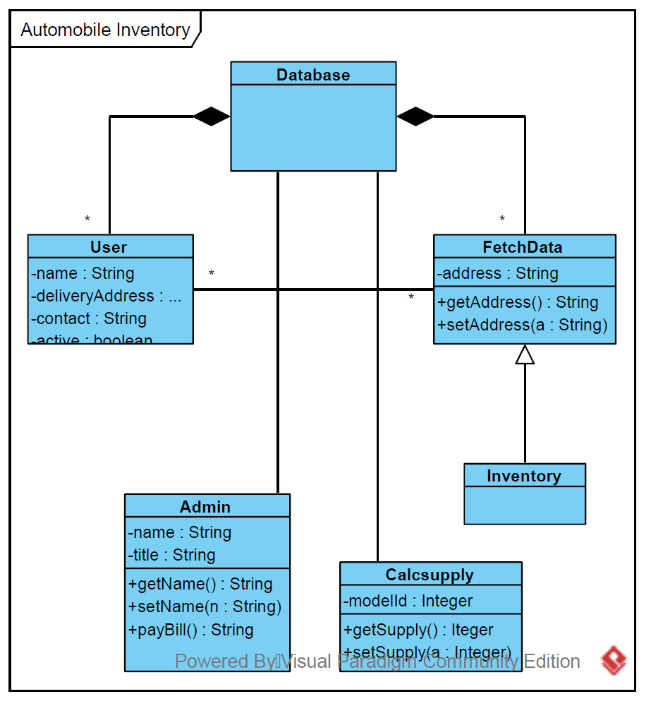

7.2 Data Types and Operation Signature

1. User

(a) Attributes

* int user_id: identification number of the user

* string username: username for the user to login and access the system.

* char password: password user uses to authenticate login.

* boolean active: to indicate whether the user is active or inactive.

* char email_address: email address of the user to identify user.

(b) Operations

* setUserID(): set the user id

* getUserID(): get the user id

* setActive(): sets the user as active(true) or inactive(false)

* getActive(): gets the activation status of user

* setEmailAddress(): sets the users email address

* getEmailAddress(): retrieves the users email address

2. FetchData

(a) Attributes

*

(b) Operations

* getData(): fetch settings from the database that were set up when system was configured.

*

3. InvSettings

(a) Attributes

* int monthSupply: sets the desired month supply of inventory for dealership.

* int cars: sets the inventory level for cars.

* int trucks: inventory level for trucks.

(b) Operations

* setMonthSupply(): sets the desired month supply of total inventory for dealership.

* setCarSupply(): sets the desired month supply for cars.

* setTruckSupply(): sets the desired month supply for trucks.

* getMonthSupply()

* getCarSupply()

* getTruckSupply()

4. CalcSettings

(a) Attributes

(b) Operations

* fetchInvSettings()

* calcSupply(): Calculates supply on the information provided.

* toString(): Displays data to the user

5. Database

(a) Attributes

* _db: Singleton connection object.Establishes connection with database server and reads data from server.

(b) Operations

* _construct(): Disallows creating a new object of the class with new Database()

* _clone(): disallow cloning of the class

* getInstance(): Establishes connection with database server and reads data from server.

6. Config

(a) Attributes

* DB_HOST: Identifies server.

* DB_NAME: Identifies database name.

* DB_USER: Identifies user.

* DB_PASS: User password.

(b) Operations: None. Just a standard configuration class.

7.3 Tracability Matrix