Report #1

For

“Better Automobile Inventory Management”

CSCI441_VA

Software Engineering

Fall 2019

<https://github.com/gculver/SoftwareEngineering_FinalProject>

Team:

Paul Whitely

James Cox

Grant Culver

September 9, 2019

Revision History:

|  |  |
| --- | --- |
| Version No. | Date of Revision |
| v.1 | 9/7/2019 |
|  |  |

**Contents**

Contents

1 Customer Statement of Requirements

1.1 Problem Statement…………………………………………………………………. 4

1.2 Glossary of Terms…………………………………………………………………... 7

2 System Requirements

2.1 Enumerated Functional Requirements…………………………………………... 8

2.2 Enumerated Non-Functional Requirements……………………………………… 9

2.3 On-Screen Appearance Requirements………………………………………….. 9

1. **Customer Statement of Requirements**
   1. **Problem Statement**

Throughout the history of civilization and business, there has been a continuous trend towards increased sophistication and efficiency. Sometimes these advancements are small and seemingly insignificant and other times they are drastic and life altering. One can look back at the Gutenberg Press and see that it was a major advancement in education and society. The industrial revolution changed the way products were manufactured and produced. It gave way to the automobile which fundamentally changed society and business by effectively enlarging the geographic area that businesses could compete in. Today, businesses face another revolution and that is the technological revolution that is completely altering the landscape for society and business. It has given way to self-driving cars, space shuttles that can save enormous sums of money by reusing booster rockets and in the retail business, given rise to the “Goliath” of Amazon. Amazon is fundamentally altering the rules and the playing field that small business must compete in. It does no good to debate the equality or the goodness or badness to society of such a mammoth company. Amazon will force, through survival of the fittest, businesses to adapt and modify the way they engage and profit in today's business climate. It is both exciting and perplexing to be a part of. Fortunately, the same technology that has enabled amazon to flourish and prosper will also enable small businesses to perhaps gain an advantage and compete toe-to-toe with a seemingly unbeatable “Goliath”. This has given rise to companies such as salesforce that allow small business to compete on cost with many larger competitors. Open source software has driven down the cost for many businesses. Our company reduced our CRM expense by over $150,000 per year due to these developments. Our proposed solution plans to start the process by enabling our company to economically develop a new car inventory management system with the goal of maximizing shareholder profit by reducing expense and providing relevant, convenient and up-to date information.

The goal of a new car inventory management system is to understand quickly and easily where in relation to a model inventory our current inventory stands. A model inventory is based 3 variables. First, the dealership must be informed as to what the past 3 months sales history looks like regarding total new vehicles sold by brand and then broken down by model. Industry standard is to have a four month’s supply of new car inventory. Second, the dealership must realize what the current inventory levels are by brand and by model. Third, the dealership must be informed as-to whether it is short or long in inventory by model and brand. Currently all of this information is scattered over 3 or more systems and leads to frustration and indigestion. Our customer centric solution is to consolidate these 3 systems into 1 system that will ultimately save the customer money and time.

The monetary savings will largely be due to three main factors. First, the dealership will no longer be stocking inventory it doesn’t need, or that it is too long in. When considering 10,000,000 dollars in inventory at 4.5% interest, stocking the right inventory is not a matter of just increased profitability but ultimately of long-term survivability. Second, savings will be increased by the lessening of time it takes to tackle implementing a model inventory. There will no longer be a need for logging into 3 different systems to obtain information. This will allow user to focus on other business-related tasks and ultimately be more efficient. Thirdly, this will save money due to the unnecessary expense of paying for 3 complimentary but uniquely different software solutions. With the combination of all three features of creating a model inventory software solution, additional or unneeded software can be cancelled.

Additional features of the software solution will include authentication to access the system. System will allow additional users to register or sign-up according to dealership policy. The system will require dealership setting up the recommended months supply with a degree of granularity for specifying months supply not only for vehicle make but also by model. The user interface will be user friendly and will focus heavily on keeping system user friendly with clutter kept to a minimum. The system will utilize a combination of API feeds and database feeds to gather required information for system to calculate model inventory.

* 1. **Glossary of Terms**

To provide better understanding of the contents of this report, listed below are important terms of our proposed software solution:

**Month’s Supply** – Units in stock (at month end) divided by Sales history (in months).

**Model Inventory** – Guideline for stocking new car inventory that takes into account past sales history, user defined month’s supply and the output is recommended number of units in stock.

**Long Inventory** – Inventory in-stock that is above model inventory suggestion.

**Short Inventory** – Inventory in-stock that is less than model inventory suggestion.

**Make** – Manufacturer of vehicle. Ex. Jeep, Dodge, Chevrolet, Toyota, etc.

**Model** – Particular model of vehicle made by a respective manufacturer.

Ex. Wrangler, Silverado, 1500, 4-Runner, Land Cruiser, etc.

**Inventory Manager** – (AKA New Car Inventory Manager) – is principle person concerend with managing state of inventory and forecasting sales in the coming months.

1. **System Requirements**

**2.1 Enumerated Functional Requirements**

|  |  |  |
| --- | --- | --- |
| Identifier | Priority  Weight (Low 1 - 5 High) | Requirement Description |
| REQ-1 | **3** | System shall support user login and authentication |
| REQ-2 | 1 | System shall support registering new users. |
| REQ-3 | 4 | System shall support users to define month supply of inventory by both make and model |
| REQ-4 | 5 | System shall pull in-stock inventory from dealership CRM |
| REQ-5 | 2 | System shall calculate month’s supply of inventory |
| REQ-6 | 4 | System shall compute long or short position of inventory |

**2.2 Enumerated Non-Functional Requirements**

A model called FURPS+ will be used here to qualify software attributes, which stand for functionality, usability, reliability, performance, supportability and the + stands for other possible attributes needed. We will be focusing on the non-functional requirements which cover FURPS+.

Functionality: Our tool should satisfy the needs of the customer such that they no longer have the need to subscribe to multiple inventory tools for their dealership. The software should use an API to gather the information that it needs to calculate model inventory.

Usability: The system should be easy to use and simple to understand. The software to consistently give accurate inventory model information so that the customer can rely on it when making decisions regarding their inventory.

Reliability: The system should give accurate and reliable results regarding the needs of the dealership and the inventory on hand.

Performance: The system to be should have high performance. The process of signing in and receiving data should take no more than 5 minutes.

Supportability: The system is benign and user friendly. The learning curve will be modest and user documentation will introduce designed program usage and will contain a software demonstration video or text. Support will all be available via email to handle software bugs and imperfection.

**2.3 On-Screen Appearance Requirements**

|  |  |  |
| --- | --- | --- |
| Identifier | Priority  Weight (Low 1 – 5 High) | Requirement Description |
| REQ-7 | 3 | User-friendly: The operation of system should be easy to operate with limited training for new users. |
| REQ-8 | 2 | Sign-In Button: Allow authorized users to gain access to system. |
| REQ-9 | 5 | Inventory Selection Drop Down: Users can select make and model of inventory to compare to model. |
| REQ-10 | 3 | UI Appearance: solution should be both functional and aesthetically pleasing to user. |
| REQ-11 | 4 | Inventory Pull Button: Allows user to pull necessary vehicle information based on selection. |
| REQ-12 | 1 | Registration Button: Allow new users to register for system. |

1. **Function Requirements**

3.1 Automotive Professionals and Administrative Staff

This software is principally designed for senior level, mid-level automotive managers and administrative staff (i.e. accounting department).

In the current business environment and as business evolves to a more data driven approach to inventory management, people are going to make decisions based on previous data, and therefore is a defining characteristic of this software solution. Hence, in this software, all agents make decisions according to previous sales results. The principle stakeholders of this system are mentioned below.

The principle stakeholder of this software proposal is the new car inventory manager or inventory manager. This persons job exists to minimize carrying costs associated with stocking inventory and maximizing dealership profit by stocking the right make and models based off prior selling history and future market conditions.

The General Manager or Owner of the Automotive dealership is another stakeholder. Their interaction with the system to be would be more monitoring and ensuring utilization of the software system.

The controller would ensure that billing of the software solution is completed within agreed upon terms and would likely use the portal to ensure correct billing and payment processing.

3.2 Actors and Goals

|  |  |  |
| --- | --- | --- |
| **Actor** | **Actor’s Goal** | **Use Case Name** |
| User | Fetch Database Records | FetchData(UC – 3) |
| Admin | Set up user | UserAdmin (UC – 2) |
| User | Set Inventory Settings | InvSettings (UC – 1) |
| User | Calculate Month’s Supply | CalcSupply (UC – 4) |
| Admin | Pay Bill | BillPay(UC – 5) |

3.3 Use Cases

|  |  |  |
| --- | --- | --- |
| **UC – 1** | | **InvSettings** |
| Related requirements | |  |
| Initiating actor | | User |
| Actor’s goal | | Set initial settings for evaluation |
| Participating actors | | System, User |
| Preconditions | | User is active and initial screen is showing |
| Post conditions | | Initial settings are set and evaluation is ready to start |
| **Flow of events for main success scenario** | | |
|  | User (a) selects the menu item “Settings” (b) types in Month’s supply | |
|  | User (a) clicks save | |
|  | System verifies values and stores them in database | |
| **Flow of events for alternate scenario** | | |
|  | User (a) submits invalid Month’s Supply | |
|  | System prompts user for valid Month’s supply | |
|  | User (a) enters valid Month’s supply | |
|  | System verifies values and stores them in database | |

|  |  |  |
| --- | --- | --- |
| UC – 2 | | UserAdmin |
| Related requirements | |  |
| Initiating actor | | Admin |
| Actor’s Goal | | Set up an authorized user account |
| Participating actor | | Database, User |
| Preconditions | |  |
| Post condidtions | | User account is active |
| **Flow of events for main success scenario** | | |
|  | Admin user clicks “Admin” icon on home page | |
|  | Admin user submits required information | |
|  | System stores user in database and shows “Success” to Admin user | |
| **Flow of events for alternate scenario** | | |
|  | Admin user submits user info | |
|  | System notifies Admin user is already active | |

|  |  |  |
| --- | --- | --- |
| UC – 3 | | FetchData |
| Related requirements | |  |
| Initiating actor | | User |
| Actor’s goal | | Pull sales history from database to allow comparison. |
| Participating actor’s | | Database |
| Preconditions | | System is connected to database |
| Post conditions | | Data is pulled from database |
| **Flow of events for main success scenario** | | |
| C | User clicks button to initiate download of data | |
|  | Software solution pulls data from database | |
|  | Software sends success message to users browser | |
| **Flow of events for alternate scenario** | | |
|  | User clicks button to initiate download of data | |
|  | System notifies user connection cannot be established | |

|  |  |  |
| --- | --- | --- |
| UC – 4 | | CalcSupply |
| Related requirements | |  |
| Initiating actor | | User |
| Actor’s goal | | To calculate month’s supply of inventory based off previous sales data |
| Participating actor | | Database, User |
| Preconditions | | Month supply calculation and settings entered correctly |
| Postconditions | | Data is displayed to user |
| Flow of events for main success scenario | | |
|  | User clicks calculate supply button | |
|  | Software calculates Months supply and displays to user | |
| Flow of events for alternate scenario | | |
|  | User clicks calculate supply button | |
|  | Settings are incorrect or not defined software sends error message to interface | |

|  |  |  |
| --- | --- | --- |
| UC - 5 | | Admin |
| Related requirements | |  |
| Initiating actor | | Admin |
| Actor’s goal | | Pay bill |
| Participating actor | | Vendor System |
| Preconditions | | Admin is logged in and can access pay bill page |
| Postconditions | | Admin succesfully pays vendor |
| Flow of events for main success scenario | | |
|  | | Admin logs in and access pay bill page |
|  | | Admin enters payment information and clicks submit |
|  | | System successfully process payment and displays success |
| Flow of events for alternate scenario | | |
|  | Admin logs in and access pay bill page | |
|  | Error processing payments and sends Admin user error message | |

3.3.1 Use Case Diagram

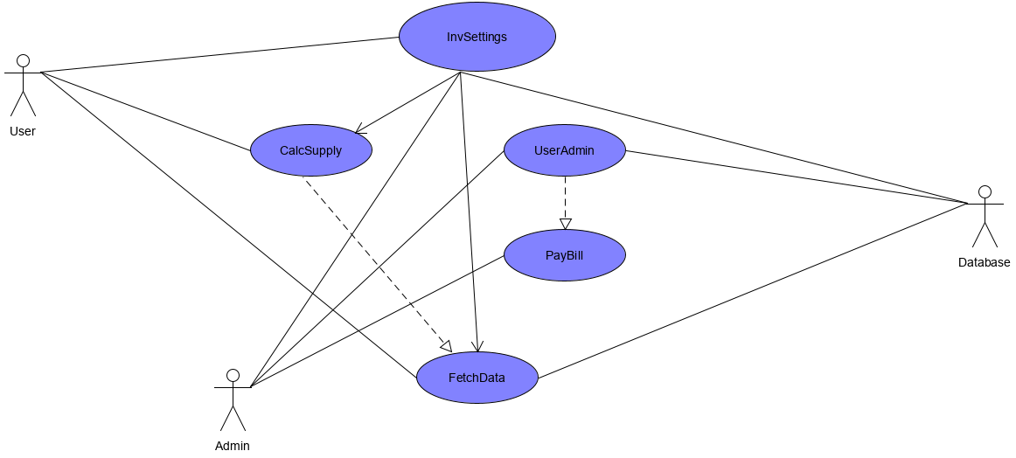

3.3.2 Traceability Matrix