**Startup & Investment SQL Analysis**

**Overall Objective:**  
Leverage SQL to analyze startup performance, funding activity, acquisitions, geographic trends, and influencer networks using a unified database schema. The goal is to uncover actionable insights that support investor decision-making, risk analysis, and marketing outreach.

**Key Analyses Performed:**

1. **Startup Landscape Analysis** – Measured baseline success rates by counting failed versus surviving companies.
2. **Sector Analysis for US Investors** – Identified funding trends in US-based news/media companies to benchmark investment potential.
3. **Cash Acquisition Trends** – Calculated total value of cash-based acquisitions during the 2011–2013 recovery period.
4. **Industry Influencer Identification** – Found individuals with strong social branding (“Silver” in Twitter handles) for marketing outreach.
5. **Finance Influencer Analysis** – Targeted finance-focused influencers (“money” in handles, last name starting with K) for FinTech campaigns.
6. **Geographic Investment Analysis** – Ranked countries by total venture funding raised to highlight top global markets.
7. **Funding Round Volatility** – Detected unusual market activity by analyzing gaps between smallest and largest funding rounds per date.
8. **Fund Activity Classification** – Categorized venture funds (high/middle/low activity) based on number of companies invested in.
9. **Investment Strategy by Fund Activity** – Compared average funding rounds per company across activity categories to reveal fund strategies.
10. **Employee Education & Startup Success** – Explored whether employee education levels correlated with startup failure after one funding round.

**ER Diagram:**

**Startup Landscape Analysis**

**Objective:**  
Provide an overview of the startup landscape by quantifying how many companies have failed (closed down), helping establish a baseline success rate within the ecosystem.

**Sector Analysis for US Investors**

**Objective:**  
Analyze funding trends for US-based news and media companies by listing the total funding raised, sorted from highest to lowest, to help investors benchmark potential investment amounts.

**Note:** Chart continues several more rows

**Analyzing Cash Acquisitions**

**Objective:**  
Measure post-recession acquisition trends by calculating the total value of cash-only company acquisitions between 2011 and 2013, providing insight into acquisition strategies during the economic recovery period.

**Identifying Industry Influencers**

**Objective:**  
Identify potential industry influencers for marketing outreach by listing individuals whose Twitter handles begin with “Silver,” including their names and usernames, to support targeted partnership opportunities.

**Finding Finance Influencers**

**Objective:**  
Support targeted influencer outreach by identifying finance-related individuals whose Twitter handles contain “money” and whose last names begin with “K,” providing the marketing team with relevant contacts for the FinTech investment report.

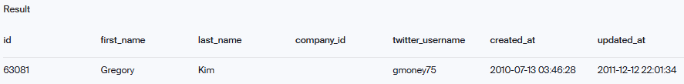

**Geographic Investment Analysis**

**Objective:**  
Analyze global funding patterns by calculating the total capital raised by companies in each country, highlighting the top-funded regions to guide international investment strategies.

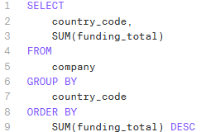

**Note:** Chart continues several more rows

**Funding Round Volatility Analysis**

**Objective:**  
Assess funding round volatility by identifying dates with significant gaps between the smallest and largest funding amounts (excluding zero or identical values), helping the risk analysis team detect unusual market activity.

**Note:** Chart continues several more rows

**Fund Activity Classification**

**Objective:**  
Classify venture funds by activity level (high, middle, low) based on the number of companies they have invested in, enabling investors to identify potential co-investment partners aligned with their strategic preferences.

**Note:** Chart continues several more rows

**Investment Strategy by Fund Activity**

**Objective:**  
Evaluate investment strategies by measuring the average number of funding rounds per company across fund activity categories, revealing whether highly active funds engage more broadly or more deeply with their portfolio companies.

**Employee Education Impact on Startup Success**

**Objective:**  
Analyze whether the educational background of employees impacts startup success by comparing the education levels of employees at startups that failed after only one funding round. This involves identifying the failed companies, linking their employees to education records, and calculating the average number of degrees per employee to uncover potential correlations between education and startup outcomes.

