Write the step-by-step instructions for completing the Graph Analysis part of your case study.

You will post Part 1 of your Case Study (including the data) to the Week 7 Discussion Forum.

I would like to analyze the correlation of certain words with more expensive menu prices, specifically at places that serve pizza.

Here are my steps for completing the graph analysis:

1. Load data and create the dataframe
2. Check dataframe dimensions
3. Examine the variables and their types
4. Draw histograms of appropriate variables
5. Visualize the zip codes of the restaurants in my data using folium
6. Use agate to determine outliers in price columns (> 3 std deviations from the mean)
7. View the distribution of the number of words in each restaurant name using a histogram
8. View the most common words names, as well as distribution of all words used (minus stopwords)
9. Bar plot the 20 most common words in order to visualize them for better understanding

For the next phase of my analysis, the steps would include defining distinct price range categories using the min/max ranges for each restaurant, then using Tf-Idf to determine which words in restaurant names are most predictive of the price ranges.

**(See next page for output.)**

The dimension of the table is: (3510, 21)

id ... province

0 AVwc_6KEIN2L1WUfrKAH ... OR

1 AVwc_6KEIN2L1WUfrKAH ... OR

2 AVwc_6qRByjofQCxkcxw ... Brentwood

3 AVwc_6qRByjofQCxkcxw ... Brentwood

4 AVwc_6qRByjofQCxkcxw ... Brentwood

[5 rows x 21 columns]

Describe Data

latitude longitude ... priceRangeMin priceRangeMax

count 3510.000000 3510.000000 ... 1557.000000 1557.000000

mean 38.555114 -87.472055 ... 15.597945 36.566474

std 4.651092 16.430008 ... 18.495854 21.737839

min 18.411826 -157.837461 ... 0.000000 12.000000

25% 35.769852 -94.202573 ... 0.000000 30.000000

50% 40.020710 -81.675414 ... 25.000000 40.000000

75% 41.455179 -74.743820 ... 25.000000 40.000000

max 64.854370 -66.024871 ... 347.000000 666.000000

[8 rows x 6 columns]

Summarized Data

id address ... priceRangeCurrency province

count 3510 3510 ... 1557 3510

unique 989 984 ... 1 281

top AVwdIsuzkufWRAb52p9M 1605 Kanawha Blvd W ... USD CA

freq 64 64 ... 1557 256

[4 rows x 15 columns]

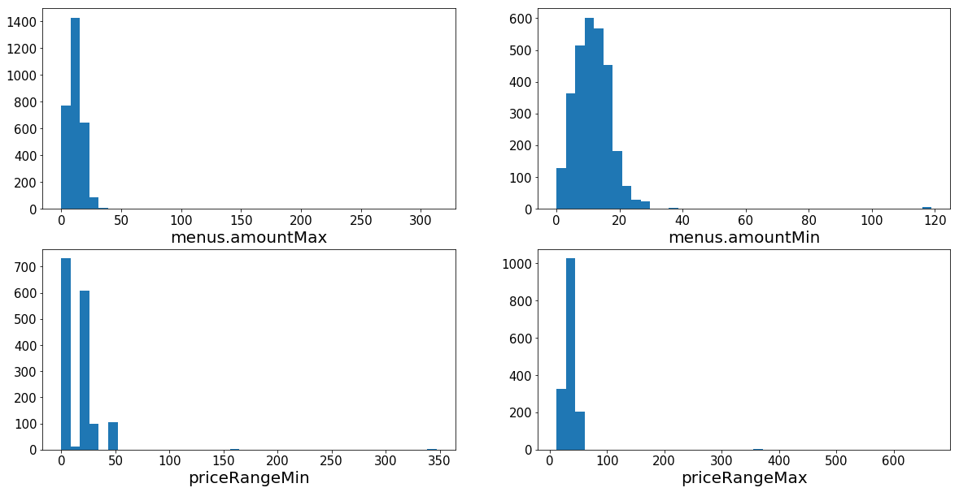

Menus.amountMin / Max = Price range for specific menu items that I have data for. (There may be multiple menu items per restaurant.)

priceRangeMin / Max = Price range for the restaurant as a whole.

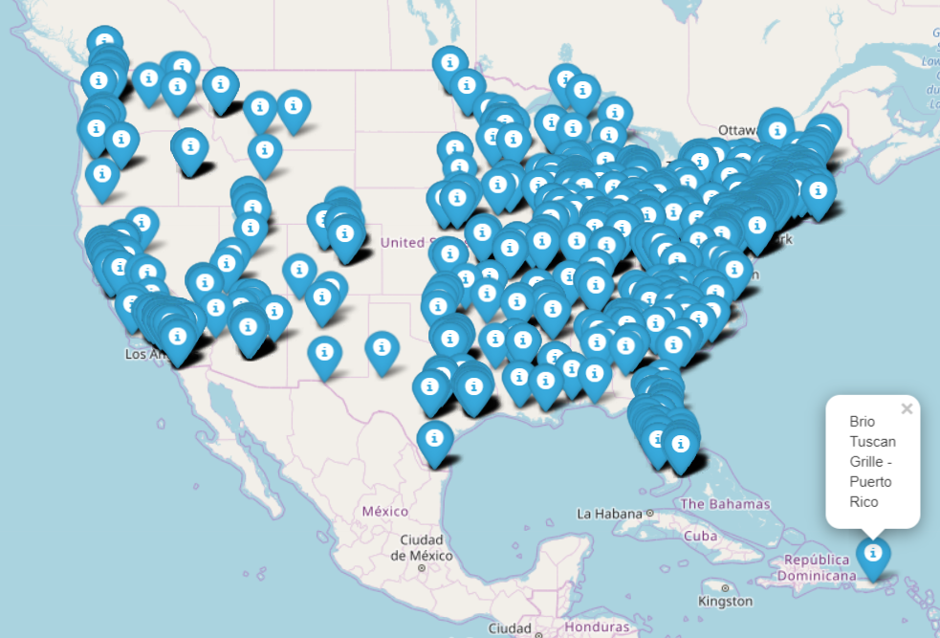

menus.amountMax: 11 Outliers

Mean 12.479

116.99

116.99

116.99

118.99

100.0

116.99

312.95

310.95

311.95

312.95

69.95

menus.amountMin: 14 Outliers

Mean 11.427

37.99

116.99

116.99

116.99

118.99

100.0

116.99

35.99

36.99

47.5

39.99

50.99

44.0

69.95

priceRangeMin: 3 Outliers

Mean 15.597

164.0

164.0

347.0

priceRangeMax: 3 Outliers

Mean 36.566

363.0

363.0

666.0

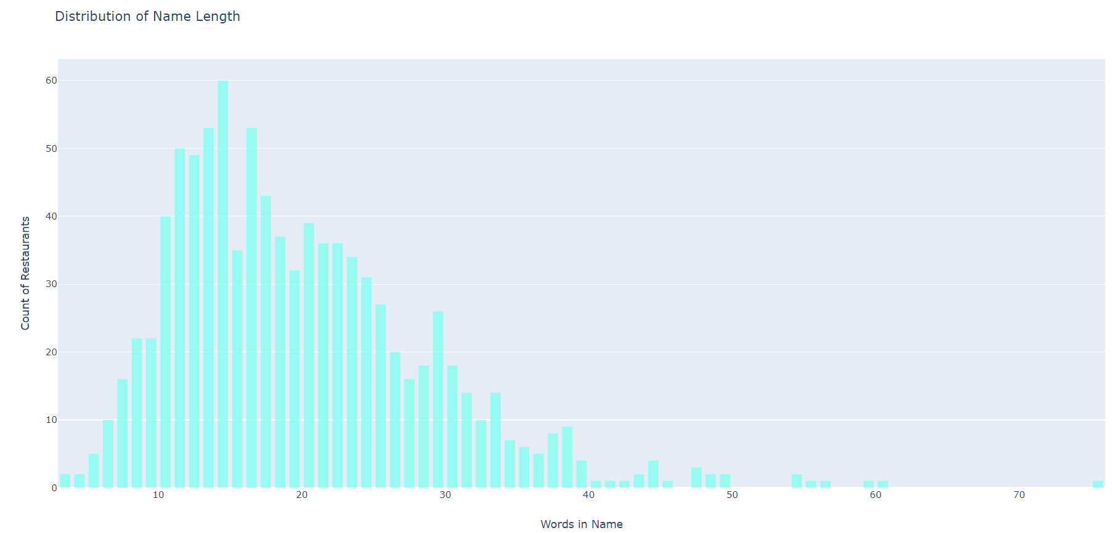

The number of unique words in our training sample is 1399.

