# ***Book Universe***

**About Book Universe**

Book Universe is a python cli (command line interface) bookshop inventory system with a csv database.

**CSV library in python**

Csv (Comma Separated Values) is a simple file format used to store tabular data, such as a spread sheet or database, where each line of the file represents a row, and the values within each line are separated by commas or other delimiters.

**Authors of this project**

|  |  |
| --- | --- |
| Amr Adel - 149 | Programmer |
| Mohamed Ahmed - 148 | Programmer |
| Zeyad Etman - 152 | Reviewer |
| Mohamed Abu Gharbia - 190 | Documenter |

**implementing our project in real life**

it’s perfect method to keep track of libraries for example in the D&R store and many other libraries , also it’s automated

**Functions of Book Universes**

In this project we have 11 main functions which are shown in the table.

* **Main**
* **Print menu**
* **Read data.**
* **List data**
* **Search by title**
* **Search by author**
* **Add book function.**
* **Remove book function.**
* **Add stock function.**
* **Remove stock function.**
* **Show total value of books.**
* **Save data function.**
* **Exit**.

|  |  |  |
| --- | --- | --- |
| ***Functions*** | ***Purpose of this Function*** | ***Methods Needed*** |
| Main () function | Inside the main function the first thing we do is call the intro () function, which prints a nice-looking intro with the system name and the name of the developers of this system.  We print the menu of options using print_menu (), also we start accessing the database using get_database () . | Intro()  get_database ()  print_menu () |
| Print_menu () function | This function prints the menu using a for loop with an if statement to make the look cleaner, it prints the menu from dictionary | Menu_options () |
| Read_data () function | This function prints the database using the database file handle and the csv.dictreader methods | Read_data () |
| List data () function | This function prints the database in a nice format using, format method. | Format () |
| Search by title function | This function gets input from the user and compares it to the database: Title column using a for loop and the find method | Find () |
| Search by Author function | This function gets input from the user and compares it to the database: author column using a for loop and find the method | Find () |
| Add book function | This function adding a book gets user input and stores it temporarily in variables then writes them to the database using csv.dictwriter to write the database. | Try ()  except ()  using ()  with ()  csv.dictwriter () |
| Remove book function | This function removes a book from the database by reading the database and rewrites it without the book you want to remove. | with () |
| Add stock function | Adding stock is more complicated we first get the id of the book and the number of the stocks to add then we read the database, after reading the database we store it in list then we modify the items inside of the list then rewrite it to the database with the changes.  We also need to update the total value and make sure to convert the strings to integers and vice versa. | with ()  if ()  for () |
| Remove stock function | We first get the id of the book and the number of the stocks to remove then we read the database after reading the database we store it in the list then we modify the items inside of the list then rewrite it to the database with the changes we also need the total value and make sure to convert the strings to integers and vice versa. | with ()  if ()  for () |
| Show total value of the books function | This function allows the user to see the total book in the whole database. | Total books () |
| Save Data function | This function closing the database and re-opening it again causing a quick save | get database () |
| Exit function | This function closes the program using the exit function | Exit () |

1- Main Menu

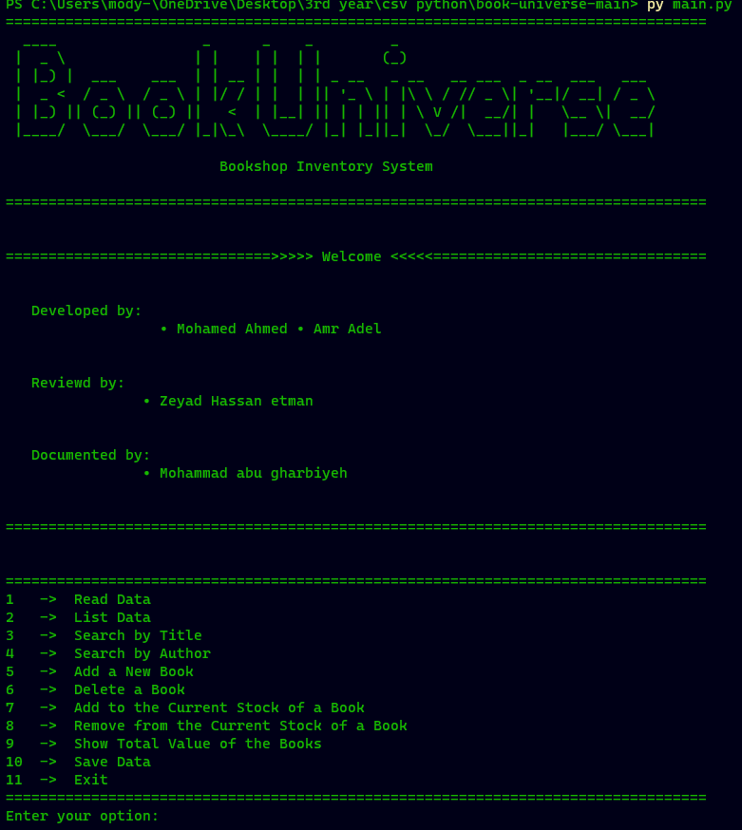

2- Read data

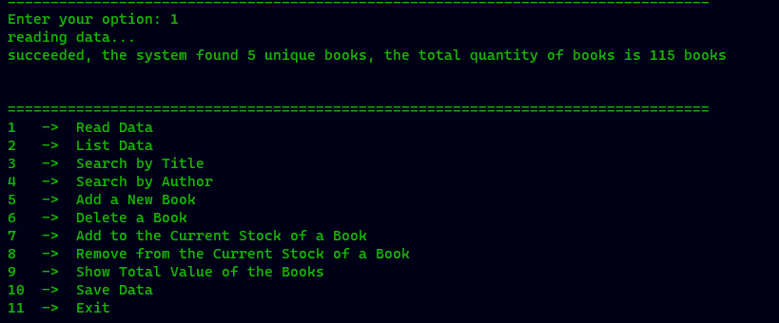

3- List Data

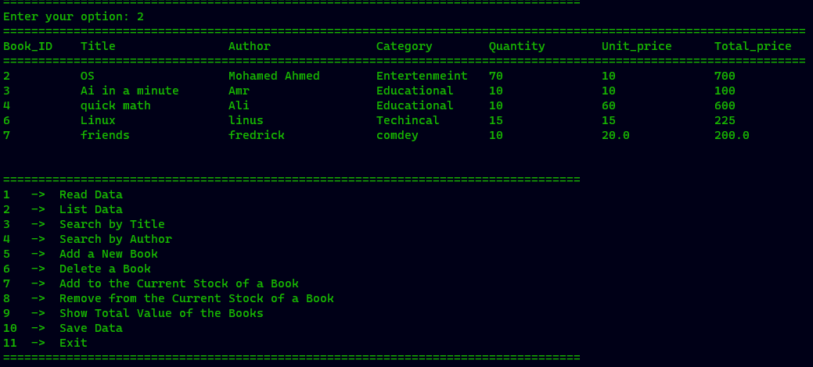

4- Search by title

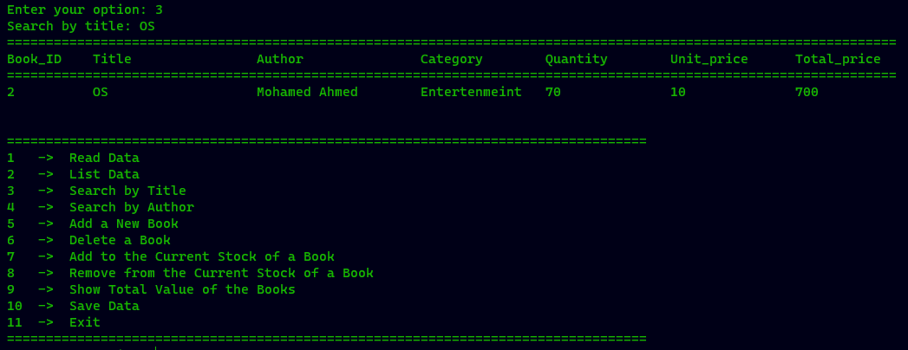

5-Search by Author

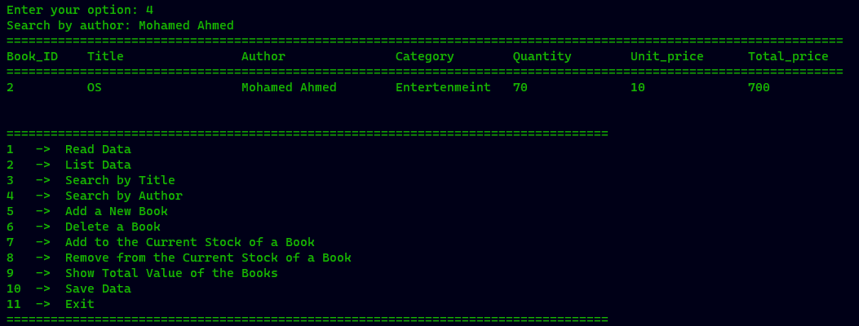

6-Add a New Book

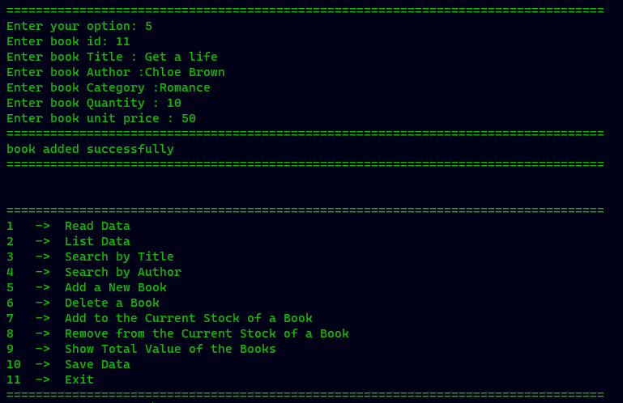

7-Delete a Book

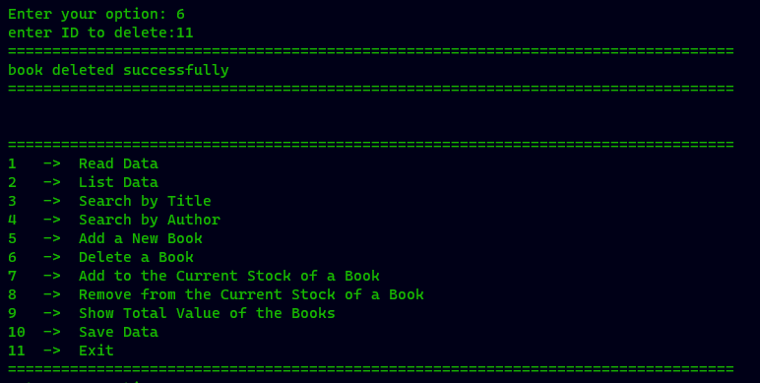

8-Add to the Current stock of a book

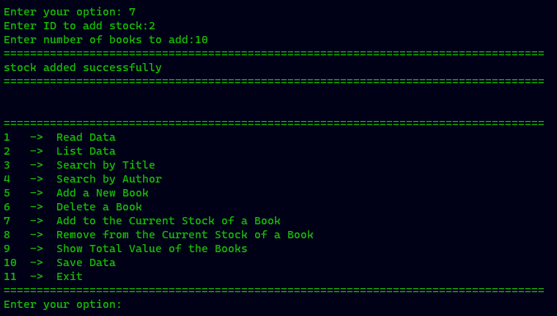

9-Remove from the Current Stock of a Book

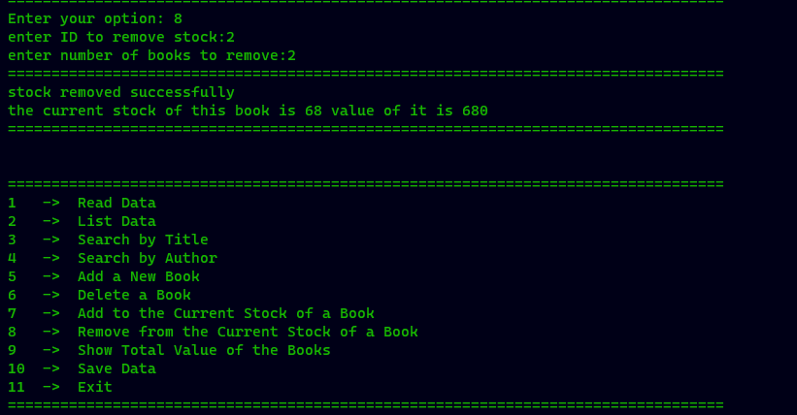

10- Show Total Value of the Books

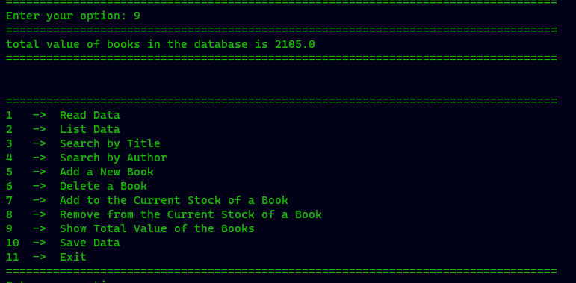

11-save Data

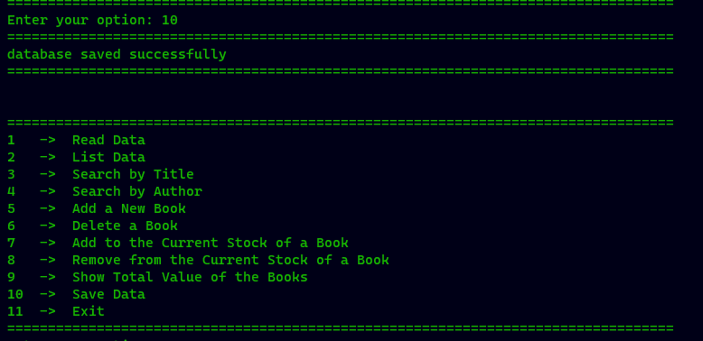

12-Exit

