Board Opening Remarks
Catherine Park, CEO • Annual Strategic Review • ~5 minutes

Headline
Meridian is a healthy company with a decelerating growth story, and 2026 is the year we decide whether to defend that or break it.

Where we stand (30 seconds)
Good morning. I want to use my five minutes to do three things: tell you honestly where Meridian stands at the end of my first year, name the three issues I believe deserve this board's attention, and ask you for one thing.
We closed 2025 at $400 million in revenue, up eleven percent. ARR ended the year at $413 million. Operating margin expanded to 12.4 percent. Free cash flow margin 17.8 percent. Cash on hand $463 million, no debt. In absolute terms these are good numbers. They are also the slowest growth Meridian has ever reported as a public company.

Three issues the board needs to weigh in on
1. The deceleration is structural, not transitory. Revenue grew 28% in 2022, 19% in 2023, 16% in 2024, and 11% in 2025. Our 2026 guide of 10-14% concedes the trend continues. Overall NRR has compressed from 114% to 109%; CAC payback has lengthened from 18 to 22 months; magic number is now 0.92, down from 1.20. We are trading growth for margin discipline (see chart below). This is a deliberate choice. It deserves a deliberate board conversation.
2. The AI window is open, and it is closing. We GA'd Copilot in September after an 18-month delay. We closed Helio Labs in November - 28 engineers, $10M cash plus $68M retention equity over four years, compressing our roadmap an estimated 15 months. Copilot paying seats went from zero to 710 in three quarters, with a 44% attach rate on Q4 enterprise renewals. Those are real proof points. But Asana shipped their full agent suite in November and is bundling it into the standard tier. Monday is now larger than us by ARR. Atlassian launched agentic Jira last week and will be in our enterprise deals directly. The window to be a credible AI-native enterprise platform is measured in quarters, not years.
3. The fragile asset is mid-market, not SMB. Enterprise (40% of ARR) is healthy: 21% YoY growth, NRR 125%, 2.6% logo churn. SMB (13% of ARR) is in managed decline at NRR 84% - that decision is made. The asset to defend is mid-market: 47% of ARR, NRR compressed from 108% to 102% in eight quarters, customers pushing for price holds and Copilot bundled at no cost. If mid-market NRR crosses below 100%, our deceleration story becomes a contraction story, and no Investor Day narrative will fix that.

The chart I'd ask you to remember
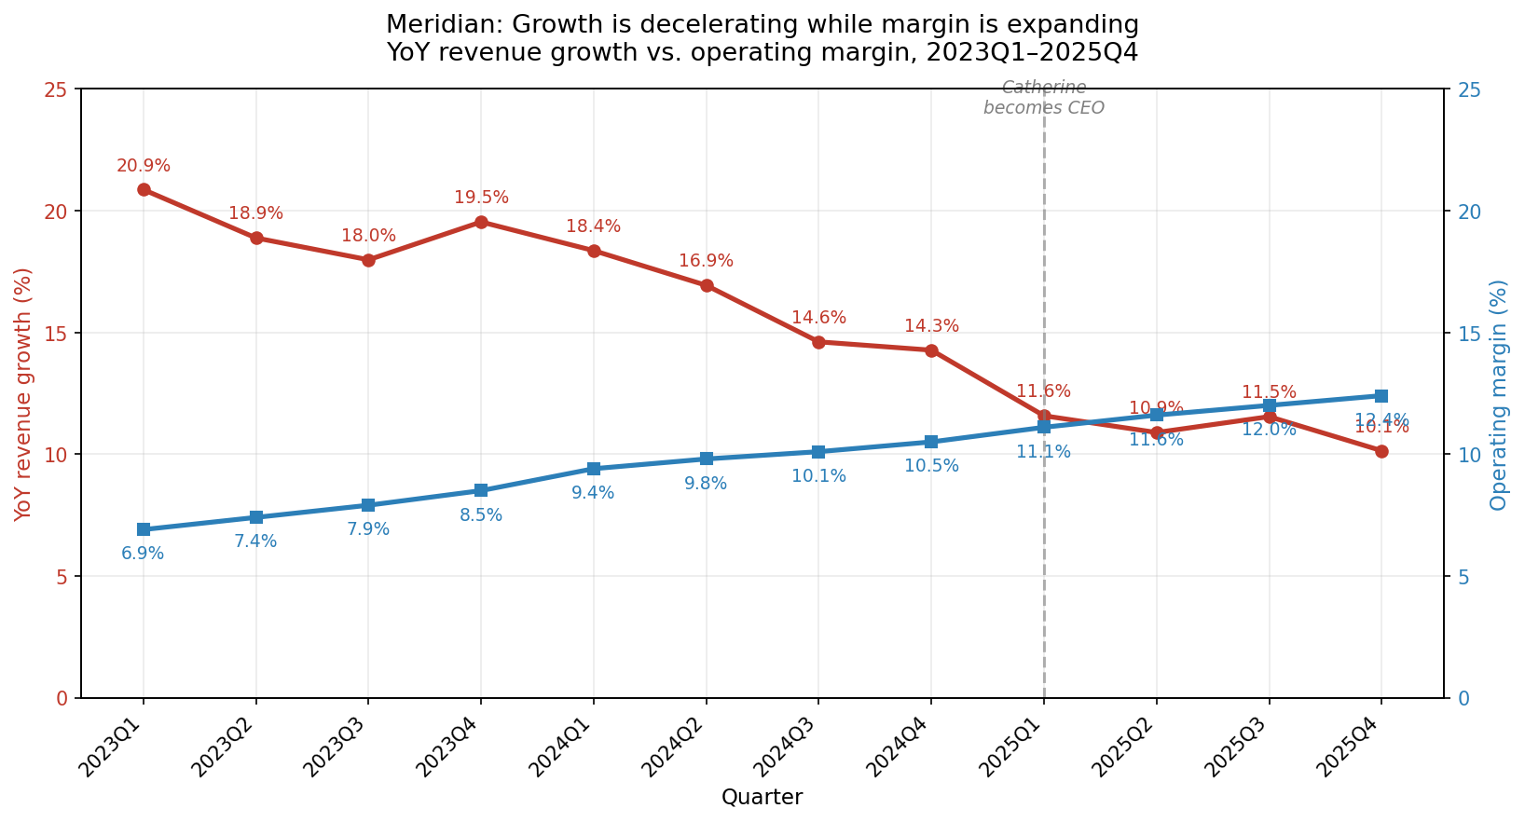
YoY revenue growth (red) and operating margin (blue) crossed in Q1 2025. Companion chart - NRR by segment - in board pre-read appendix (nrr_by_segment.png).

My one ask of the board
Before we leave this room, I want alignment on the identity question I raised on the Q4 call and that I will answer publicly at Investor Day on March 11: is Meridian a project management platform with AI features, or an agentic work platform with project management as one surface? The two paths imply different R&D intensity, a different pricing model, a different sales motion, and different capital allocation in 2026. I have a recommendation. I need the board's challenge and the board's commitment before I take it to the Street.

I'll stop there so we have time for the discussion that matters. Thank you.

