Investor Day Positioning Memo
Catherine Park, CEO • For board pre-read • Investor Day, March 11, 2026
Executive summary
On March 11, I intend to declare Meridian the enterprise-grade agentic work platform — built on the most trusted governance infrastructure in the category. This is not a rebrand; it is a strategic commitment that aligns our R&D, sales motion, pricing, and capital allocation around a single white-space position no competitor occupies today. Three of four direct competitors have already moved decisively to agentic language; the fourth (Smartsheet) is decelerating and is a takeout candidate. Our customers — 18 of 22 enterprise advisory sessions in the last 90 days — are asking us for exactly the product this positioning describes: governed agents an audit committee can sign off on. We have the assets (Helio agent framework + FedRAMP/HIPAA infrastructure), the balance sheet ($506M total liquidity), and the customer demand to claim this slot. This memo lays out the position, the rationale, the competitive picture, the risks I own, and three commitments I will make to investors.
The position
"Meridian is the enterprise-grade agentic work platform — built on the most trusted governance infrastructure in the category."
Project management is the surface we started with. Agents are how enterprise work gets done in the next decade. Our differentiator is not the most ambitious agent — it is the agent that a chief compliance officer can deploy in production.
Why this position wins
- Category gravity is agentic. Asana, Monday, and Atlassian have all moved to agentic positioning in the last six months. Smartsheet — the only Option A holdout — is growing low-single-digits and is a takeout candidate. Staying in PM-with-AI is the loser's seat by 2027.
- Customers are asking for the product only we can build. Governance for AI agents was the #1 enterprise theme in 18 of 22 advisory sessions: auditability, role-based agent permissions, model selection, data residency. PM competitors have not built this; AI-native upstarts likely never will. Helio's agent framework plus our existing governance is a combination no competitor has.
- The white space is real. No competitor today occupies the agentic-platform + premium-governance quadrant with broad enterprise reach. Atlassian's Rovo is the nearest, but its governance story is dev-centric. Regulated industries (banking, pharma, federal) where we already win are the moat.
- We can afford the bet. $506M total liquidity, $200M undrawn revolver, no debt, 17% FCF margin guided 2026. Option B's downside case is $550M revenue at 5% growth — still profitable, still cash-generative. The asymmetry is the right way around.
Competitive landscape (summary)
 | Asana | Monday | Smartsheet | Atlassian
AI positioning | PM platform w/ AI built in (soft-agentic) | Work OS, AI as a layer | Enterprise platform you can trust (rejects "agentic") | Agentic enterprise platform (Rovo)
Pricing posture | Bundled (Advanced+) | Bundled (Pro+) | Base bundled; Compliance Pack +$15/seat | Separate paid; consumption hybrid
Latest flagship (last 6 mo.) | Nov 2025: AI Studio bundled | Jan 2026: monday AI Agents GA | Dec 2025: AI Compliance Pack | Jan 2026: Rovo Studio agent builder
Closest to Meridian option | B (Agentic) | A in framing / B-lite in execution | A (PM-with-AI) | B (Agentic platform)
See positioning_matrix.png (embedded below) and competitive_landscape.docx for the full 8-dimension comparison.
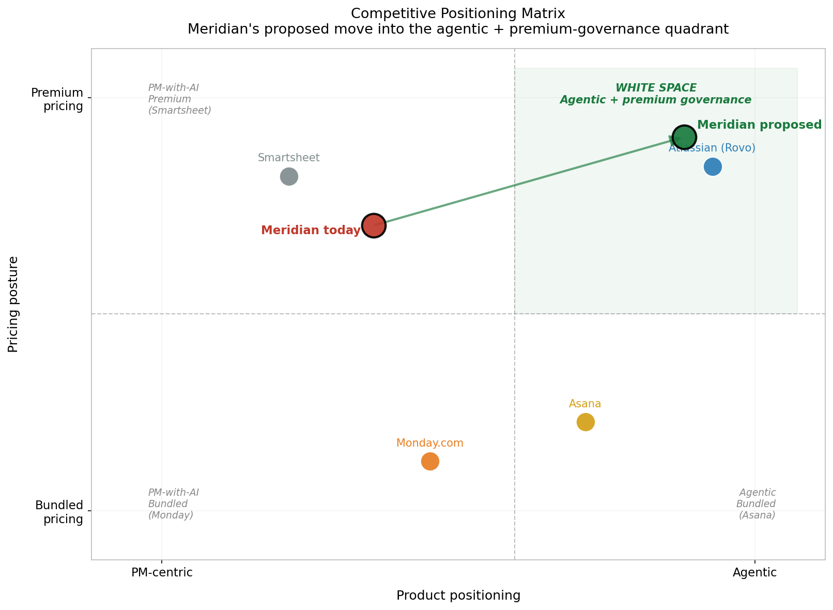
Three risks I own
- Revenue air gap. Mid-market (47% of ARR, NRR 102%) is fragile while agentic revenue is small ($3.5M ARR). If PM gets maintenance-only investment before agentic compounds, Q2 2026 earnings becomes the durable narrative. Mitigation: bundle a Copilot baseline into mid-market standard tier on the same day as Investor Day.
- Model lab disintermediation. If Anthropic or OpenAI ship native enterprise agent governance (audit, RBAC, model pinning), our moat compresses. Mitigation: public multi-model neutrality, vertical depth as the second moat.
- Helio retention cliff. $68M retention equity vests through 2029; 2026 cash-comp cliff is the inflection. Mitigation: give the team genuine roadmap autonomy on the agent platform — Option B does exactly this.
Three commitments to investors on March 11
- Quarterly Copilot KPIs starting Q1 2026. Paying seats, ARR contribution, attach rate on enterprise renewals, and in-product usage of agentic actions — reported publicly each quarter.
- Mid-market pricing redesign announced the same day. Baseline Copilot bundled into mid-market standard tier; consumption pricing on the agent platform rolled out H2 2026. Removes the renewal headwind.
- Model neutrality, in writing. Meridian will not sign exclusive strategic partnerships with any model lab. BYO-model is the default. Customer optionality is the principle.

