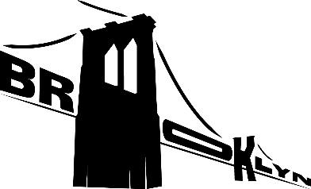 Brooklyn Bridge Park – Outdoor Films Festival

**Summary**

Host a family event at one the best locations for an outdoor movie event possible. The biggest challenge is not the event itself, but spreading the word beforehand with an trendy, eye-catching website. It needs to make people want to attend the event, and feel the need to “save a seat” as well. The recommended website is: <https://BrooklynOutdoorFilms.org> (available).

**Stakeholders**

OFF owner/Organizer- Jennifer Viala

Marketing director- Joseph Smith

Brooklyn Bridge Park Director – Gloria Boria

Brooklyn Parks District Manager – Stevie Wonder

Holmes Development Co owner – Michael Holmes

**Goals**

Four days of family, films and fun. The event will host 5,000 people and we expect the venue to maxed the entire time. Functional Website finished Eight weeks before the event providing enough time for the marketing department at OFF to broadcast the event through social media and the web.

**Budget**

$3,500

Web development services - $1,000

Event Photographer - $700

Domain Hosting/web services- $500

Travel costs - $500

Park Permit - $300

Hardware Emergency fund - $500

**Timeline**

|  |  |  |
| --- | --- | --- |
| * OFF/Brooklyn Parks meeting | * 3 hours | * 05/01/2018 |
| * OFF marketing/Holmes | * 2 hours | * 05/02/2018 |
| * Park Permit request | * 6 weeks | * 05/04/2018 |
| * Website construction | * 6 weeks | * 05/04/2018 |
| * Beta testing | * 1 day | * 06/18/2018 |
| * Website final approval | * 1 day | * 06/19/2018 |
| * Permit approval | * 3 days | * 06/19/2018 |
| * Film event! | * 4 days | * 08/05-08/08/2018 |

**Tech-Specs**

The website is designed utilizing HTML, CSS, JavaScript and Bootstrap. Design was chosen based on a visual even (films) and the webpage is responsive to view nicely on any size of device from mobile phone to widescreen computer monitor.