**Question 1 (15 minutes): Solar Radiation Spectrum Modeling**

The radiation emitted by the sun is called the solar radiation. Solar radiation is a source of energy and it can be converted into electrical energy if the radiation lands on a device such as a solar cell. In this question, we will learn how to model the solar radiation using Planck’s Law.

**Solar Radiation Spectrum**

Figure 1 below shows the solar radiation at various wavelengths, such plot is a *histogram* or a *spectrum* (when the x-axis is frequency). The spectrum below shows the solar radiation at various heights above the earth’s sea level. As you can see, solar radiation is greatest (yellow region) at the top of the atmosphere and is at a minimum (red region) at the sea level, this is due to the attenuation that photons experience as they travel through the earth’s atmosphere. The valleys for the (red) spectrum at the sea level are due to absorption by water and carbon dioxide molecules. The smooth curve is the spectrum of a black body at 5250 degree Celsius based on Planck’s law. Planck’s law is described in the next paragraph. We see that the sun can be modeled as a black body.

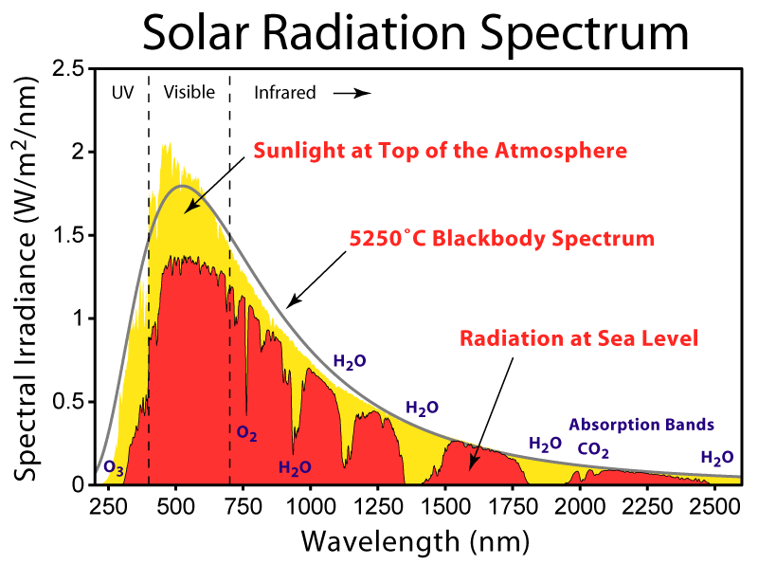

Figure 1 Solar radiation spectrum at various altitudes.

**Planck’s Law of Black Body Radiation**

Planck’s law describes the electromagnetic radiation emitted from a black body at temperature specified in Kelvin. A black body is an object that absorbs incident radiation across all wavelengths (thus it is called a black body) and emits thermal radiation across a continuous frequency spectrum based on the object’s temperature. Planck’s law is:

$$R\left(λ,T\right)=\frac{2πc^{2}h}{λ^{5}}\left(\frac{1}{e^{{(hc)}/{(λkT)}}-1}\right)$$

Where $λ$ is the wavelength in meters, c = 3 $×{10}^{8} meter/second$ is speed of light,

h = 6.63 $×{10}^{-34} Joule-second$ is Planck’s constant, and

k = 1.38 $×{10}^{-23} Joule/Kelvin$ is Boltzman’s constant.

1) Using Planck’s law, write a MATLAB script to plot the spectral radiance of a black body at T=5700 degrees Celsius from 0 to 2000 nanometers (nm). Label the x-axis, y-axis, and the title of your plot correctly with units. (xlabel(), ylabel(), title()) Hint: “aVec = [0:2:100]” is a one-dimensional vector from 0 to 100 at intervals of 2. 0 is the starting point, 100 is the end point, and 2 is the step size.

When the TA runs your program, a plot should pop-up on the window. The plot should be labeled.

2) Now we will learn how to use MATLAB’s built-in function to find the wavelength that gives *maximum* radiance. We will use the function ‘max’.

At MATLAB’s prompt, type ‘help max. Read through the output to learn how to use this function. Note: in the future, you can type ‘help <function-name>’ to learn about built-in functions. Try, ‘help plot’, ‘help title’, ‘help exp’…

Below is a description on how to use ‘max()’.

If ‘X’ is an one dimensional vector, ‘max(X)’ will return the largest element in ‘X’. For example, if ‘X=[1 2 5 3.2 0]’, ‘max(X)’ will return 5.

Now, max(X) can also return the index (location) of the maximum value in ‘X’.

If you type ‘[y i] = max(X)’ at the command prompt, ‘y’ will contain the maximum value in vector ‘X’, and ‘i’ will contain the index in ‘X’ that contains the maximum value.

Hint: in part 1), you have defined an array for the x-values (wavelength), and another array for the y-values (radiance) of the graph.   Use the ‘max’ function on the y-values, identify the corresponding location of the y-maxima, and use that location to extract the corresponding x-value.

Now, use the above approach to determine the wavelength that gives maximum solar radiance. Report the wavelength value in meters.

When the TA runs your program, a line displaying the answer should appear in MATLAB’s command prompt. See below for example.

Example: (this is just an example, the wavelength value here may not be correct)

*The wavelength that gives maximum radiance is*

*5.0000e-007*

3) Repeat problem 2) using the four temperatures (T1 to T4) given below.

Hint1: plot the spectrums first to help you estimate the range of wavelengths where the solutions might lie. **Think about changing the step size and the range of the wavelength vector.**

Hint2: ‘wavelength = [0:1e-9:1000e-9];’ is a vector from 0 to 1000 nanometers with a step size of 1 nm. ‘length(wavelength)’ returns 1001.

T1 = 450 pico (${10}^{-12}$) Kelvin – coldest temperature measured

Hint: answer is between 5,000 kilometers and 10,000 kilometers

T2 = 3 Giga (${10}^{9}$) Kelvin – the core of a massive star on its last day

Hint: answer is between 0 and 10x10-3 nanometers

T3 = 350 Mega (${10}^{6}$) Kelvin – temperature achievable by thermonuclear weapons

Hint: answer is between 0 and 20x10-3 nanometers

T4 = 350 Giga Kelvin – merging binary neuron star system

Hint: answer is between 0 and 20x10-6 nanometers

Again, when the TA runs your program, a line displaying the answer should appear in MATLAB’s command prompt, similar to the example in 2)

**Question 2 (15 minutes): Rainwater Storage System**

At the UC Davis Robert Mondavi Institute Winery, there are four water tanks capable of capturing and storing 176,000 gallons of rainwater. The stored water is treated on-site, and is used for vineyard irrigation and cooling of fermentation tanks. Figure 2 below is a picture of the four storage tanks.

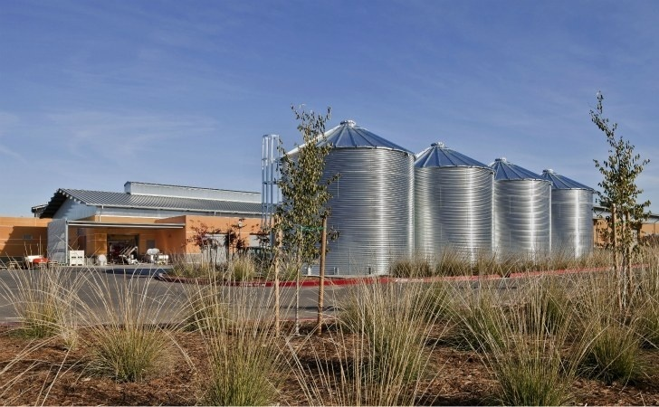

Figure 2 Rainwater collection and storage tanks at Robert Mondavi Institute.

In this question, you will perform some analysis of the rainwater capture and storage system if it is implemented in another city. The Excel database for this lab contains precipitation data for many cities. Your teaching assistant will tell you which city to use. Answer all tasks in this question using the data for this city.

**Task 1**: Enter the precipitation data into a single vector. This vector should have a length of 12.

**Task 2**: Convert the precipitation data from inches to meters.

1 inches = 2.54 centimeters, and 1 meter = 100 centimeters

**Task 3**: Given the precipitation data, calculate the amount of total rain fall in a year for the city you are assigned. The land area of each city is also given in the Excel database. Give answer with units in both liters and gallons. (1 liter = 0.001 cubic meters; 1 gallon = 3.78 liters)

Hint: You are calculating a volume quantity here. Precipitation data is the height.

**Task 4**: You would like to install a similar system. The tanks will be connected to a rain water collector on the roof with a collection area of 10 feet by 30 feet. Calculate the amount of rain water that can be collected by this system in a year. Give answer with units in both liters and gallons.

In Table 1 below, daily water usage in a home equipped with efficient water fixtures with minimal leakage is listed. (Handbook of Water Use and Conservation, 2001)

|  |  |
| --- | --- |
| Activity | Average usage per person (gallons) *daily* |
| Showers | 8.8 |
| Clothes Washers | 10.0 |
| Toilets | 8.2 |
| Dishwashers | 0.7 |
| Baths | 1.2 |
| Leaks | 4.0 |
| Faucets | 10.8 |
| Other Domestic Uses | 1.6 |

Table 1 Average *daily* water usage per person for various activities.

**Task 5:** Enter the daily usage data in Table 1 into a 1D vector. Convert the data from gallons into liters.

**Task 6:** Calculate the yearly water usage for each activity. (liters)

**Task 7:** Calculate the amount of water one person uses in a year. (liters)

**Task 8:** Assuming the water usage profile in Table 1, what is the area of the rainwater collector in order to meet the demands for a family of 5 people? Assume same usage for all five people.

**Question 3 (10 minutes): Degree-day Calculations**

One concept used in meteorology, and HVAC (Heating, Ventilation, and Air Conditioning) analysis and design is *degree-day* (DD). There are two types of DD, *heating* and *cooling* DD. For heating, DD is defined as the average daily temperature in degrees Fahrenheit below 65 degrees for one day.

$${DD}_{heating}=\left(65℉-{Temperature}_{average}\right)*(1 day)$$

For *cooling*, DD is defined as the average daily temperature in degrees Fahrenheit above 65 degrees for one day.

$${DD}_{cooling}=\left({Temperature}_{average}-65℉\right)*(1 day)$$

Example: If on July first, the average temperature that day was 90F, then ${DD}_{cooling}$ = 90 – 65 = 25 degree-day. If for the entire month of July, average daily temperature was also 90F, then the total ${DD}_{cooling}$ for this month is equal to (90-65)*31 days = 775 degree-days.

Cooling and heating degree day numbers for various cities are given in the Excel database for this lab. Your teaching assistant will tell you which four cities to use for calculations below, and whether to use cooling or heating degree-day for all four cities.

**Task 1**: Enter the degree-day data into 4 vectors, each with 12 elements. Let each vector represent a city.

**Task 2**: For each city, calculate the average temperature for each month.

Note: Remember the degree-day data given to you is for one month, while the formulas shown are for one day.

**Question 4 (20 minutes): Ventilation System Design**

Another term commonly used in specifying HVAC system requirements is *air change per hour*. Air change per hour is the number of times the total amount of air in an enclosed space must be replaced in an hour.

Table 1 below contains 6 different types of ventilation fans and their performance. Your teaching assistant will tell you which fan type to use to complete problems below.

|  |  |  |  |  |
| --- | --- | --- | --- | --- |
| Fan Type | Blade Diameter (inches) | Cubic Feet per Minute (CFM) | Revolutions per Minute (RPM) | Current Draw (Amps) @115V |
| 1 | 10 | 695 | 1550 | 1.8 |
| 2 | 12 | 1025 | 1550 | 1.8 |
| 3 | 14 | 1600 | 1050 | 3.5 |
| 4 | 16 | 1200 | 1550 | 3.5 |
| 5 | 18 | 3075 | 1050 | 3.5 |
| 6 | 20 | 3275 | 1075 | 3.5 |

Table 1 Data for mounted exhaust fan. (Alpine Air)

Table 2 below contains dimension information and air change requirements for 6 different locations.

|  |  |  |  |  |
| --- | --- | --- | --- | --- |
| Location Type | Length (feet) | Width (feet) | Height (feet) | Air Changes per Hour Required |
| Chem 194 | 65 | 50 | 35 | 12 |
| Wellman 101 | 20 | 19 | 10 | 12 |
| Mondavi center’s main stage | 113 | 50 (depth) | 60 | 10 |
| Coffee shop | 20 | 30 | 10 | 5 |
| Machine shop/factory | 50 | 50 | 20 | 15 |
| Small research lab/office | 15 | 20 | 8 | 10 |

Table 2 Dimension and air change requirements for 6 different locations.

**Task 1**: Enter the data in Table 2 into 4 different vectors, each with 6 elements. One vector will hold length data, one will hold width, one will hold height, and one will contain air change data.

**Task 2**: Calculate the number of fans required for each location using the specified fan type.

Given: Number of fans = $\frac{total volume that needs to be exchanged per hour }{rate of air flow per hour}$

**Task 3**: Calculate the power required for each location using the specified fan type.

Given: Power = current * voltage

**Task 4**: If a fan creates roughly 3dB (decibel) of noise for every 300 revolutions per minute, calculate the total noise (dB) created for each location using the specified fan type.

For Your Information (FYI), an air conditioning unit at 100 ft away is approx. 60db while a powerful lawn mower is approx. 90 db.

Hint: quantities in the dB (decibel) scale add. For example 5 fans each running at 300 RPM will create a total noise of 5fans*3dB per fan @ 300RPM = 15 dB

**Task 5**: (For this task, you will work with all six fan types) It is common to create a metric that allows the fair comparison of multiple products each have different specifications for different parameters. This is called the figure of merit (FOM). The FOM, can be a large number or a small number, depending on the application. Note: placing a parameter in the numerator of the FOM equation increases the FOM while placing it in the denominator decreases the FOM.

Enter each column of the fan data into MATLAB as vectors. Write a line line of code to calculate the FOM for the 6 fan types based on the simple equation below. Which fan type has the largest FOM?

Figure of Merit for the fans, FOM = $\frac{cubic feet per minute}{blade diameter*RPM*current draw}$

**Task 6:** (For this task, you will work with all six fan types) Often, only a single parameter in the specifications is of interest. For example, the current draw of the fans. The FOM above can be modified to account for this by simply squaring the parameter of interest in the FOM equation. Below is a modified equation for FOM that emphasizes the RPM for reducing the overall noise, and current for lowering power consumption.

Re-calculate the FOM for the 6 fan types based on this equation. Which fan has the largest FOM?

Modified Figure of Merit for the fans,

FOM = $\frac{cubic feet per minute}{blade diameter*RPM*RPM*current draw*current draw}$

**Task 7**: (optional) For simplicity, let’s assume all 6 fan types cost the same (which is probably not true). Taking noise, power consumption, and air-change requirements into consideration, which fan type is the best in a small office? How about a large factory? Keep in mind you probably can’t install a large number of fans at a physically small space. Hint: Think of the figure of merit.

**Question 5 (10 minutes): Solar Power on Satellite**

NASA has hired you to design the solar power system for the newest satellite it is planning to launch. In this system, there are many design constraints that affect the overall satellite’s performance. A few of those constraints will be explored in this question.

|  |  |  |  |  |
| --- | --- | --- | --- | --- |
| Panel type | Area per panel (square feet) | Cost per panel ($) | Weight per panel (kg) | Power per panel (Watts) |
| Monocrystalline | 5x2 | 150 | 10 | 60 |
| Polycrystalline | 5x3 | 200 | 19.5 | 240 |
| Multi-Junction | 3x2 | 150 | 7 | 60 |
| Cadmium Telluride | 5x2 | 100 | 8 | 72 |

Table for question 5.

**Task 1**: The overall satellite’s weight is limited to 10 metric tons. 9 tons is reserved for instruments and the satellite’s chassis. This gives a weight budget of 1 ton for solar panels. How many panels can be used for each type of solar panel listed in table above, while meeting the 1 ton weight limit?

**Task 2**: Using results from Task 1, how much total power is available for each solar panel type?

**Task 3:** Using results from Task 1, how much does it cost to use each solar panel type?

**Task 4:** Using results from Tasks 2 and 3, calculate the watts-per-dollar metric for each solar panel type.

**Task 5:** A last minute decision limits the area of the solar panel array. The area for the solar panel array on the satellite is now limited to 200 square meters. There is no restriction on width and lengths. Re-calculate the watts-per-dollar metric.

**Question 6 (10 minutes): Renewable Gym**

A local gym decides that one way to reduce its membership fees is by selling the electricity generated from workout machines back to the electricity company. To do this, the gym connects its exercise equipments to motor generators.

|  |  |  |  |
| --- | --- | --- | --- |
| Equipment | Number of units | Power per unit (Watt) | Average daily usage per unit (minutes) |
| Treadmill | 20 | 500 | 500 |
| Stationary Bicycle | 15 | 500 | 200 |
| Exercise Bicycle | 15 | 300 | 300 |
| Elliptical | 20 | 200 | 700 |
| Weight Lifting Machine | 10 | 100 | 200 |

**Task 1:** What is the total energy generated in the gym each day? Note: Watt is energy per unit time, which is Joules per second.

**Task 2:** If the electricity company agrees to buy back the electricity at 0.0001 cents per Watt-hour, how much money does the gym make in one month?

**Task 3:** Before installing the generators, the monthly membership fee is $59 per person, 35% of the fee accounts for electricity. Using results from Task 2, how much of the membership fees (per person) can be reduced after installing the generators? Assuming all profits made from selling electricity is for subsidizing membership fees, and the gym has 500 members.

**Question 7 (10 minutes): Smart Battery**

A start-up company is making “Smart Batteries”. A smart battery is a battery that contains a vibration energy harvesting device. This allows smart battery to recharge itself using vibration energy while a person is on the go. This potentially results in a longer cell phone operation lifetime. Table below lists some measured lifetime data for a few smart phones (SP).

|  |  |  |
| --- | --- | --- |
| Phone Type | Battery capacity | Average cell phone operation lifetime |
| SP1  (SP – Smart Phone) | 1500mAh | 0.8 days |
| SP2 | 2500 mAh | 1.5 days |
| SP3 | 3000 mAh | 4.2 days |
| SP4 | 2700 mAh | 2.3 days |
| SP5 | 2000 mAh | 1.8 days |

Note: mAh stands for milli-amp hours. This is a unit of energy. It tells you how much constant current can be drawn for one hour. For example, a battery with 100 mAh of capacity will be fully discharged if a constant current of 100 mA is drawn for one hour. Alternatively, if 50 mA of constant current is drawn from the battery, it will take 2 hours to discharge.

**Task 1:** For all 5 smart phones listed in table above, how much energy (mAh) is consumed every hour? Hint: capacity divided by average lifetime.

**Task 2:** If the battery capacity for all 5 smart phones above is decreased by 10%, but the rate of energy consumption is still the same (what you calculated in Task 1), what is the average cell phone operation lifetime now?

**Task 3:** The experimental vibration harvester can generate an average current of 1 mA under walking conditions. If a person carries the harvester for 10 minutes, how much energy can be harvested? Express answer in units of mAh.

**Task 4:** To avoid making changes to the smart phone, the overall battery dimension must be kept the same, before and after integrating the vibration harvester. As a result, integrating the vibration harvester requires reducing the battery capacity by 20%, to maintain the same overall dimension. Calculate the average operation lifetime of a cell phone utilizing a smart battery Hint: what is the effective rate of energy consumption now? Energy consumption of smart phone is reduced by harvested energy.

**Question 8 (10 minutes): Investing in Solar Power**

**Task 1:** You recently decide to invest in solar energy, below is your investment portfolio is shown below. How much is your portfolio currently worth?

|  |  |  |  |
| --- | --- | --- | --- |
| Company | Number of shares | *Purchase* price per share | *Current* price per share |
| Great Photons | 100 | $0.88 | $0.96 |
| RentUhWatt | 70 | $0.56 | $1.23 |
| Silicon Plus | 10 | $0.12 | $0.13 |
| Solar Magic | 200 | $1.32 | $3.20 |
| Panel Plus | 30 | $2.32 | $1.98 |

**Task 2:** You decide to sell all of your stock. What is profit/loss?

**Task 3:** When selling your share, the stock broker charges a different percentage on the *net worth* of your portfolio. The rates are shown in table below. Calculate your overall profit/loss after sale.

|  |  |
| --- | --- |
| Company | Broker Rate |
| Great Photons | 1.2% |
| RentUhWatt | 0.8% |
| Silicon Plus | 0.3% |
| Solar Magic | 1.8% |
| Panel Plus | 1.1% |

**Task 4:** 20 percent of your profit is taxed, and you pay a one-time cost of $100 to your accountant for preparing your taxes. Calculate your profit after accounting for these costs.