The Holocron.Foundation presents:

Ourobourous

Transcendence through Transformation



[[Replace w/ custom animation: One point -> many points -> labels appear -> gain structure as snake -> snake turns in to eat tail -> eats tail and grows -> transforms into holocron.foundation 2019 logo -> collapse back to point]]  
[[Misc to do: Cite the use of knowledge in society]]

This document outlines Phase I of the Holocron.Foundation, entitled Ouroborous. Ourobouros entails the creation a galactic intelligence network (GIN) and a framework for decentralized governance, UNGovern, as well as the preceding steps needed to achieve these goals. The GIN will attempt to solve any problem thrown at it, and can work on a multitude of problems simultaneously. It can also improve itself and the predecessor components, leading to a dynamic system which transcends itself through transforming itself through interlinked feedback and feedforward mechanisms. UNGovern builds on the democratic and decentralized economic system embodied by cryptocurrencies by turning them towards politics rather than economics. It also notably guarantees certain rights such as freedom of speech, the right to vote, and the right to bear arms mathematically rather than through the promises written on a piece of parchment that holds no true power itself.

Ouroboros is a unification of  
the entirety of humanity,  
the entirety of knowledge,  
& the entirety of computers  
in an interlinked network.

Contents

Goals 2

Guiding Principles 2

Components 3

External Components 4

Python 4

Ethereum 4

Vyper 5

Linux 5

InterPlanetary File System (IPFS) 5

Github 5

Web Stack (HTML, CSS, JavaScript) 5

Internal Components 6

Phoenix 6

Communal.Network 11

Eden Drive 13

Apollo Network 13

PyO 18

QuickTMI 18

Fluent 19

UOS 20

CiteIt 20

Journal 20

GIN 21

UNGovern 21

Ouroboros 22

References 22

Cut Content 24

EndIP 24

Apollo Network 24

# Goals

# Guiding Principles

There are just a handful of key guiding principles underlying Ouroboros. These components may clash at times, but all should be considered when creating Ouroboros. These principles are listed below and are sorted in decreasing order of priority:

* Results: No other component matters if the results are not desired.
* Availability: Components must be built from widely available technologies, and must be made widely available, including in-progress builds.
* Simplicity: Components and components of components must be as reasonably simple as possible.
* Speed: [[Something about the speed to run a program which randomly guesses would take longer than the age of the universe]] [[Important for optimization across different device types]]

# Components

Ouroboros consists of several elements, some of which rely upon other elements of Ouroboros, and others of which are singular elements. Ouroboros also builds upon existing external technologies. Figure 1 displays the full structure of Ouroboros.

Figure 1: Ouroboros Component Diagram

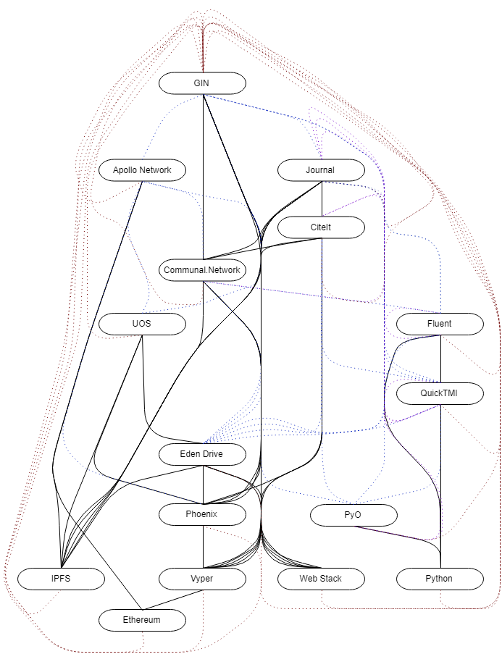

[[Make background clear, add UNGovern]]

Ouroboros is a heavily interconnected system, where some components are directly reliant on others (black lines in Figure 1), some components have synergies with latter components (blue dashed lines in Figure 1), some components will lead to improvements in prior components (purple dashed lines in Figure 1]), and GIN, the final component of Ouroboros, is able to improve all prior components (red dashed lines in Figure 1).

## External Components

Several existing technologies already provide large portions of the capabilities needed to build Ouroboros. There are thousands of programming languages, millions of utilities, and ultimately selecting a handful will simplify and speed up development to prevent redundant builds across languages.

### Python

[[Python is both a high level and a general-purpose programming language. Originally created in 1989, the language is open source and features a large community of developers who contribute to the development of the language and packages. Packages are useful pieces of code, which enable you to work with Excel documents (openpyxl), perform regressions and other data analysis (pandas), work with advanced mathematical functions and large matrices (NumPy), perform machine learning (TensorFlow), and a wide variety of other functions. It is the third most used language in January 2019 according to the TIOBE index.]] [[The long lifespan,[1] large base of familiar developers,[2] the availability of libraries,[3] and simplicity[4] of the syntax make this a clear choice for a primary programming language.]]

### Ethereum

2017 and 2018 saw a global and media fixation on cryptocurrencies such as Bitcoin (BTC), Litecoin (LTC), and Ethereum (Ξ). While the currency and business applications of these technologies are interesting, there are many more potential uses of the underlying technology that have not been publicly explored or announced.

The key technology underlying cryptocurrencies is blockchain. Blockchain, conceptually, is a chain of transactions.[5] These transactions are lumped together into “blocks”, which may contain a number of transactions ranging from 0 to hundreds or even potentially thousands. The frequency of block issuance depends upon which blockchain is in use (e.g. BTC, LTC, Ξ). Another key feature is the consensus mechanism, which enables thousands of disparate individuals to agree upon a single canonical chain. For a deeper and more technical look at what a blockchain is, I recommend seeing the section *Introduction to Bitcoin and Existing Concepts* in the *Ξ Whitepaper* by V. Buterin.

Selecting a blockchain depends upon what applications a user is looking to undertake. BTC primarily allows for decentralized purchases and transfers of value for a relatively low price. LTC also fulfills a similar function. Ξ can serve this function, but also has a key distinction that makes it open to a much wider variety of applications: it contains a virtual machine[6] that is Turing complete.[7] This means it can run *any* computer code that can be executed on a traditional desktop, laptop, server, cellphone, or other device. [[No other blockchain brings the combination of features[8] and security[9] Ethereum provides.]]

Ξ is relatively young: it was initially released in 2015.[10] Only a few decentralized applications (ÐApps) have been released.[11] These generally revolve around digital commoditization, digital collectibles, and online gambling. Each of these applications functions more effectively on Ξ than traditional networks and computers for a variety of reasons, but a discussion of that is beyond the scope of this paper.

### Vyper

[[Explain Vyper]] [[The pythonic syntax,[12] and easy auditability[13] make this an ideal programming language for Ethereum.]]

### Linux

[[Explain Linux]] [[The open-source nature of this operating system (OS) makes it the only rational choice of OS at present.]]

### InterPlanetary File System (IPFS)

[[explain ipfs]]

### Github

[[explain github]]

### Web Stack (HTML, CSS, JavaScript)

[[explain web stack]]

## Internal Components

The components below build out the capabilities needed to complete Ouroboros.

### Phoenix

#### Description

Phoenix is an advanced file system which can supports bytes of any format. It lives within a single smart contract on the Ethereum Blockchain. It allows for unhindered sharing of any item which can be held in a digital format.

#### Prerequisite Components

Vyper: Phoenix is built upon the Ethereum blockchain, and therefore must be coded in some language upon the chain.

#### Feedback Mechanisms

Vyper is not impacted by any feedback mechanisms. It is designed to be basic, simple, and forever upon launch.

#### Benefits & Outcomes

The nature of Phoenix provides many advantages over traditional file systems:

* Decentralized
* Global: The network is spread out across most countries in the world, including the U.S., U.K., France, Germany, Russia, and China.
* Simple & minimal: Phoenix is designed to be simple and minimal by design. You can used a traditional web stack combined with smart contracts to use the system for more advanced functionality, but at it’s core Phoenix is simple by design.
* No management: Phoenix has no management or administrators. The Holocron.Foundation (or anyone else) cannot change the functionality of the core contract. It will function as designed indefinitely, regardless of the whims of a controlling organization or other actor, such as a government.
* Censorship resistant: Ethereum uses peer to peer networking rather than the traditional server model, and therefore Phoenix does as well. Combined good encryption practices, this enables our network to function in hostile regimes, opening up the possibility to run a global file system that includes countries such as China and Iran.
* $0 in variable costs: Ethereum currently does not charge long-term rental costs, meaning that the initial cost to upload data is the only current cost.
* Redundant: All data is backed up on approximately 13,000 computers globally. Data can be recovered by connecting to any of these computers. You can setup a node relatively quickly to maintain a backup, or several.
* Passwords and keys never leave users: We never touch crucial security data, making it literally impossible to be stolen from us. You could encrypt your files using whatever encryption methodology you want, and we (or anyone) would have no way to know the contents of your file, or any location to target to take your keys.
* Unhackable: There is no central point to target, since there is no server holding user data, passwords, and other sensitive information.

#### Potential Applications

##### Military, Security, and Espionage-Intelligence Applications

###### Distributing Information under Restrictive Regimes

This technology allows for the distribution of any information that can be stored on a computer. This could be communications, files, or any other item that can be done on any normal computer. Both the *library* and *reincarnati.online* **already do this**. Currently these sites are accessed via a web server, but the sites could be distributed using USB, satellite, MMS, or other method. The HTML and JavaScript for *reincarnati.online* take up 1.551 MB, which is trivial to transmit using a wide variety of methods.[14] This would then allow users to access *any* site that has been uploaded to the Ξ blockchain, such as the blockchain implementation of the *library*, or any other site that has been prepared for the blockchain. This would be impossible to stop or censor,[15] provided a handful of minor changes are made to Ethereum Node Software.[16] The Great Firewall would be rendered obsolete.

###### Information Transmission During a Disaster/Combat

Maintaining internet communications during a disaster or combat has previously been difficult due to the need to maintain servers and connections to said servers. Using the Ξ blockchain turns every node into a point of distribution for the network, meaning that information could be transmitted in a more flexible fashion, propagating through shorter and more local active network connections. This could be paired with satellite internet, couriers, and other methods of delivery to ensure a robust network, even as the connections vary in terms of speed, connectivity, uptime, and throughput. There are even experimental developments of BTC over fax, SMS, Morse code, high frequency audio, and other novel methods, which could be used with slight modification to work with the Ξ blockchain.[17] This essentially creates a highly flexible internet, and with developments such as sharding scheduled to come to the Ξ network this year, the effectiveness of the network for this purpose will only grow.[18]

###### Backdoor Information Distribution in Foreign Nations

Using the Ξ blockchain to distribute information means anyone who is participating in it must distribute that information as well. At the time of writing, 35.7% of nodes are in the U.S., with 13.39% of nodes in China, and 5.14% of nodes in Russia.[19] These nodes are all currently distributing copies of both *The Declaration of Independence* and *The Gettysburg Address* because of the holocron.foundation.

These nodes could distribute any information that can be placed on a computer. It cannot be censored without stopping the entire internet in an area. Additionally, even if the network connection were interrupted or stopped, any data that has already reached these nodes would still be accessible locally and could be used to distribute information through other means such as USB, CD, or DVD.

###### Information Recovery Following Natural or Manmade[20] Electromagnetic Pulses (EMPs)

We will consider pulses of 3 scales: Regional scale,[21] national scale,[22] and global scale.[23] The price and difficulty of recovery increase as the scale increases, but the price would be lower and recovery time would be shorter at any scale than traditional recovery methods, as well as significantly more likely to succeed. The reason for this is that data, under the current methods of information distribution, is highly centralized. Approximately 34% of cloud infrastructure is hosted by Amazon Web Services, 11% by Microsoft Azure, 8% by IBM, and 5% by Google Cloud Platform.[24] This means that well targeted manmade emps (or other types of attacks, or an unlucky natural EMP) could eliminate 58% of current cloud infrastructure. Note that these services host the vast majority of frequently used and crucial information, meaning that the 58% hosted doesn’t even take into account the importance of the information stored. It’s estimated that 70% of the world’s web traffic is routed through Loudoun County, Virginia.[25] Several examples of the danger of this centralization already exist: In 2017, a technical glitch brought down a significant portion of Amazon’s servers in Loudoun County, bringing over 100,000 sites offline and interrupting other key internet services.[26]

Regional Scale

Restoring all data[27] to a region affected by an EMP is simple. Simply restoring power, internet, and providing new computers to key areas, such as crucial government offices, businesses, and manufacturing hubs would allow all of these to quickly resync their information. Additionally, setting up centers that provide laptops and an internet connection would reestablish networking and allow a resync for the general population. These connections would then resync to the Ξ blockchain, which would be maintained globally as a city recovered. All data would be recovered, and paired with blockchain compatible applications, would allow immediate resumption of prior computational application upon resync. For a simple, yet crucial, example of recovering the New York Stock Exchange (NYSE) using this technology, see appendix a.

National Scale

Though not quite as quick as recovery from a regional scale EMP, recovery on the national scale is relatively straightforward as well. A connection would have to be reestablished between a hub or hubs[28] in the U.S. and whatever global cities are unaffected. This would then be paired with a national level effort to do what was described in the case of a regional scale EMP.

There is the possibility that connections could not be reestablished in the case where foreign actors prevent the creation of a connection with a friendly nation, or if hostile foreign actors are the only nations unaffected. This can be overcome through one of, or a combination of, the following courses of action:

* Maintenance of backup nodes: nodes could be backed up regularly and cycled through faraday cages to maintain a stock of functioning hard drives with the necessary data to reestablish a network. The design and construction of these could be built with particular attention to the research contained in *U.S. Army Corps of Engineers Pamphlet No. 1110-3-2*.
* General hard disk drive (HDD) recovery: Any node that used an HDD could have its platters recovered and placed into a new case with functioning circuits. The platters would maintain data because the electronics present would be destroyed prior to causing damage to the platters due to the high susceptibility of these circuits to damage from electric pulses. Note that this approach would not work for solid state drives (SSDs).
* Satellite Backups: By placing several Ξ nodes on satellites, these could be used in cases where the surface of the planet was affected, but space was left unaffected. These could transmit information to any location needed.

Global Scale

Recovery on a global scale would necessitate using the techniques described to recover on a national level in the cases where reestablishing connection with an unaffected city is impossible.

###### Economic Liberalization and Market Introduction

As discussed earlier, the primary current usage of BTC and Ξ are related to business. This means that encouraging and propagating the Ξ network for all the applications listed herein would also serve to allow individuals anywhere access to the global financial market. The Ξ network also supports the usage of smart contracts, which can facilitate significant and complex economic activities without a judicial system to arbitrate disputes by using computer programs to validate terms of agreements and contracts. This can be used to securitize commodities, create bidding markets, transfer currencies globally, create and purchase insurance, and more. This would allow individuals under illiberal regimes to connect with the global market or create a local market, even if the regime they live under is opposed to this activity.

###### Outbound Communication in Foreign Nations

This one is quite simple: By connecting to the network anywhere, information, such as encrypted communications, can be distributed globally, quickly, in an accessible, but secure format. Only those authorized to decrypt information could do so using traditional cryptographic techniques. This could be paired with the novel transmission techniques such as fax, SMS, Morse code, or other techniques to create simple, secure, easy, and unblockable communications out of nearly any nation.

###### Disincentivizing Nuclear Combat

By forming a dynamic and robust internet that can more successfully survive EMPs and other large events, this serves as a further deterrent to nuclear combat. By drastically reducing the probability of eliminating data, and by using nodes located globally, most notably in any country that could launch a nuclear strike, data would be maintained in hostile nations, which means that unless a foreign nation nuked themselves and destroyed their own internet, by surviving they would maintain key internet infrastructure for the U.S. By causing such a shift in the information dynamics of nuclear combat, eliminating knowledge and culture through nuclear combat is no longer an achievable goal. This reduces the effectiveness of a nuclear strike drastically, while leaving the drawbacks of launching nuclear weapons the same, creating a new, safer paradigm for nuclear combat.

#### Current Progress

Phoenix is close to launch. The code base is ready for testing, and will be tested in conjunction with Communal.Network, which will serve as a dynamic test case for Phoenix. The code is available on Github.[29]

### Communal.Network

#### Description

Communal.Network is a social network, file sharing service, messaging service, and web hosting service. It is able to be accessed and extended by additional smart contracts as well.[30] Communal network is built on top of IPFS, Vyper, and Phoenix. This enables it to be a service where *you* are in charge of your data – not a faceless multi-billion dollar corporation which uses you as a product.

As with all components of Ouroboros, Communal.Network will be open sourced and released to the public domain. This means that *you* can inspect *exactly* what the network is doing and what data it uses. This means that you can verify it is not collecting excessive data.[31] Additionally, since Communal.Network is built upon Phoenix, the benefits of Phoenix flow through to Communal.Network: Unlike other social networks, which are a corporation or hackers dream, Communal.Network shuts out these malicious actors by construction.

Because Communal.Network can be optionally linked to a users identity, it will also be able to serve as a decentralized identity system, where you can locate the Ethereum address of a person or company you would like to interact with, and then perform any potential interactions that can occur using Communal.Network or external smart contracts that you can imagine. This will enable Communal.Network to catalyze identity-linked interactions without superseding the potential for anonymous interaction. In the long run, this could serve as the foundation for a credit system that is not linked to traditional governments or financial institutions.

#### Prerequisite Components

[[IPFS]]

[[Vyper]]

[[Phoenix]]

#### Feedback Mechanisms

[[Journal]]

[[Fluent]]

[[CiteIt]]

#### Benefits & Outcomes

#### Potential Applications

#### Current Progress

Communal.Network is close to launch. The code base is based upon an earlier code base owned by Samuel Troper and licensed to Tweed.Social,[32] which already serves as a functional proof of concept. The Vyper contract needs some refinement, and the web stack will need to be adjusted based upon refinement to the Vyper contracts. The initial launch will feature a general feed, and additional features will continue to be built out over time.

### Eden Drive

#### Description

[[Essential files]]

[[Wikipedia, project Gutenberg, ETH, linux distro, python…]]

[[Initial release targeting 1 TB, with new versions covering smaller and larger sizes]]

[[Can serve as training data source and a knowledge base for people and/or AI]]

#### Prerequisite Components

[[Phoenix]]

[[Vyper]]

[[IPFS]]

[[Web stack]]

#### Feedback Mechanisms

#### Benefits & Outcomes

#### Potential Applications

#### Current Progress

### Apollo Network

#### Description

Apollo Network consists of the extension of the internet from a (mostly) global scale to a galactic scale. It also is designed to enable more dynamic scientific experimentation across the galaxy.

##### Earth Orbit Network (EON)

Establishing an effective EON provides a variety of benefits not yet available. It ensures useful data is *already* available upon request, before being requested. For example, storing key manuals on the Ξ blockchain would allow for astronauts to pull said manuals as needed, without having to request them from Earth, or even in the case that communications are interrupted for a wide variety of reasons.

Additionally, using the Ξ blockchain provides a method for communicating back to Earth easily and effectively. If several satellites in low earth orbit (LEO) were equipped with this technology, it would effectively allow for redundant communication back to Earth, through a wide variety of points, which would ensure any information effectively propagates throughout the network.

As satellites and space stations become more computationally dependent, this could also allow for effective patching and upgrades to systems. Since the Ξ blockchain allows for Turing complete code, this could be used to transmit code effectively to a variety of equipment in LEO. An additional benefit is that this would allow greater compatibility *between* equipment, as transmitting via the Ξ blockchain would ensure every Ξ blockchain enabled piece of equipment would have the code for each other machine on the network, allowing them to interact effectively, even with major system upgrades.

Using Ξ could also allow for supplementing costs of equipment in space by establishing a bidding mechanism for civilian use. There are already effective bidding mechanisms described for Ξ, so this would be simple to create.[33] Someone who wants to take a picture of their house from space could bid on unused time of a telescope, point it at their home, and take a picture. This is a simplified example, and I am sure there would be more creative and useful applications that could be developed by our strong tech sector and aspiring entrepreneurs.

A final benefit of this system is that it would allow for the establishment of effective and trusted market systems in the LEO. Since Ξ also functions as a cryptocurrency, this would allow for commerce in space, and even between Earth and entities in LEO, since Ξ doesn’t need to be physically transferred, unlike traditional cash.

##### Solar Orbit Network (SON)

Taking the above techniques and benefits to the next level, an effective internet could be developed that encompasses all key points in the solar system. The satellites and space stations hosting these could all serve unique functions in addition to serving as a node for the SON. For example, a satellite could be established in orbit around the sun to form the core of the SON, but it could also be equipped with equipment to perform observations and experiments related to the sun.

[[Figure 2]]

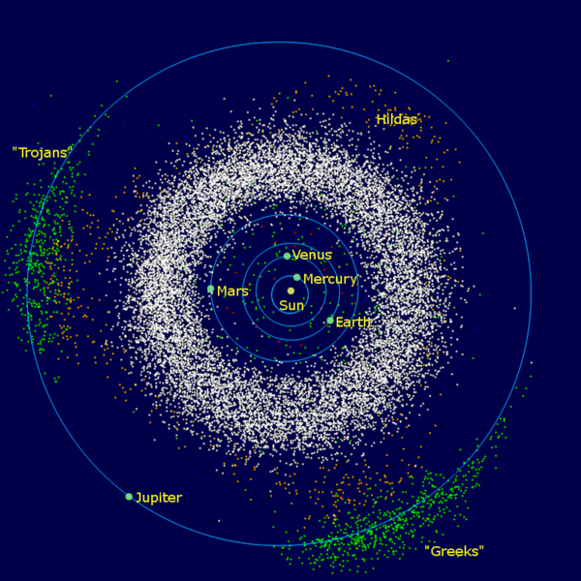

|  |  |
| --- | --- |
| Sun      Jupiter trojans      Planetary orbit  Node + range | Asteroid belt      Hilda asteroids      NEOs (selection) |

The Inner Solar System, with sample node locations added. Ranges and locations of nodes are for explanatory purposes only. These do not represent final recommendations.  
Source: <https://en.wikipedia.org/wiki/File:InnerSolarSystem-en.png>

The SON would provide a foundation for an internet that could provide communications from Earth to the Moon, or Earth to Mars, or anywhere else desired. Additionally, it wouldn’t require a single route between two locations. For example, a station located on Mars could communicate with a station in orbit near the Sun by communicating via Earth. This enables a more flexible system so long as there is a potential route to reach an endpoint, but it need not be direct.

This system would also allow the continued use of the SON even with major communication interruptions. A network established on Mars and in orbit around Mars could fully function even if communication with Earth were interrupted for an indefinite length of time.

Establishing the SON would allow for a modular system. It could be built out in parts, allowing for the slow but steady expansion to key areas of importance within the solar system. Focus could begin near Earth and expand outward as resources allow. Additionally, these functions could be added into a wide variety of satellites, stations, and other man-made items throughout the solar system relatively easily.

[[Figure 3]]

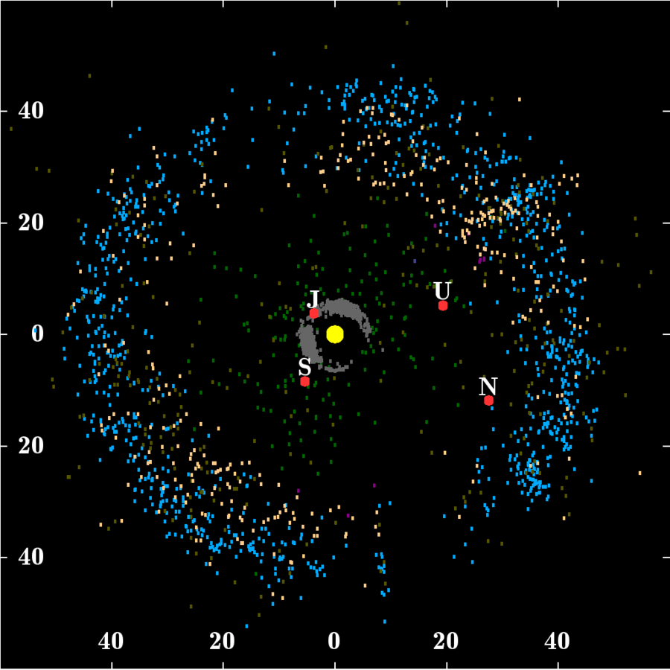

|  |  |
| --- | --- |
| Sun      Jupiter trojans      Giant planets  Node network + range | Kuiper belt      Scattered disc      Neptune trojans |

The Outer Solar System, with sample node networks added. Ranges and locations of nodes are for explanatory purposes only. These do not represent final recommendations.  
Source: <https://en.wikipedia.org/wiki/File:Kuiper_belt_plot_objects_of_outer_solar_system.png>

An additional benefit would be ensuring and establishing market mechanisms throughout our solar system. Should SON be established using Ξ, the cryptocurrency aspects would continue to exist, allowing for the establishment of markets in new locations such as Mars. Ξ also provides frameworks to guarantee democratic frameworks, which could easily provide a secure framework for democracy and governance in distant location such as Mars.[34] We could guarantee the establishment of societies in the vein of American Democracy we have come to know and love.

The other benefits of the EON would also apply: Multi-directional communication would be easy and effective, patches could be deployed using this network, and private actors could supplement costs by bidding to use equipment.

##### Galactic Internet (GI) & Voyagers 3 to Infinity & Science Network

Extending the above proposals to the galactic scale would again be doable, though there may be issues transmitting information backwards along this network. Essentially, this network would allow us to transmit information outwards from our solar system, and to a certain extent receive information back. It would establish a base set of knowledge and networking throughout our galaxy.

The primary limitation mentioned above would be that probes would have issues transmitting backwards. This would occur because of a lack of power when travelling between galactic landmarks. This could be mitigated by providing several sources of power, including solar, battery cells, and radioisotope thermoelectric generators. This would reduce the downtime that these probes experience in vast swaths of space. Additionally, these probes could be made with a connection that could be used by future spacecraft to charge these probes, pull data from them, or update them. Experimental technologies designed around wireless electricity transmission could also be explored to essentially create a “chain” of electrical-internet nodes.[35] Should this technology be deemed feasible, then it would be possible to transmit back to Earth. It is also possible to initiate the GI without that technology and then begin launching probes with electrical-internet technology once it is fully developed.

Once probes arrive at a galactic destination, they could begin charging and using the light of a destination star. This would enable networking wherever they end up. This would begin to establish our civilization galactically.

The internet would exist throughout the galaxy,  
prior to our arrival.

These probes would also serve another key purpose: they would function as an extension of the Voyager Program. Blockchain is inherently mathematical in nature, which means that having these probes contain a copy of the blockchain would allow intelligent life to decode and understand everything that is contained in the blockchain. It would just take an understanding of math, which is generally assumed to be fundamental knowledge for an intelligent species. These probes could contain a vast amount of data compared to Voyagers 1 and 2, and not only that, but they could be constantly updated through the standard Ξ network.

#### Prerequisite Components

[[IPFS]]

[[Ethereum]]

#### Feedback Mechanisms

[[Communal Network]]

[[Eden Drive]]

#### Benefits & Outcomes

#### Potential Applications

#### Current Progress

[[Galactic internet and science network]]

[[IPFS + ETH]]

[[Also delivers censorless net globally too]]

### PyO

#### Description

#### Prerequisite Components

[[Python]]

#### Feedback Mechanisms

[[QuickTMI]]

[[Fluent]]

[[Journal]]

[[CiteIt]]

#### Benefits & Outcomes

#### Potential Applications

#### Current Progress

[[Easy IO package]]

[[Combine existing utilities]]

[[Optional processing – OCR, to RGB matrix, etc.]]

[[Images, PDFs, Office, etc.]]

[[Useful for ML, or general coding]]

### QuickTMI

#### Description

QuickTMI is designed to make starting up AIs extremely quick and easy. The program essentially allows the creation of an AI in a single line of code, and then execution of training with one additional line.

QuickTMI will also pack some useful features, including optimizing to the architecture of the system it is running on. This means taking advantage of GPUs and TPUs where present, managing memory effectively on smaller systems, and choosing the optimal architecture for a given problem.

QuickTMI will also feature a neural network that is designed to optimize networks produced by QuickTMI. This network will be trained on several unique problems and will be distributed with QuickTMI, and can then be customized automatically for any problem at hand, leading to ideal AIs for a problem.

#### Prerequisite Components

* Python: QuickTMI is written in Python, and uses the TensorFlow library

#### Feedback Mechanisms

* Fluent: Fluent will be built using QuickTMI, and offers a quality benchmark to use when improving QuickTMI. Development of Fluent will help inform and shape the design of QuickTMI.
* PyO: By simplifying the IO process, PyO simplifies the other key aspect of building an AI – getting the data you need loaded and processed. PyO and QuickTMI will be developed in tandem to ensure that outputs of PyO can be used easily with QuickTMI, and PyO will enable quicker and more robust testing of QuickTMI.
* Journal: AI is both a science and an art. Sometimes a mathematic or computer science result will lead to an improvement in AI, and Journal will open up the whole world as a resource for this type of scientific inquiry. Additionally, sometimes it is an art designing the proper AI architecture for a given task (even if it is proven later) and these results could also be published in Journal, providing a positive feedback loop.

#### Benefits & Outcomes

#### Potential Applications

#### Current Progress

### Fluent

#### Description

Fluent is designed to be a translation program with *no* predetermined language options. It is designed to function based upon training data which conforms to certain standards. This will enable the translation software to be able to quickly and effectively embrace any languages thrown at it.

Fluent will exist as open source software, setting it apart from major translation software such as Google translate.

Fluent will enable communication between individuals speaking any languages which have enough documents to use as the training data for fluent.

Fluent will also exist to prepare for an influx of AI generated languages. It has already been demonstrated that AIs in certain situations will develop unique languages.[36] Rather than suppressing the development of new languages which are likely more efficient for accomplishing limited goals that AIs are often tasked with, fluent will allow for an embrace of these new languages and dialects. Fluent will prevent the constraint of our traditional languages on those that may develop in the future, whether by man or machine.

#### Prerequisite Components

#### Feedback Mechanisms

#### Benefits & Outcomes

#### Potential Applications

#### Current Progress

### UOS

#### Description

[[Linux distro designed with these technologies in mind]]

[[Distributed via these technologies]]

#### Prerequisite Components

#### Feedback Mechanisms

#### Benefits & Outcomes

#### Potential Applications

#### Current Progress

### CiteIt

#### Description

[[A revisioning of current citations to incorporate Ethereum and IPFS]]

[[Quicker to cite items using a plugin]]

[[Uses hashing – ensures security of underlying cited items, and functional version control]]

#### Prerequisite Components

#### Feedback Mechanisms

#### Benefits & Outcomes

#### Potential Applications

#### Current Progress

### Journal

#### Description

Academia has become stifled and void of creative and new ideas because format and connections takes priority over content. As such, Ouroboros will consist of the creation of an eternal and openly accessible journal to enable the advancement of science, medicine, and other disciplines. Anyone can publish – instantly – at anytime.

Of course, there needs to still be a filtering mechanism to separate the chaff from the wheat. As such, anyone can review a paper, send notes to an author, or leave comments.

[[Anyone can review papers and send comments to authors]]

[[Anyone can vote on papers]]

[[You can publish anonymously and review anonymously, but may optionally reveal your name]]

#### Prerequisite Components

#### Feedback Mechanisms

#### Benefits & Outcomes

#### Potential Applications

#### Current Progress

### GIN

#### Description

#### Prerequisite Components

#### Feedback Mechanisms

#### Benefits & Outcomes

#### Potential Applications

#### Current Progress

[[“Final” portion of Ouroboros]]

[[Galactic network working to solve problems]]

[[Combines human intelligence and TMI (eventually quantum intelligence too)]]

[[Combo of humanitarian and profit seeking opportunities]]

### UNGovern

#### Description

UNGovern is a culmination of the philosophy of cryptocurrencies and the espoused philosophy of the western geopolitical order. UNGovern is a reference implementation of a government and nation built using technology rather than promises of the powerful. UNGovern is a distinct governance model originating in the 21st century, rather than hobbling along using frameworks from the 18th century. UNGovern embraces technology and freedom, both personal and economic, rather than suppressing the development of technology and true freedom.

UNGovern will be minimalist – government should strive to be as small as possible whilst still accomplishing the goals it has been delegated by the people. It will also be designed to be understandable by a layperson. The rights guaranteed should be straightforward and should be simple.

UNGovern will also embrace a few key ideas which are quickly becoming crucial in an interconnected world: a universal basic income (UBI) and no taxes. These two concepts traditionally fall on far opposite ends of the political spectrum, but actually fit together quite well given a proper implementation.

These ideas will be built upon a nationally issued cryptocurrency using a Turing-complete chain supporting smart contracts (likely Ethereum). This will enable the currency to be used directly in smart contracts, which will reduce the need for a judiciary branch, particularly in contract related cases.

Rather than being issued by a central bank, currency will be issued automatically, based upon a set annual UBI, to each citizen. The government, rather than collecting taxes, will issue an equivalent amount of currency to itself – which means the spending power of the government will not exceed that of the people (and only the spending power of the annual UBI, which will become a smaller and smaller portion of the total currency supply each year). This will be done automatically, eliminating the possibility for corruption, and eliminating all of the work currently associated with taxes.[37]

Through the embrace of mathematics, UNGovern will also be able to guarantee the rights consisting of freedom of speech, voting, and bearing arms, so long as the underlying computational network exists.

#### Prerequisite Components

#### Feedback Mechanisms

#### Benefits & Outcomes

#### Potential Applications

#### Current Progress

[[Democratic]]

[[Socialist]]

# Ouroboros

[[Describe how the sum of the whole functions]]

[[Phase II hints? Quantum computers, advanced physics experiments, physical machining, biological components, 3d printing, fully autonomous agents, or is that too ambitious to hint at now?]]

# References

Burlacu, Alexandra. “Amazon Web Services Cloud Glitch: Outage Breaks Part Of The Internet, But It's Fine Now.” *Tech Times*, Tech Times, 1 Mar. 2017, www.techtimes.com/articles/199777/20170301/amazon-web-services-cloud-glitch-outage-breaks-part-of-the-internet-but-its-fine-now.htm.

Buterin, Vitalik. “Ethereum White Paper.” *GitHub*, Ethereum Foundation, 26 Apr. 2018, github.com/ethereum/wiki/wiki/White-Paper.

“Create a Democracy Contract in Ethereum.” *Ethereum Project*, Ethereum Foundation, www.ethereum.org/dao.

De, Nikhilesh, and Rachel Rose O'Leary. “Vitalik Releases Partial Proof-of-Concept for Ethereum 'Sharding' Tech.” *CoinDesk*, CoinDesk, 1 May 2018, www.coindesk.com/vitalik-releases-partial-proof-concept-ethereum-sharding-tech/.

“Ethereum Price.” *CoinDesk*, CoinDesk, www.coindesk.com/ethereum-price/.

“Explore Decentralized Applications.” *State of the ÐApps*, www.stateofthedapps.com/.

Freed, Benjamin. “70 Percent of the World's Web Traffic Flows Through Loudoun County.” *Washingtonian*, Washingtonian, 20 Sept. 2016, www.washingtonian.com/2016/09/14/70-percent-worlds-web-traffic-flows-loudoun-county/.

“Global Bitcoin Nodes Distribution.” *Global Bitcoin Nodes Distribution*, Addy Yeow, bitnodes.earn.com/.

Herndon, Robert. *Pamphlet No. 1110-3-2*. US Army Corps of Engineers, www.jrmagnetics.com/security/specs/EP_1110-3-2.pdf.

“MuleTools.” *GitHub*, MuleTools, mule.tools/.

Rama, Gladys. “Report: AWS Market Share Is Triple Azure's.” *AWS Insider*, AWS Insider, 1 Aug. 2017, awsinsider.net/articles/2017/08/01/aws-market-share-3x-azure.aspx?m=1.

“The Ethereum Node Explorer.” *Ethernodes.org*, www.ethernodes.org/.

“Turing Completeness.” *Wikipedia*, Wikimedia Foundation, en.wikipedia.org/wiki/Turing_completeness.

“Turing Machine.” *Wikipedia*, Wikimedia Foundation, en.wikipedia.org/wiki/Turing_machine.

“Vyper by Example: Simple Open Auction.” *Vyper by Example - Vyper Documentation*, Vitalik Buterin, viper.readthedocs.io/en/latest/vyper-by-example.html#simple-open-auction.

“Wireless Power Transfer.” *Wikipedia*, Wikimedia Foundation, en.wikipedia.org/wiki/Wireless_power_transfer.

Wood, Gavin. *Ethereum: A Secure Decentralised Generalised Transaction Ledger*. Ethereum Foundation, ethereum.github.io/yellowpaper/paper.pdf.

# Cut Content

### EndIP

Intellectual property is a distortion of the underlying market principles enshrined in capitalism. Intellectual property provides for a government granted, long term monopoly on items which largely arise out of the collective – even if an individual is the one to put it to paper.

There is no empirical evidence supporting intellectual property. [[Research more]] In fact, there is evidence that patents may cause harm.[38] A portion of Ouroboros will consist of further empirical research related to patents and to share the results of said research.

Ouroboros will also propose alternatives and suggestions to current systems.

EndIP also plays another key role: most breakthroughs require access to past breakthroughs. The distortions presented via modern intellectual property laws create a system in which innovation is stifled, people die, and capitalism and markets are subverted via a gross injustice to society. Ouroboros, in order to create further innovations, requires the freedom to use the vast sum of human knowledge we have acquired – not a fragmented subset of the knowledge.

Additionally, Ouroboros will make certain portions of intellectual property entirely obsolete through design. Files transmitted on Ouroboros are censor resistant and globally accessible, meaning Ouroboros also facilitates the bypass of IP directly.

### Apollo Network

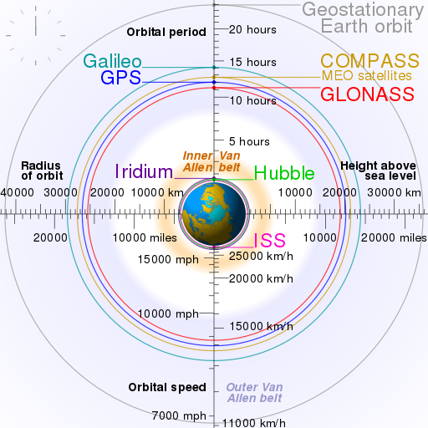

A diagram of LEO, with landmarks including GPS satellites and the ISS.  
For an animated version of this chart and the source, see:  
<https://en.wikipedia.org/wiki/File:Comparison_satellite_navigation_orbits.svg>

1. [[Python original release date]]
2. [[Python popularity]]
3. [[Python libraries]]
4. [[Discuss simplicity of syntax?]]
5. Though the common usage of transaction refers to *financial* transactions, in this instance and throughout this paper I will use transaction to refer to *digital* transactions, meaning the sending and receiving of computer code to and from a ledger, unless otherwise noted.
6. A virtual machine emulates the functions of a computer.
7. A Turing-complete system can run any potential Turing machine. A Turing machine can run *any* current or potential computer algorithm. For further exploration of these concepts, see the *Wikipedia* pages entitles *Turing completeness* and *Turing machine*.
8. [[Discuss features]]
9. [[Discuss security]]
10. For comparison, BTC, the first implementation of blockchain technology, was released in 2009.
11. *State of the ÐApps* only lists about 1500 applications, many of which are simple proof of concepts, incomplete, or clones of existing ÐApps.
12. [[Discuss syntax]]
13. [[Discuss auditability]]
14. You could transmit the entirety in 5 MMS messages, sent from one user to another, or USB drives, CDs, or another method.
15. The only exception, again, would involve entirely shutting down the internet.
16. These changes would largely involve setting nodes to cycle to a random port, as the Great Firewall and other implementations could block the default port on node software. Another key item would be ensuring traffic is encrypted. With both implemented, it would essentially be impossible to block transmitting any form of information.
17. See MuleTools
18. See the article by Nikhilesh De and Rachel Rose O'Leary.
19. The Ethereum Node Explorer, data retrieved 2018/05/04.
20. A natural EMP could be the result of a solar flare or another natural phenomenon. Manmade EMPs could be the result of a nuclear blast or a non-nuclear electromagnetic pulse weapon.
21. Regional, in this context, means any sized area so long as several continental U.S. cities remain unaffected
22. National scale means at least some significant collection of major cities outside of the U.S. remains unaffected. The location of these cities does not matter.
23. Global scale means that few or no cities globally are unaffected.
24. See the article by Gladys Rama.
25. See the article by Benjamin Freed.
26. See the article by Alexandra Burlacu.
27. Data that was previously stored on the Ξ blockchain.
28. These could be cities, military bases, network hubs, or something else entirely.
29. [[Add link to github]]
30. [[Discuss how this enables it to be able to do more]] [[Combined with an effective voter registration process, Communal.Network could enable governments to allow their citizens to vote via blockchain, allowing for a secure voting process without the vulnerabilities of the current process, all while allowing for easy auditability and recounts to be completed quickly. This could also increase civic engagement, as users could vote from the same site that they use for their social networking.]]
31. [[FN examples of excessive data collection]]
32. [[Link]]
33. See Vyper by Example: Simple Open Auction
34. See the webpage entitled Create a Democracy Contract in Ethereum.
35. See the Wikipedia article on Wireless Power Transfer for background about current wireless electricity standards.
36. [[Cite]]
37. [[Cite how much the US spends on the IRS and taxes]]
38. [[Cite and include patents and aids document]]