 | Worksheet 10  Cantilever strain sensors  CP1972-10 |  | Sensors and  microcontrollers
 | Cantilever strain sensors are extensively used to measure forces in mechanical systems. The choice of compressive or cantilever sensors is governed by the mechanical properties of the system being measured.  In this worksheet / project you learn how Cantilever sensors are used to measure weight. |  | 

There is no video for this worksheet.

Over to you:
- Load the file “BL0132 Compression - Tedea". Set up the hardware appropriately.
- Make sure you understand how the program works. To start with you can activate the sensor with your hands to get a measurement.

Challenge:
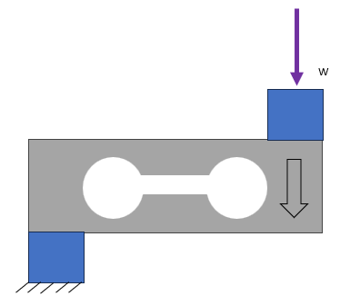
The diagram shows a typical cantilever setup. You can set up the cantilever load cell provided in such a way that that it represents a weighting scale. Design yourself a base which can be clamped down or won’t move. Raise the load cell so that there is clearance for deflection. Then design a platform which will attach to the top side of the load cell, so that you can balance items over it.
- Modify the program to make a weighing scale with the following characteristics:
  - Cantilever strain sensor
  - A display showing the weight of the object
  - A zero switch or touch object

Hints:
- Review the worksheets in Introduction to microcontrollers where you will find examples of touchable buttons for graphical displays.

