 | Worksheet 11  Pressure sensors  CP1972-11 |  | Sensors and  microcontrollers
 | Pressure sensors are used extensively in the automotive industry for tyre pressure monitoring in vehicles, in carburettors, and exhaust systems.  In this worksheet / project you learn how to use pressure sensors in microcontroller circuits. |  | 

There is no video for this worksheet.

Over to you:
- Load the file “BL0122 Pressure". Set up the hardware appropriately.
- Make sure you understand how the program works. To start with you can blow, or suck, on the sensor to make sure it works.

Challenge:
- Get hold of a syringe style pump and hose to attach to the sensor.
- Modify the program to make a pressure measuring system with the following characteristics:
  - Microcontroller system, sensor, pump and hose
  - A display of pressure rate, set flow rate and pump status
  - A graph showing flow rate variation over time – refreshing every 30 seconds. Temperature range 15C to 30C.
  - An LED that lights up when the target flow rate is over run
  - A way of altering the set flow rate with either switches or display touch areas ‘+’ and ‘-‘.
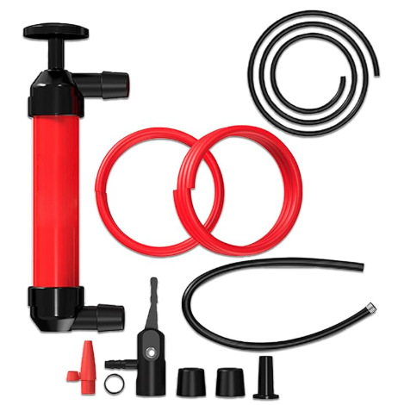You can get hold of a simple pump like this one from Amazon.

