 | Worksheet 6  Floats and Ints  CP1972-6 |  | Sensors and  microcontrollers
 | As you start to measure real world quantities you will need to understand how to manipulate numbers outside the range of a single byte: 0 to 255.  Variables of type INT have a range of -32768 to + 32767. Floating point numbers allow you to manipulate numbers with decimal points. |  | 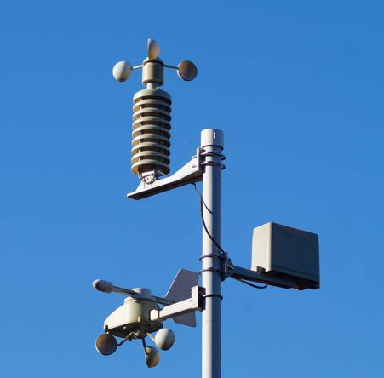

There is no video for this worksheet.

Over to you:
- Load the file “Floats and ints". Set up the hardware appropriately.
- The program shows how Floats and Ints are used in programs.
- Make sure you read the comments thoroughly, so you understand how to use these new types of variables.

Challenge:
- Use the BL0144 temperature and humidity sensor to make a small weather station with the following properties:
  - A display of temperature, and humidity to 2 decimal places. Temperature range -10C to +40C. Humidity from 0% to 100%.
  - A graph showing temperature variation over time – refreshing every 24 hours.
  - A clock

Hints:
- Review the worksheets in Introduction to microcontrollers where you will find examples of graphs and graphical displays, and touchable buttons for graphical displays.
- Review the worksheets in Introduction to microcontrollers where you will find information on timer interrupts. Create a second timer, use variables Minutes and Hours to track time.
<\worksheet>

