 | Worksheet 7  Thermocouples  CP1972-7 |  | Sensors and  microcontrollers
 | Thermocouples are often used for measuring temperature in industrial processes. They are not as accurate as some modern chips – but they have a much greater range – up to 2,500°C.  In this worksheet / project you learn how to use a thermocouple to make a temperature control system. |  | 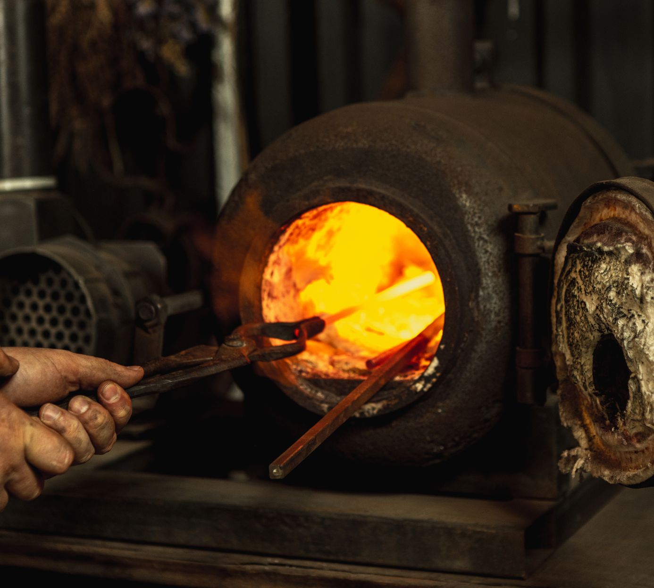

There is no video for this worksheet.

Over to you:
- Load the file “BL0126 Thermocouple". Set up the hardware appropriately.
- Make sure you understand how the program works

Challenge:
- Modify the program to make a heating controller which includes the following features:
  - A display of temperature, set temperature and heater status
  - A graph showing temperature variation over time – refreshing every 30 minutes. Temperature range 15°C to 30°C.
  - An LED that lights up when the target temperature is over run
  - A way of altering the set temperature with either switches or graphical display touch areas ‘+’ and ‘-‘.

Hints:
- Review the worksheets in Introduction to microcontrollers where you will find examples of graphs and graphical displays, and touchable buttons for graphical displays.

