 | Worksheet 8  Flow sensors  CP1972-8 |  | Sensors and  microcontrollers
 | Flow rate sensors are everywhere: from petrol pumps, to drug delivery systems to water meters and industrial processors. At the heart of them all is a flow rate sensor.  In this worksheet / project you learn how flow rate sensors work and use one to make a water flow regulator. |  | 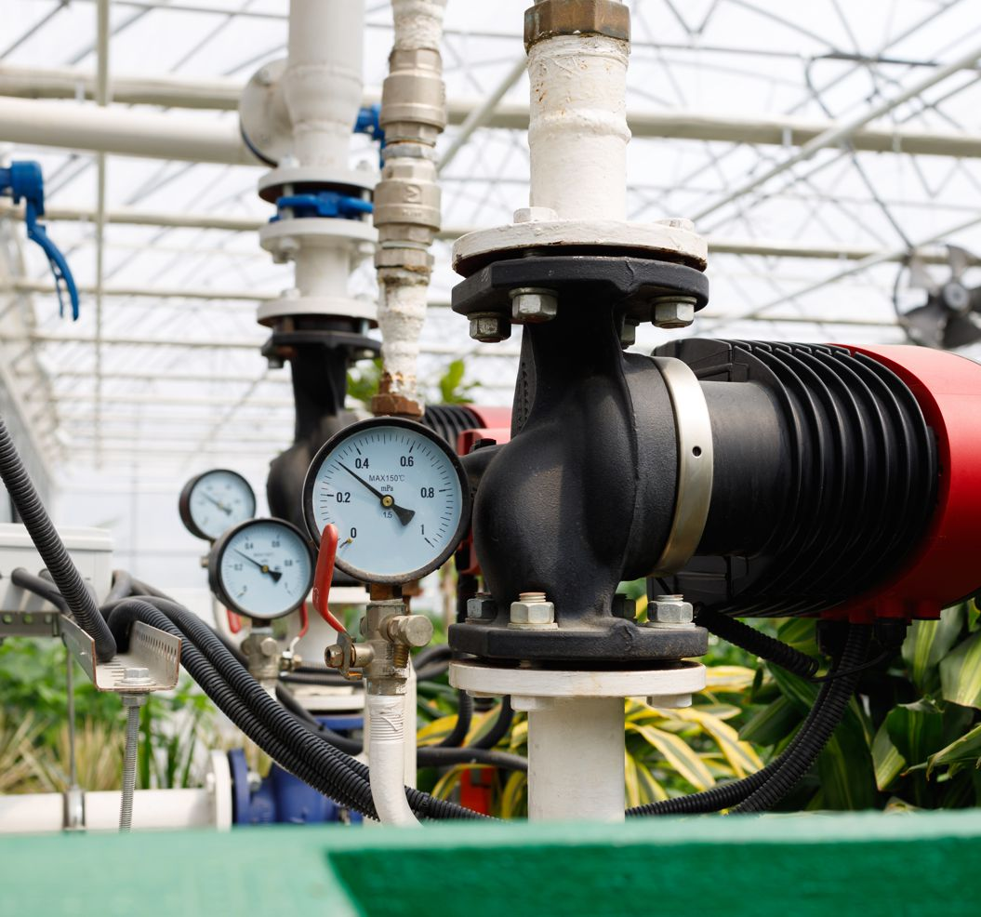

There is no video for this worksheet.

Over to you:
- Load the file “BL0121 Flow". Set up the hardware appropriately.
- Make sure you understand how the program works. To start with you can blow through the sensor to make sure it works.

Challenge:
- Make a mechanical rig that allows fluid or air to pass through the sensor. You may need a pump, a tank and appropriate pipes. You will need to use the Power board and power supply to activate a 12 or 24V pump.
- Modify the program to make a water flow regulator and meter with the following characteristics:
  - Microcontroller system, sensor, tank, pump, pipes
  - A display of flow rate, set flow rate and pump status
  - A graph showing flow rate variation over time – refreshing every 30 minutes. Temperature range 15C to 30C.
  - An LED that lights up when the target flow rate is over run
  - A way of altering the set flow rate with either switches or display touch areas ‘+’ and ‘-‘.

Hints:
- There is a worksheet in Microcontrollers and motors where you can learn how to use the BL0110 Power board.
- Review the worksheets in Introduction to microcontrollers where you will find examples of graphs and graphical displays, and touchable buttons for graphical displays.

