 | Worksheet 9  Compressive force sensors  CP1972-9 |  | Sensors and  microcontrollers
 | Force sensors are used with some mechanical attachment for measuring weight.  In this worksheet / project you learn how compressive force sensors are used to measure weight. |  | 

There is no video for this worksheet.

Over to you:
- Load the file “BL0132 Compression - Forsentek". Set up the hardware appropriately.
- Make sure you understand how the program works. To start with you can compress the sensors to get a measurement.

Challenge:
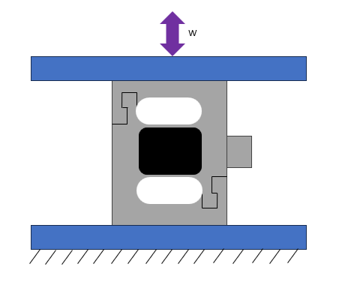
The compressive and tensile load cell, works by deflecting the internal strain gauges. These type of sensors are great in applications for axial loads. For example, reading forces applied to a structural member of a frame. Most of these sensors come with a threaded bolt hole down the vertical axis of the load cell for attachment.
- Make a mechanical rig that compresses the sensor when weights are placed on the rig.
- Modify the program to make a weighing scale with the following characteristics:
  - Fore sensor with a platform
  - A display showing the weight of the object
  - A zero switch or touch object

Hints:
- Review the worksheets in Introduction to microcontrollers where you will find examples of touchable buttons for graphical displays.

