

Microcontrollers for T levels

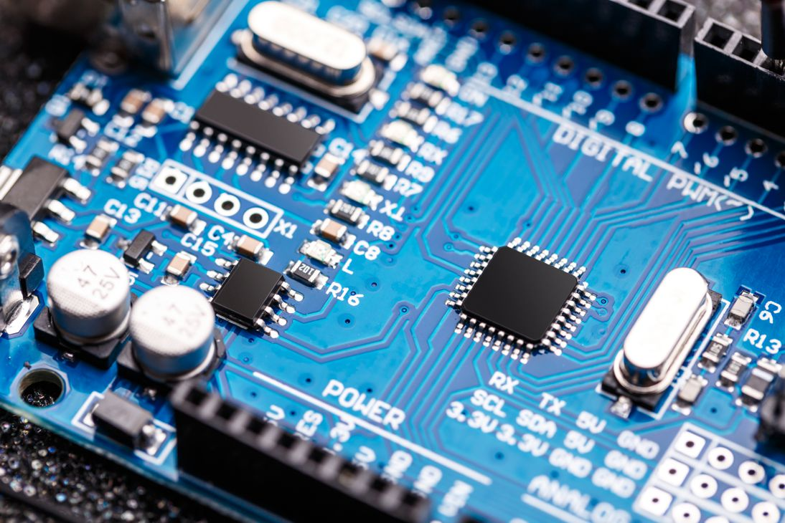

CP2563

