 | Preparation | Introduction to  microcontrollers

Before tackling the worksheets you will need to understand some basic information:

Microcontroller basics
This document gives a basic explanation as to how microcontrollers work.

Introduction to E-blocks
This document explains how the E-blocks system works.

E-blocks datasheet
This document gives the full schematics of all the E-blocks 3 circuit boards.

Flowcode Embedded getting started guide
This document shows you how to construct your first program from scratch.

Introduction to Flowcode Embedded video


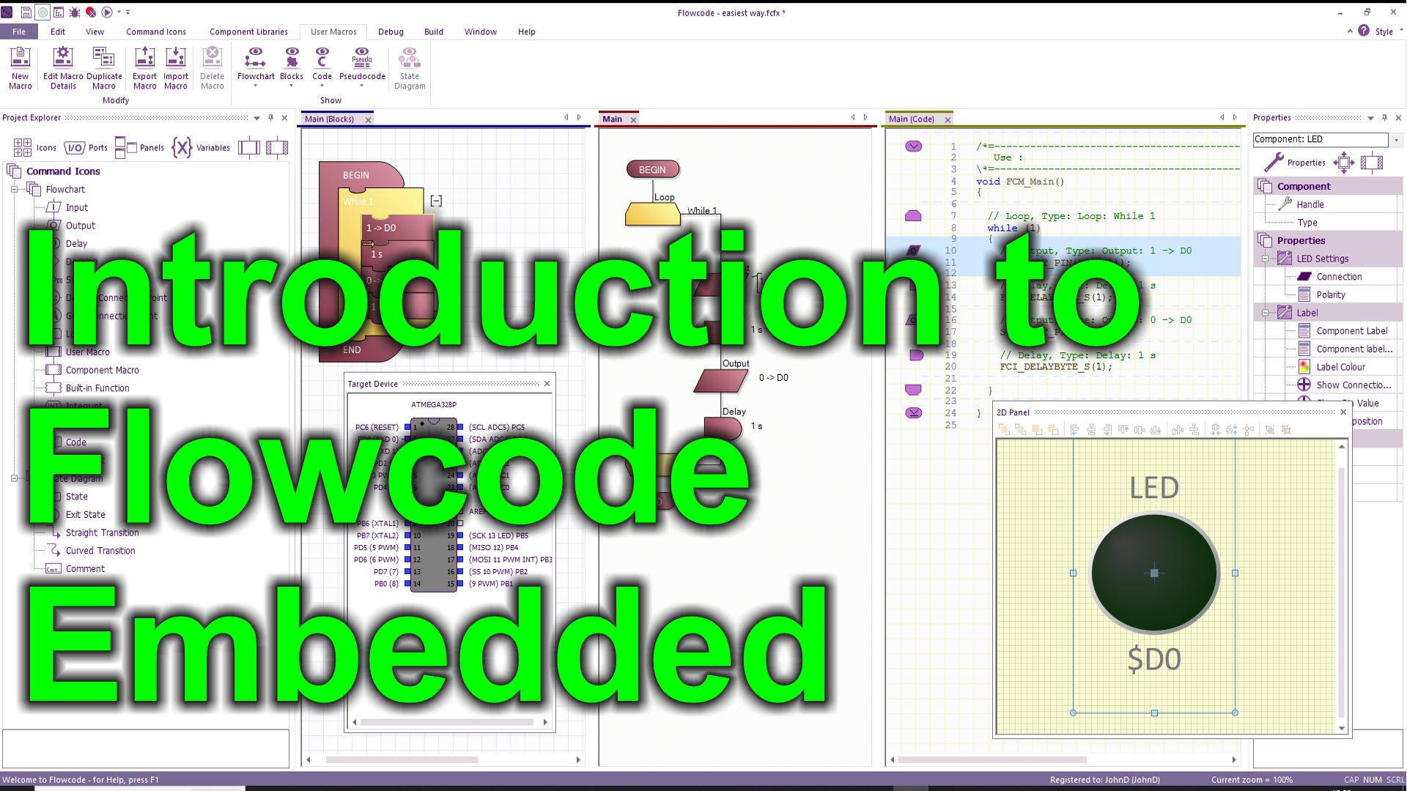
https://youtu.be/_9WAcrK9LjE

