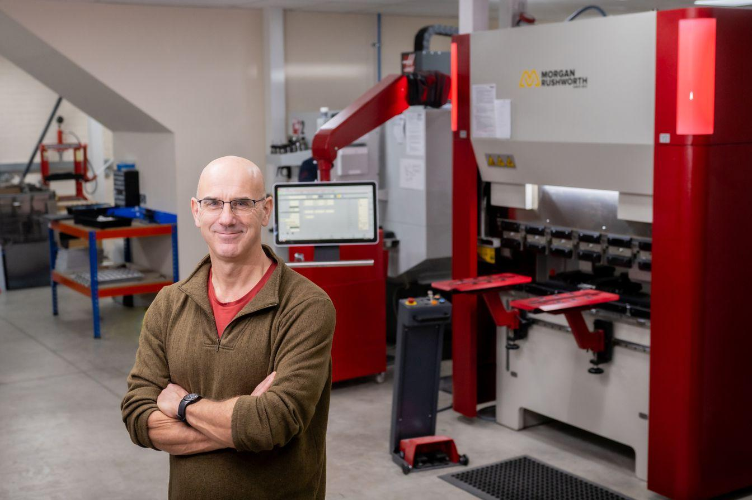
This course is written by John Dobson.
John Dobson is the Chairman of Matrix TSL.
Stuff I learned in putting this course together:
- This has taken me around 20 - 30 hours to put together. Maybe more.
- In general for a 60 hour course it will take a teacher 60 hours to plan a SOW and create presentations. A Scheme Of Work is a massive effort for teachers. It has a big value.
- Note that this course is probably not that high quality - I am not a teacher.
- There are not that many good PowerPoint slides available off the shelf online. Maybe there are if you pay for them. Loads of videos - but not necessarily good.
- AI is amazing at generating assessment. I wonder if it works?
- I have used AI to generate PowerPoint presentations. Varied quality output. But I have not tried hard. I don’t think it matters too much - we just need to be honest about what we have done. Certainly, the Powerpoints are a good start.
- Our transformers provision in terms of worksheets could be better. It would not take much to put this tougher and this is a major chunk of this unit.
- Customers may want a battery and a gearbox as part of the project work.
- We have discussed Applied Electrical Machines but not implemented it. That’s a shame - it would be really useful in this unit. Customers may want a gearbox separate from the Mechanical modules. It’s a key part. But at the moment they got to buy all add-ons.
- When we release a range of products we should produce a Scheme of Work. For example when we release Process Control 2 we should do this. Each machine is different. Students need to use them all.
- Worksheets need to be editable. For so many reasons……how are we gong to achieve this?
- We need to sort out whether we want to pursue this project and how much we are going to resource it.
- The Course Viewer and Splitter are Betas. We need to sort out what we want here and go to the next level.

