 | Worksheet 4  Digital inputs  CP4807-4 |  | Introduction to  microcontrollers
 | We need a way of controlling electronic devices locally. Often this is done in a digital context – with different types of switches. In this case we need to get the input ‘commands’ and then process this to alter the state of the microcontroller or alter its processes.  In this exercise you look at how to get command data into a microcontroller. |  | 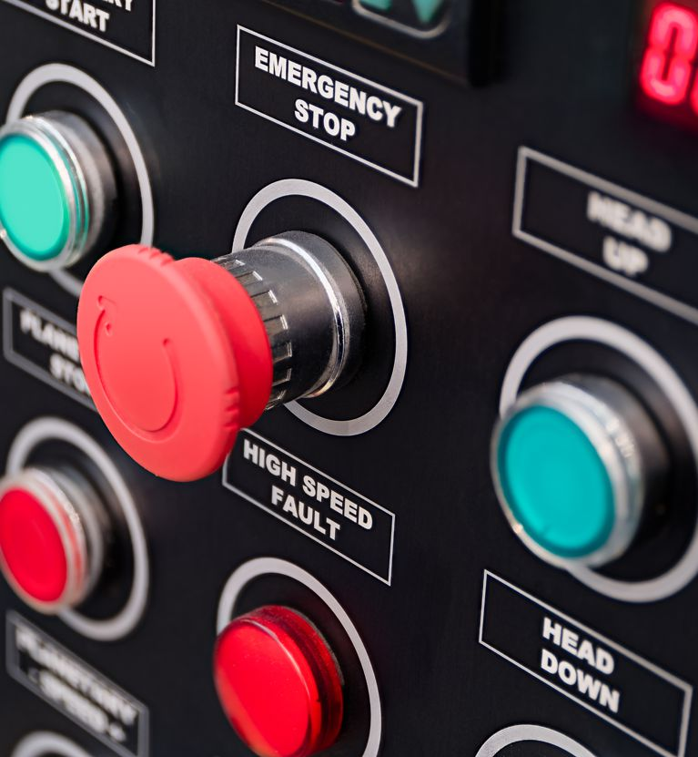
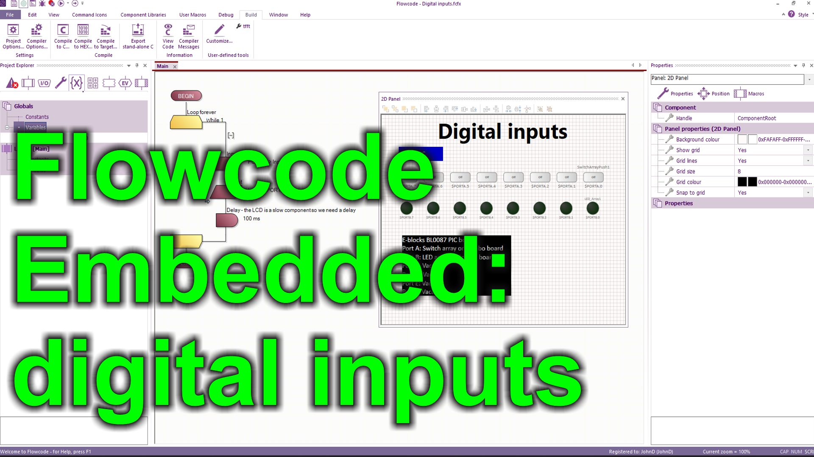
https://youtu.be/Xvs7-iTPXcQ

Over to you:
- Watch the video “Flowcode Embedded: digital inputs” on the Flowcode YouTube site.
- Load the file “Digital inputs". Set up the hardware appropriately, download it, and make sure you understand it.
- The program reflects the input on one 8 bit port to another by storing the port status into a variable and then sending that to the output of another port.

Challenges:
- Alter the program so that it works on only the least significant input bit using a Boolean variable.
- Alter the program so that the state of the least significant bit input is reflected to the most significant bit of the same port.

Hints:
- Setup a new variable called ‘input_bit0’ of Type Boolean.
- Use the Advanced options of the Input command to read the state of the switch on bit 0 into ‘input_bit0’.
- Change the Output icon using Advanced options so that it outputs ‘input_bit0’ to bit 7 of the same port as the input: so now you have an output LED on bit7 and an input switch on bit 0.

Challenges:
- Alter the program again so that the state of the second bit input switch is placed in a Boolean variable ‘input_bit1’
- Alter the program so that bit 7 of the same port only lights up when both ‘input_bit0’ and ‘input_bit1’ are logic high – or 1.

Hints:
- Use the AND operator in the Output statement: input_bit0 AND input_bit1

Challenges:
- Look up Mathematical operators in the Flowcode Wiki: select HELP…WIKI
- Experiment with operators OR, XOR, and NOT and make sure you understand how they are used.

