 | Teacher’s notes | Introduction to  microcontrollers

Previous learning
Some understanding of electronics is needed.

Pedagogy
This set of worksheets provides structure for the study of microcontroller programming. The worksheets provide structure to the learning but do not provide all the information students need. Our vision as to how you teach this subject is:
- This is a very practical subject. We expect that 90% of the time students spend on this module will be spent working alone.
- Each student should have Flowcode Embedded software and a set of E-blocks 3 hardware. Don’t be tempted to try to get students to learn this subject in pairs.
- Students should be introduced to each topic or worksheet. They should be given time to investigate the topic using the internet. If students are investigating this on their own, you may want to give additional structure to this activity.
- Students should then load an example program and download this to the microcontroller so that they can see how the program works. Example programs are available on the Flowcode Wiki for each of PIC, Arduino Mega and ESP32 microcontrollers.
- Students should be given the opportunity to watch the accompanying YouTube video – individually or as a class activity. This explains the program.
- Students then modify each example as detailed in the worksheet. This ensures that they have success, but also ensures that they have understanding. Our scheme of work includes 3 assessments and a final project.
- Students do not have to do all worksheets or tasks. That’s up to you to decide. Worksheet 10 and 11 are quite advanced.
- There are three sets of worksheets in this series: Introduction to microcontrollers, Sensors and microcontrollers, and Motors and microcontrollers. We have split the content by topic for ease of publication. You will need to decide what sequence your students complete the worksheets in. We have split the worksheet difficulty into Bronze, Silver, and Gold. Not all students will be able to complete all exercises. A reasonable approach would be to deliver Bronze in each of Introduction to microcontrollers, Sensors and microcontrollers, and Motors and microcontrollers, then deliver Silver then deliver Gold to those students who are capable.
- The curriculum is based on the requirements of the BTEC level 3 in Engineering – Unit 6: Microcontroller systems for engineers. This can be downloaded from the Pearson web site.
- We have included – below – a full scheme of work for a 60 hour module in microcontroller development.

Example programs
In general the worksheets make use of prewritten functional examples. Students load the example, understand it and then modify it to make sure that they have learned the principles under discussion.

The examples are available directly from within the Flowcode package. From within Flowcode select: FILE…NEW PROJECT…OPEN EXAMPLE OR TEMPLATE…and select the example you want from the relevant worksheet pack.

Examples are available separately for PIC, Arduino and ESP32 microcontrollers.

Time
Of course this depends on student capability. We estimate that it will take 15 hours to complete all the worksheets in this module.

Software
The videos make use of Flowcode embedded and we anticipate that you are likely to use this for your programs. But you can use these worksheets with any microcontroller development software. The flowchart programs can easily be followed by C programmers.

Assessment
Creating programs from scratch will be suitable as a way of assessing that students have understood the programs and have programming ability.

Hardware

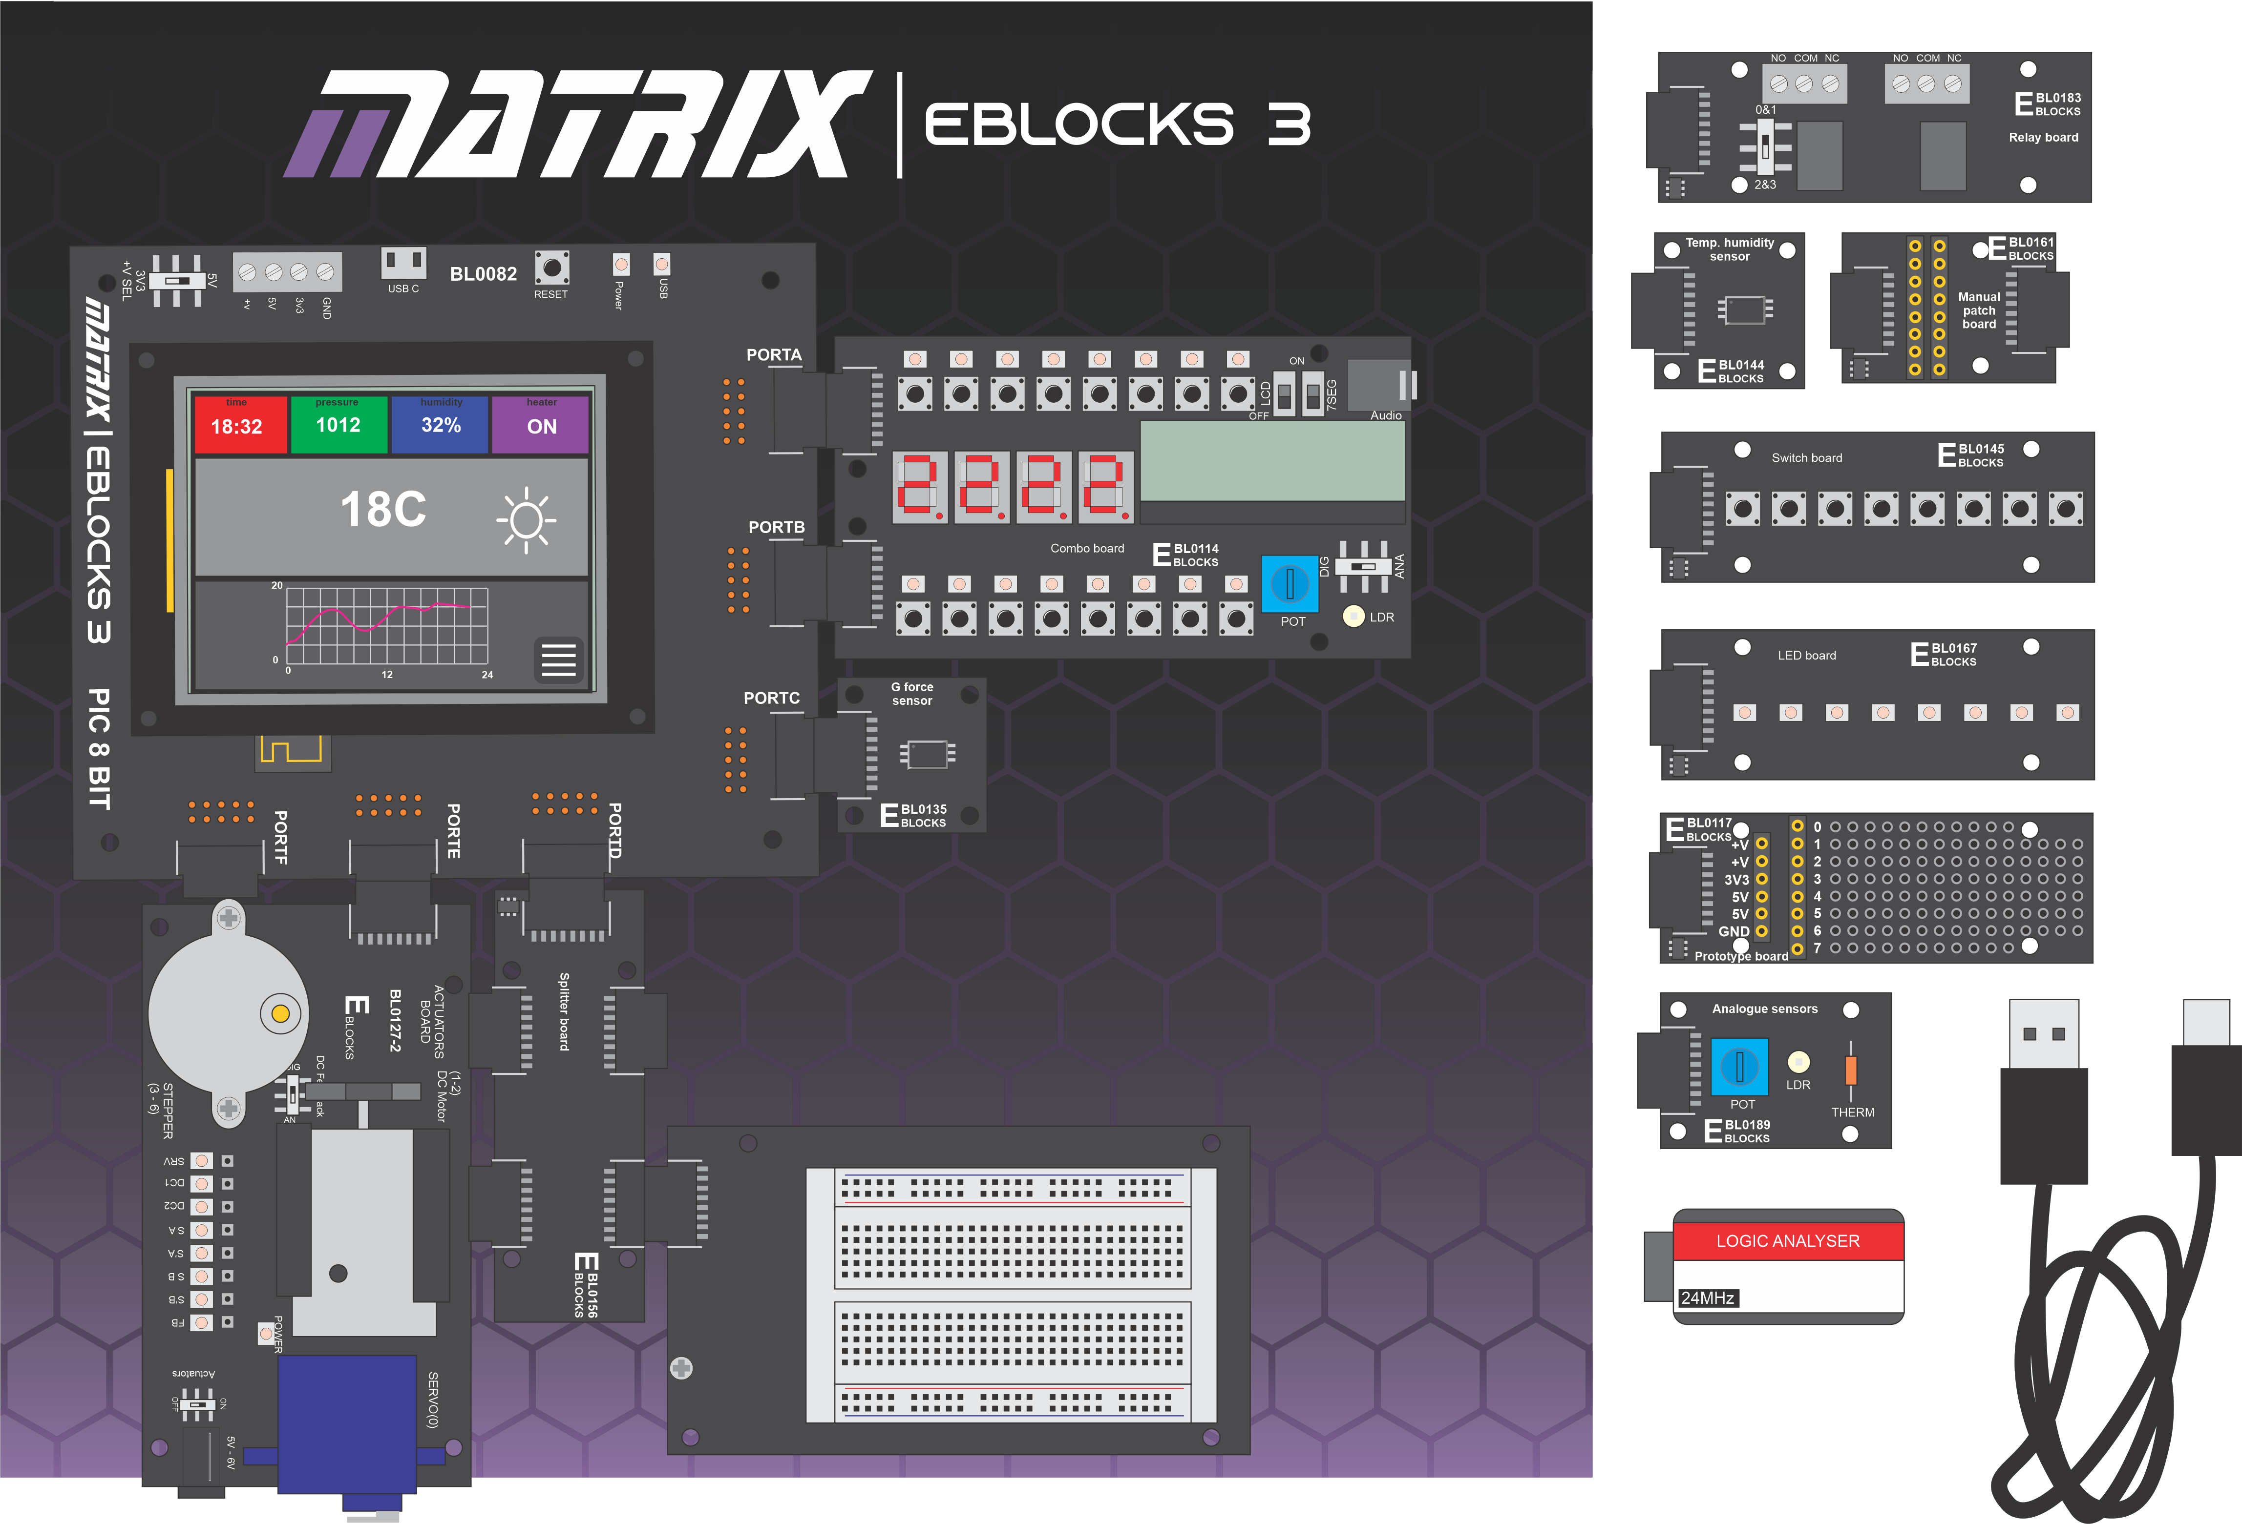

This course is designed to be used with a Matrix Microcontroller development centre. There are three versions:
BL5394 ESP32 microcontroller development centre
BL8624 PIC microcontroller development centre
BL3797 Arduino microcontroller development centre
These consist of:
Upstream board – BL0082 PIC, BL0040 Arduino, or BL0070 ESP32
BL0114 Combo board
BL0117 Prototype board
BL0118 Project board
BL0127 Actuators board
BL0135 9 axis motion / accelerometer board
BL0144 Temp/humidity board
BL0145 Switch board
BL0156 Splitter board
BL0172 Logic analyser with ribbon cable
BL0167 LED board
BL0183 Relay board
BL0189 Analogue board

List of all tutorials across workbooks

Introduction to microcontrollers

Bronze
Worksheet 1 First program
Worksheet 2 Performing calculations
Worksheet 3 Connection points
Worksheet 4 Digital inputs
Worksheet 5 Making decisions
Worksheet 6 Macros / subroutines
Worksheet 7 Using prototype boards

Silver
Worksheet 8 Colour graphical displays
Worksheet 9 Pin interrupts
Worksheet 10 Timer interrupts

Gold
Worksheet 11 Touch control systems
Worksheet 12 Web mirror

Sensors and Microcontrollers
Bronze
Worksheet 1 Analogue inputs
Worksheet 2 Light sensor
Worksheet 3 Analogue temperature sensor
Worksheet 4 Digital temperature sensor
Worksheet 5 Digital accelerometer

Silver
Worksheet 6 Floats and ints

Gold Any one of the following mechanical sensor projects:

Additional worksheets for mechanical sensors. These can be used as worksheets or projects.
Worksheet 7 Thermocouple
Worksheet 8 Flow sensor
Worksheet 9 Compressive force sensor
Worksheet 10 Strain sensor
Worksheet 11 Pressure sensor

Motors and microcontrollers
Bronze
Worksheet 1 Basic DC motor control
Worksheet 2 Full bridge motor control
Worksheet 3 Servo motor control
Worksheet 4 Stepper motor control

Gold
Worksheet 5 DC motor speed control

PC interfacing
Bronze
Worksheet 1 Beginning hardware interfacing – PC to hardware
Worksheet 2 Bidirectional hardware control
Worksheet 3 JSON encoding

Silver
Worksheet 4 Full PC – Embedded project

