SysML Diagrams for Elevator Simulator

Use Case Diagram – Actors and Interactions
This diagram captures the high-level interactions between the Passenger (guest) and Simulation Operator and the system use cases. Passengers call the elevator, enter/exit and select floors, while the operator configures and manages the simulation. Dependencies (e.g. «includes» and «extends») show common functions across use cases.
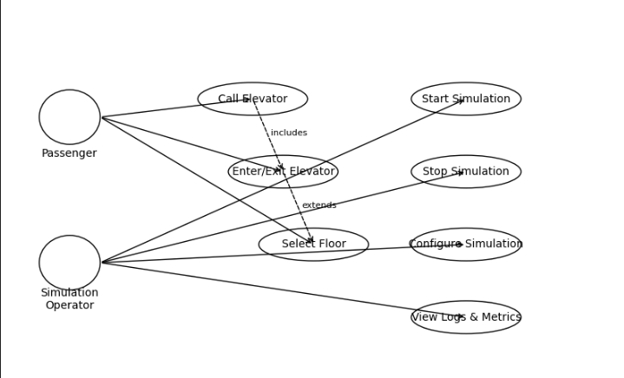

Block Definition Diagram (BDD)
The structural view decomposes the system into classes/blocks corresponding to the C# simulator: Building, PassengerController, ElevatorController, Elevator, Person, ConfigLoader, DataLogger, and the strategy interface IElevatorDispatchStrategy. Composition relationships model how the building owns elevators and controllers. Associations indicate that PassengerController creates persons, ElevatorController controls elevators and uses strategies, and DataLogger records events.
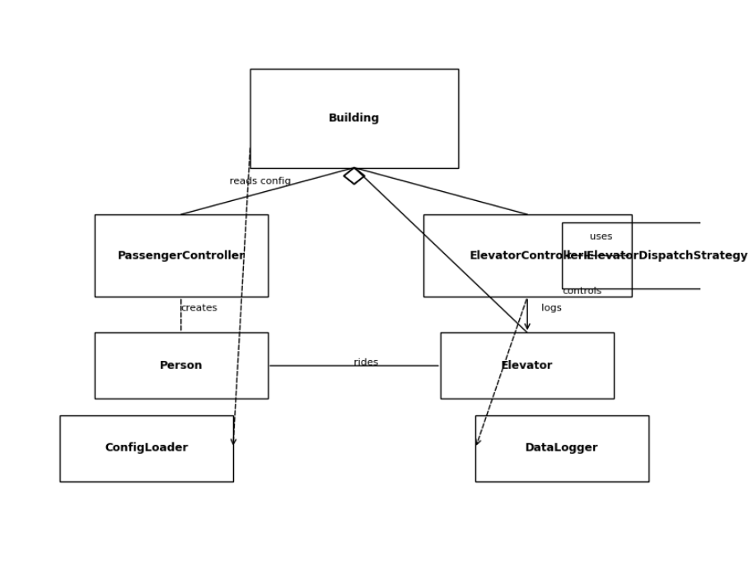

Internal Block Diagram (IBD)
This diagram shows the internal connections and signal flow between components. The Building contains the PassengerController, ElevatorController, Elevator, and DataLogger. A passenger outside the system signals a “call elevator” event to the PassengerController; the controller forwards requests to the ElevatorController. The controller commands the Elevator and receives status feedback, then notifies the passenger when the elevator arrives. Logging connections illustrate decoupled event reporting.
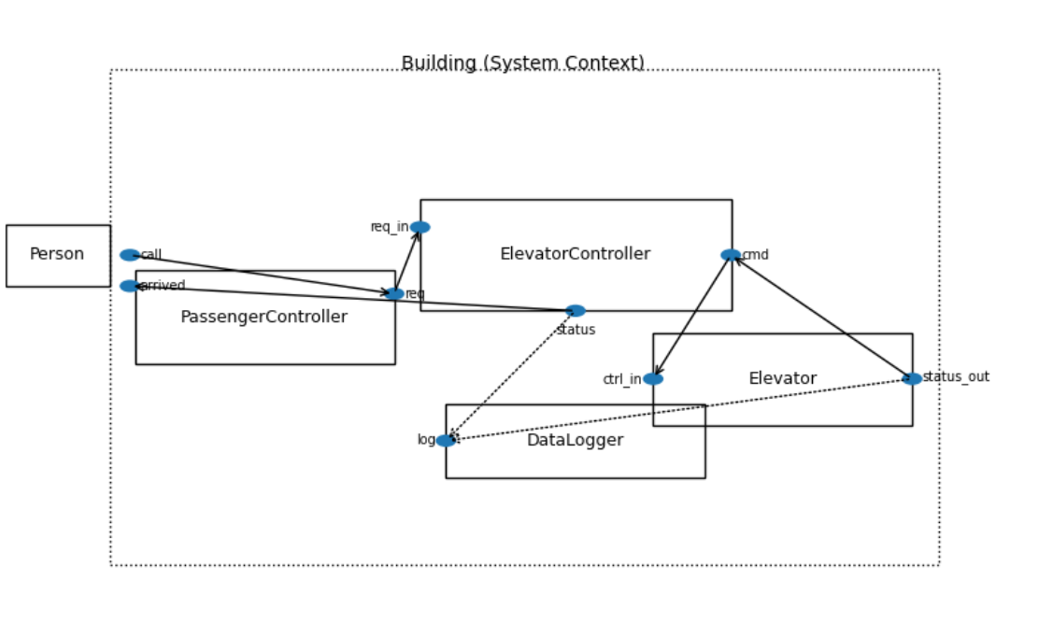

Activity Diagram – Passenger Ride Scenario
The activity flow models the sequence of actions for a single passenger: arrival and elevator call, assignment and arrival of the elevator, boarding, selecting a destination floor, riding to that floor and exiting. This flow ensures all necessary actions (like button press, door opening, movement and exit) are represented in the simulation logic.

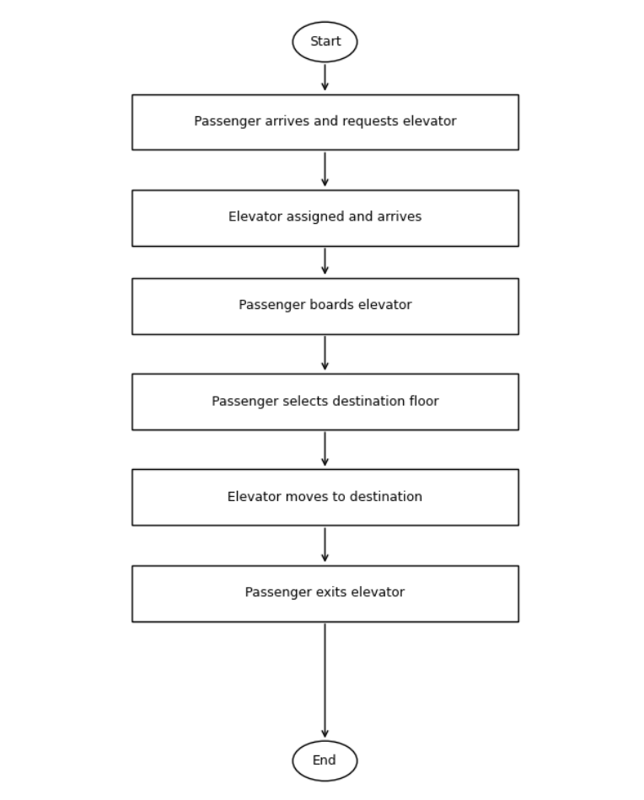

Elevator State Machine
This state machine defines the operational states of an elevator: Idle, MovingUp, MovingDown and Loading. Transitions between states are triggered by events such as new requests, reaching a floor and completing loading. Idle represents no pending requests; moving states capture direction and speed; loading covers door opening and passenger transfers.
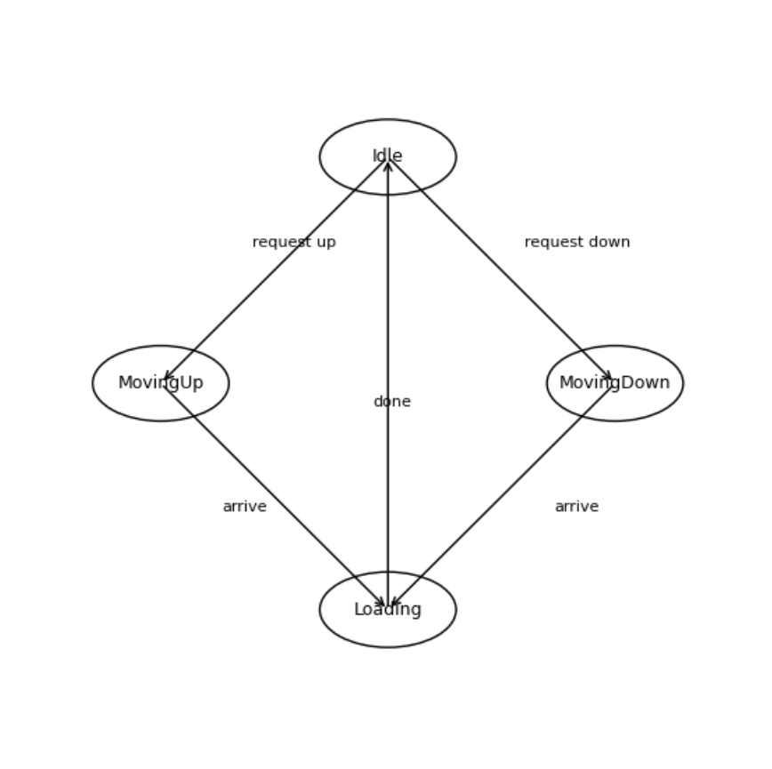

Passenger State Machine
The passenger lifecycle comprises Waiting, Riding and Completed. A passenger transitions from waiting to riding when an elevator arrives and boards, and from riding to completed upon reaching the destination and exiting. These states mirror how individual passengers interact with the system.
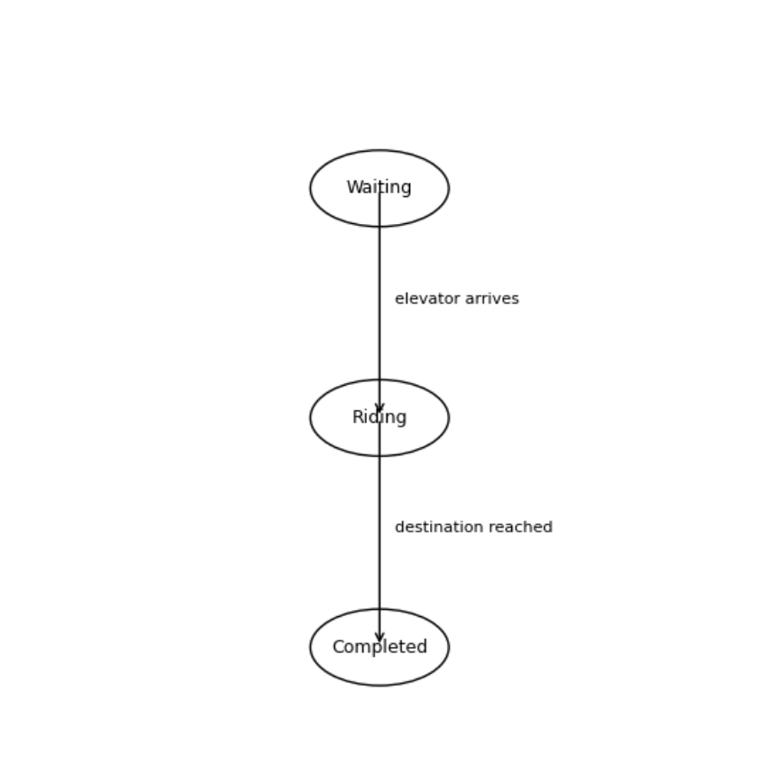

These diagrams together present a comprehensive SysML model for the simple elevator simulator. The use‑case diagram sets the high‑level context; the block definition and internal block diagrams establish structure and communication; the activity diagram outlines workflow; and the state machines specify detailed behavior. The design adheres to MBSE principles and provides a solid foundation for implementing the C# simulator.

