PartA

Garland Williams

5/20/2020

# 1. Invoke R and use the “Tree” dataset

#Dataset data(“trees”) # 2. Find the 5 summary numbers in the data summary(trees)

knitr::kable(summary(trees))

|  |  |  |  |
| --- | --- | --- | --- |
|  | Girth | Height | Volume |
|  | Min. : 8.30 | Min. :63 | Min. :10.20 |
|  | 1st Qu.:11.05 | 1st Qu.:72 | 1st Qu.:19.40 |
|  | Median :12.90 | Median :76 | Median :24.20 |
|  | Mean :13.25 | Mean :76 | Mean :30.17 |
|  | 3rd Qu.:15.25 | 3rd Qu.:80 | 3rd Qu.:37.30 |
|  | Max. :20.60 | Max. :87 | Max. :77.00 |

## 3. Graph a straight line regression

trees%>%  
 ggplot(aes(Girth,Height))+  
 geom_point()+  
 geom_smooth(method = "lm", formula = y~x, se=FALSE)+  
 labs( title = "Trees Data Set: ",  
 subtitle = "Height Vs Girth")+   
 xlab(label= "Height (ft)")+  
 ylab(label = "Girth (IN)")+  
 theme_tufte()

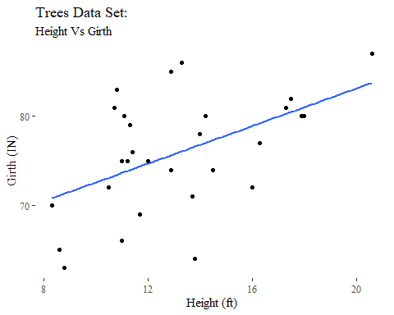

trees%>%  
 ggplot(aes(Volume,Height))+  
 geom_point()+  
 geom_smooth(method = "lm", formula = y~x, se=FALSE)+  
 labs( title = "Trees Data Set: ",  
 subtitle = "Height Vs Volume")+   
 xlab(label= "Height (ft)")+  
 ylab(label = "Volume (cubic ft)")+  
 theme_tufte()

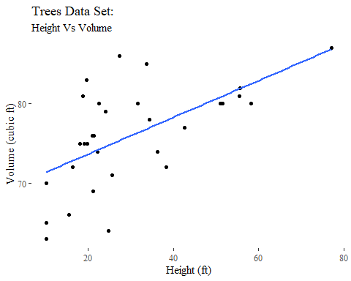

## 4. Create Histograms and density plots

#histogram  
trees%>%gather()%>%  
 ggplot(aes(value))+  
 geom_histogram(bins=10)+  
 facet_wrap(~key, scales='free')+  
 labs( title = "Trees Data Set: ",  
 subtitle = "Histograms: Bins=10")+   
 xlab(label= NULL)+  
 ylab(label = "Count")+  
 theme_tufte()

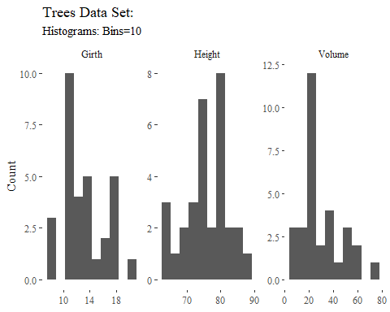

#density Plot  
trees%>%gather()%>%  
 ggplot(aes(value))+  
 geom_density()+  
 facet_wrap(~key, scales='free')+  
 labs( title = "Trees Data Set: ",  
 subtitle = "Density plots")+   
 xlab(label= NULL)+  
 ylab(label = "Count")+  
 theme_tufte()

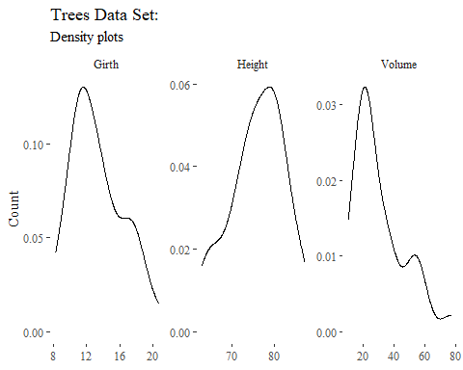

## 5. Create Boxplots

#boxplots  
trees%>%gather()%>%  
 ggplot(aes(value))+  
 geom_boxplot()+coord_flip()+  
 facet_wrap(~key, scales='free')+  
 labs( title = "Trees Data Set: ",  
 subtitle = "Boxplots")+   
 xlab(label= NULL)+  
 ylab(label = "Count")+  
 theme_tufte()

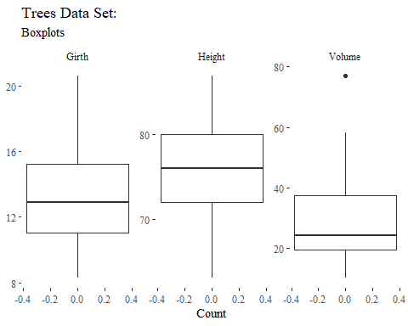

## 6. Normal probability plots

# 6. Normal probability plots  
  
trees%>%gather()%>%  
 ggplot(aes(sample=value))+  
 geom_qq()+  
 facet_wrap(~key, scales='free')+  
 labs( title = "Trees Data Set: ",  
 subtitle = "Normal Probability Plots")+   
 xlab(label= NULL)+  
 ylab(label = "Count")+  
 theme_tufte()

