PartB

Garland Williams

5/20/2020

#Load Relevant Libraries and Datasets  
library(MASS)  
library(DAAG)

## Warning: package 'DAAG' was built under R version 3.6.3

## Loading required package: lattice

##   
## Attaching package: 'DAAG'

## The following object is masked from 'package:MASS':  
##   
## hills

library(ggcorrplot)  
data("Rubber")  
data("oddbooks")

#Rubber EDA  
  
a<-Rubber%>%gather()%>%filter(key=="loss")%>%  
 ggplot(aes(x=value))+  
 geom_density()+  
 labs( title = " ",  
 subtitle = NULL)+   
 xlab(label= "LOSS: Abrasion loss in gm/hr")+  
 ylab(label = NULL)+  
 theme_tufte()  
  
b<-Rubber%>%gather()%>%filter(key=="hard")%>%  
 ggplot(aes(x=value))+  
 geom_density()+  
 labs( title = " ",  
 subtitle = NULL)+   
 xlab(label= "hard: Hardness in Shore Units")+  
 ylab(label = NULL)+  
 theme_tufte()  
  
c<-Rubber%>%gather()%>%filter(key=="tens")%>%  
 ggplot(aes(x=value))+  
 geom_density()+  
 labs( title = " ",  
 subtitle = NULL)+   
 xlab(label= "tens: Tensile strength in kg/sq m")+  
 ylab(label = NULL)+  
 theme_tufte()  
  
d<-Rubber%>%gather()%>%filter(key=="tens")%>%  
 ggplot(aes(x=log(value)))+  
 geom_density()+  
 labs( title = " ",  
 subtitle = NULL)+   
 xlab(label= "log(tens): Tensile strength in kg/sq m")+  
 ylab(label = NULL)+  
 theme_tufte()  
  
grid.arrange(a,b,c,d,nrow=2)

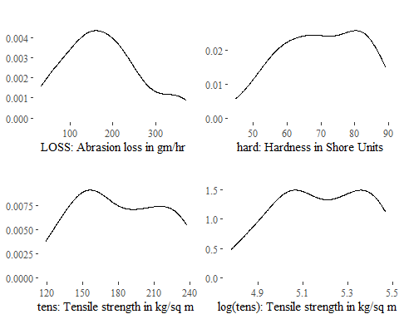

g<- Rubber%>%  
 ggplot(aes(x=hard, y=loss))+  
 geom_point()+  
 geom_smooth(method = "lm", formula = y~x, se=FALSE)+  
 labs( title = " ",  
 subtitle = NULL)+   
 xlab(label= "Hard")+  
 ylab(label = "Loss")+  
 theme_tufte()  
   
h<- Rubber%>%  
 ggplot(aes(x=log(tens), y=loss))+  
 geom_point()+  
 geom_smooth(method = "lm", formula = y~x, se=FALSE)+  
 labs( title = " ",  
 subtitle = NULL)+   
 xlab(label= "log(Tens)")+  
 ylab(label = "Loss")+  
 theme_tufte()  
  
i<- Rubber%>%  
 ggplot(aes(x=log(tens), y=hard))+  
 geom_point()+  
 geom_smooth(method = "lm", formula = y~x, se=FALSE)+  
 labs( title = " ",  
 subtitle = NULL)+   
 xlab(label= "log(Tens)")+  
 ylab(label = "hard")+  
 theme_tufte()  
  
grid.arrange(g,h, i,nrow=1)

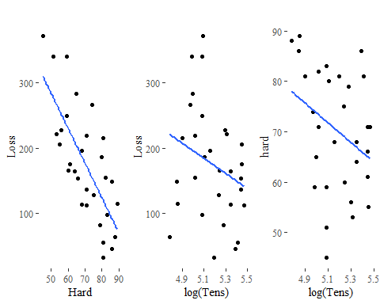

#Model Creation  
RubberModel<- lm(loss~hard + log(tens), data=Rubber)  
summary(RubberModel)

##   
## Call:  
## lm(formula = loss ~ hard + log(tens), data = Rubber)  
##   
## Residuals:  
## Min 1Q Median 3Q Max   
## -89.746 -14.567 2.037 18.552 66.132   
##   
## Coefficients:  
## Estimate Std. Error t value Pr(>|t|)   
## (Intercept) 1919.9258 196.7864 9.756 2.40e-10 ***  
## hard -6.7153 0.5878 -11.424 7.58e-12 ***  
## log(tens) -245.9099 34.6141 -7.104 1.22e-07 ***  
## ---  
## Signif. codes: 0 '***' 0.001 '**' 0.01 '*' 0.05 '.' 0.1 ' ' 1  
##   
## Residual standard error: 36.38 on 27 degrees of freedom  
## Multiple R-squared: 0.8412, Adjusted R-squared: 0.8294   
## F-statistic: 71.49 on 2 and 27 DF, p-value: 1.634e-11

#Correlation plot  
ggcorrplot(round(cor(Rubber),2), lab=TRUE, ggtheme=theme_tufte(),colors = c("Light Blue", "white", "#E46726"))

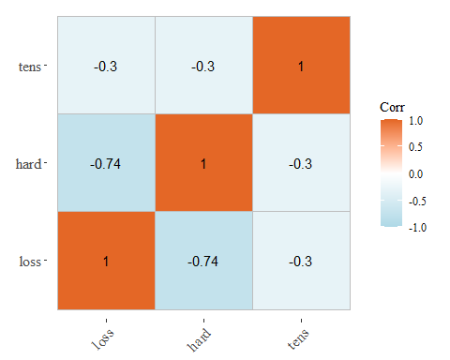

#Oddbooks EDA  
oddbooks%>%gather()%>%  
 ggplot(aes(x=value))+  
 geom_density()+  
 facet_wrap(~key, scales='free')+  
 labs( title = " ",  
 subtitle = "Histograms")+   
 xlab(label= NULL)+  
 ylab(label = "Count")+  
 theme_tufte()

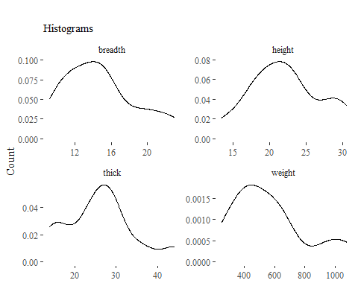

oddbooks%>%gather()%>%  
 ggplot(aes(x=log(value)))+  
 geom_density()+  
 facet_wrap(~key, scales='free')+  
 labs( title = " ",  
 subtitle = "Histograms: Logged values")+   
 xlab(label= NULL)+  
 ylab(label = NULL)+  
 theme_tufte()

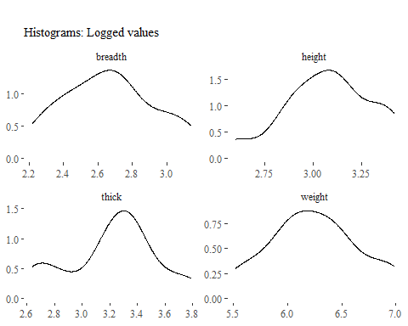

# Model Creation  
oddbooksModel<- lm(oddbooks$weight~ log(oddbooks$thick)+oddbooks$height)  
summary(oddbooksModel)

##   
## Call:  
## lm(formula = oddbooks$weight ~ log(oddbooks$thick) + oddbooks$height)  
##   
## Residuals:  
## Min 1Q Median 3Q Max   
## -202.99 -18.16 12.90 62.25 152.61   
##   
## Coefficients:  
## Estimate Std. Error t value Pr(>|t|)   
## (Intercept) -1321.48 1597.66 -0.827 0.4295   
## log(oddbooks$thick) 192.95 343.31 0.562 0.5878   
## oddbooks$height 56.87 22.95 2.478 0.0351 *  
## ---  
## Signif. codes: 0 '***' 0.001 '**' 0.01 '*' 0.05 '.' 0.1 ' ' 1  
##   
## Residual standard error: 112.5 on 9 degrees of freedom  
## Multiple R-squared: 0.8305, Adjusted R-squared: 0.7929   
## F-statistic: 22.05 on 2 and 9 DF, p-value: 0.0003396

oddbooksModel<- lm(log(oddbooks$weight)~oddbooks$thick+log(oddbooks$breadth))  
summary(oddbooksModel)

##   
## Call:  
## lm(formula = log(oddbooks$weight) ~ oddbooks$thick + log(oddbooks$breadth))  
##   
## Residuals:  
## Min 1Q Median 3Q Max   
## -0.31947 -0.03533 0.05037 0.09131 0.13883   
##   
## Coefficients:  
## Estimate Std. Error t value Pr(>|t|)   
## (Intercept) 0.89855 1.47930 0.607 0.5586   
## oddbooks$thick 0.01399 0.01379 1.015 0.3368   
## log(oddbooks$breadth) 1.87066 0.42834 4.367 0.0018 **  
## ---  
## Signif. codes: 0 '***' 0.001 '**' 0.01 '*' 0.05 '.' 0.1 ' ' 1  
##   
## Residual standard error: 0.1541 on 9 degrees of freedom  
## Multiple R-squared: 0.8949, Adjusted R-squared: 0.8715   
## F-statistic: 38.3 on 2 and 9 DF, p-value: 3.963e-05

#Correlation plot  
ggcorrplot(round(cor(oddbooks),2), lab=TRUE, ggtheme=theme_tufte(),colors = c("Light Blue", "white", "#E46726"))

