WilliamsM3LASSORegression

G. Holt Williams

6/1/2020

# Introduction

The goal of this project is to practice LASSO regularization in the glmnet R package. Areas of practice include utilizng big data, LASSO model fitting, and linear/logistic regression. The project is broken into two parts, first being the “Regularization Assignment” and the second being “LASSO Regression in R Exercises.” The first part looks at an insurance company Datset, while the second utilizes an exercise from “r-exercises” and the diabetes dataset to show the fundamentals of LASSO in R.

# Regularizartion Assignment

## Data Set Selection

For this assignment, the analysis will utilize the “Insurance Company Benchmark (COIL 2000) Data Set(Putten 2000).” This dataset has 5,822 rows with about 86 variables which are mostly dummy/factor variables. This dataset was retrieved from UCI’s Machine Learning Repository which describes the set as “product usage and socio-demographic data(Putten 2000).” Due to the large quanitity of variables exploratory analysis will only look at the varibles that were found to have the most influence in the LASSO model utilized. This assignment will start with the model, then go into a simple exploratory data analysis section on the variables selected. The response variable for this exercise is if the customer has a mobile home insurance policy.Note: The variables that start with M are zip-coder variables, which likely mean they are information on the maekupe of the zip-code the customer live sin versus direct information on the customer.

### Load Libraries and Datasets

library(glmnet)  
library(tidyverse)  
library(broom)  
library(psych)  
library(ggthemes)  
library(gridExtra)  
df<-read.table("ticdata2000.txt", header=FALSE)  
dictionary<-read.csv("dictionary.txt")  
var<- (dictionary$DATA.DICTIONARY[2:87])  
#Change to factors as required  
df$V1<-factor(df$V1)  
df$V4<-factor(df$V4)  
df$V6<-factor(df$V6)  
df$V44<-factor(df$V44)  
df$V86<-factor(df$V86)  
var<-str_sub(var,3)  
var<-gsub(" ","_", var)  
colnames(df)<-var #Add variable names to data frame

nrow(df)

## [1] 5822

The dataset has 5822 rows

summary(df[86])

|  |  |
| --- | --- |
|  | *CARAVAN_Number_of_mobile_home_policies_0*-_1 |
|  | 0:5474 |
|  | 1: 348 |

The above table shows us the outcome is binary, which lends the model selection towards a logistic lasso model.

## Model Selection

As shown above, the outcome variable is binary which lends to the use of a logsitic regression. With that, the regularization technique of LASSO will be utilized to reduce the quanitity of independant variables used in the final model. The analysis will start with a logistic regression to show us the base case if all variables are included

bench<-glm(df$`_CARAVAN_Number_of_mobile_home_policies_0_-_1` ~ ., data=df, family = "binomial")  
coeff<-as.data.frame(summary(bench)$coef)%>%rownames_to_column()  
tidy(bench)%>%filter(p.value<0.1)%>%mutate_if(is.numeric,round, digits=3)

|  |  |  |  |  |
| --- | --- | --- | --- | --- |
| term | estimate | std.error | statistic | p.value |
| MGODRK_Roman_catholic_see_L34 | -2.024 | 1.169 | -1.731 | 0.083 |
| _MOPLLAAG_Lower_level_education | -0.263 | 0.143 | -1.835 | 0.067 |
| _PPERSAUT_Contribution_car_policies | 0.226 | 0.043 | 5.277 | 0.000 |
| _PTRACTOR_Contribution_tractor_policies | 0.749 | 0.441 | 1.699 | 0.089 |
| _PLEVEN_Contribution_life_insurances | -0.264 | 0.119 | -2.225 | 0.026 |
| _PBRAND_Contribution_fire_policies | 0.208 | 0.079 | 2.632 | 0.008 |
| _ALEVEN_Number_of_life_insurances | 0.532 | 0.229 | 2.326 | 0.020 |
| _APLEZIER_Number_of_boat_policies | 2.499 | 1.064 | 2.349 | 0.019 |

To reduce page length the full coefficeint breakdown is not included. Only values that are statistically significant at the 90% confidence interval are shown. The variable with the most influence looks to be the number of boat policies. This suggests there is a larger likliehood of not only having a mobile home, but having an insurance policy for it, if the consumer has a boat policy.

Next, glmnet is run, and only the plotted output is shown. This shows the changes in the coefficients as the model penalizes diffrent variables toward zero. It is important here to set the seed to ensure you are able to reproduce the results later on.

set.seed(555)  
glm1<-glmnet(as.matrix(df[c(1:84)]),as.matrix(df$`_CARAVAN_Number_of_mobile_home_policies_0_-_1`),family = "binomial")  
plot(glm1, label=TRUE)

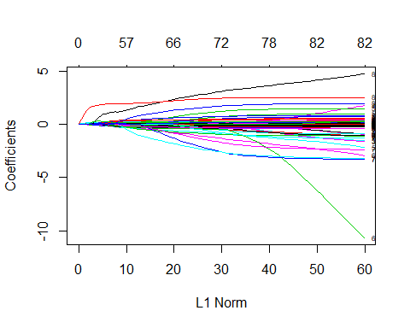

This plot is useful as it shows where diffrent variables reduce to zero in viusual way, instead of parsing through all the models that were run.

Next, cross validation is utilized to determine at what lambda the model should be chosen. The model is run with the number of lambdas at 1000.

set.seed(555)  
cvglm1<-cv.glmnet(data.matrix(df[c(1:84)]),as.matrix(df$`_CARAVAN_Number_of_mobile_home_policies_0_-_1`),family = "binomial", nlambda=1000, alpha=1)  
plot(cvglm1)

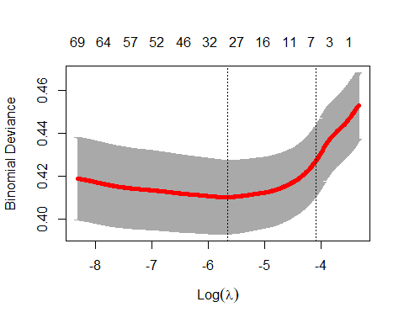

cvglm1$lambda.min

## [1] 0.003471954

cvglm1$lambda.1se

## [1] 0.01679804

The resulting information is utilized to select the lambda for the glmnet. In the above cross validation run a the lambda that give minimum cvm is 0.00347. The output also give the “1se” lambda (0.0168), which is the value of lambda such that error is within one standard erro of the minimum. Outputs of both lambdas are below, but the “1se” lambda will be focused on for the EDA.

set.seed(555)  
glm_min<- glmnet(data.matrix(df[c(1:84)]),as.matrix(df$`_CARAVAN_Number_of_mobile_home_policies_0_-_1`),family = "binomial", lambda=cvglm1$lambda.min, alpha=1)  
tidy(glm_min)%>%mutate_if(is.numeric,round, digits=3)

|  |  |  |  |  |
| --- | --- | --- | --- | --- |
| term | step | estimate | lambda | dev.ratio |
| (Intercept) | 1 | -4.883 | 0.003 | 0.119 |
| MGEMLEEF_Avg_age_see_L1 | 1 | 0.021 | 0.003 | 0.119 |
| MGODPR_Protestant_… | 1 | 0.020 | 0.003 | 0.119 |
| MGODGE_No_religion | 1 | -0.006 | 0.003 | 0.119 |
| _MRELGE_Married | 1 | 0.048 | 0.003 | 0.119 |
| _MRELSA_Living_together | 1 | -0.011 | 0.003 | 0.119 |
| _MOPLHOOG_High_level_education | 1 | 0.047 | 0.003 | 0.119 |
| _MOPLLAAG_Lower_level_education | 1 | -0.050 | 0.003 | 0.119 |
| _MBERBOER_Farmer | 1 | -0.116 | 0.003 | 0.119 |
| _MBERMIDD_Middle_management | 1 | 0.025 | 0.003 | 0.119 |
| _MHHUUR_Rented_house | 1 | -0.018 | 0.003 | 0.119 |
| _MAUT1_1_car | 1 | 0.045 | 0.003 | 0.119 |
| *MINKM30_Income*<_30.000 | 1 | -0.004 | 0.003 | 0.119 |
| _MINK7512_Income_75-122.000 | 1 | 0.016 | 0.003 | 0.119 |
| *MINK123M_Income*>123.000 | 1 | -0.071 | 0.003 | 0.119 |
| _MINKGEM_Average_income | 1 | 0.047 | 0.003 | 0.119 |
| _MKOOPKLA_Purchasing_power_class | 1 | 0.042 | 0.003 | 0.119 |
| _PWAPART_Contribution_private_third_party_insurance_see_L4 | 1 | 0.124 | 0.003 | 0.119 |
| *PWALAND_Contribution_third_party_insurane*(agriculture) | 1 | -0.107 | 0.003 | 0.119 |
| _PPERSAUT_Contribution_car_policies | 1 | 0.199 | 0.003 | 0.119 |
| _PGEZONG_Contribution_family_accidents_insurance_policies | 1 | 0.075 | 0.003 | 0.119 |
| _PWAOREG_Contribution_disability_insurance_policies | 1 | 0.134 | 0.003 | 0.119 |
| _PBRAND_Contribution_fire_policies | 1 | 0.098 | 0.003 | 0.119 |
| _PFIETS_Contribution_bicycle_policies | 1 | 0.003 | 0.003 | 0.119 |
| _PBYSTAND_Contribution_social_security_insurance_policies | 1 | 0.093 | 0.003 | 0.119 |
| _ATRACTOR_Number_of_tractor_policies | 1 | -0.038 | 0.003 | 0.119 |
| _AZEILPL_Number_of_surfboard_policies | 1 | 0.652 | 0.003 | 0.119 |
| _APLEZIER_Number_of_boat_policies | 1 | 1.794 | 0.003 | 0.119 |
| _AFIETS_Number_of_bicycle_policies | 1 | 0.309 | 0.003 | 0.119 |

set.seed(555)  
glm_1se<- glmnet(data.matrix(df[c(1:84)]),as.matrix(df$`_CARAVAN_Number_of_mobile_home_policies_0_-_1`),family = "binomial", lambda=cvglm1$lambda.1se, alpha=1)  
tidy(glm_1se)%>%mutate_if(is.numeric,round, digits=3)

|  |  |  |  |  |
| --- | --- | --- | --- | --- |
| term | step | estimate | lambda | dev.ratio |
| (Intercept) | 1 | -3.379 | 0.017 | 0.063 |
| _MOPLLAAG_Lower_level_education | 1 | -0.017 | 0.017 | 0.063 |
| _MINKGEM_Average_income | 1 | 0.016 | 0.017 | 0.063 |
| _MKOOPKLA_Purchasing_power_class | 1 | 0.032 | 0.017 | 0.063 |
| _PWAPART_Contribution_private_third_party_insurance_see_L4 | 1 | 0.033 | 0.017 | 0.063 |
| _PPERSAUT_Contribution_car_policies | 1 | 0.115 | 0.017 | 0.063 |
| _PBRAND_Contribution_fire_policies | 1 | 0.021 | 0.017 | 0.063 |
| _APLEZIER_Number_of_boat_policies | 1 | 0.912 | 0.017 | 0.063 |

The diffrence between the two is how large of a penalty is added to the model. This is why the first model has 28 coefficients while the second model has 7.

mincoef<-tibble(tidy(glm_min$beta))  
onesecoeff<-tibble(tidy(glm_1se$beta))  
comparison<-left_join(mincoef[-2],onesecoeff[-2], by='row')  
comparison%>%mutate_if(is.numeric,round, digits=3)

|  |  |  |
| --- | --- | --- |
| row | value.x | value.y |
| MGEMLEEF_Avg_age_see_L1 | 0.021 | NA |
| MGODPR_Protestant_… | 0.020 | NA |
| MGODGE_No_religion | -0.006 | NA |
| _MRELGE_Married | 0.048 | NA |
| _MRELSA_Living_together | -0.011 | NA |
| _MOPLHOOG_High_level_education | 0.047 | NA |
| _MOPLLAAG_Lower_level_education | -0.050 | -0.017 |
| _MBERBOER_Farmer | -0.116 | NA |
| _MBERMIDD_Middle_management | 0.025 | NA |
| _MHHUUR_Rented_house | -0.018 | NA |
| _MAUT1_1_car | 0.045 | NA |
| *MINKM30_Income*<_30.000 | -0.004 | NA |
| _MINK7512_Income_75-122.000 | 0.016 | NA |
| *MINK123M_Income*>123.000 | -0.071 | NA |
| _MINKGEM_Average_income | 0.047 | 0.016 |
| _MKOOPKLA_Purchasing_power_class | 0.042 | 0.032 |
| _PWAPART_Contribution_private_third_party_insurance_see_L4 | 0.124 | 0.033 |
| *PWALAND_Contribution_third_party_insurane*(agriculture) | -0.107 | NA |
| _PPERSAUT_Contribution_car_policies | 0.199 | 0.115 |
| _PGEZONG_Contribution_family_accidents_insurance_policies | 0.075 | NA |
| _PWAOREG_Contribution_disability_insurance_policies | 0.134 | NA |
| _PBRAND_Contribution_fire_policies | 0.098 | 0.021 |
| _PFIETS_Contribution_bicycle_policies | 0.003 | NA |
| _PBYSTAND_Contribution_social_security_insurance_policies | 0.093 | NA |
| _ATRACTOR_Number_of_tractor_policies | -0.038 | NA |
| _AZEILPL_Number_of_surfboard_policies | 0.652 | NA |
| _APLEZIER_Number_of_boat_policies | 1.794 | 0.912 |
| _AFIETS_Number_of_bicycle_policies | 0.309 | NA |

## Input analysis

In this section each of the variables determined by using the value of lambda such that error is within one standard erro of the minimum is explored. This includes:

tidy(glm_1se)%>%select(term)

|  |
| --- |
| term |
| (Intercept) |
| _MOPLLAAG_Lower_level_education |
| _MINKGEM_Average_income |
| _MKOOPKLA_Purchasing_power_class |
| _PWAPART_Contribution_private_third_party_insurance_see_L4 |
| _PPERSAUT_Contribution_car_policies |
| _PBRAND_Contribution_fire_policies |
| _APLEZIER_Number_of_boat_policies |

Lower level education, average income, and purchasing power class all give information “on the distribution of that variable…in the zipcode area of the customer.”

## MOPLLAAG Lower Level Education

df$`_MOPLLAAG_Lower_level_education`%>%describe(quant=c(.25,.75),omit=TRUE)%>%select(n, sd,mean, median, min, max, Q0.25, Q0.75)%>%round(digits=2)

|  |  |  |  |  |  |  |  |
| --- | --- | --- | --- | --- | --- | --- | --- |
| n | sd | mean | median | min | max | Q0.25 | Q0.75 |
| 5822 | 2.3 | 4.57 | 5 | 0 | 9 | 3 | 6 |

df%>%  
 ggplot(aes(`_MOPLLAAG_Lower_level_education`,color=`_CARAVAN_Number_of_mobile_home_policies_0_-_1`))+  
 geom_density()+  
 theme_tufte()+  
 xlab("Lower Level Education")+  
 labs(color="Mobile Home Policies")

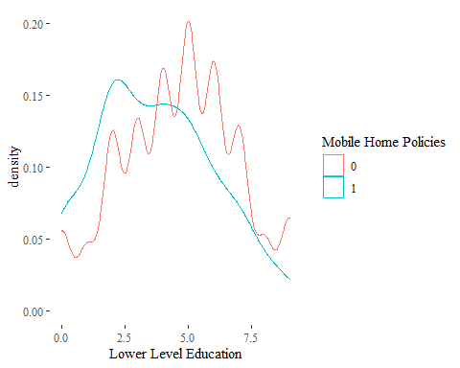

df%>%  
 ggplot(aes(`_MOPLLAAG_Lower_level_education`,color=`_CARAVAN_Number_of_mobile_home_policies_0_-_1`))+  
 geom_boxplot()+  
 theme_tufte()+  
 xlab("Lower Level Education")+  
 labs(color="Mobile Home Policies")

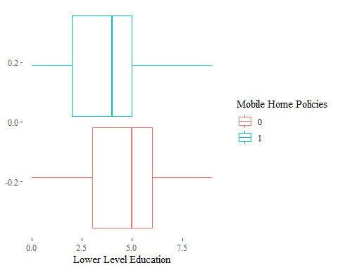

As expected from the name of the variable, as the distribution of lower level income in a zip-code increases the liklihood of having an insurance for a mobile home policy decreases. This is the reason the chosen model has an estimate of -0.017, so as this variable increases the model predicts the individual is less likley to have a policy.

## MINKGEM Average Income

df$`_MINKGEM_Average_income`%>%describe(quant=c(.25,.75),omit=TRUE)%>%select(n, sd,mean, median, min, max, Q0.25, Q0.75)%>%round(digits=2)

|  |  |  |  |  |  |  |  |
| --- | --- | --- | --- | --- | --- | --- | --- |
| n | sd | mean | median | min | max | Q0.25 | Q0.75 |
| 5822 | 1.32 | 3.78 | 4 | 0 | 9 | 3 | 4 |

df%>%  
 ggplot(aes(`_MINKGEM_Average_income`,color=`_CARAVAN_Number_of_mobile_home_policies_0_-_1`))+  
 geom_density()+  
 theme_tufte()+  
 xlab("Average Income")+  
 labs(color="Mobile Home Policies")

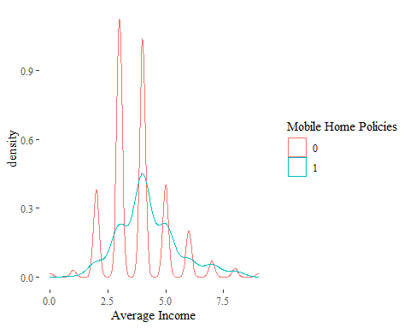

df%>%  
 ggplot(aes(`_MINKGEM_Average_income`,color=`_CARAVAN_Number_of_mobile_home_policies_0_-_1`))+  
 geom_boxplot()+  
 theme_tufte()+  
 xlab("Average Income")+  
 labs(color="Mobile Home Policies")

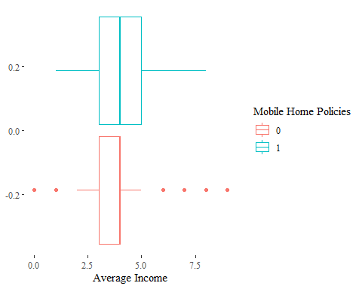

Understanding this variable is a little difficult as the data dictionary does not give many clues. It is listed as Average Income which can be interpreted as the percent of the distirubtion of average income in the zipcode area of that customer. Would that make this an estimate of variability of the income in the area? or something elese. None the less, the model shows that as this variable increases, the output is pushed closer to 1.

## MKOOPKLA Purchasing power class

df$`_MKOOPKLA_Purchasing_power_class`%>%describe(quant=c(.25,.75),omit=TRUE)%>%select(n, sd,mean, median, min, max, Q0.25, Q0.75)%>%round(digits=2)

|  |  |  |  |  |  |  |  |
| --- | --- | --- | --- | --- | --- | --- | --- |
| n | sd | mean | median | min | max | Q0.25 | Q0.75 |
| 5822 | 2.01 | 4.24 | 4 | 1 | 8 | 3 | 6 |

df%>%  
 ggplot(aes(`_MKOOPKLA_Purchasing_power_class`,color=`_CARAVAN_Number_of_mobile_home_policies_0_-_1`))+  
 geom_density()+  
 theme_tufte()+  
 xlab("Purchasing Power Class")+  
 labs(color="Mobile Home Policies")

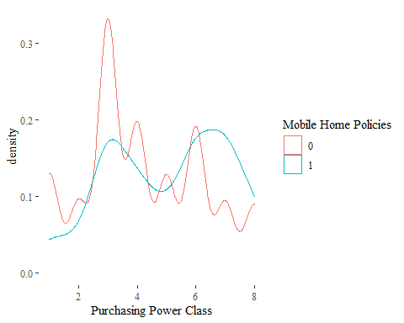

df%>%  
 ggplot(aes(`_MKOOPKLA_Purchasing_power_class`,color=`_CARAVAN_Number_of_mobile_home_policies_0_-_1`))+  
 geom_boxplot()+  
 theme_tufte()+  
 xlab("Purchasing Power Class")+  
 labs(color="Mobile Home Policies")

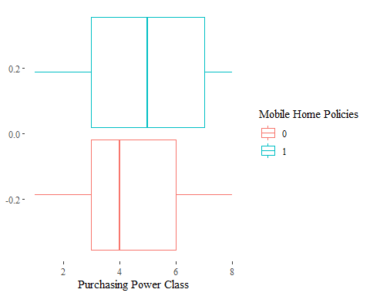

There is not much information to gather from these set of graphs other than zip codes with a higher purchasing power have the capacity to afford a mobile home.

## PWAPART Contribution private third party insurance see L4

levels(df$`_PWAPART_Contribution_private_third_party_insurance_see_L4`)<-c("0","1-49","50-99","100-199")  
  
df%>%  
 select(Expenditure =`_PWAPART_Contribution_private_third_party_insurance_see_L4`,Policy = `_CARAVAN_Number_of_mobile_home_policies_0_-_1`)%>%  
 table()

|  |  |  |
| --- | --- | --- |
| Expenditure/Policy | 0 | 1 |
| 0 | 3335 | 147 |
| 1-49 | 193 | 8 |
| 50-99 | 1937 | 191 |
| 100-199 | 9 | 2 |

graph<-df%>%  
 ggplot(aes(fill=`_PWAPART_Contribution_private_third_party_insurance_see_L4`,x=`_CARAVAN_Number_of_mobile_home_policies_0_-_1`))  
  
graph+  
 geom_bar()+  
 theme_tufte()+  
 xlab("Contribution private third party insurance")+  
 labs(color="Mobile Home Policies")

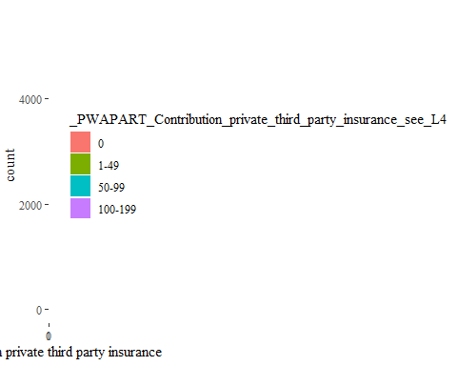

This variable hints at an interesting question of what types of consumers buy insurance policy for mobile homes. The cost of owning a mobile home is likely cost prohibitive, and as such low earners who don’t have any third party insurance contributions likely can’t afford a mobile home. However, on the other end is the high earners who are unlikely to purchase a mobile home due to it not being a high end luxury, but would likely have multiple third party insurance contributions.

## PPERSAUT Contribution car policies

df$`_PPERSAUT_Contribution_car_policies`%>%describe(quant=c(.25,.75),omit=TRUE)%>%select(n, sd,mean, median, min, max, Q0.25, Q0.75)%>%round(digits=2)

|  |  |  |  |  |  |  |  |
| --- | --- | --- | --- | --- | --- | --- | --- |
| n | sd | mean | median | min | max | Q0.25 | Q0.75 |
| 5822 | 2.92 | 2.97 | 5 | 0 | 8 | 0 | 6 |

df%>%  
 ggplot(aes(`_PPERSAUT_Contribution_car_policies`,color=`_CARAVAN_Number_of_mobile_home_policies_0_-_1`))+  
 geom_density()+  
 theme_tufte()+  
 xlab("Contribution car policies")+  
 labs(color="Mobile Home Policies")

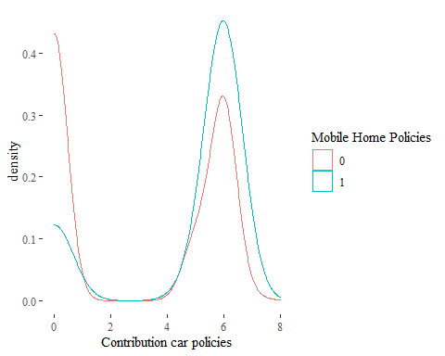

df%>%  
 ggplot(aes(`_PPERSAUT_Contribution_car_policies`,color=`_CARAVAN_Number_of_mobile_home_policies_0_-_1`))+  
 geom_boxplot()+  
 theme_tufte()+  
 xlab("Contribution car policies")+  
 labs(color="Mobile Home Policies")

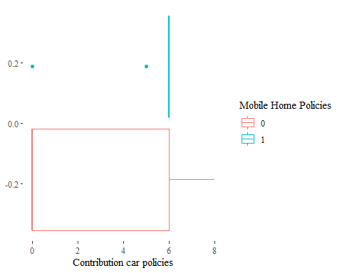

Interstingly, the density graph shows that some individuals only have a mobile home with a policy, but do not have any car insurance, which suggests they likely live in the home. Another intersting takeaway is that most consumers either have a car for themselves or likely have multiple cars, likely for a family. Other reasosn could be an extra truck for moving the home.

## PBRAND Contribution fire policies

df$`_PBRAND_Contribution_fire_policies`%>%describe(quant=c(.25,.75),omit=TRUE)%>%select(n, sd,mean, median, min, max, Q0.25, Q0.75)%>%round(digits=2)

|  |  |  |  |  |  |  |  |
| --- | --- | --- | --- | --- | --- | --- | --- |
| n | sd | mean | median | min | max | Q0.25 | Q0.75 |
| 5822 | 1.88 | 1.83 | 2 | 0 | 8 | 0 | 4 |

df%>%  
 ggplot(aes(`_PBRAND_Contribution_fire_policies`,color=`_CARAVAN_Number_of_mobile_home_policies_0_-_1`))+  
 geom_density()+  
 theme_tufte()+  
 xlab("Contribution fire policies")+  
 labs(color="Mobile Home Policies")

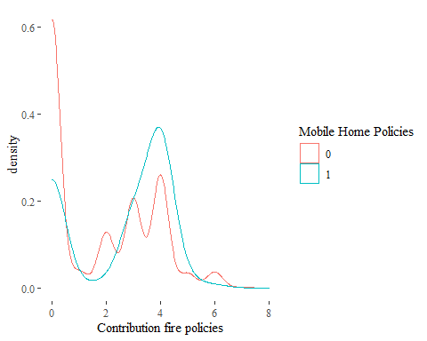

df%>%  
 ggplot(aes(`_PBRAND_Contribution_fire_policies`,color=`_CARAVAN_Number_of_mobile_home_policies_0_-_1`))+  
 geom_boxplot()+  
 theme_tufte()+  
 xlab("Contribution fire policies")+  
 labs(color="Mobile Home Policies")

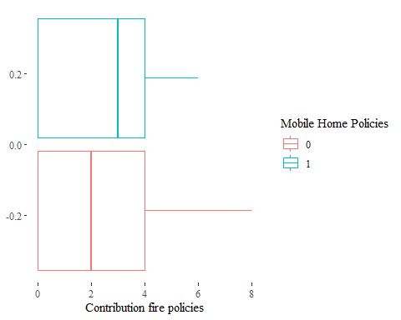

Similar to the contribution to car policy variable, the majority of customers who purchase a mobile home insurance policy also have contribution to fire policies. This may be correlated to having additional property with fire insruacne, or maybe mobile homes require fire insurance.

## APLEZIER Number of boat policies

df$`_APLEZIER_Number_of_boat_policies`%>%describe(quant=c(.25,.75),omit=TRUE)%>%select(n, sd,mean, median, min, max, Q0.25, Q0.75)%>%round(digits=2)

|  |  |  |  |  |  |  |  |
| --- | --- | --- | --- | --- | --- | --- | --- |
| n | sd | mean | median | min | max | Q0.25 | Q0.75 |
| 5822 | 0.08 | 0.01 | 0 | 0 | 2 | 0 | 0 |

df%>%  
 ggplot(aes(`_APLEZIER_Number_of_boat_policies`,color=`_CARAVAN_Number_of_mobile_home_policies_0_-_1`))+  
 geom_density()+  
 theme_tufte()+  
 xlab("Number of boat policies")+  
 labs(color="Mobile Home Policies")

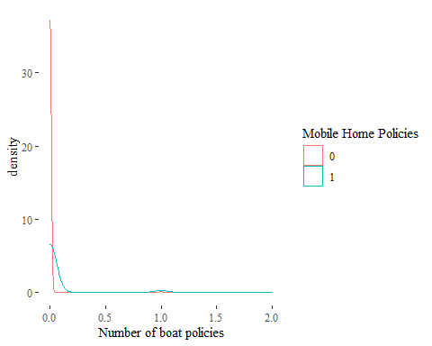

df%>%  
 ggplot(aes(`_APLEZIER_Number_of_boat_policies`,color=`_CARAVAN_Number_of_mobile_home_policies_0_-_1`))+  
 geom_boxplot()+  
 theme_tufte()+  
 xlab("Number of boat policies")+  
 labs(color="Mobile Home Policies")

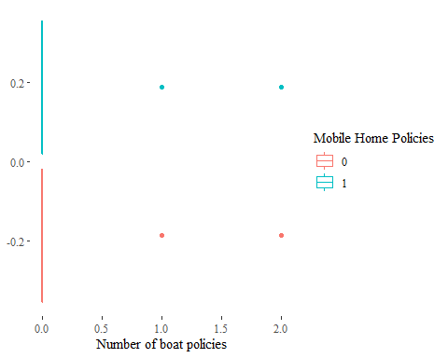

This is an interesting variable when it comes to why it was included in the model. This is likely hgihly correlated with a seperate variable that was dropped. In further model iterations this variable should probably be dropped before running as the value this adds is likley little.

## Refrences

Putten and Someren (eds) . CoIL Challenge 2000: The Insurance Company Case. Published by Sentient Machine Research, Amsterdam. Also a Leiden Institute of Advanced Computer Science Technical Report 2000-09. June 22, 2000.

# LASSO Regression in R Exercises

Source: <https://www.r-exercises.com/2017/06/12/lasso-regression-in-r-exercises/>

## Exercise 1:

library(lars)  
library(glmnet)  
data("diabetes")  
attach(diabetes)

## Exercise 2:

for (i in 1:10){  
 plot(x[,i],y, xlab =colnames(x)[i])  
 abline(lm(y~x[,i]))  
}

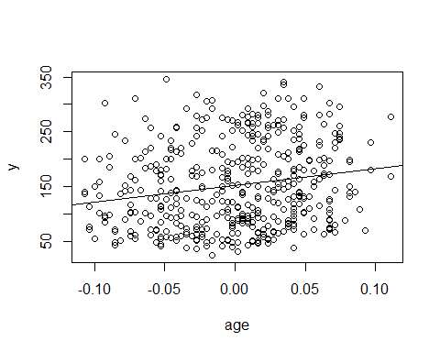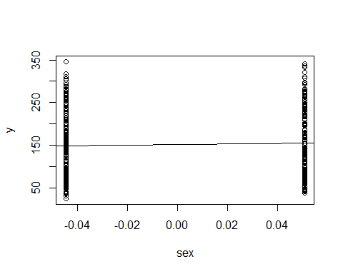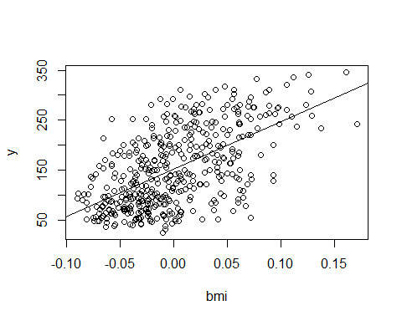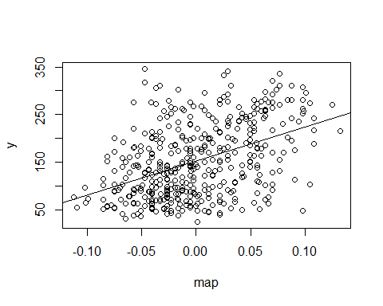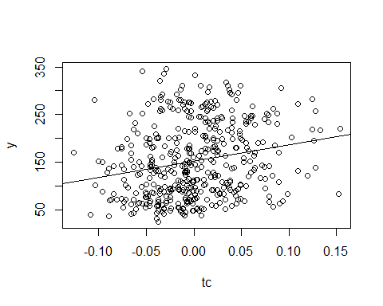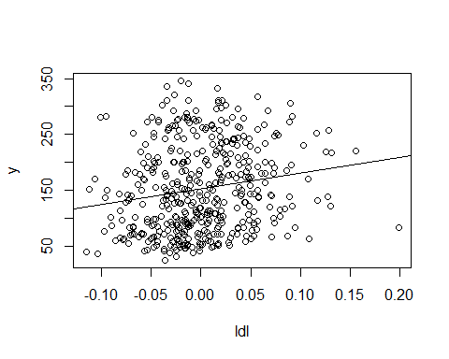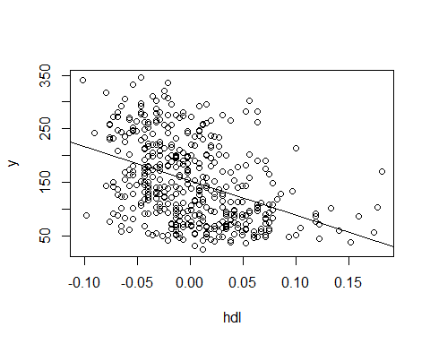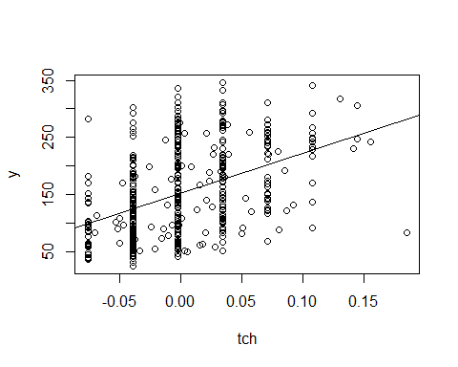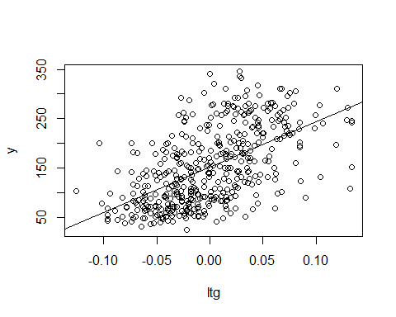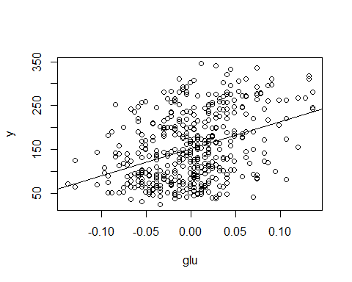

## Exercise 3:

bench<-lm(y ~ x, data=diabetes)  
class(x)

## [1] "AsIs"

summary(bench)

##   
## Call:  
## lm(formula = y ~ x, data = diabetes)  
##   
## Residuals:  
## Min 1Q Median 3Q Max   
## -155.829 -38.534 -0.227 37.806 151.355   
##   
## Coefficients:  
## Estimate Std. Error t value Pr(>|t|)   
## (Intercept) 152.133 2.576 59.061 < 2e-16 ***  
## xage -10.012 59.749 -0.168 0.867000   
## xsex -239.819 61.222 -3.917 0.000104 ***  
## xbmi 519.840 66.534 7.813 4.30e-14 ***  
## xmap 324.390 65.422 4.958 1.02e-06 ***  
## xtc -792.184 416.684 -1.901 0.057947 .   
## xldl 476.746 339.035 1.406 0.160389   
## xhdl 101.045 212.533 0.475 0.634721   
## xtch 177.064 161.476 1.097 0.273456   
## xltg 751.279 171.902 4.370 1.56e-05 ***  
## xglu 67.625 65.984 1.025 0.305998   
## ---  
## Signif. codes: 0 '***' 0.001 '**' 0.01 '*' 0.05 '.' 0.1 ' ' 1  
##   
## Residual standard error: 54.15 on 431 degrees of freedom  
## Multiple R-squared: 0.5177, Adjusted R-squared: 0.5066   
## F-statistic: 46.27 on 10 and 431 DF, p-value: < 2.2e-16

## Exercise 4:

glm1<-glmnet(diabetes$x, diabetes$y)  
summary(glm1)

|  |  |  |  |
| --- | --- | --- | --- |
|  | Length | Class | Mode |
| a0 | 88 | -none- | numeric |
| beta | 880 | dgCMatrix | S4 |
| df | 88 | -none- | numeric |
| dim | 2 | -none- | numeric |
| lambda | 88 | -none- | numeric |
| dev.ratio | 88 | -none- | numeric |
| nulldev | 1 | -none- | numeric |
| npasses | 1 | -none- | numeric |
| jerr | 1 | -none- | numeric |
| offset | 1 | -none- | logical |
| call | 3 | -none- | call |
| nobs | 1 | -none- | numeric |

plot(glm1)

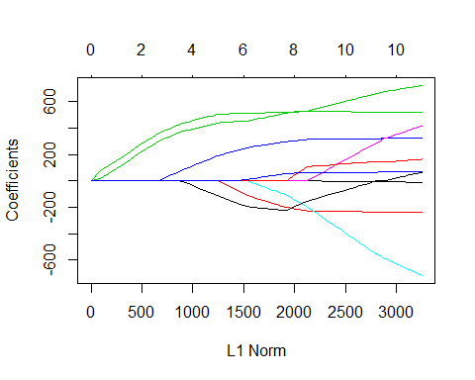

glm1$beta

## 10 x 88 sparse Matrix of class "dgCMatrix"

## [[ suppressing 88 column names 's0', 's1', 's2' ... ]]

##   
## age . . . . . . . .   
## sex . . . . . . . .   
## bmi . 76.88293 130.02092 178.4416 222.5606 262.7603 299.3887 332.7819  
## map . . . . . . . .   
## tc . . . . . . . .   
## ldl . . . . . . . .   
## hdl . . . . . . . .   
## tch . . . . . . . .   
## ltg . 16.74669 69.89093 118.3125 162.4325 202.6329 239.2621 272.6289  
## glu . . . . . . . .   
##   
## age . . . . . . .   
## sex . . . . . . .   
## bmi 362.882285 384.18816 403.56947 421.2928 436.738959 447.18511 456.78809  
## map 1.049765 24.26724 45.37674 64.6454 82.307193 98.99238 114.15538  
## tc . . . . . . .   
## ldl . . . . . . .   
## hdl . . . . -3.104737 -20.12834 -35.57045  
## tch . . . . . . .   
## ltg 302.763925 324.19336 343.75113 361.5294 376.763057 386.37120 395.13120  
## glu . . . . . . .   
##   
## age . . . . . . .   
## sex . . . . . . .   
## bmi 465.53779 473.51020 480.77435 487.39318 493.42401 498.9191 503.9260  
## map 127.97136 140.55998 152.03025 162.48154 172.00436 180.6812 188.5872  
## tc . . . . . . .   
## ldl . . . . . . .   
## hdl -49.64078 -62.46113 -74.14256 -84.78625 -94.48438 -103.3210 -111.3725  
## tch . . . . . . .   
## ltg 403.11304 410.38579 417.01246 423.05042 428.55200 433.5648 438.1323  
## glu . . . . . . .   
##   
## age . . . . . .   
## sex -13.59236 -33.35229 -51.33499 -67.72019 -82.922210 -96.957619  
## bmi 506.66309 508.13935 509.50955 510.75796 511.428467 511.695073  
## map 199.02672 210.34606 220.64138 230.02210 238.119244 245.071753  
## tc . . . . . .   
## ldl . . . . . .   
## hdl -124.16053 -138.84433 -152.19412 -164.35796 -175.401082 -185.364621  
## tch . . . . . .   
## ltg 441.69986 444.59064 447.22918 449.63335 451.053356 451.723115  
## glu . . . . 2.612794 7.186267  
##   
## age . . . . . .   
## sex -109.75014 -120.78251 -130.70471 -139.77055 -148.03029 -155.55625  
## bmi 511.94125 513.17920 514.21854 515.29864 516.28780 517.18917  
## map 251.41407 257.15022 262.23795 266.95584 271.25644 275.17502  
## tc . -10.53351 -22.94188 -33.91082 -43.89945 -53.00065  
## ldl . . . . . .   
## hdl -194.45492 -199.00251 -201.97255 -204.92948 -207.62737 -210.08564  
## tch . . . . . .   
## ltg 452.31596 458.64993 466.27153 472.84408 478.82660 484.27758  
## glu 11.35493 16.40720 21.44909 25.95892 30.06523 33.80671  
##   
## age . . . . . .   
## sex -162.41362 -168.66181 -174.35492 -179.5423 -184.26879 -188.54837  
## bmi 518.01046 518.75878 519.44063 520.0619 520.62799 521.17946  
## map 278.74548 281.99875 284.96301 287.6639 290.12491 292.36363  
## tc -61.29331 -68.84929 -75.73400 -82.0071 -87.72292 -92.98377  
## ldl . . . . . .   
## hdl -212.32551 -214.36641 -216.22600 -217.9204 -219.46424 -220.81702  
## tch . . . . . .   
## ltg 489.24430 493.76979 497.89325 501.6504 505.07376 508.26094  
## glu 37.21581 40.32205 43.15234 45.7312 48.08096 50.20429  
##   
## age . . . . . .   
## sex -192.47489 -196.05252 -199.613568 -202.92429 -205.94926 -208.70759  
## bmi 521.64423 522.06966 522.333887 522.90423 523.38742 523.82271  
## map 294.40618 296.26816 298.122927 300.14848 301.97829 303.64301  
## tc -97.72765 -102.04702 -107.259553 -117.92398 -127.52172 -136.20923  
## ldl . . . . . .   
## hdl -222.10137 -223.27372 -222.507843 -214.12178 -206.65172 -199.91868  
## tch . . 3.436326 15.92492 27.10400 37.21320  
## ltg 511.10045 513.68443 515.314123 517.05725 518.65315 520.09746  
## glu 52.15790 53.93678 55.427498 56.54720 57.58378 58.52938  
##   
## age . . . . . .   
## sex -211.21122 -213.50043 -215.57818 -217.47954 -219.20424 -220.78374  
## bmi 524.24174 524.60465 524.95444 525.25300 525.54420 525.78823  
## map 305.17148 306.55450 307.82443 308.97137 310.02607 310.97637  
## tc -144.39883 -151.63957 -158.46116 -164.45454 -170.12521 -175.07730  
## ldl . . . . . .   
## hdl -193.43545 -187.81013 -182.39904 -177.75264 -173.25088 -169.42518  
## tch 46.78812 55.21756 63.19674 70.16906 76.80345 82.55659  
## ltg 521.46099 522.66556 523.80143 524.79973 525.74382 526.57119  
## glu 59.38637 60.17137 60.88245 61.53514 62.12526 62.66858  
##   
## age . . . . . -0.4845628  
## sex -222.21550 -223.52767 -224.71648 -225.79672 -226.77490 -227.9024401  
## bmi 526.03050 526.22847 526.42974 526.61997 526.80091 526.3505753  
## map 311.85224 312.63865 313.36588 314.03207 314.68215 315.4683407  
## tc -179.78705 -183.87041 -187.77618 -191.41981 -199.57382 -248.2968993  
## ldl . . . . 4.46890 43.1148311  
## hdl -165.68510 -162.54705 -159.44704 -156.51457 -151.88564 -130.9537960  
## tch 88.06767 92.80035 97.37108 101.64839 105.70126 111.8901407  
## ltg 527.35489 528.04154 528.69064 529.29685 531.63068 549.5611438  
## glu 63.15828 63.61112 64.01749 64.38638 64.62026 64.7845109  
##   
## age -1.415403 -2.166592 -2.851997 -3.478839 -4.046617  
## sex -228.969566 -229.918225 -230.783757 -231.575218 -232.292272  
## bmi 525.724415 525.235634 524.787698 524.373244 524.004780  
## map 316.260073 316.968077 317.614269 318.205707 318.740773  
## tc -294.225344 -335.630187 -373.571736 -408.668750 -439.885861  
## ldl 79.828702 112.904016 143.206893 171.223703 196.163421  
## hdl -111.472046 -93.897882 -77.785852 -62.862734 -49.616274  
## tch 117.279741 122.172495 126.662388 130.831124 134.517261  
## ltg 566.628672 581.986597 596.059550 609.076565 620.655759  
## glu 65.084847 65.311863 65.518610 65.706745 65.878511  
##   
## age -4.566271 -5.038575 -5.467969 -5.860508 -6.164782  
## sex -232.948431 -233.544859 -234.087145 -234.582820 -235.082642  
## bmi 523.662765 523.354360 523.075946 522.818763 522.574054  
## map 319.230937 319.676230 320.080903 320.451094 320.794781  
## tc -468.852729 -494.980350 -518.573846 -540.362823 -558.072609  
## ldl 219.291197 240.158959 259.008296 276.408054 290.657723  
## hdl -37.305653 -26.210944 -16.199756 -6.943665 .   
## tch 137.953084 141.044772 143.830708 146.412142 148.040169  
## ltg 631.399432 641.090408 649.841736 657.923258 664.564459  
## glu 66.034778 66.177272 66.307195 66.425441 66.526597  
##   
## age -6.405643 -6.62609 -6.829204 -7.015121 -7.184096 -7.441081  
## sex -235.520228 -235.98713 -236.400627 -236.792790 -237.137302 -237.450373  
## bmi 522.397120 522.13081 521.903038 521.670772 521.479283 521.195477  
## map 321.036432 321.24746 321.438205 321.611379 321.769492 321.933108  
## tc -561.236080 -565.68036 -569.561840 -573.394887 -576.648375 -590.910438  
## ldl 293.900176 298.49852 302.520461 306.493473 309.865596 321.830108  
## hdl . . . . . 5.492946  
## tch 147.080457 145.55907 144.236190 142.906289 141.793925 142.538777  
## ltg 665.977635 667.99392 669.752138 671.497725 672.972979 678.454078  
## glu 66.662225 66.80703 66.936312 67.059604 67.167472 67.274826  
##   
## age -7.659526 -7.857256 -8.038924 -8.203286 -8.35194 -8.488398  
## sex -237.649098 -237.828235 -237.993264 -238.142233 -238.27663 -238.400297  
## bmi 521.101023 521.019499 520.941181 520.872947 520.81377 520.757143  
## map 322.137930 322.325037 322.497326 322.652898 322.79336 322.922585  
## tc -606.350411 -620.296633 -633.351965 -644.976480 -655.31543 -664.972371  
## ldl 333.728223 344.457292 354.500990 363.444026 371.39770 378.826474  
## hdl 12.832719 19.486566 25.710710 31.256119 36.19204 40.799453  
## tch 145.212026 147.660815 149.944879 151.984740 153.80560 155.501022  
## ltg 684.028537 689.057010 693.767034 697.958786 701.68486 705.166979  
## glu 67.308329 67.337779 67.364398 67.388825 67.41122 67.431457  
##   
## age -8.613371 -8.725468 -8.827985 -8.923698 -9.008557  
## sex -238.513748 -238.614993 -238.707682 -238.794902 -238.871577  
## bmi 520.703826 520.659998 520.619095 520.575646 520.542320  
## map 323.041061 323.146876 323.243836 323.334944 323.415099  
## tc -673.915878 -681.653876 -688.799997 -695.844049 -701.716448  
## ldl 385.706716 391.659643 397.156435 402.574767 407.092329  
## hdl 45.064191 48.759346 52.171545 55.527711 58.331889  
## tch 157.067258 158.431813 159.691039 160.919288 161.954649  
## ltg 708.393088 711.181169 713.756519 716.299417 718.415388  
## glu 67.449828 67.466826 67.482203 67.495886 67.508713  
##   
## age -9.085676 -9.157794 -9.220679  
## sex -238.941193 -239.006809 -239.063410  
## bmi 520.512538 520.480489 520.458638  
## map 323.488031 323.556704 323.616100  
## tc -707.033644 -712.304505 -716.483385  
## ldl 411.181675 415.235190 418.448411  
## hdl 60.872788 63.385923 65.386847  
## tch 162.894885 163.816744 164.562823  
## ltg 720.330659 722.232732 723.735577  
## glu 67.520347 67.530678 67.540420

## Exercise 5:

cvglm1<-cv.glmnet(diabetes$x, diabetes$y, alpha=1, nlambda=1000)  
summary(cvglm1)

|  |  |  |  |
| --- | --- | --- | --- |
|  | Length | Class | Mode |
| lambda | 532 | -none- | numeric |
| cvm | 532 | -none- | numeric |
| cvsd | 532 | -none- | numeric |
| cvup | 532 | -none- | numeric |
| cvlo | 532 | -none- | numeric |
| nzero | 532 | -none- | numeric |
| call | 5 | -none- | call |
| name | 1 | -none- | character |
| glmnet.fit | 12 | elnet | list |
| lambda.min | 1 | -none- | numeric |
| lambda.1se | 1 | -none- | numeric |

plot(cvglm1)

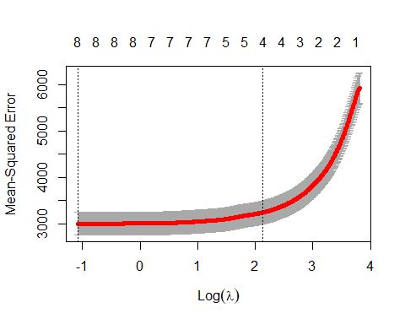

cvglm1$lambda.min

## [1] 0.3377755

## Exercise 6:

minValue<- glmnet( diabetes$x, diabetes$y, alpha=1, lambda=cvglm1$lambda.min)  
summary(minValue)

|  |  |  |  |
| --- | --- | --- | --- |
|  | Length | Class | Mode |
| a0 | 1 | -none- | numeric |
| beta | 10 | dgCMatrix | S4 |
| df | 1 | -none- | numeric |
| dim | 2 | -none- | numeric |
| lambda | 1 | -none- | numeric |
| dev.ratio | 1 | -none- | numeric |
| nulldev | 1 | -none- | numeric |
| npasses | 1 | -none- | numeric |
| jerr | 1 | -none- | numeric |
| offset | 1 | -none- | logical |
| call | 5 | -none- | call |
| nobs | 1 | -none- | numeric |

minValue$beta

## 10 x 1 sparse Matrix of class "dgCMatrix"  
## s0  
## age .   
## sex -223.08368  
## bmi 526.09917  
## map 312.37829  
## tc -182.35395  
## ldl .   
## hdl -163.72954  
## tch 91.08108  
## ltg 527.84490  
## glu 63.41608

## Exercise 7:

cvglm1$lambda.1se

## [1] 8.356444

lambda1SE<- glmnet(diabetes$x, diabetes$y, alpha=1, lambda=cvglm1$lambda.1se)  
summary(lambda1SE)

|  |  |  |  |
| --- | --- | --- | --- |
|  | Length | Class | Mode |
| a0 | 1 | -none- | numeric |
| beta | 10 | dgCMatrix | S4 |
| df | 1 | -none- | numeric |
| dim | 2 | -none- | numeric |
| lambda | 1 | -none- | numeric |
| dev.ratio | 1 | -none- | numeric |
| nulldev | 1 | -none- | numeric |
| npasses | 1 | -none- | numeric |
| jerr | 1 | -none- | numeric |
| offset | 1 | -none- | logical |
| call | 5 | -none- | call |
| nobs | 1 | -none- | numeric |

lambda1SE$beta

## 10 x 1 sparse Matrix of class "dgCMatrix"  
## s0  
## age .   
## sex .   
## bmi 488.31841  
## map 163.80820  
## tc .   
## ldl .   
## hdl -86.12416  
## tch .   
## ltg 423.80501  
## glu .

## Exercise 8:

second<-lm(y ~ x2, data=diabetes)  
summary(second)

##   
## Call:  
## lm(formula = y ~ x2, data = diabetes)  
##   
## Residuals:  
## Min 1Q Median 3Q Max   
## -158.216 -30.809 -3.857 31.348 153.946   
##   
## Coefficients:  
## Estimate Std. Error t value Pr(>|t|)   
## (Intercept) 152.133 2.532 60.086 < 2e-16 ***  
## x2age 50.721 65.513 0.774 0.4393   
## x2sex -267.344 65.270 -4.096 5.15e-05 ***  
## x2bmi 460.721 84.601 5.446 9.32e-08 ***  
## x2map 342.933 72.447 4.734 3.13e-06 ***  
## x2tc -3599.542 60575.187 -0.059 0.9526   
## x2ldl 3028.281 53238.699 0.057 0.9547   
## x2hdl 1103.047 22636.179 0.049 0.9612   
## x2tch 74.937 275.807 0.272 0.7860   
## x2ltg 1828.210 19914.504 0.092 0.9269   
## x2glu 62.754 70.398 0.891 0.3733   
## x2age^2 67.691 69.470 0.974 0.3305   
## x2bmi^2 45.849 83.288 0.550 0.5823   
## x2map^2 -8.460 71.652 -0.118 0.9061   
## x2tc^2 6668.449 7059.159 0.945 0.3454   
## x2ldl^2 3583.174 5326.148 0.673 0.5015   
## x2hdl^2 1731.821 1590.574 1.089 0.2769   
## x2tch^2 773.374 606.967 1.274 0.2034   
## x2ltg^2 1451.581 1730.103 0.839 0.4020   
## x2glu^2 114.149 94.122 1.213 0.2260   
## x2age:sex 148.678 73.407 2.025 0.0435 *   
## x2age:bmi -18.052 79.620 -0.227 0.8208   
## x2age:map 18.534 76.303 0.243 0.8082   
## x2age:tc -158.891 617.109 -0.257 0.7970   
## x2age:ldl -67.285 494.527 -0.136 0.8918   
## x2age:hdl 209.245 280.614 0.746 0.4563   
## x2age:tch 184.960 210.330 0.879 0.3798   
## x2age:ltg 124.667 223.765 0.557 0.5778   
## x2age:glu 62.575 80.377 0.779 0.4367   
## x2sex:bmi 64.612 77.902 0.829 0.4074   
## x2sex:map 88.472 74.744 1.184 0.2373   
## x2sex:tc 433.598 590.709 0.734 0.4634   
## x2sex:ldl -352.823 468.951 -0.752 0.4523   
## x2sex:hdl -124.731 273.870 -0.455 0.6491   
## x2sex:tch -131.223 199.714 -0.657 0.5115   
## x2sex:ltg -118.995 226.493 -0.525 0.5996   
## x2sex:glu 45.758 73.650 0.621 0.5348   
## x2bmi:map 154.720 86.340 1.792 0.0739 .   
## x2bmi:tc -302.045 667.930 -0.452 0.6514   
## x2bmi:ldl 241.540 561.026 0.431 0.6671   
## x2bmi:hdl 121.942 329.884 0.370 0.7118   
## x2bmi:tch -33.445 230.836 -0.145 0.8849   
## x2bmi:ltg 114.673 255.987 0.448 0.6544   
## x2bmi:glu 23.377 91.037 0.257 0.7975   
## x2map:tc 478.303 682.264 0.701 0.4837   
## x2map:ldl -326.740 574.317 -0.569 0.5697   
## x2map:hdl -187.305 309.589 -0.605 0.5455   
## x2map:tch -58.294 198.601 -0.294 0.7693   
## x2map:ltg -154.795 271.966 -0.569 0.5696   
## x2map:glu -133.476 91.314 -1.462 0.1447   
## x2tc:ldl -9313.775 11771.220 -0.791 0.4293   
## x2tc:hdl -3932.025 3816.572 -1.030 0.3036   
## x2tc:tch -2205.910 1761.843 -1.252 0.2113   
## x2tc:ltg -3801.442 13166.091 -0.289 0.7729   
## x2tc:glu -176.295 595.459 -0.296 0.7673   
## x2ldl:hdl 2642.645 3165.926 0.835 0.4044   
## x2ldl:tch 1206.822 1470.512 0.821 0.4123   
## x2ldl:ltg 2773.697 10960.214 0.253 0.8004   
## x2ldl:glu 85.626 505.102 0.170 0.8655   
## x2hdl:tch 1188.406 1002.242 1.186 0.2365   
## x2hdl:ltg 1467.845 4609.793 0.318 0.7503   
## x2hdl:glu 217.541 296.749 0.733 0.4640   
## x2tch:ltg 389.805 624.671 0.624 0.5330   
## x2tch:glu 235.693 235.064 1.003 0.3167   
## x2ltg:glu 83.525 264.726 0.316 0.7525   
## ---  
## Signif. codes: 0 '***' 0.001 '**' 0.01 '*' 0.05 '.' 0.1 ' ' 1  
##   
## Residual standard error: 53.23 on 377 degrees of freedom  
## Multiple R-squared: 0.5924, Adjusted R-squared: 0.5233   
## F-statistic: 8.563 on 64 and 377 DF, p-value: < 2.2e-16

## Exercise 9:

glm2<-glmnet(x2, y)  
summary(glm2)

|  |  |  |  |
| --- | --- | --- | --- |
|  | Length | Class | Mode |
| a0 | 100 | -none- | numeric |
| beta | 6400 | dgCMatrix | S4 |
| df | 100 | -none- | numeric |
| dim | 2 | -none- | numeric |
| lambda | 100 | -none- | numeric |
| dev.ratio | 100 | -none- | numeric |
| nulldev | 1 | -none- | numeric |
| npasses | 1 | -none- | numeric |
| jerr | 1 | -none- | numeric |
| offset | 1 | -none- | logical |
| call | 3 | -none- | call |
| nobs | 1 | -none- | numeric |

plot(glm2)

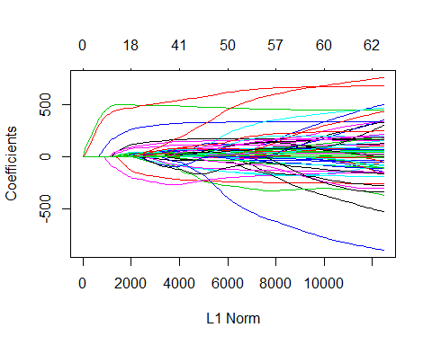

## Exercise 10:

cvglm2<-cv.glmnet(x2, y, alpha=1, nlambda=1000)  
summary(cvglm2)

|  |  |  |  |
| --- | --- | --- | --- |
|  | Length | Class | Mode |
| lambda | 780 | -none- | numeric |
| cvm | 780 | -none- | numeric |
| cvsd | 780 | -none- | numeric |
| cvup | 780 | -none- | numeric |
| cvlo | 780 | -none- | numeric |
| nzero | 780 | -none- | numeric |
| call | 5 | -none- | call |
| name | 1 | -none- | character |
| glmnet.fit | 12 | elnet | list |
| lambda.min | 1 | -none- | numeric |
| lambda.1se | 1 | -none- | numeric |

plot(cvglm2)

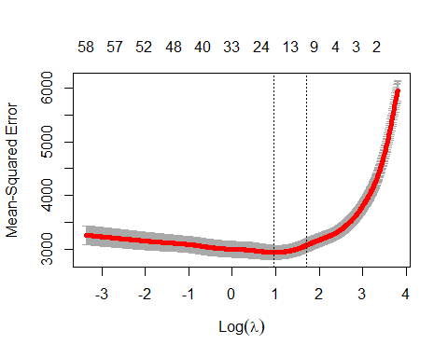

cvglm2$lambda.min

## [1] 2.615273

minValue2<- glmnet( x2, y, alpha=1, lambda=cvglm2$lambda.min)  
summary(minValue2)

|  |  |  |  |
| --- | --- | --- | --- |
|  | Length | Class | Mode |
| a0 | 1 | -none- | numeric |
| beta | 64 | dgCMatrix | S4 |
| df | 1 | -none- | numeric |
| dim | 2 | -none- | numeric |
| lambda | 1 | -none- | numeric |
| dev.ratio | 1 | -none- | numeric |
| nulldev | 1 | -none- | numeric |
| npasses | 1 | -none- | numeric |
| jerr | 1 | -none- | numeric |
| offset | 1 | -none- | logical |
| call | 5 | -none- | call |
| nobs | 1 | -none- | numeric |

minValue2$beta

## 64 x 1 sparse Matrix of class "dgCMatrix"  
## s0  
## age .   
## sex -128.304096  
## bmi 500.934368  
## map 260.961328  
## tc .   
## ldl .   
## hdl -198.230814  
## tch .   
## ltg 469.533077  
## glu 24.105605  
## age^2 15.769532  
## bmi^2 42.141611  
## map^2 .   
## tc^2 .   
## ldl^2 .   
## hdl^2 .   
## tch^2 .   
## ltg^2 .   
## glu^2 75.308603  
## age:sex 114.070727  
## age:bmi .   
## age:map 30.542265  
## age:tc .   
## age:ldl .   
## age:hdl .   
## age:tch .   
## age:ltg 11.929952  
## age:glu 9.766166  
## sex:bmi .   
## sex:map 6.349543  
## sex:tc .   
## sex:ldl .   
## sex:hdl .   
## sex:tch .   
## sex:ltg .   
## sex:glu .   
## bmi:map 89.697462  
## bmi:tc .   
## bmi:ldl .   
## bmi:hdl .   
## bmi:tch .   
## bmi:ltg .   
## bmi:glu .   
## map:tc .   
## map:ldl .   
## map:hdl .   
## map:tch .   
## map:ltg .   
## map:glu .   
## tc:ldl .   
## tc:hdl .   
## tc:tch .   
## tc:ltg .   
## tc:glu .   
## ldl:hdl .   
## ldl:tch .   
## ldl:ltg .   
## ldl:glu .   
## hdl:tch .   
## hdl:ltg .   
## hdl:glu .   
## tch:ltg .   
## tch:glu .   
## ltg:glu .