Министерство образования и науки РФ

Санкт-Петербургский Политехнический Университет Петра Великого

Институт компьютерных наук и технологий - ИКНТ

Иссуственный Интеллект и Машинное Обучение

**Тема:**

**ЧИСЛЕННО-ОПРЕДЕЛЕННЫЙ ИНТЕГРАЛ ПО ФОРМУЛЕ НЬЮТОНА-КОТЕСА**

(NUMERICAL DEFINITE INTEGRAL BY THE NEWTON-COTES FORMULA)

Проект по дисциплине «ПАРАЛЛЕЛЬНОЕ ПРОГРАММИРОВАНИЕ ДЛЯ СУПЕРКОМПЬЮТЕР»

**Выполнил:**

студент гр. 3540201/20301 Эспинола Ривера Хольгер Э.

подпись, дата

**Проверил:**

к.т.н., доцент Лукашин А.А подпись, дата

Санкт-Петербург

2023

**1. FORMULATION OF THE PROBLEM**

1. Select a task and work out the implementation of an algorithm that allows parallelization into several threads / processes.

2. Develop tests to check the correctness of the algorithm (input data, output data, code for comparing results). To prepare test sets, you can use mathematical packages, for example, MATLAB (available in the Supercomputational center class and on the SCC itself).

3. Implement algorithms using selected technologies.

4. Conduct a study on the effect of using multi-core / multi-threading / multi-processing on the SCC, varying nodes from 1 to 4 (for MPI) and varying the number of processes / threads.

5. Prepare an electronic report.

**APPLICATION TASK:**

Definite integrals by the Newton-Cotes formula.

**2. MATHEMATICAL DEFINITIONS**

**Definition of Rieman’s Integral**

The Rieman’s integral is defined by the next formula:

 , where using the fundamental theorem of calculus for F(x) antiderivative, we get:

Definition 1.



Using the geometrical interpretation of Rieman’s integral, we have the generic definition of the definitive Rieman’s integral, like a sum of the infinitesimal areas of rectangles:

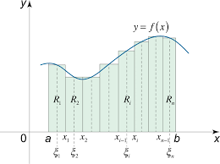

Image 1. Geometrical representation of Rieman’s integral

Definition 2.



The problem of Numerical Methods is to calculate an approximate version of the analytical Rieman’s integral. Thus, we formulate this integral like a sum of finite rectangle areas.

Definition 3.



To calculate this approximate integral, we define a finite number of intervals, which divide the original interval [a, b] in minor intervals, using the formula:



Where:

* n: number of partitions/subintervals
* a: lower limit of definite integral
* b: upper limit of definite integral
* h: step to next interval

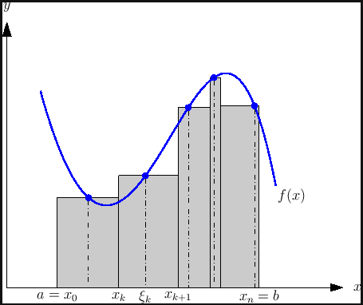

Image 2. Partitions of approximate Rieman’s integral

**Generic Newton-Cotes Integration Algorithm**

The main idea to use the method of Newton-Cotes to calculate the numerical approximate definitive integral, is divide the original interval [a, b] in several subintervals, where in each subinterval, we will calculate the approximate partial-integral. The partial integral for each subinterval is given by the formula:

Definition 4.



Where:

I_part: is the result of calculating the partial-integral in subinterval [x0, xk].

f(x): is the function to need integrate

k: degree of polynomial quadrature

Ak: coefficient for the k-th quadrature rule

Ci(k): vector of Newton-Cotes parameters

Xi: specific point which belongs subinterval [x0, xk].

f(xi): image of the point xi in the function f

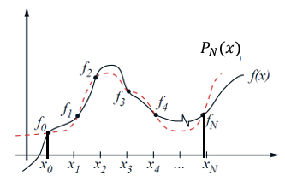

Image 3. Quadrature of Newton-Cotes

The coefficients Ak and Ci(k) can be calculated using Lagrange interpolating polynomials, where k is the polynomial degree of Newton-Cotes quadrature.

In the project, we consider quadrature from k = 1 (linear polynomial) to k = 10 (polynomial with 10-th degree). The values of the coefficients Ak and Ci(k) for the Newton-Cotes formulas is given by:

Table 1. List of Newton-Cotes coefficients

|  |  |  |  |  |  |  |  |
| --- | --- | --- | --- | --- | --- | --- | --- |
| k | Ak | C0(k) | C1(k) | C2(k) | C3(k) | C4(k) | C5(k) |
|  |  | C6(k) | C7(k) | C8(k) | C9(k) | C10(k) |  |
| 0 | 0 | 0 |  |  |  |  |  |
| 1 | 1/2 | 1 | 1 |  |  |  |  |
| 2 | 1/3 | 1 | 4 | 1 |  |  |  |
| 3 | 3/8 | 1 | 3 | 3 | 1 |  |  |
| 4 | 2/45 | 7 | 32 | 12 | 32 | 7 |  |
| 5 | 5/288 | 19 | 75 | 50 | 50 | 75 | 19 |
| 6 | 1/140 | 41 | 216 | 27 | 272 | 27 | 216 |
| 41 |  |  |  |  |  |
| 7 | 7/17280 | 751 | 3577 | 1323 | 2989 | 2989 | 1323 |
| 3577 | 751 |  |  |  |  |
| 8 | 4/14175 | 989 | 5888 | -928 | 10496 | -4540 | 10496 |
| -928 | 5888 | 989 |  |  |  |
| 9 | 9/89600 | 2857 | 15741 | 1080 | 19344 | 5778 | 5778 |
| 19344 | 1080 | 15741 | 2857 |  |  |
| 10 | 5/299376 | 16067 | 106300 | -48525 | 272400 | -260550 | 427368 |
| -260550 | 272400 | -48525 | 106300 | 16067 |  |

With the coefficients of Newton-Cotes defined above, each case of partial-integrate will be solved using a formula in definition 4 with help of the coefficients.

To calculate the final value of the approximate integral, we define the number of iterations/quadrature (in the future, this will be too the number of processes) and for each iteration/quadrature, we will take this partial-integrals and sum all, to obtain the final result: the approximate integral of function f(x) between [a, b].

Definition 5.



Where:

Itotal: final result of approximate integral

Hi: result of partial-integral for i-th subinterval

q: number of quadratures/ subintervals

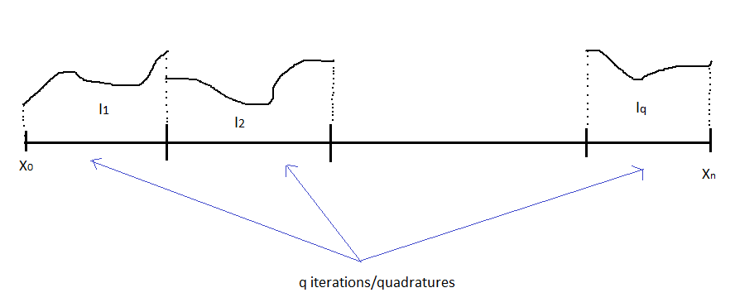

Image 4. Division of original integral in “q” partial integrals

**3. METHODOLOGY**

1) Dictionary of variables

k: degree of quadrature

[datatype: int]

q: number of quadratures/ number of processes

[datatype: int]

n: number of partitions/intervals (defined like n = k*q)

[datatype: int]

coeff_newton_cotes: structure of newton-cotes coefficients

- pvec_ncotes_k: vector of positions, which represent degree of quadrature

[datatype: double vector]

- pvec_ncotes_Ak: vector of characteristic coefficients for h

[datatype: double vector]

- pmatrix_ncotes_Ci: matrix of newton-cotes coefficients

[datatype: double matrix]

part_int: result of partial integrals for each quadrature [datatype: double]

Formula:

part_int{f(x), lim = [low = x0, upper = xk]} =

Ak * h * sum{i = 0...k} {Ci_k * f(xi)}

a: lower limit of definite integral

[datatype: double]

b: upper limit of definite integral

[datatype: double]

expression: function to integrate

[datatype: char vector]

I_exact: exact value of integral

[datatype: double]

2) Strategy of solution

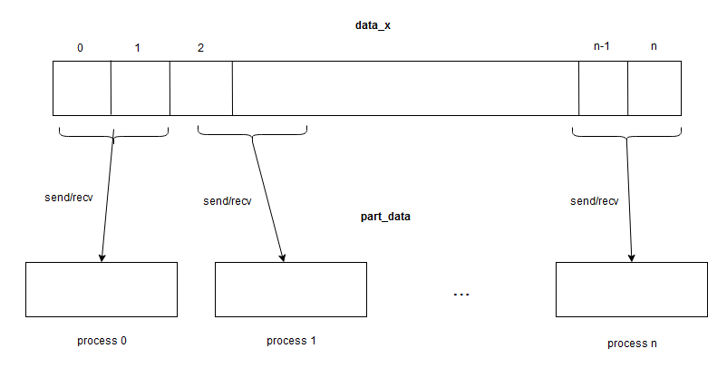In the initial step, need to split the initial dataset and massive distribute the slices of data for each process, from master process (process 0) to slave’s processes (process 1 until q).

Image 5. Massive distribution of data for each slave process

In the final step for calculate the approximate integral, we do a process of reduce, which sum all the partial-integrals belongs slaves processes and accumulate the results in the master process 0.

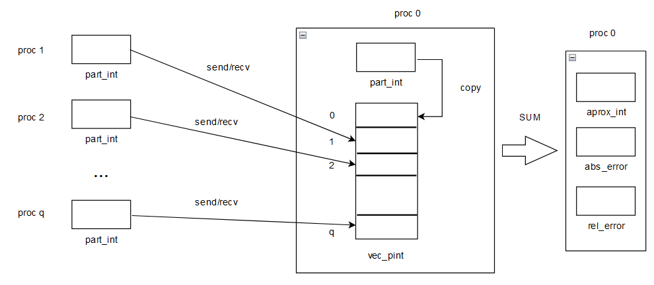

Image 6. Final step of integral calculation sums

3) Code implementation in MPI + Python

File: newton_cotes_final1.py

##############################################################################

#      PARALLEL PROGRAMMING - GENERIC-NUMERICAL SOLUTION FOR NEWTON-COTES INTEGRATION    #

##############################################################################

# SOLUTION DESIGNED IN MPI + PYTHON

# dictionary of variables

# k: degree of quadrature

# q : number of quadratures/ number of processes

# n: number of intervals/partitions (defined like n = k*q)

# coeff_newton_cotes: table of newton-cotes coefficient

#   - Ak: coefficient of h

#   - Ci: vector of weights

# partial integrals of each quadrature:

# I_part{f(x), lim = [low = x0, upper = xk]} = Ak * h * sum{i = 0..k} {Ci_k * f(xi)}

# a: lower limit of definite integral

# b: upper limit of definite integral

# expresion: function to integrate

# I_exact: exact value of integral

# import packages

from mpi4py import MPI

import numpy as np

import math

# generic parameters

comm = MPI.COMM_WORLD

numproc = comm.Get_size()

myid = comm.Get_rank()

# function to read files

def read_file():

    # read line for line the text file

    file_name = str(input("Name of file: "))

    with open(file_name) as file:

        lines = [line.strip() for line in file]

    # define input variables

    a = float(eval(lines[0]))

    b = float(eval(lines[1]))

    k = int(eval(lines[2]))

    expression = lines[3]

    I_exact = float(eval(lines[4]))

    return a, b, k, expression, I_exact

#########################################

#    MAIN: process of paralelization    #

#########################################

##### paralelization process 1: broadcast of input-data #####

comm.Barrier()

# master process 0

if(myid == 0):

    # get the variables

    print("Name of file: ")

    a, b, k, expression, I_exact = read_file()

    q = numproc

    # Dictionary of Newton-Cotes coefficients

    #link: https://mathworld.wolfram.com/Newton-CotesFormulas.html

    # quadratures: k = 1...10 (from linear functions to power 10)

    newton_cotes_coeff = {

        1: {'Ak': 1/2, 'Ci': [1, 1]},

        2: {'Ak': 1/3, 'Ci': [1, 4, 1]},

        3: {'Ak': 3/8, 'Ci': [1, 3, 3, 1]},

        4: {'Ak': 2/45, 'Ci': [7, 32, 12, 32, 7]},

        5: {'Ak': 5/288, 'Ci': [19, 75, 50, 50, 75, 19]},

        6: {'Ak': 1/140, 'Ci': [41, 216, 27, 272, 27, 216, 41]},

        7: {'Ak': 7/17280, 'Ci': [751, 3577, 1323, 2989, 2989, 1323, 3577, 751]},

        8: {'Ak': 4/14175, 'Ci': [989, 5888, -928, 10496, -4540, 10496, -928, 5888, 989]},

        9: {'Ak': 9/89600, 'Ci': [2857, 15741, 1080, 19344, 5778, 5778, 19344, 1080, 15741, 2857]},

        10: {'Ak': 5/299376, 'Ci': [16067, 106300, -48525, 272400, -260550, 427368, -260550, 272400,

                                    -48525, 106300, 16067]}

    }

elif(myid != 0):    # slave processes

    # initialization of variables

    a = b = k = q = expression = I_exact =  None

    newton_cotes_coeff = {}

    print("This is the process ", myid)

comm.Barrier()

# broadcast all arguments from process 0 to every process [1, ... numproc]

a = comm.bcast(a, root = 0)

b = comm.bcast(b, root = 0)

k = comm.bcast(k, root = 0)

q = comm.bcast(q, root = 0)

expression = comm.bcast(expression, root = 0)

I_exact = comm.bcast(I_exact, root = 0)

newton_cotes_coeff = comm.bcast(newton_cotes_coeff, root = 0)

# print the information that was obtained for each process

print(" ############# ")

print("Process ", myid, " ===> variables: ")

print("a = ", a)

print("b = ", b)

print("k = ", k)

print("q = ", q)

print("expression = ", expression)

print("I = ", I_exact)

print("Newton-cotes coeff = ", newton_cotes_coeff)

comm.Barrier()

###### paralelization process 2: send/recv of original data #######

if(myid == 0):

    # number of intervals

    n = k * q

    # compute step

    h = (b - a) / n

    # generate X

    data_x = np.linspace(start = a, stop = b, num = n + 1)

    # extract subsets of data for each process

    # send SLICE from process 0 ===> to process i

    for i in range(1, q):

        # send h for each process

        comm.send(h, dest = i)

        # split the data

        slice = data_x[i*k:(i+1)*k+1]

        # print the send

        print("Process ", myid, " sends ", (k+1), " values to process ", i, " ===> ", slice)

        # send each slice from process 0 ===> to process i

        comm.send(slice, dest = i)

    # partial-data from process 0

    part_data = data_x[0:(k+1)]

    print("Process ", myid, " have this data: ", part_data)

else:

    # initialize h

    h = None

    # process i <== receive h from process 0

    h = comm.recv(source = 0)

    # initialize partial-data

    part_data = np.empty(k + 1, dtype = np.float64)

    # process i <=== receive slice from process 0

    part_data = comm.recv(source = 0)

    # print the receiver

    print("Process ", myid, " <=== receive ", (k+1), " values from process 0: ", part_data)

comm.Barrier()

# each process show the corresponding partial-data

print(myid, " process ======> ", part_data)

comm.Barrier()

############################################

#       Compute the partial-integral       #

############################################

# internal interpreter for string-math expressions

def f(x):

    f = eval(expression)

    return f

# start clock

start_time = MPI.Wtime()

# initialize y

part_y = np.zeros(k + 1)

# calculate y

for i in range(k + 1):

    part_y[i] = f(part_data[i])

# calculate part-int

part_int = 0

for j in range(k + 1):

    part_int += newton_cotes_coeff[k]['Ci'][j] * part_y[j]

part_int = newton_cotes_coeff[k]['Ak'] * h * part_int

# stop clock

end_time = MPI.Wtime()

# count time

count_time = (end_time - start_time) * 1000

comm.Barrier()

print("Process ", myid, " has f(x) ===> ", part_y, " with partial-integral = ", part_int)

print("Time to calculate partial-integral = ", count_time, " ms")

comm.Barrier()

##################################################

# FINAL STEP: CALCULATE THE APROXIMATE INTEGRAL  #

##################################################

# master-process 0 ==> manage the computation of final-results of integral

if myid == 0:

    final_time = 0

    # define array of partial integral-sums and

    # initialize array with [0, ... 0]

    vec_pint = np.zeros(numproc, np.float64)

    # copy result of part-int in process 0 to vector of partial-integral-sums[0]

    vec_pint[0] = part_int

    # define array of time-stamp

    vec_times = np.zeros(numproc, np.float64)

    # copy time-processing of process 0

    vec_times[0] = count_time

    # capture partial-integral results and times for each process

    # and save in vector of results in master-process

    for j in range(1, numproc):

        start_t2 = MPI.Wtime()

        vec_pint[j] = comm.recv(source = j)

        vec_times[j] = comm.recv(source = j)

        end_t2 = MPI.Wtime()

        final_time += (end_t2 - start_t2) * 1000

        print("Time to send/recv part-integrals = ", (end_t2 - start_t2) * 1000, " ms")

    start_t3 = MPI.Wtime()

    # finnaly, calculate the value of approximate-integral

    aprox_int = sum(vec_pint)

    # calculate absolute-error

    abs_error = abs(I_exact - aprox_int)

    # calculate relative-error

    rel_error = (abs_error / I_exact) * 100

    end_t3 = MPI.Wtime()

    # calculate final time

    final_time += sum(vec_times)

    final_time += (end_t3 - start_t3) * 1000

    print("Time to calculate approx-integral = ", (end_t3 - start_t3) * 1000, " ms")

    # PRINT THE FINAL RESULTS

    print("***** FINAL RESULTS ***** from process ", myid)

    print("Integral ", expression, " with limits = ( ", a, ", ", b, ") ===> ")

    print("Exact-integral = ", I_exact)

    print("Approximate-integral = ", aprox_int)

    print("Absolute-error = ", abs_error)

    print("Relative-error = ", rel_error, "%")

    print("Total-time to compute aproximate integral = ", final_time, " ms")

    print("Finish!")

else:   # slave processes [1..q] ==> sends part_int (partial-results) ===> to master-process 0

    comm.send(part_int, dest = 0)

    comm.send(count_time, dest = 0)

comm.Barrier()

[240 lines of code]

4) Code implementation in MPI + C

File: newton_cotes_vc14.c

Description: This main file have the Newton-Cotes algorithm and the process of parallelization in MPI + C

/*

    ==========================================================================

PARALLEL PROGRAMMING IN C - GENERIC SOLUTION FOR NEWTON-COTES INTEGRATION    |

    ==========================================================================

                                    VERSION 14.0

    Dictionary of variables:

    k: degree of quadrature

    q: number of quadratures/ number of processes

    n: number of partitions/intervals (defined like n = k*q)

    coeff_newton_cotes: structure of newton-cotes coefficients

        - k: position of vector of structure and represent degree of quadrature

        - Ak: coefficient for h

        - Ci: vector of weights

    part_int: partial integrals for each quadrature

    part_int{f(x), lim = [low = x0, upper = xk]} = Ak * h * sum{i = 0...k} {Ci_k * f(xi)}

    a: lower limit of definite integral

    b: upper limit of definite integral

    expression: function to integrate

    I_exact: exact value of integral

*/

#include <math.h>

#include <stdio.h>

#include <string.h>

#include <stdlib.h>

#include <mpi.h>

#include "tinyexpr.h"

#define MAX 11

#define v 1

#define tag 100

// functions defined by programmer

void read_files(char name_file[40], char lines[5][200]);

void input_variables(double *a, double *b, int *k, char expression[200],

                        double *I_exact, char lines[5][200]);

void print_results(double a, double b, int k, char expression[200], double I_exact);

void define_parameters(double *x, double *y, double **z);

void print_vector(double *x);

void print_matrix(double **x);

double func(double a, char expression[200]);

int main(int argc, char *argv[])

{

    // variables related with MPI

    int myid, numproc;

    // variables related with input data

    double a, b, I_exact;

    int k, q;

    char expression[200];

    // variables related with file manager

    char name_file[40], lines[5][200];

    // variables related with newton-cotes

    double *pvec_ncotes_k, *pvec_ncotes_Ak, **pmatrix_ncotes_Ci;

    // variable to manage communication status

    MPI_Status status;

    // output variables

    double approx_int, abs_error, rel_error;

    // initialize parallel processing

    MPI_Init(&argc, &argv);

    // take the total number of processes

    MPI_Comm_size(MPI_COMM_WORLD, &numproc);

    // take the number of the current process

    MPI_Comm_rank(MPI_COMM_WORLD, &myid);

    // ******************** STEP 1: broadcast input-data *************************

    // allocate memory for newton-cotes parameters

    pvec_ncotes_k = (double *) calloc(MAX, sizeof(double));

    pvec_ncotes_Ak = (double *) calloc(MAX, sizeof(double));

    pmatrix_ncotes_Ci = (double **) calloc(MAX, sizeof(double *));

    for(int i=0; i<MAX; i++)

    {

        pmatrix_ncotes_Ci[i] = (double *) calloc(MAX, sizeof(double));

    }

    // master process 0 ==> read the input data

    if(myid == 0)

    {

        printf("Name of file: ");

        // request the name of the file

        scanf("%s", name_file);

        // read the txt file

        read_files(name_file, lines);

        // asign the values to input-variables

        input_variables(&a, &b, &k, expression, &I_exact, lines);

        q = numproc;

        // asign parameters of newton-cotes

        // newton-cotes parameters

        define_parameters(pvec_ncotes_k, pvec_ncotes_Ak, pmatrix_ncotes_Ci);

        // print the results of input-data readed

        if(v > 0)

        {

            printf("\n Master process 0 ");

            // print unidimensional variables

            print_results(a, b, k, expression, I_exact);

            // print newton-cotes variables

            printf("\n Newton-cotes k coefficients: \n");

            print_vector(pvec_ncotes_k);

            printf("\n Newton-cotes Ak coefficients: \n");

            print_vector(pvec_ncotes_Ak);

            printf("\n Newton-cotes Ci coefficients: \n");

            print_matrix(pmatrix_ncotes_Ci);

        }

    }

    MPI_Barrier(MPI_COMM_WORLD);

    // broadcast all arguments from process 0 to every process [0 until numproc]

    MPI_Bcast(&a, 1, MPI_DOUBLE, 0, MPI_COMM_WORLD);

    MPI_Bcast(&b, 1, MPI_DOUBLE, 0, MPI_COMM_WORLD);

    MPI_Bcast(&k, 1, MPI_INT, 0, MPI_COMM_WORLD);

    MPI_Bcast(&q, 1, MPI_INT, 0, MPI_COMM_WORLD);

    MPI_Bcast(expression, 200, MPI_CHAR, 0, MPI_COMM_WORLD);

    MPI_Bcast(&I_exact, 1, MPI_DOUBLE, 0, MPI_COMM_WORLD);

    //

    MPI_Bcast(pvec_ncotes_k, MAX, MPI_DOUBLE, 0, MPI_COMM_WORLD);

    MPI_Bcast(pvec_ncotes_Ak, MAX, MPI_DOUBLE, 0, MPI_COMM_WORLD);

    for(int i=0; i<MAX; i++)

        MPI_Bcast(pmatrix_ncotes_Ci[i], MAX, MPI_DOUBLE, 0, MPI_COMM_WORLD);

    MPI_Barrier(MPI_COMM_WORLD);

    // print the information that was obtained for each process

    if(v > 0)

    {

        printf("********** Broadcast of input-data ***********");

        printf("\n Process %d ===> variables: \n", myid);

        print_results(a, b, k, expression, I_exact);

        //

        printf("\n Newton-cotes Ak coefficients: \n");

        printf("\n Coeff k: \n");

        print_vector(pvec_ncotes_k);

        printf("\n Coeff Ak: \n");

        print_vector(pvec_ncotes_Ak);

        printf("\n Coeff Ci: \n");

        print_matrix(pmatrix_ncotes_Ci);

    }

    MPI_Barrier(MPI_COMM_WORLD);

    // ********************* STEP 2: send/recv of original data **********************

    // variables related with computation

    int n;

    double h, *data_x, *part_data, *slice;

    // master process ==> manage data partition

    if(myid == 0)

    {

        // number of intervals

        n = k * q;

        // calculate the steps

        h = (b-a)/n;

        // allocate memory for data_x

        data_x = (double *) calloc(n+1, sizeof(double));

        // generate full dataset data_x

        for(int i=0; i<n+1; i++)

        {

            *(data_x + i) = a + i*h;

        }

        // print dataset

        if(v>0)

        {

            printf("\n **** All data: *** \n");

            for(int i=0; i<n+1; i++)

            {

                printf("%f \t", *(data_x + i));

            }

            printf("\n");

        }

        // PROCESS OF SENDING ...................

        // extract subsets of data for each process

        // send SLICE from process 0 ==> to ptocess i

        for(int i=1; i<q; i++)

        {

            // send h for each process

            MPI_Send(&h, 1, MPI_DOUBLE, i, tag, MPI_COMM_WORLD);

            // split the data in small pieces

            slice = (double *) calloc(k+1, sizeof(double));

            for(int j=0; j<k+1; j++)

            {

                *(slice + j) = *(data_x + i*k + j);

            }

            // send each slice from process 0 ==> to process i

            MPI_Send(slice, k+1, MPI_DOUBLE, i, tag, MPI_COMM_WORLD);

            // print the send

            if(v>0)

            {

                printf("\n Process %d sent %d values to process %d  ===> \n", myid, k+1, i);

                for(int j=0; j<k+1; j++)

                    printf("%f \t", *(slice +j));

            }

        }

        // allocate memory for part_data speciffied for process master 0

        part_data = (double *) calloc(k+1, sizeof(double));

        // fill partial-data for process 0

        for(int i=0; i<k+1; i++)

        {

            *(part_data + i) = *(data_x + i);

        }

        if(v>0)

        {

            printf("\n Process %d have this data: \n", myid);

            for(int i=0; i<k+1; i++)

                printf("%f \t", *(part_data + i));

            printf("\n");

        }

        // **************

    }else if(myid != 0){    // slaves processes ==> take the partial-data

        printf("\n Process %d \n", myid);

        // PROCESS OF RECEIVING..................................

        // process i <== receive h from process 0

        MPI_Recv(&h, 1, MPI_DOUBLE, 0, tag, MPI_COMM_WORLD, &status);

        // initialize part-data

        part_data = (double *) calloc(k+1, sizeof(double));

        // process i <== receive slice from process 0

        MPI_Recv(part_data, k+1, MPI_DOUBLE, 0, tag, MPI_COMM_WORLD, &status);

        if(v>0)

        {

            printf("\n Process %d <== receive %d values from process 0: \n", myid, k+1);

            for(int i=0; i<k+1; i++)

                printf("%f \t", *(part_data + i));

            printf("\n");

        }

        // **************************

    }

    // each process show the corresponding partial-data

    printf("\n ********************************* \n");

    printf("Data for process %d: \n", myid);

    for(int i=0; i<k+1; i++)

        printf("%f \t", *(part_data + i));

    printf("\n ********************************* \n");

    // ********************* STEP 3: Compute the partial integral **********************

    double *part_y, part_int, start_time, end_time, count_time;

    // initialize timing of computation calculus

    start_time = MPI_Wtime();

    // evaluate expression in vector variable ......................

    // initialize y

    part_y = (double *) calloc(k+1, sizeof(double));

    // calculate y

    for(int i=0; i<k+1; i++)

    {

        *(part_y + i) = func(*(part_data + i), expression);

    }

    // calculate partial-integral

    part_int = 0;

    for(int j=0; j<k+1; j++)

        part_int += pmatrix_ncotes_Ci[k][j] * part_y[j];

    part_int = pvec_ncotes_Ak[k] * h * part_int;

    // *******************************************************

    // stop clock

    end_time = MPI_Wtime();

    // count time in ms

    count_time = (end_time - start_time) * 1000;

    MPI_Barrier(MPI_COMM_WORLD);

    printf("\n +++++++++++ PARTIAL RESULTS +++++++++ \n");

    printf("\n Process %d has f(x) = \n", myid);

    for(int i=0; i<k+1; i++)

        printf("%f \t", *(part_y + i));

    printf("\n Process %d has partial-integral = %f", myid, part_int);

    printf("\n Time to calculate partial-integral: %f ms", count_time);

    MPI_Barrier(MPI_COMM_WORLD);

    // ********************* STEP 4: Calculate the approximate integral **********************

    // variables

    double final_time, *vec_pint, *vec_times, start_t2, end_t2, start_t3, end_t3;

    // master process 0 ==> manage the computation of final-results of numerical integral

    if(myid == 0)

    {

        // initialize time

        final_time = 0;

        // define array of partial-integral sums

        vec_pint = (double *) calloc(numproc, sizeof(double));

        // copy result of part-int in process 0 to partial-integral-sums[0]

        vec_pint[0] = part_int;

        // define array of time-stamps

        vec_times = (double *) calloc(numproc, sizeof(double));

        // copy the time-processing of processing 0

        vec_times[0] = count_time;

        // capture the partial-integral results and times for each process

        // and save in vector of results in master-process

        for(int j=1; j<numproc; j++)

        {

            // initialize time

            start_t2 = MPI_Wtime();

            // receive the partial-integral result corresponding to j-th process

            MPI_Recv(&vec_pint[j], 1, MPI_DOUBLE, j, tag, MPI_COMM_WORLD, &status);

            // receive the j-th speending time of process

            MPI_Recv(&vec_times[j], 1, MPI_DOUBLE, j, tag, MPI_COMM_WORLD, &status);

            // finalize time

            end_t2 = MPI_Wtime();

            // calculate total time

            final_time += (end_t2 - start_t2) * 1000;

            // print time2

            printf("\n Time to send/recv part-integrals = %f ms", (end_t2 - start_t2)*1000);

        }

        // initialize time

        start_t3 = MPI_Wtime();

        // Finnaly... calculate the approximate value of integral

        approx_int = 0;

        for(int i=0; i<numproc; i++)

        {

            approx_int += *(vec_pint + i);

        }

        // calculate absolute-error

        abs_error = fabs(I_exact - approx_int);

        // calculate relative-error

        rel_error = (abs_error/I_exact)*100;

        // finish time

        end_t3 = MPI_Wtime();

        // print time to calculate approx-integral

        printf("\n Time to calculate apprx. integral= %f ms \n", (end_t3 - start_t3)*1000);

        // calculate final accumulate time

        final_time = 0;

        for(int i=0; i<numproc; i++)

        {

            final_time += *(vec_times + i);

        }

        final_time += (end_t3 - start_t3) * 1000;

        // print the final results

        printf("\n ******************************************** \n");

        printf("FINAL RESULTS from process %d \n", myid);

        printf("\n ******************************************** \n");

        printf("\n Integral %s with limits = (%f , %f) ========> ", expression, a, b);

        printf("\n Exact-integral = %f", I_exact);

        printf("\n Approximate-integral = %.15f", approx_int);

        printf("\n Absolute-error = %.15f", abs_error);

        printf("\n Relative-error = %.15f %%", rel_error);

        printf("\n Total time to compute integral = %.8f ms", final_time);

        printf("\n ********* FINISH! ************");

    }else if(myid != 0){       // slave processes [1...q] ==> sends (part-res) ==> to master-process 0

        // send the partial-integrals-sum to master process 0

        MPI_Send(&part_int, 1, MPI_DOUBLE, 0, tag, MPI_COMM_WORLD);

        // send the partial-integrals-sum

        MPI_Send(&count_time, 1, MPI_DOUBLE, 0, tag, MPI_COMM_WORLD);

    }

    MPI_Barrier(MPI_COMM_WORLD);

    printf("\n");

    MPI_Finalize();

    return 0;

}

// evaluate expression in function

double func(double a, char expression[200])

{

    double x;

    int err;

    // define the input variables

    te_variable vars[] = {"x", &x};

    // compile the math-expression

    te_expr *expr = te_compile(expression, vars, 1, &err);

    if(expr)

    {

        x = a;

        const double res = te_eval(expr);

        te_free(expr);

        return res;

    }else{

        return 0;

    }

}

// define function to read files

void read_files(char name_file[40], char lines[5][200])

{

    // open file

    FILE *file = fopen(name_file, "r");

    size_t len = 200;

    // allocate memory

    char *line = malloc(sizeof(char) * len);

    // check if file to read exits

    if(file == NULL)

    {

        printf("Can't open this file ... this file not exist \n");

        return;

    }

    // save each line in array of lines

    int i=0;

    while(fgets(line, len, file)!= NULL)

    {

        strcpy(lines[i], line);

        i++;

    }

    free(line);

}

void input_variables(double *a, double *b, int *k, char expression[200],

                        double *I_exact, char lines[5][200])

{

    *a = te_interp(lines[0], 0);

    *b = te_interp(lines[1], 0);

    *k = te_interp(lines[2], 0);

    strcpy(expression, lines[3]);

    *I_exact = te_interp(lines[4], 0);

}

void print_results(double a, double b, int k, char expression[200], double I_exact)

{

    printf("\n a = %f", a);

    printf("\n b = %f", b);

    printf("\n k = %d", k);

    printf("\n expr = %s", expression);

    printf("\n I = %f", I_exact);

}

// define parameters

void define_parameters(double *x, double *y, double **z)

{

    double vec_ncotes_k[MAX] = {0, 1, 2, 3, 4, 5, 6, 7, 8, 9, 10};

    for(int i=0; i<MAX; i++)

    {

        *(x+i) = vec_ncotes_k[i];

    }

    double vec_ncotes_Ak[MAX] = {

        0.0, 1.0/2.0, 1.0/3.0, 3.0/8.0, 2.0/45.0, 5.0/288.0,

        1.0/140.0, 7.0/17280.0, 4.0/14175.0, 9.0/89600.0, 5.0/299376.0

    };

    for(int i=0; i<MAX; i++)

    {

        *(y+i) = vec_ncotes_Ak[i];

    }

    double matrix_ncotes_Ci[MAX][MAX] = {

        {0.0, 0.0, 0.0, 0.0, 0.0, 0.0, 0.0, 0.0, 0.0, 0.0, 0.0},

        {1.0, 1.0, 0.0, 0.0, 0.0, 0.0, 0.0, 0.0, 0.0, 0.0, 0.0},

        {1.0, 4.0, 1.0, 0.0, 0.0, 0.0, 0.0, 0.0, 0.0, 0.0, 0.0},

        {1.0, 3.0, 3.0, 1.0, 0.0, 0.0, 0.0, 0.0, 0.0, 0.0, 0.0},

        {7.0, 32.0, 12.0, 32.0, 7.0, 0.0, 0.0, 0.0, 0.0, 0.0, 0.0},

        {19.0, 75.0, 50.0, 50.0, 75.0, 19.0, 0.0, 0.0, 0.0, 0.0, 0.0},

        {41.0, 216.0, 27.0, 272.0, 27.0, 216.0, 41.0, 0.0, 0.0, 0.0, 0.0},

        {751.0, 3577.0, 1323.0, 2989.0, 2989.0, 1323.0, 3577.0, 751.0, 0.0, 0.0, 0.0},

        {989.0, 5888.0, -928.0, 10496.0, -4540.0, 10496.0, -928.0, 5888.0,

                    989.0, 0.0, 0.0},

        {2857.0, 15741.0, 1080.0, 19344.0, 5778.0, 5778.0, 19344.0, 1080.0,

                    15741.0, 2857.0, 0.0},

        {16067.0, 106300.0, -48525.0, 272400.0, -260550.0, 427368.0, -260550.0,

                    272400.0, -48525.0, 106300.0, 16067.0}

    };

    for(int i=0; i<MAX; i++)

    {

        for(int j=0; j<MAX; j++)

        {

            z[i][j] = matrix_ncotes_Ci[i][j];

        }

    }

}

// print vectors

void print_vector(double *x)

{

    for(int i=0; i<MAX; i++)

    {

        printf("%f \t", *(x+i));

    }

}

// print matrices

void print_matrix(double **x)

{

    for(int i=0; i<MAX;i++)

    {

        printf("k = %d \n", i);

        for(int j=0; j<MAX; j++)

        {

            printf("%f \t", x[i][j]);

        }

        printf("\n");

    }

}

[575 lines of code]

File: tinyexpr.h

Description: This file has the header to link the 3-rd library tinyexpr (library to interpreter string math functions and convert to mathematical functions, and compute the numerical value of this function given some argument) implemented in C.

// SPDX-License-Identifier: Zlib

/*

 * TINYEXPR - Tiny recursive descent parser and evaluation engine in C

 *

 * Copyright (c) 2015-2020 Lewis Van Winkle

 *

 * http://CodePlea.com

 *

 * This software is provided 'as-is', without any express or implied

 * warranty. In no event will the authors be held liable for any damages

 * arising from the use of this software.

 *

 * Permission is granted to anyone to use this software for any purpose,

 * including commercial applications, and to alter it and redistribute it

 * freely, subject to the following restrictions:

 *

 * 1. The origin of this software must not be misrepresented; you must not

 * claim that you wrote the original software. If you use this software

 * in a product, an acknowledgement in the product documentation would be

 * appreciated but is not required.

 * 2. Altered source versions must be plainly marked as such, and must not be

 * misrepresented as being the original software.

 * 3. This notice may not be removed or altered from any source distribution.

 */

#ifndef TINYEXPR_H

#define TINYEXPR_H

#ifdef __cplusplus

extern "C" {

#endif

typedef struct te_expr {

    int type;

    union {double value; const double *bound; const void *function;};

    void *parameters[1];

} te_expr;

enum {

    TE_VARIABLE = 0,

    TE_FUNCTION0 = 8, TE_FUNCTION1, TE_FUNCTION2, TE_FUNCTION3,

    TE_FUNCTION4, TE_FUNCTION5, TE_FUNCTION6, TE_FUNCTION7,

    TE_CLOSURE0 = 16, TE_CLOSURE1, TE_CLOSURE2, TE_CLOSURE3,

    TE_CLOSURE4, TE_CLOSURE5, TE_CLOSURE6, TE_CLOSURE7,

    TE_FLAG_PURE = 32

};

typedef struct te_variable {

    const char *name;

    const void *address;

    int type;

    void *context;

} te_variable;

/* Parses the input expression, evaluates it, and frees it. */

/* Returns NaN on error. */

double te_interp(const char *expression, int *error);

/* Parses the input expression and binds variables. */

/* Returns NULL on error. */

te_expr *te_compile(const char *expression, const te_variable *variables, int var_count, int *error);

/* Evaluates the expression. */

double te_eval(const te_expr *n);

/* Prints debugging information on the syntax tree. */

void te_print(const te_expr *n);

/* Frees the expression. */

/* This is safe to call on NULL pointers. */

void te_free(te_expr *n);

#ifdef __cplusplus

}

#endif

#endif /*TINYEXPR_H*/

**4. DEFINITION OF EXPERIMENTS**

In this project, was considered 4 different experiments in increasing order of complexity:

1) Experiment 01: Study the influence of the quadrature parameter “k”

Formula:



Input data:

a = 0.000000 // this is the lower limit

b = 3.141593 // this is the upper limit

expr = sin(x) // this is the function to integrate

I = 2.000000 // this is the exact value of the integral

2) Experiment 02: Study the influence of the number of processes “q”

Formula:



Input data:

a = 1

b = 2

expr = ln(x)/x

I = (ln(2)^2)/2

3) Experiment 03: Study the influence of the number of nodes “N”

Formula:



Input data:

a = 0

b = 1

expr = exp(-(x^2))

I = sqrt(pi)/2 * erf(1)

4) Experiment 04: Study the influence of the programming language

Formula:



Input data:

a = 0.75

b = 1

expr = math.atan(x)/(1+(1/x)**2)

I = 1/32 * (8*math.pi - (math.pi)**2 - 8 * (math.log(1024/625)) - 24 * math.atan(3/4) + 16 * (math.atan(3/4))**2)

**5. EXPERIMENTAL RESULTS**

1) Experiment 01: study **k**

Study the influence of quadrature (k) in performance of error and time. Here, we fix the number of processes in 4 (q = 4) and number of nodes in 1 (N = 1).

#processes = 4

[tm5u6@n06p001 project_C]$ mpicc newton_cotes_vc14.c tinyexpr.c -o newton_cotes_vc14 -l m

[tm5u6@n06p001 project_C]$ mpirun -np 4 ./newton_cotes_vc14

**For q = 4, k = 1**

**OUTPUTS:**

**** All data: ***

0.000000 0.785398 1.570796 2.356194 3.141593

*********************************

Data for process 1:

0.785398 1.570796

*********************************

Data for process 0:

0.000000 0.785398

*********************************

Data for process 3:

2.356194 3.141593

*********************************

Data for process 2:

1.570796 2.356194

*********************************

FINAL RESULTS:

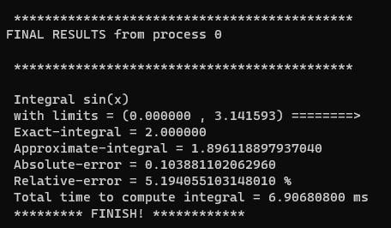

********************************************

FINAL RESULTS from process 0

********************************************

Integral sin(x)

with limits = (0.000000 , 3.141593) ========>

Exact-integral = 2.000000

Approximate-integral = 1.896118897937040

Absolute-error = 0.103881102062960

Relative-error = 5.194055103148010 %

Total time to compute integral = 6.90680800 ms

********* FINISH! ************

**For q = 4, k = 2**

**OUTPUTS:**

**** All data: ***

0.000000 0.392699 0.785398 1.178097 1.570796 1.963495 2.356194 2.748894 3.141593

*********************************

Data for process 0:

0.000000 0.392699 0.785398

*********************************

Data for process 3:

2.356194 2.748894 3.141593

*********************************

Data for process 1:

0.785398 1.178097 1.570796

*********************************

Data for process 2:

1.570796 1.963495 2.356194

*********************************

FINAL RESULTS

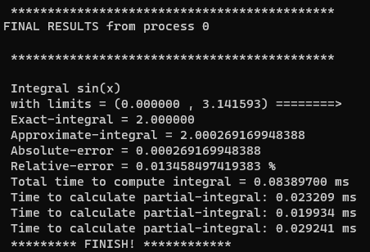

********************************************

FINAL RESULTS from process 0

********************************************

Integral sin(x)

with limits = (0.000000, 3.141593) ========>

Exact-integral = 2.000000

Approximate-integral = 2.000269169948388

Absolute-error = 0.000269169948388

Relative-error = 0.013458497419383 %

Total time to compute integral = 0.08389700 ms

********* FINISH! ************

**For q = 4, k = 3**

OUTPUTS:

**** All data: ***

0.000000 0.261799 0.523599 0.785398 1.047198 1.308997 1.570796 1.832596 2.094395 2.356194 2.617994 2.879793 3.141593

*********************************

Data for process 0:

0.000000 0.261799 0.523599 0.785398

*********************************

Data for process 2:

1.570796 1.832596 2.094395 2.356194

*********************************

Data for process 3:

2.356194 2.617994 2.879793 3.141593

*********************************

Data for process 1:

0.785398 1.047198 1.308997 1.570796

*********************************

FINAL RESULTS

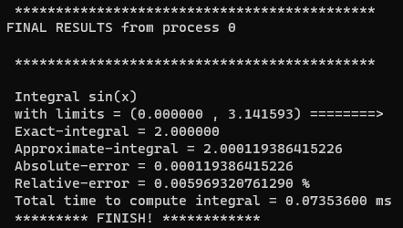

********************************************

FINAL RESULTS from process 0

********************************************

Integral sin(x)

with limits = (0.000000, 3.141593) ========>

Exact-integral = 2.000000

Approximate-integral = 2.000119386415226

Absolute-error = 0.000119386415226

Relative-error = 0.005969320761290 %

Total time to compute integral = 0.07353600 ms

********* FINISH! ************

**For q = 4, k = 4**

OUTPUTS:

*** All data: ***

0.000000 0.196350 0.392699 0.589049 0.785398 0.981748 1.178097 1.374447 1.570796 1.767146 1.963495 2.159845 2.356194 2.552544 2.748894 2.945243 3.141593

*********************************

Data for process 1:

0.785398 0.981748 1.178097 1.374447 1.570796

*********************************

Data for process 0:

0.000000 0.196350 0.392699 0.589049 0.785398

*********************************

Data for process 2:

1.570796 1.767146 1.963495 2.159845 2.356194

*********************************

Data for process 3:

2.356194 2.552544 2.748894 2.945243 3.141593

*********************************

FINAL RESULTS

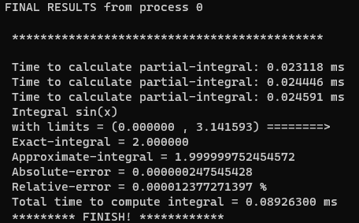

********************************************

FINAL RESULTS from process 0

********************************************

Integral sin(x)

with limits = (0.000000, 3.141593) ========>

Exact-integral = 2.000000

Approximate-integral = 1.999999752454572

Absolute-error = 0.000000247545428

Relative-error = 0.000012377271397 %

Total time to compute integral = 0.08926300 ms

********* FINISH! ************

**For q = 4, k = 5**

OUTPUTS:

*** All data: ***

0.000000 0.157080 0.314159 0.471239 0.628319 0.785398 0.942478 1.099557 1.256637 1.413717 1.570796 1.727876 1.884956 2.042035 2.199115 2.356194 2.513274 2.670354 2.827433 2.984513 3.141593

*********************************

Data for process 0:

0.000000 0.157080 0.314159 0.471239 0.628319 0.785398

*********************************

Data for process 1:

0.785398 0.942478 1.099557 1.256637 1.413717 1.570796

*********************************

Data for process 3:

2.356194 2.513274 2.670354 2.827433 2.984513 3.141593

*********************************

Data for process 2:

1.570796 1.727876 1.884956 2.042035 2.199115 2.356194

*********************************

FINAL RESULTS:

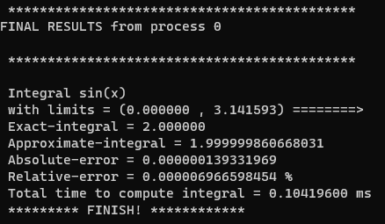

********************************************

FINAL RESULTS from process 0

********************************************

Integral sin(x)

with limits = (0.000000, 3.141593) ========>

Exact-integral = 2.000000

Approximate-integral = 1.999999860668031

Absolute-error = 0.000000139331969

Relative-error = 0.000006966598454 %

Total time to compute integral = 0.10419600 ms

********* FINISH! ************

EXPERIMENT 01: ANALYSIS OF K

|  |  |  |  |
| --- | --- | --- | --- |
| N = 1, q = 4 | | | |
| Function: sin(x); limits: [0, pi] | | | |
| k (degree of quadrature) | Absolute error (abs_err) | Relative error (%) | Total time (ms) |
| 1 | 0.103881102062960 | 5.194055103148010 | 6.90680800 |
| 2 | 0.000269169948388 | 0.013458497419383 | 0.08389700 |
| 3 | 0.000119386415226 | 0.005969320761290 | 0.07353600 |
| 4 | 0.000000247545428 | 0.000012377271397 | 0.08926300 |
| 5 | 0.000000139331969 | 0.000006966598454 | 0.10419600 |

2) Experiment 02: study **q**

Study the influence of number of processes (q) in performance of error and time. Here, we fix degree of quadrature in 3 (k = 3) and number of nodes in 1 (N = 1).

#processes = 4

[tm5u6@n06p001 project_C]$ mpicc newton_cotes_vc14.c tinyexpr.c -o newton_cotes_vc14 -l m

[tm5u6@n06p001 project_C]$ mpirun -np 4 ./newton_cotes_vc14

File: exp2_c/exp2c_k3.txt

**For q = 4, k = 3**

OUTPUTS:

**** All data: ***

1.000000 1.083333 1.166667 1.250000 1.333333 1.416667 1.500000 1.583333 1.666667 1.750000 1.833333 1.916667 2.000000

*********************************

Data for process 0:

1.000000 1.083333 1.166667 1.250000

*********************************

Data for process 2:

1.500000 1.583333 1.666667 1.750000

*********************************

Data for process 1:

1.250000 1.333333 1.416667 1.500000

*********************************

Data for process 3:

1.750000 1.833333 1.916667 2.000000

*********************************

FINAL RESULTS:

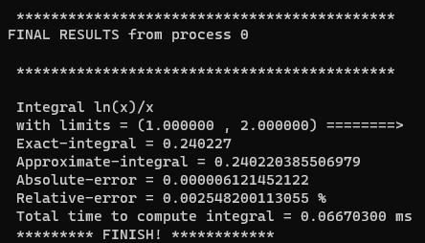

******************************************

FINAL RESULTS from process 0

********************************************

Integral ln(x)/x

with limits = (1.000000, 2.000000) ========>

Exact-integral = 0.240227

Approximate-integral = 0.240220385506979

Absolute-error = 0.000006121452122

Relative-error = 0.002548200113055 %

Total time to compute integral = 0.06670300 ms

********* FINISH! ************

#processes = 8

[tm5u6@n06p001 project_C]$ mpicc newton_cotes_vc14.c tinyexpr.c -o newton_cotes_vc14 -l m

[tm5u6@n06p001 project_C]$ mpirun -np 8 ./newton_cotes_vc14

File: exp2_c/exp2c_k3.txt

**For q = 8, k = 3**

OUTPUTS:

**** All data: ***

1.000000 1.041667 1.083333 1.125000 1.166667 1.208333 1.250000 1.291667 1.333333 1.375000 1.416667 1.458333 1.500000 1.541667 1.583333 1.625000 1.666667 1.708333 1.750000 1.791667 1.833333 1.875000 1.916667 1.958333 2.000000

*********************************

Data for process 0:

1.000000 1.041667 1.083333 1.125000

*********************************

Data for process 6:

1.750000 1.791667 1.833333 1.875000

*********************************

Data for process 1:

1.125000 1.166667 1.208333 1.250000

*********************************

Data for process 7:

1.875000 1.916667 1.958333 2.000000

*********************************

Data for process 2:

1.250000 1.291667 1.333333 1.375000

*********************************

Data for process 3:

1.375000 1.416667 1.458333 1.500000

*********************************

Data for process 4:

1.500000 1.541667 1.583333 1.625000

*********************************

Data for process 5:

1.625000 1.666667 1.708333 1.750000

*********************************

FINAL RESULTS:

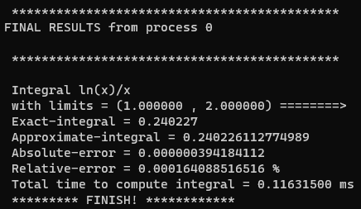

*******************************************

FINAL RESULTS from process 0

********************************************

Integral ln(x)/x

with limits = (1.000000, 2.000000) ========>

Exact-integral = 0.240227

Approximate-integral = 0.240226112774989

Absolute-error = 0.000000394184112

Relative-error = 0.000164088516516 %

Total time to compute integral = 0.11631500 ms

********* FINISH! ************

#processes = 12

[tm5u6@n06p001 project_C]$ mpicc newton_cotes_vc14.c tinyexpr.c -o newton_cotes_vc14 -l m

[tm5u6@n06p001 project_C]$ mpirun -np 12 ./newton_cotes_vc14

File: exp2_c/exp2c_k3.txt

**For q = 12, k = 3**

OUTPUTS:

**** All data: ***

1.000000 1.027778 1.055556 1.083333 1.111111 1.138889 1.166667 1.194444 1.222222 1.250000 1.277778 1.305556 1.333333 1.361111 1.388889 1.416667 1.444444 1.472222 1.500000 1.527778 1.555556 1.583333 1.611111 1.638889 1.666667 1.694444 1.722222 1.750000 1.777778 1.805556 1.833333 1.861111 1.888889 1.916667 1.944444 1.972222 2.000000

*********************************

Data for process 10:

1.833333 1.861111 1.888889 1.916667

*********************************

Data for process 7:

1.583333 1.611111 1.638889 1.666667

*********************************

Data for process 8:

1.666667 1.694444 1.722222 1.750000

*********************************

Data for process 11:

1.916667 1.944444 1.972222 2.000000

*********************************

Data for process 0:

1.000000 1.027778 1.055556 1.083333

*********************************

Data for process 9:

1.750000 1.777778 1.805556 1.833333

*********************************

Data for process 2:

1.166667 1.194444 1.222222 1.250000

*********************************

Data for process 1:

1.083333 1.111111 1.138889 1.166667

*********************************

Data for process 4:

1.333333 1.361111 1.388889 1.416667

*********************************

Data for process 3:

1.250000 1.277778 1.305556 1.333333

*********************************

Data for process 6:

1.500000 1.527778 1.555556 1.583333

*********************************

Data for process 5:

1.416667 1.444444 1.472222 1.500000

*********************************

FINAL RESULTS:

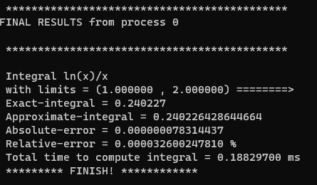

********************************************

FINAL RESULTS from process 0

********************************************

Integral ln(x)/x

with limits = (1.000000, 2.000000) ========>

Exact-integral = 0.240227

Approximate-integral = 0.240226428644664

Absolute-error = 0.000000078314437

Relative-error = 0.000032600247810 %

Total time to compute integral = 0.18829700 ms

********* FINISH! ************

#processes = 16

[tm5u6@n06p001 project_C]$ mpicc newton_cotes_vc14.c tinyexpr.c -o newton_cotes_vc14 -l m

[tm5u6@n06p001 project_C]$ mpirun -np 16 ./newton_cotes_vc14

File: exp2_c/exp2c_k3.txt

**For q = 16, k = 3**

OUTPUTS:

**** All data: ***

1.000000 1.020833 1.041667 1.062500 1.083333 1.104167 1.125000 1.145833 1.166667 1.187500 1.208333 1.229167 1.250000 1.270833 1.291667 1.312500 1.333333 1.354167 1.375000 1.395833 1.416667 1.437500 1.458333 1.479167 1.500000 1.520833 1.541667 1.562500 1.583333 1.604167 1.625000 1.645833 1.666667 1.687500 1.708333 1.729167 1.750000 1.770833 1.791667 1.812500 1.833333 1.854167 1.875000 1.895833 1.916667 1.937500 1.958333 1.979167 2.000000

*********************************

Data for process 0:

1.000000 1.020833 1.041667 1.062500

*********************************

Data for process 15:

1.937500 1.958333 1.979167 2.000000

*********************************

Data for process 2:

1.125000 1.145833 1.166667 1.187500

*********************************

Data for process 3:

1.187500 1.208333 1.229167 1.250000

*********************************

Data for process 1:

1.062500 1.083333 1.104167 1.125000

*********************************

Data for process 4:

1.250000 1.270833 1.291667 1.312500

*********************************

Data for process 5:

1.312500 1.333333 1.354167 1.375000

*********************************

Data for process 7:

1.437500 1.458333 1.479167 1.500000

*********************************

Data for process 6:

1.375000 1.395833 1.416667 1.437500

*********************************

Data for process 8:

1.500000 1.520833 1.541667 1.562500

*********************************

Data for process 9:

1.562500 1.583333 1.604167 1.625000

*********************************

Data for process 11:

1.687500 1.708333 1.729167 1.750000

*********************************

Data for process 12:

1.750000 1.770833 1.791667 1.812500

*********************************

Data for process 13:

1.812500 1.833333 1.854167 1.875000

*********************************

Data for process 14:

1.875000 1.895833 1.916667 1.937500

*********************************

Data for process 10:

1.625000 1.645833 1.666667 1.687500

*********************************

FINAL RESULTS:

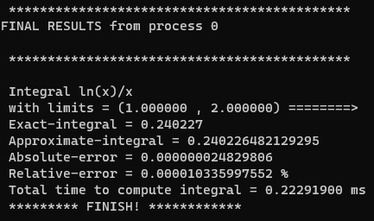

********************************************

FINAL RESULTS from process 0

********************************************

Integral ln(x)/x

with limits = (1.000000, 2.000000) ========>

Exact-integral = 0.240227

Approximate-integral = 0.240226482129295

Absolute-error = 0.000000024829806

Relative-error = 0.000010335997552 %

Total time to compute integral = 0.22291900 ms

********* FINISH! ************

#processes = 20

[tm5u6@n06p001 project_C]$ mpicc newton_cotes_vc14.c tinyexpr.c -o newton_cotes_vc14 -l m

[tm5u6@n06p001 project_C]$ mpirun -np 20 ./newton_cotes_vc14

File: exp2_c/exp2c_k3.txt

**For q = 20, k = 3**

OUTPUTS:

**** All data: ***

1.000000 1.016667 1.033333 1.050000 1.066667 1.083333 1.100000 1.116667 1.133333 1.150000 1.166667 1.183333 1.200000 1.216667 1.233333 1.250000 1.266667 1.283333 1.300000 1.316667 1.333333 1.350000 1.366667 1.383333 1.400000 1.416667 1.433333 1.450000 1.466667 1.483333 1.500000 1.516667 1.533333 1.550000 1.566667 1.583333 1.600000 1.616667 1.633333 1.650000 1.666667 1.683333 1.700000 1.716667 1.733333 1.750000 1.766667 1.783333 1.800000 1.816667 1.833333 1.850000 1.866667 1.883333 1.900000 1.916667 1.933333 1.950000 1.966667 1.983333 2.000000

*********************************

Data for process 0:

1.000000 1.016667 1.033333 1.050000

*********************************

Data for process 1:

1.050000 1.066667 1.083333 1.100000

*********************************

Data for process 2:

1.100000 1.116667 1.133333 1.150000

*********************************

Data for process 3:

1.150000 1.166667 1.183333 1.200000

*********************************

Data for process 4:

1.200000 1.216667 1.233333 1.250000

*********************************

Data for process 5:

1.250000 1.266667 1.283333 1.300000

*********************************

Data for process 6:

1.300000 1.316667 1.333333 1.350000

*********************************

Data for process 19:

1.950000 1.966667 1.983333 2.000000

*********************************

Data for process 7:

1.350000 1.366667 1.383333 1.400000

*********************************

Data for process 8:

1.400000 1.416667 1.433333 1.450000

*********************************

Data for process 9:

1.450000 1.466667 1.483333 1.500000

*********************************

Data for process 10:

1.500000 1.516667 1.533333 1.550000

*********************************

Data for process 11:

1.550000 1.566667 1.583333 1.600000

*********************************

Data for process 12:

1.600000 1.616667 1.633333 1.650000

*********************************

Data for process 13:

1.650000 1.666667 1.683333 1.700000

*********************************

Data for process 14:

1.700000 1.716667 1.733333 1.750000

*********************************

Data for process 15:

1.750000 1.766667 1.783333 1.800000

*********************************

Data for process 16:

1.800000 1.816667 1.833333 1.850000

*********************************

Data for process 17:

1.850000 1.866667 1.883333 1.900000

*********************************

Data for process 18:

1.900000 1.916667 1.933333 1.950000

*********************************

FINAL RESULTS:

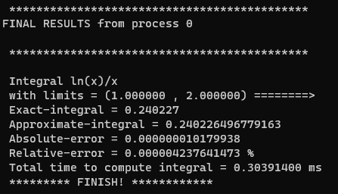

********************************************

FINAL RESULTS from process 0

********************************************

Integral ln(x)/x

with limits = (1.000000 , 2.000000) ========>

Exact-integral = 0.240227

Approximate-integral = 0.240226496779163

Absolute-error = 0.000000010179938

Relative-error = 0.000004237641473 %

Total time to compute integral = 0.30391400 ms

********* FINISH! ************

ANALYSIS OF Q

|  |  |  |  |
| --- | --- | --- | --- |
| N = 1, k = 3 | | | |
| Function: ln(x)/x; limits: [1, 2] | | | |
| q (number of processes) | Absolute error (abs_err) | Relative error (%) | Total time (ms) |
| 4 | 0.000006121452122 | 0.002548200113055 | 0.06670300 |
| 8 | 0.000000394184112 | 0.000164088516516 | 0.11631500 |
| 12 | 0.000000078314437 | 0.000032600247810 | 0.18829700 |
| 16 | 0.000000024829806 | 0.000010335997552 | 0.22291900 |
| 20 | 0.000000010179938 | 0.000004237641473 | 0.30391400 |

3) Experiment 03: study **of programming language**

Study the performance of variable number of processes versus programming languages (C x Python) respect the error and time. We fix the degree of quadrature (k = 2) and number of nodes (N = 1).

**For N = 1, k = 2, q = 4 (Language C)**

#processes = 4

[tm5u6@n06p002 project_C]$ mpirun -np 4 ./newton_cotes_vc14

Name of file:

exp3_c/exp3c_k2.txt

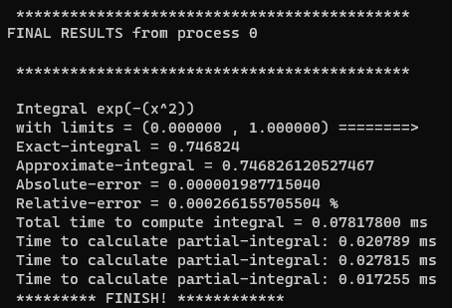

********************************************

FINAL RESULTS from process 0

********************************************

Integral exp(-(x^2))

with limits = (0.000000 , 1.000000) ========>

Exact-integral = 0.746824

Approximate-integral = 0.746826120527467

Absolute-error = 0.000001987715040

Relative-error = 0.000266155705504 %

Total time to compute integral = 0.07817800 ms

********* FINISH! ************

**For N = 1, k = 2, q = 8 (Language C)**

#processes = 8

[tm5u6@n06p002 project_C]$ mpirun -np 8 ./newton_cotes_vc14

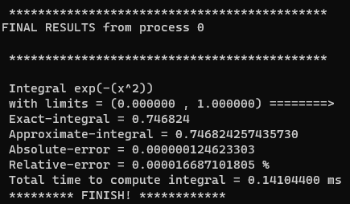

********************************************

FINAL RESULTS from process 0

********************************************

Integral exp(-(x^2))

with limits = (0.000000 , 1.000000) ========>

Exact-integral = 0.746824

Approximate-integral = 0.746824257435730

Absolute-error = 0.000000124623303

Relative-error = 0.000016687101805 %

Total time to compute integral = 0.14104400 ms

********* FINISH! ************

**For N = 1, k = 2, q = 12 (Language C)**

# processes = 12

[tm5u6@n06p002 project_C]$ mpirun -np 12 ./newton_cotes_vc14

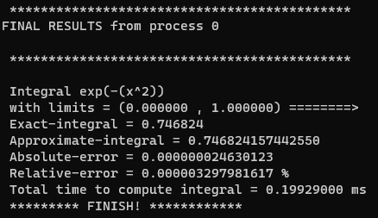

********************************************

FINAL RESULTS from process 0

********************************************

Integral exp(-(x^2))

with limits = (0.000000 , 1.000000) ========>

Exact-integral = 0.746824

Approximate-integral = 0.746824157442550

Absolute-error = 0.000000024630123

Relative-error = 0.000003297981617 %

Total time to compute integral = 0.19929000 ms

********* FINISH! ************

**For N = 1, k = 2, q = 16 (Language C)**

# processes = 16

[tm5u6@n06p002 project_C]$ mpirun -np 16 ./newton_cotes_vc14

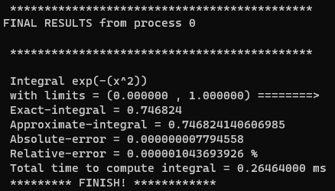

********************************************

FINAL RESULTS from process 0

********************************************

Integral exp(-(x^2))

with limits = (0.000000 , 1.000000) ========>

Exact-integral = 0.746824

Approximate-integral = 0.746824140606985

Absolute-error = 0.000000007794558

Relative-error = 0.000001043693926 %

Total time to compute integral = 0.26464000 ms

********* FINISH! ************

**For N = 1, k = 2, q = 4 (Language python)**

# processes = 4

(ex) [tm5u6@n06p003 labpy]$ mpirun -np 4 python3 newton_cotes_final1.py

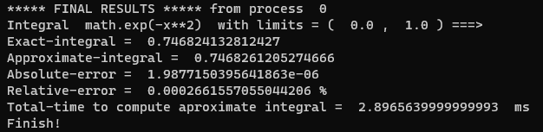

***** FINAL RESULTS ***** from process 0

Integral math.exp(-x**2) with limits = ( 0.0 , 1.0 ) ===>

Exact-integral = 0.746824132812427

Approximate-integral = 0.7468261205274666

Absolute-error = 1.9877150395641863e-06

Relative-error = 0.0002661557055044206 %

Total-time to compute aproximate integral = 2.8965639999999993 ms

Finish!

**For N = 1, k = 2, q = 8 (Language python)**

#processes = 8

(ex) [tm5u6@n06p003 labpy]$ mpirun -np 8 python3 newton_cotes_final1.py

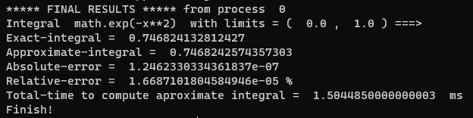

***** FINAL RESULTS ***** from process 0

Integral math.exp(-x**2) with limits = ( 0.0 , 1.0 ) ===>

Exact-integral = 0.746824132812427

Approximate-integral = 0.7468242574357303

Absolute-error = 1.2462330334361837e-07

Relative-error = 1.6687101804584946e-05 %

Total-time to compute aproximate integral = 1.5044850000000003 ms

Finish!

**For N = 1, k = 2, q = 12 (Language python)**

#processes = 12

(ex) [tm5u6@n06p003 labpy]$ mpirun -np 12 python3 newton_cotes_final1.py

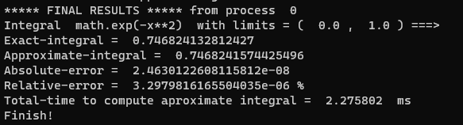

***** FINAL RESULTS ***** from process 0

Integral math.exp(-x**2) with limits = ( 0.0 , 1.0 ) ===>

Exact-integral = 0.746824132812427

Approximate-integral = 0.7468241574425496

Absolute-error = 2.4630122608115812e-08

Relative-error = 3.2979816165504035e-06 %

Total-time to compute aproximate integral = 2.275802 ms

Finish!

**For N = 1, k = 2, q = 16 (Language python)**

#processes = 16

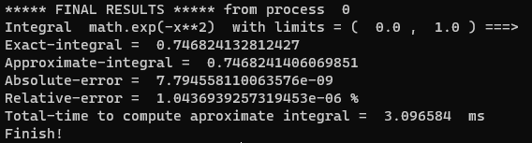

***** FINAL RESULTS ***** from process 0

Integral math.exp(-x**2) with limits = ( 0.0 , 1.0 ) ===>

Exact-integral = 0.746824132812427

Approximate-integral = 0.7468241406069851

Absolute-error = 7.794558110063576e-09

Relative-error = 1.0436939257319453e-06 %

Total-time to compute aproximate integral = 3.096584 ms

Finish!

ANALYSIS OF LANGUAGE AND VARIABLE Q

|  |  |  |  |
| --- | --- | --- | --- |
| N = 1, k = 2 | | | |
| Function: math.exp(-x**2); limits: [0, 1] | | | |
| LANGUAGE C | | | |
| q (number of processes) | Absolute error (abs_err) | Relative error (%) | Total time (ms) |
| 4 | 0.000001987715040 | 0.000266155705504 | 0.07817800 |
| 8 | 0.000000124623303 | 0.000016687101805 | 0.14104400 |
| 12 | 0.000000024630123 | 0.000003297981617 | 0.19929000 |
| 16 | 0.000000007794558 | 0.000001043693926 | 0.26464000 |
| LANGUAGE PYTHON | | | |
| 4 | 1.9877150395641863e-06 | 0.0002661557055044206 | 2.8965639999999993 |
| 8 | 1.2462330334361837e-07 | 1.6687101804584946e-05 | 1.5044850000000003 |
| 12 | 2.4630122608115812e-08 | 3.2979816165504035e-06 | 2.275802 |
| 16 | 7.794558110063576e-09 | 1.0436939257319453e-06 | 3.096584 |

4) Experiment 04: study **language**

Study the influence of variable number of quadrature and programming language (C or Python) in performance of error and time. Here, we fix number of processes (q = 5) and number of nodes in 1 (N = 1).

#processes = 5

tm5u6@login1:~/project_C

$ salloc -N 1 -p cascade

[tm5u6@n06p001 project_C]$ mpicc newton_cotes_vc14.c tinyexpr.c -o newton_cotes_vc14 -l m

[tm5u6@n06p001 project_C]$ mpirun -np 5 ./newton_cotes_vc14

File: exp4_c/exp4c_k4.txt

**For N = 1, q = 5, k = 4 (Language C)**

OUTPUTS:

**** All data: ***

0.750000 0.762500 0.775000 0.787500 0.800000 0.812500 0.825000 0.837500 0.850000 0.862500 0.875000 0.887500 0.900000 0.912500 0.925000 0.937500 0.950000 0.962500 0.975000 0.987500 1.000000

*********************************

Data for process 0:

0.750000 0.762500 0.775000 0.787500 0.800000

*********************************

Data for process 2:

0.850000 0.862500 0.875000 0.887500 0.900000

*********************************

Data for process 1:

0.800000 0.812500 0.825000 0.837500 0.850000

*********************************

Data for process 4:

0.950000 0.962500 0.975000 0.987500 1.000000

*********************************

Data for process 3:

0.900000 0.912500 0.925000 0.937500 0.950000

*********************************

FINAL RESULTS:

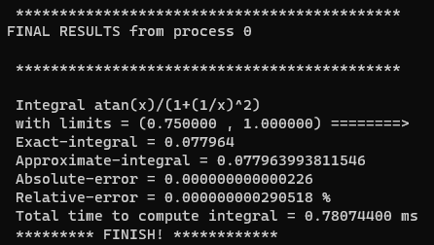

********************************************

FINAL RESULTS from process 0

********************************************

Integral atan(x)/(1+(1/x)^2)

with limits = (0.750000, 1.000000) ========>

Exact-integral = 0.077964

Approximate-integral = 0.077963993811546

Absolute-error = 0.000000000000226

Relative-error = 0.000000000290518 %

Total time to compute integral = 0.78074400 ms

********* FINISH! ************

**For N = 1, q = 5, k = 4 (Language Python)**

#processes = 5

(ex) [tm5u6@n06p001 labpy]$ mpirun -np 5 python3 newton_cotes_final1.py

File: exp4/exp4_k4.txt

OUTPUTS:

0 process ======> [0.75 0.7625 0.775 0.7875 0.8 ]

4 process ======> [0.95 0.9625 0.975 0.9875 1. ]

3 process ======> [0.9 0.9125 0.925 0.9375 0.95 ]

2 process ======> [0.85 0.8625 0.875 0.8875 0.9 ]

1 process ======> [0.8 0.8125 0.825 0.8375 0.85 ]

FINAL RESULTS:

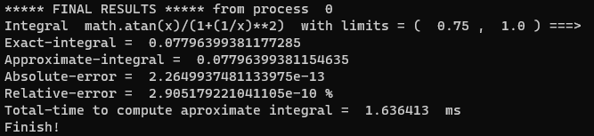

***** FINAL RESULTS ***** from process 0

Integral math.atan(x)/(1+(1/x)**2) with limits = ( 0.75 , 1.0 ) ===>

Exact-integral = 0.07796399381177285

Approximate-integral = 0.07796399381154635

Absolute-error = 2.2649937481133975e-13

Relative-error = 2.905179221041105e-10 %

Total-time to compute aproximate integral = 1.636413 ms

Finish!

**For N = 1, q = 5, k = 6 (Language C)**

#processes = 5

tm5u6@login1:~/project_C

$ salloc -N 1 -p cascade

[tm5u6@n06p001 project_C]$ mpicc newton_cotes_vc14.c tinyexpr.c -o newton_cotes_vc14 -l m

[tm5u6@n06p001 project_C]$ mpirun -np 5 ./newton_cotes_vc14

File: exp4_c/exp4c_k6.txt

OUTPUTS:

**** All data: ***

0.750000 0.758333 0.766667 0.775000 0.783333 0.791667 0.800000 0.808333 0.816667 0.825000 0.833333 0.841667 0.850000 0.858333 0.866667 0.875000 0.883333 0.891667 0.900000 0.908333 0.916667 0.925000 0.933333 0.941667 0.950000 0.958333 0.966667 0.975000 0.983333 0.991667 1.000000

*********************************

Data for process 2:

0.850000 0.858333 0.866667 0.875000 0.883333 0.891667 0.900000

*********************************

Data for process 4:

0.950000 0.958333 0.966667 0.975000 0.983333 0.991667 1.000000

*********************************

Data for process 0:

0.750000 0.758333 0.766667 0.775000 0.783333 0.791667 0.800000

*********************************

Data for process 3:

0.900000 0.908333 0.916667 0.925000 0.933333 0.941667 0.950000

*********************************

Data for process 1:

0.800000 0.808333 0.816667 0.825000 0.833333 0.841667 0.850000

*********************************

FINAL RESULTS:

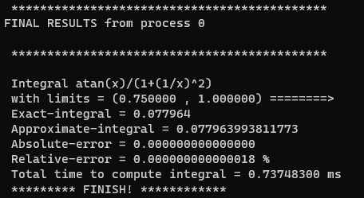

********************************************

FINAL RESULTS from process 0

********************************************

Integral atan(x)/(1+(1/x)^2)

with limits = (0.750000 , 1.000000) ========>

Exact-integral = 0.077964

Approximate-integral = 0.077963993811773

Absolute-error = 0.000000000000000

Relative-error = 0.000000000000018 %

Total time to compute integral = 0.73748300 ms

********* FINISH! ************

**For N = 1, q = 5, k = 6 (Language Python)**

#processes = 5

(ex) [tm5u6@n06p001 labpy]$ mpirun -np 5 python3 newton_cotes_final1.py

File: exp4/exp4_k6.txt

OUTPUTS:

0 process ======> [0.75 0.75833333 0.76666667 0.775 0.78333333 0.79166667

0.8 ]

4 process ======> [0.95 0.95833333 0.96666667 0.975 0.98333333 0.99166667

1. ]

2 process ======> [0.85 0.85833333 0.86666667 0.875 0.88333333 0.89166667

0.9 ]

3 process ======> [0.9 0.90833333 0.91666667 0.925 0.93333333 0.94166667

0.95 ]

1 process ======> [0.8 0.80833333 0.81666667 0.825 0.83333333 0.84166667

0.85 ]

FINAL RESULTS:

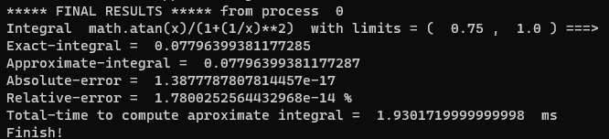

***** FINAL RESULTS ***** from process 0

Integral math.atan(x)/(1+(1/x)**2) with limits = ( 0.75 , 1.0 ) ===>

Exact-integral = 0.07796399381177285

Approximate-integral = 0.07796399381177287

Absolute-error = 1.3877787807814457e-17

Relative-error = 1.7800252564432968e-14 %

Total-time to compute aproximate integral = 1.9301719999999998 ms

Finish!

**For N = 1, q = 5, k = 8 (Language C)**

#processes = 5

tm5u6@login1:~/project_C

$ salloc -N 1 -p cascade

[tm5u6@n06p001 project_C]$ mpicc newton_cotes_vc14.c tinyexpr.c -o newton_cotes_vc14 -l m

[tm5u6@n06p001 project_C]$ mpirun -np 8 ./newton_cotes_vc14

File: exp4_c/exp4c_k8.txt

OUTPUTS:

**** All data: ***

0.750000 0.753906 0.757812 0.761719 0.765625 0.769531 0.773438 0.777344 0.781250 0.785156 0.789062 0.792969 0.796875 0.800781 0.804688 0.808594 0.812500 0.816406 0.820312 0.824219 0.828125 0.832031 0.835938 0.839844 0.843750 0.847656 0.851562 0.855469 0.859375 0.863281 0.867188 0.871094 0.875000 0.878906 0.882812 0.886719 0.890625 0.894531 0.898438 0.902344 0.906250 0.910156 0.914062 0.917969 0.921875 0.925781 0.929688 0.933594 0.937500 0.941406 0.945312 0.949219 0.953125 0.957031 0.960938 0.964844 0.968750 0.972656 0.976562 0.980469 0.984375 0.988281 0.992188 0.996094 1.000000

*********************************

Data for process 0:

0.750000 0.753906 0.757812 0.761719 0.765625 0.769531 0.773438 0.777344 0.781250

*********************************

Data for process 6:

0.937500 0.941406 0.945312 0.949219 0.953125 0.957031 0.960938 0.964844 0.968750

*********************************

Data for process 7:

0.968750 0.972656 0.976562 0.980469 0.984375 0.988281 0.992188 0.996094 1.000000

*********************************

Data for process 1:

0.781250 0.785156 0.789062 0.792969 0.796875 0.800781 0.804688 0.808594 0.812500

*********************************

Data for process 2:

0.812500 0.816406 0.820312 0.824219 0.828125 0.832031 0.835938 0.839844 0.843750

*********************************

Data for process 3:

0.843750 0.847656 0.851562 0.855469 0.859375 0.863281 0.867188 0.871094 0.875000

*********************************

Data for process 4:

0.875000 0.878906 0.882812 0.886719 0.890625 0.894531 0.898438 0.902344 0.906250

*********************************

Data for process 5:

0.906250 0.910156 0.914062 0.917969 0.921875 0.925781 0.929688 0.933594 0.937500

*********************************

FINAL RESULTS:

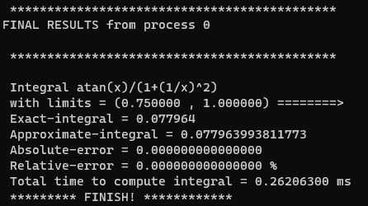

********************************************

FINAL RESULTS from process 0

********************************************

Integral atan(x)/(1+(1/x)^2)

with limits = (0.750000, 1.000000) ========>

Exact-integral = 0.077964

Approximate-integral = 0.077963993811773

Absolute-error = 0.000000000000000

Relative-error = 0.000000000000000 %

Total time to compute integral = 0.26206300 ms

********* FINISH! ************

**For N = 1, q = 5, k = 8 (Language Python)**

#processes = 5

(ex) [tm5u6@n06p001 labpy]$ mpirun -np 5 python3 newton_cotes_final1.py

File: exp4/exp4_k8.txt

OUTPUTS:

0 process ======> [0.75 0.75625 0.7625 0.76875 0.775 0.78125 0.7875 0.79375 0.8 ]

4 process ======> [0.95 0.95625 0.9625 0.96875 0.975 0.98125 0.9875 0.99375 1. ]

3 process ======> [0.9 0.90625 0.9125 0.91875 0.925 0.93125 0.9375 0.94375 0.95 ]

2 process ======> [0.85 0.85625 0.8625 0.86875 0.875 0.88125 0.8875 0.89375 0.9 ]

1 process ======> [0.8 0.80625 0.8125 0.81875 0.825 0.83125 0.8375 0.84375 0.85 ]

FINAL RESULTS:

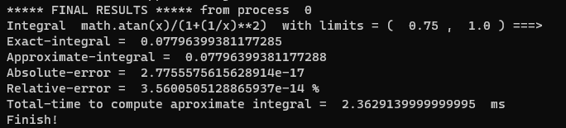

***** FINAL RESULTS ***** from process 0

Integral math.atan(x)/(1+(1/x)**2) with limits = ( 0.75 , 1.0 ) ===>

Exact-integral = 0.07796399381177285

Approximate-integral = 0.07796399381177288

Absolute-error = 2.7755575615628914e-17

Relative-error = 3.5600505128865937e-14 %

Total-time to compute aproximate integral = 2.3629139999999995 ms

Finish!

ANALYSIS OF LANGUAGE

|  |  |  |  |
| --- | --- | --- | --- |
| N = 1, q = 5 | | | |
| Function: math.atan(x)/(1+(1/x)**2); limits: [0.75, 1] | | | |
| LANGUAGE C | | | |
| k (degree of quadrature) | Absolute error (abs_err) | Relative error (%) | Total time (ms) |
| 4 | 000000000000226 | 0.000000000290518 | 0.78074400 |
| 6 | 0.000000000000000 | 0.000000000000018 | 0.73748300 |
| 8 | 0.000000000000000 | 0.000000000000000 | 0.26206300 |
| LANGUAGE PYTHON | | | |
| 4 | 2.2649937481133975e-13 | 2.905179221041105e-10 | 1.636413 |
| 6 | 1.3877787807814457e-17 | 1.7800252564432968e-14 | 1.9301719999999998 |
| 8 | 2.7755575615628914e-17 | 3.5600505128865937e-14 | 2.3629139999999995 |

6. EXPERIMENTAL GRAPHICS

1) Experiment 01

|  |  |  |  |
| --- | --- | --- | --- |
| N = 1, q = 4 | | | |
| Function: sin(x); limits: [0, pi] | | | |
| k (degree of quadrature) | Absolute error (abs_err) | Relative error (%) | Total time (ms) |
| 1 | 0.103881102062960 | 5.194055103148010 | 6.90680800 |
| 2 | 0.000269169948388 | 0.013458497419383 | 0.08389700 |
| 3 | 0.000119386415226 | 0.005969320761290 | 0.07353600 |
| 4 | 0.000000247545428 | 0.000012377271397 | 0.08926300 |
| 5 | 0.000000139331969 | 0.000006966598454 | 0.10419600 |

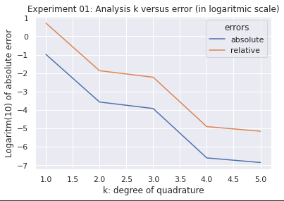

Image 1: Relation between absolute and relative error and degree of quadrature

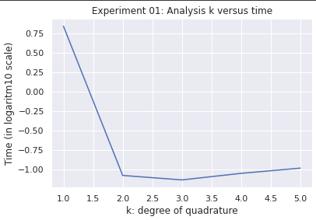

Image 2: Relation between time and degree of quadrature

2) Experiment 02

|  |  |  |  |
| --- | --- | --- | --- |
| N = 1, k = 3 | | | |
| Function: ln(x)/x; limits: [1, 2] | | | |
| q (number of processes) | Absolute error (abs_err) | Relative error (%) | Total time (ms) |
| 4 | 0.000006121452122 | 0.002548200113055 | 0.06670300 |
| 8 | 0.000000394184112 | 0.000164088516516 | 0.11631500 |
| 12 | 0.000000078314437 | 0.000032600247810 | 0.18829700 |
| 16 | 0.000000024829806 | 0.000010335997552 | 0.22291900 |
| 20 | 0.000000010179938 | 0.000004237641473 | 0.30391400 |

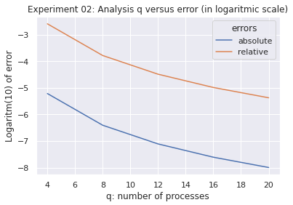

Image 3: Relation between absolute and relative error and number of processes

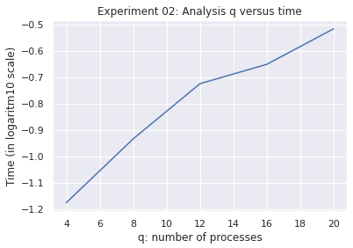

Image 4: Relation between time and number of processes

3) Experiment 03

|  |  |  |  |
| --- | --- | --- | --- |
| N = 1, k = 2 | | | |
| Function: math.exp(-x**2); limits: [0, 1] | | | |
| LANGUAGE C | | | |
| q (number of processes) | Absolute error (abs_err) | Relative error (%) | Total time (ms) |
| 4 | 0.000001987715040 | 0.000266155705504 | 0.07817800 |
| 8 | 0.000000124623303 | 0.000016687101805 | 0.14104400 |
| 12 | 0.000000024630123 | 0.000003297981617 | 0.19929000 |
| 16 | 0.000000007794558 | 0.000001043693926 | 0.26464000 |
| LANGUAGE PYTHON | | | |
| 4 | 1.9877150395641863e-06 | 0.0002661557055044206 | 2.8965639999999993 |
| 8 | 1.2462330334361837e-07 | 1.6687101804584946e-05 | 1.5044850000000003 |
| 12 | 2.4630122608115812e-08 | 3.2979816165504035e-06 | 2.275802 |
| 16 | 7.794558110063576e-09 | 1.0436939257319453e-06 | 3.096584 |

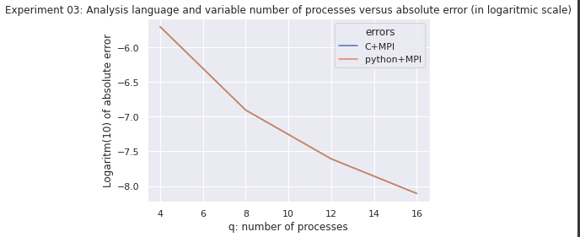

Image 5. Relation between language (C x python) with variable number of processes and absolute error

* Note in the graph above, that the graphs for C and Python are superimposed, indicating approximately equal performance

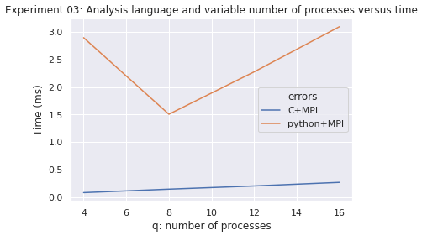

Image 6. Relation between language (C x Python) with variable number of processes and time

4) Experiment 04

|  |  |  |  |
| --- | --- | --- | --- |
| N = 1, q = 5 | | | |
| Function: math.atan(x)/(1+(1/x)**2); limits: [0.75, 1] | | | |
| LANGUAGE C | | | |
| k (degree of quadrature) | Absolute error (abs_err) | Relative error (%) | Total time (ms) |
| 4 | 0.00000000000226 | 0.000000000290518 | 0.78074400 |
| 6 | 0.0000000000000001 | 0.000000000000018 | 0.73748300 |
| 8 | 0.0000000000000001 | 0.000000000000000 | 0.26206300 |
| LANGUAGE PYTHON | | | |
| 4 | 2.2649937481133975e-13 | 2.905179221041105e-10 | 1.636413 |
| 6 | 1.3877787807814457e-17 | 1.7800252564432968e-14 | 1.9301719999999998 |
| 8 | 2.7755575615628914e-17 | 3.5600505128865937e-14 | 2.3629139999999995 |

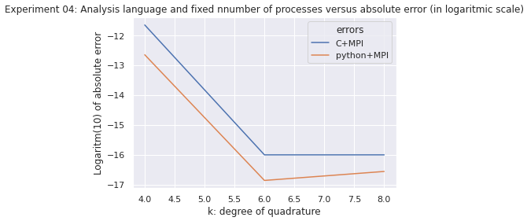

Image 7. Relation between language and absolute error for C x python

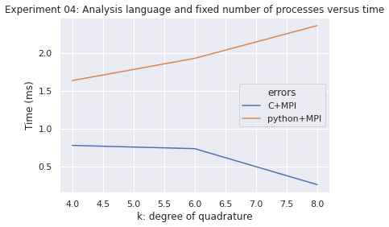

Image 8. Relation between language and time processing for C x python

**5. CONCLUSION**

In this research work, was concluded in the next aspects:

* The increasing of parameter k, improves the performance of absolute error and the relative error to calculate the approximate integral. In other words, as we use a higher degree quadrature, better is the approximation of the numerical integral. Use a higher degree of quadrature affects the time. The higher the degree of quadrature, the faster the algorithm is in the calculation process and therefore the shorter the time.
* The increasing of parameter q, improves the performance of absolute error and relative error, but take a more time to make calculations. In other words, as we use a much more processes/threads the performance of calculations increasing considerably, but the algorithm expends more time to achieve the results.
* The programming language C experimentally demonstrates experimentally it was shown to reach comparable levels of performance with respect to the Python language in less time.
* The influence of number of processes in both languages C and Python increase the time, but the grow of the time in C is much slower in comparison with the time grow in Python.
* The influence of problem’s complexity related with the quadrature’s degree (with fixed number of processes), has opposite behaviors between C and Python. Whereas in C, increasing the degree of quadrature complexity makes the algorithm perform faster, in the case of Python, increasing the degree of quadrature makes the algorithm run slower and even with a higher degree of quadrature. quasi-linear increasing trend with respect to time.
* Always Python consume approximately 1 order of magnitude more of time than C, independently if the number of the processes is fixed or not.