Credit Score Classification
────────────────────────────────────────
Multi-Model Classification Benchmark for Credit Risk Assessment
Student: Alonso
Intelligent Analysis of a Dataset
2026

Table of Contents
1. Introduction and Goal Formulation 4
1.1 Background 4
1.2 Research Objective 4
1.3 Research Tasks 4
1.4 Hypotheses 4
2. Preliminary Data Overview 5
2.1 Data Source 5
2.2 Data Quality Assessment 5
3. Data Preprocessing 6
3.1 Missing Values and Outlier Treatment 6
3.2 Feature Engineering 7
4. Exploratory Data Analysis 7
4.1 Target Variable Distribution 7
4.2 Numerical Feature Distributions 8
4.3 Categorical Feature Analysis 10
4.4 Correlation Analysis 11
4.5 Key Feature-Target Relationships 12
4.6 Loan Type Analysis 15
5. Prediction and Modeling 16
5.1 Feature Encoding and Scaling 16
5.2 Train/Test Split 17
5.3 Model Selection 17
5.4 Evaluation Methodology 18
6. Results and Discussion 18
6.1 Benchmark Comparison 18
6.2 Per-Class Performance Analysis 19
6.2.1 KNN Performance 19
6.2.2 Random Forest Performance 20
6.2.3 XGBoost Performance 21
6.2.4 LightGBM Performance 22
6.3 Confusion Matrix Comparison 23
6.4 Training Efficiency Analysis 24
6.5 Discussion and Interpretation 25
7. Conclusions 26
7.1 Key Findings 26
7.2 Hypotheses Evaluation 26
7.3 Practical Recommendations 27
7.4 Limitations 27
7.5 Future Work 27

1. Introduction and Goal Formulation

1.1 Background
Credit scoring is a fundamental function of the financial services industry, enabling institutions to evaluate customer creditworthiness for loan approvals, interest rate determination, and credit limit assignments. With the proliferation of customer transaction and behavioral data, machine learning techniques have become essential tools for building more accurate and nuanced credit scoring models than traditional statistical approaches. This project analyzes a dataset from a U.S.-based financial institution containing 100,000 customer records across 28 columns, encompassing demographic, financial, and behavioral features alongside a target variable classifying customers into Good, Standard, or Poor credit score categories.

1.2 Research Objective
The primary objective is to develop and evaluate machine learning classifiers capable of predicting customer credit score categories (Good, Standard, Poor) from a comprehensive set of financial and behavioral features. The project benchmarks four classification algorithms—K-Nearest Neighbors, Random Forest, Extreme Gradient Boost (XGBoost), and Light Gradient Boost Machines (LightGBM) —using a consistent evaluation framework with macro-averaged F1-score as the primary comparison metric. The measurable target is to achieve a macro F1-score that significantly outperforms a naive baseline of 53.2% (majority class).

1.3 Research Tasks
- Data Cleaning: Handle missing values, resolve type inconsistencies, and treat outliers.
- Exploratory Data Analysis (EDA): Statistical analysis and visualization of feature distributions and correlations.
- Feature Engineering: Encode categorical variables and apply scaling transformations.
- Model Benchmarking: Train and evaluate four classification algorithms with hyperparameter optimization.
- Reporting: Compile findings with actionable insights for credit risk management.

1.4 Hypotheses
Based on domain knowledge of credit risk factors, the following testable hypotheses guide the analysis:
- Higher annual income correlates with better credit scores. Greater financial resources improve repayment capacity.
- Lower outstanding debt is associated with higher credit scores. Lower debt burden indicates better financial management.
- More delayed payments predict poorer credit scores. Payment delinquency is a strong risk indicator.
- Longer credit history improves credit score. Extended history demonstrates sustained creditworthiness.
- Higher credit utilization ratio leads to poor credit scores. High utilization signals financial stress.
- Number of bank accounts and credit cards influences classification. Moderate values correlate with better scores.

2. Preliminary Data Overview

2.1 Data Source
The dataset originates from a U.S.-based financial institution and comprises a training set of 100,000 customer records and a test set of 50,000 records. Each record contains 28 columns: 27 feature variables spanning demographics (Age, Occupation), financial metrics (Annual_Income, Outstanding_Debt, Credit_Utilization_Ratio), and behavioral indicators (Payment_Behaviour, Num_of_Delayed_Payment), plus the target variable Credit_Score with three classes: Good, Standard, and Poor.

2.2 Data Quality Assessment
A thorough quality assessment revealed significant issues requiring systematic preprocessing:
- Missing Values: Monthly_Inhand_Salary (~15%), Type_of_Loan (~11%), Num_of_Delayed_Payment (~7%), Credit_History_Age (~9%).
- Incorrect categorization of variables nature: Variables as Age, Monthly Balance, Annual_Income, etc. are incorrectly defined as categorical, given the incorrect register of some data which requires process of cleaning or imputation.
- Type Inconsistencies: Eight columns stored as objects (Annual_Income, Age, Num_of_Loan, etc.) due to special characters.
- Outliers: Age ranges from -500 to 9,954; Num_Bank_Accounts maxes at 1,798. Clearly erroneous entries.
- Sentinel Values: Credit_Mix contains '_', Occupation contains '_______', Payment_Behaviour contains '!@9#%8'.
- Class Imbalance: Standard 53.2%, Poor 29.0%, Good 17.8% — setting a 53.2% accuracy baseline.
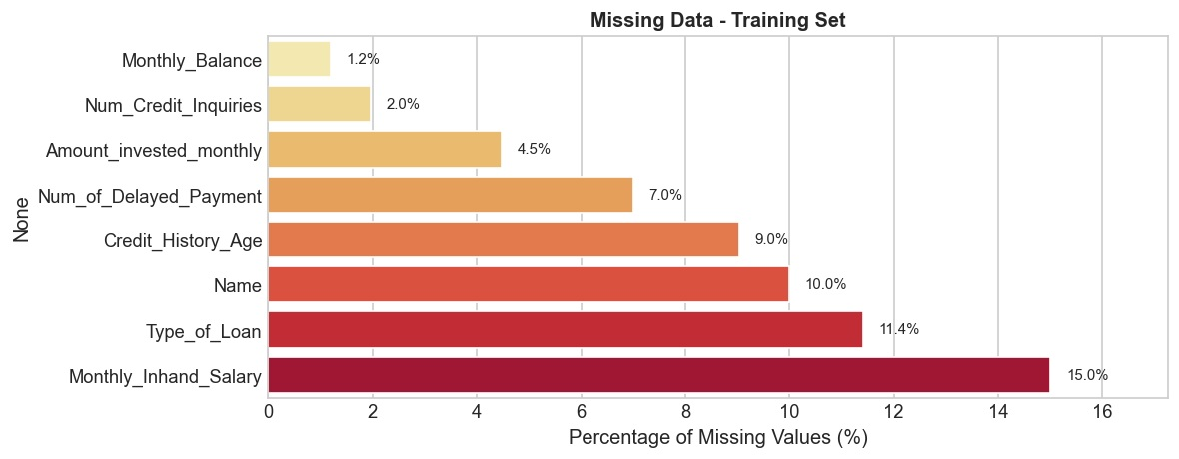
Figure 1: Missing Data Analysis — Training Set
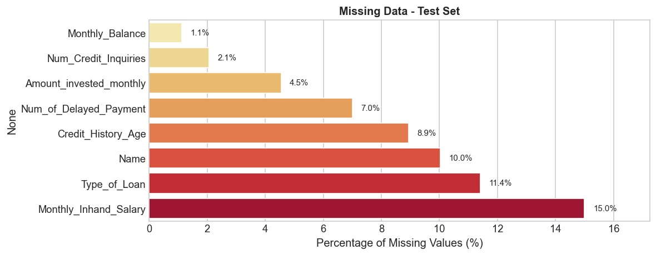
Figure 2: Missing Data Analysis — Test Set
After realize the process of data cleaning, the results of statistical metrics for numerical features from dataset are defined bellow in Figure 3.
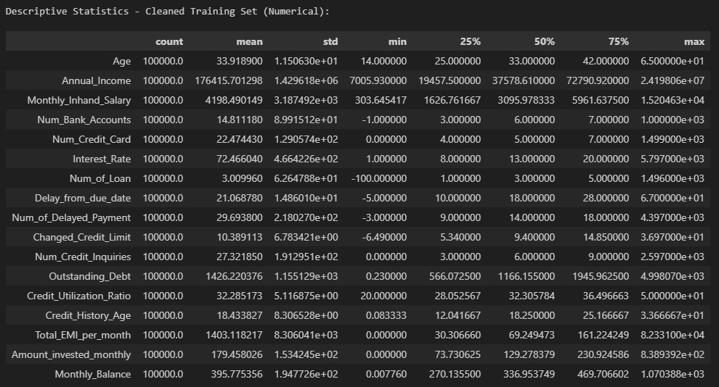
Figure 3: Descriptive Statistics Overview

3. Data Preprocessing

3.1 Missing Values and Outlier Treatment
For numerical columns, median imputation was applied as it is robust to extreme values. Categorical columns received mode imputation. Outliers were treated with domain-informed boundary capping: Age was capped to [14, 65], Num_Bank_Accounts to reasonable maximums, and Monthly_Balance values exceeding 1,000,000 were replaced. This capping approach preserves records while mitigating the influence of erroneous extreme values.

3.2 Feature Engineering
The following transformations were applied to prepare the dataset for modeling:
- Identifier Removal: Dropped ID, Customer_ID, Month, Name, and SSN (non-predictive).
- Credit_History_Age Parsing: Converted 'X Years and Y Months' format to continuous numeric months.
- Type_of_Loan Decomposition: Multi-label column split into 9 binary indicators (Auto Loan, Credit-Builder Loan, etc.).
- Sentinel Value Cleaning: Replaced '_' in Credit_Mix, '_______' in Occupation, '!@9#%8' in Payment_Behaviour.
- Numeric String Conversion: Cleaned special characters from 8 object columns and converted to float64.
Step | Operation | Impact
1 | Remove identifiers (ID, Customer_ID, Month, Name, SSN) | 5 columns removed
2 | Convert numeric object columns to float | 8 columns converted
3 | Cap/clean outliers (Age, Num_Bank_Accounts, Monthly_Balance) | Extreme values handled
4 | Clean sentinel values in categorical columns | 3 columns cleaned
5 | Parse Credit_History_Age and decompose Type_of_Loan | 1 col → numeric;  1 col → 9 binary
6 | Impute remaining NaN (median/mode) | All NaN resolved
Table 1: Data Cleaning Pipeline Summary

4. Exploratory Data Analysis

4.1 Target Variable Distribution
The target variable Credit_Score exhibits moderate class imbalance. Standard dominates with 53.2% of records (~53,200 samples), followed by Poor at 29.0% (~29,000), and Good at 17.8% (~17,800). This 3:1 ratio between majority and minority classes necessitates stratified sampling and macro-averaged evaluation metrics to ensure fair assessment across all classes. The data distribution is possible to visualize bellow in Figure 4.
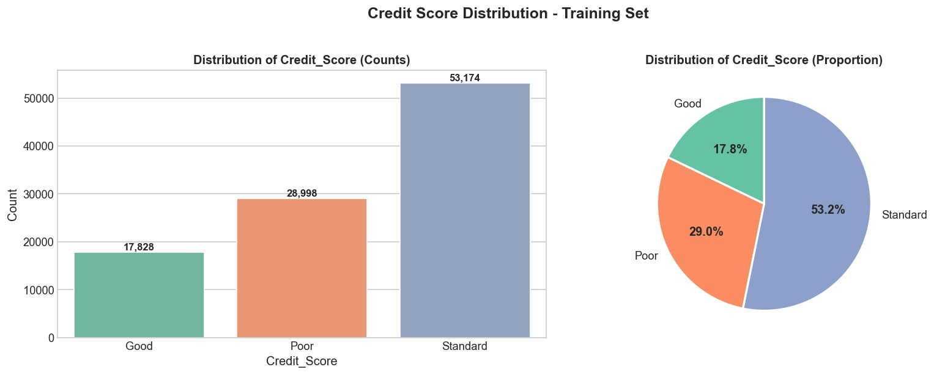
Figure 4: Credit Score Distribution — Training Set

4.2 Numerical Feature Distributions
Histogram and boxplot analysis revealed predominantly right-skewed distributions across financial variables. Annual_Income, Monthly_Inhand_Salary, and Outstanding_Debt exhibit significant positive skewness, motivating the use of RobustScaler for these features. Conversely, Credit_Utilization_Ratio and Credit_History_Age display approximately normal distributions, suitable for StandardScaler. The boxplot analysis confirmed substantial outlier presence in Num_Bank_Accounts, Num_Credit_Card, Interest_Rate, and Num_of_Loan.
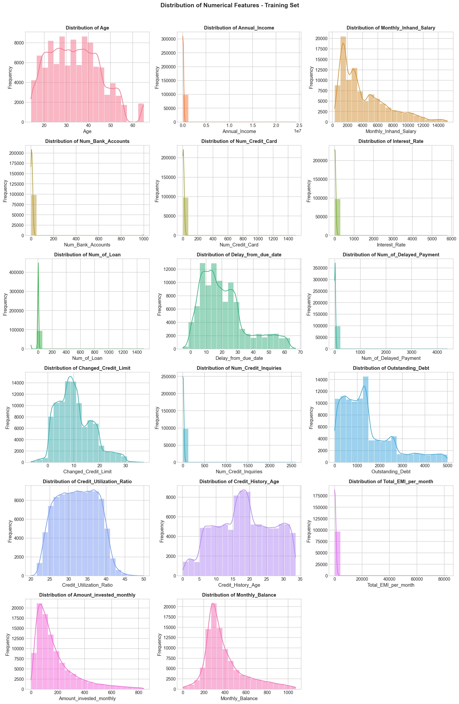
Figure 5: Numerical Feature Distributions
Boxplot statistical exploratory analysis of numerical features is realized in Figure 6.
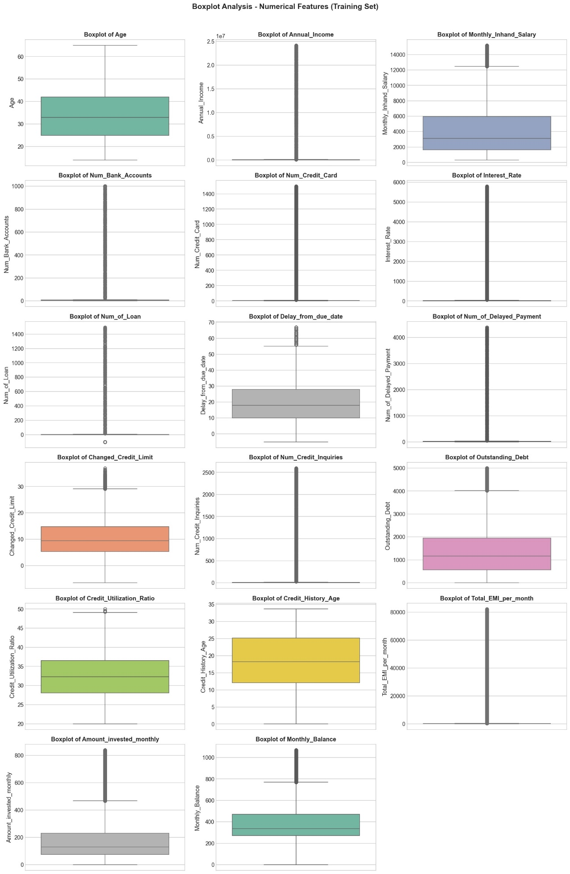
Figure 6: Boxplot Analysis — Numerical Features

4.3 Categorical Feature Analysis
Categorical features were analyzed through count plots segmented by credit score class. Credit_Mix emerged as one of the strongest categorical predictors: customers with 'Good' Credit_Mix are disproportionately classified as 'Good' credit score, while 'Bad' Credit_Mix strongly associates with 'Poor' scores. Payment_of_Min_Amount shows that customers paying only the minimum have higher proportions of Poor credit scores. Occupation and Payment_Behaviour also display distinct patterns across classes. In the figure 7, we can see the distribution of the categorical variables in pie charts. In the figure 8, the exploratory data analysis is done in bar plots.

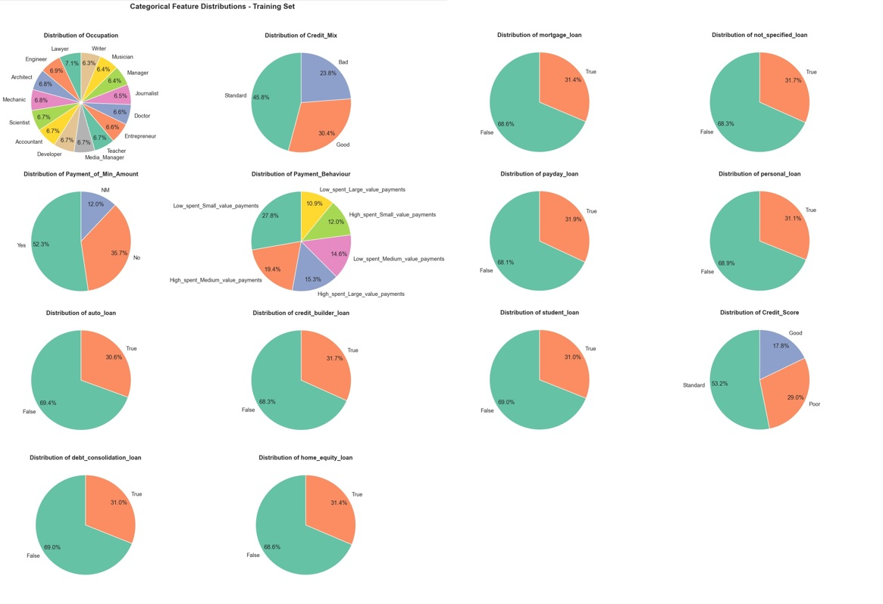
Figure 7: Categorical Feature Distributions

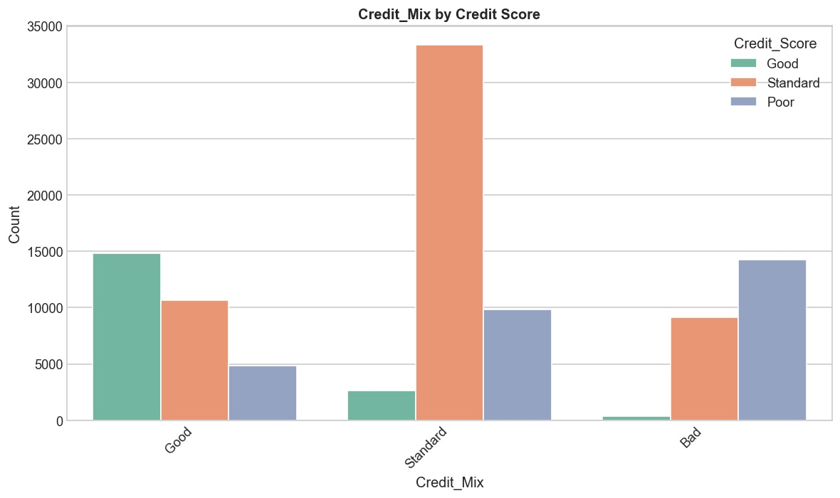
Figure 8: Credit Mix by Credit Score
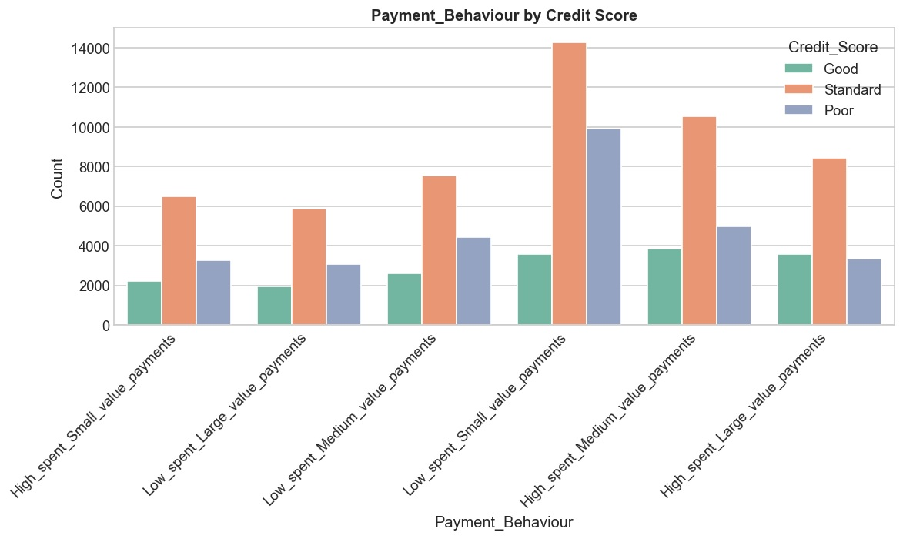
Figure 9: Payment Behaviour by Credit Score

4.4 Correlation Analysis
Pearson correlation analysis revealed a strong positive correlation between Annual_Income and Monthly_Inhand_Salary (r = 0.92), expected given their mathematical relationship. Interest_Rate and Num_of_Loan show moderate correlation (r = 0.47), while Outstanding_Debt correlates with both Interest_Rate (r = 0.43) and Num_of_Loan (r = 0.39), forming a cluster of debt-burden indicators. Credit_Utilization_Ratio shows weak correlations with most features, suggesting it captures independent behavioral information.
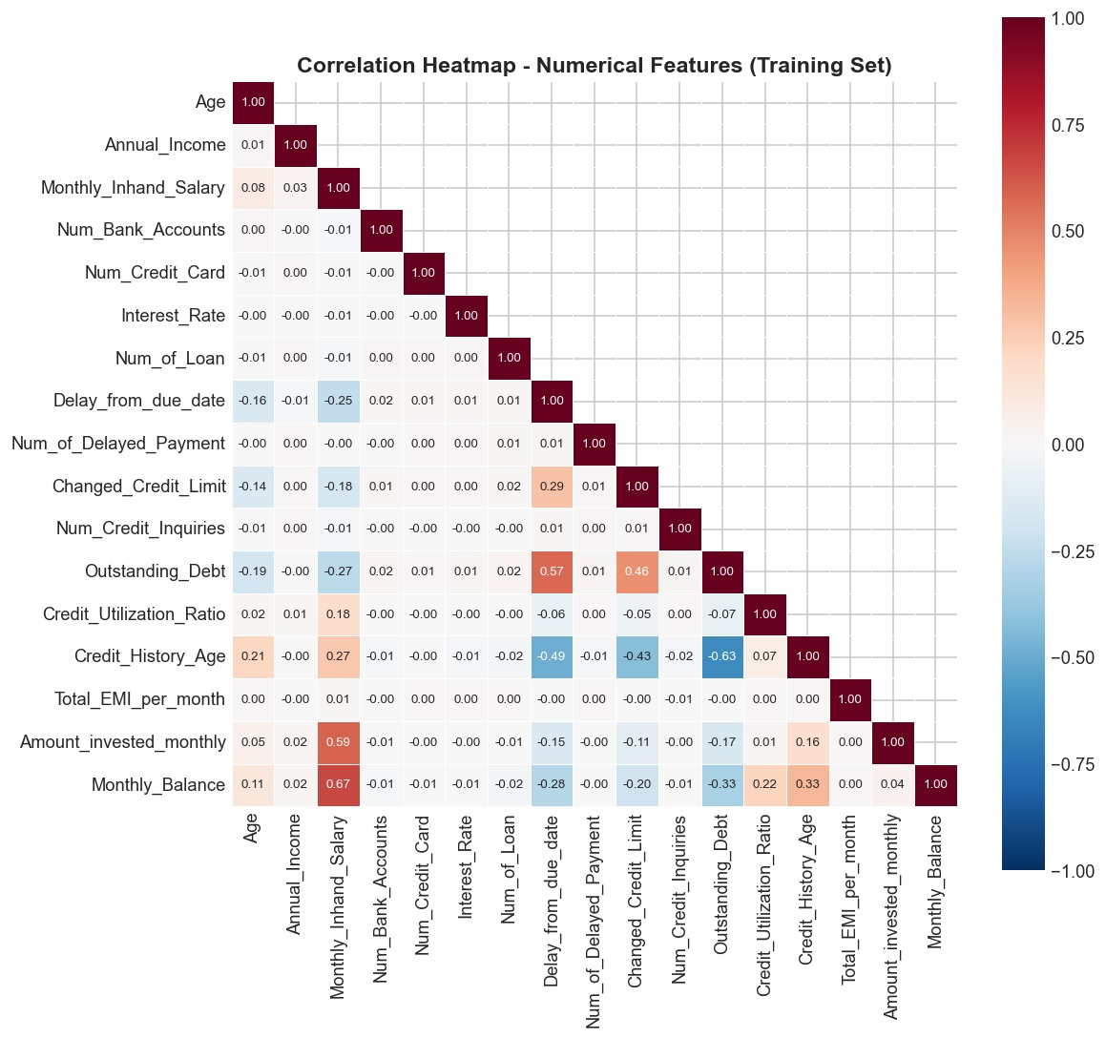
Figure 10: Correlation Heatmap — Numerical Features

4.5 Key Feature-Target Relationships
Violin plots segmented by credit score class reveal pronounced distributional differences across key features. Annual_Income and Monthly_Inhand_Salary show higher medians for Good credit customers. Outstanding_Debt and Interest_Rate are markedly elevated for Poor credit customers. Credit_History_Age is longer for Good credit holders, while Num_of_Delayed_Payment and Credit_Utilization_Ratio are elevated for Poor credit customers. These findings confirm the discriminative power of these features and validate the formulated hypotheses. Is possible observe the interaction between the numerical variables and each category of credit score in the Figures 11-16.
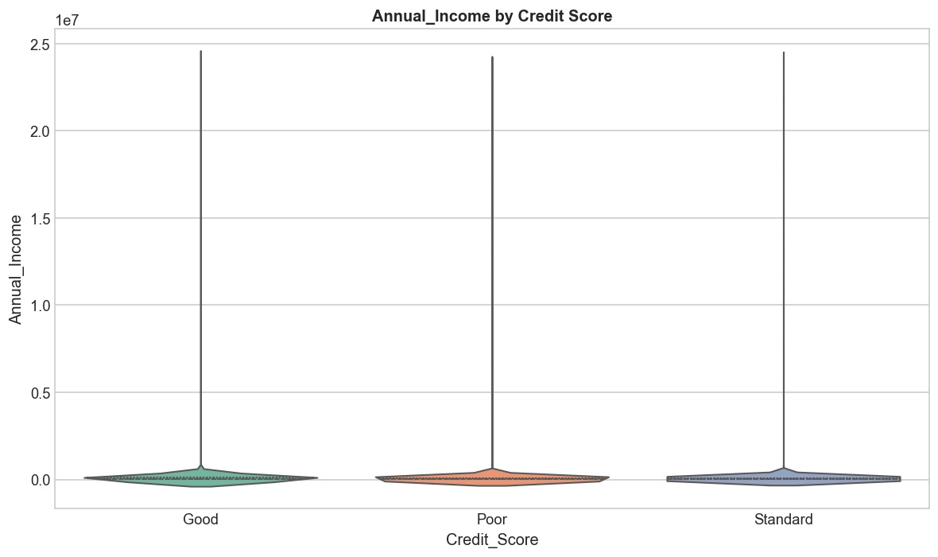
Figure 11: Annual Income by Credit Score

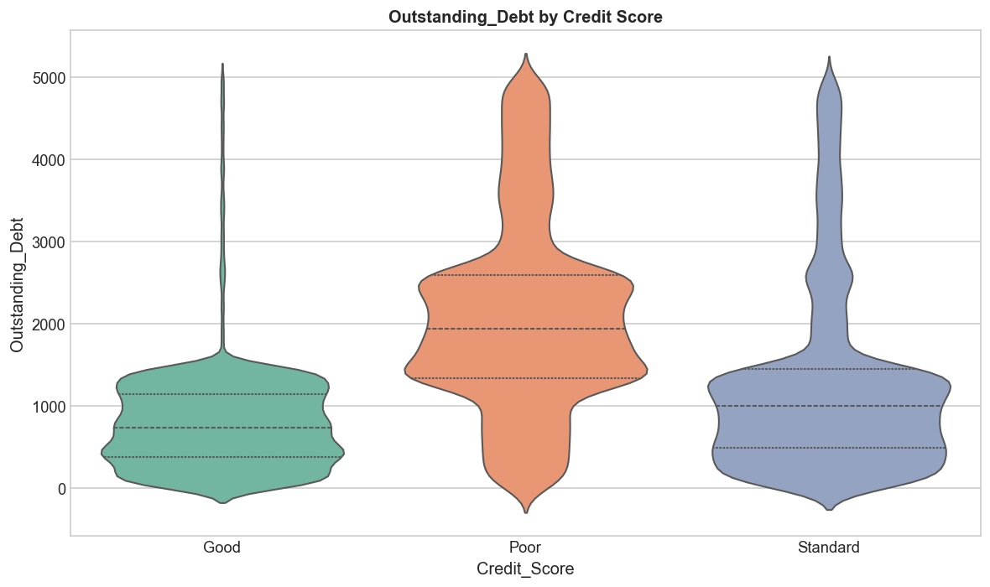
Figure 12: Outstanding Debt by Credit Score
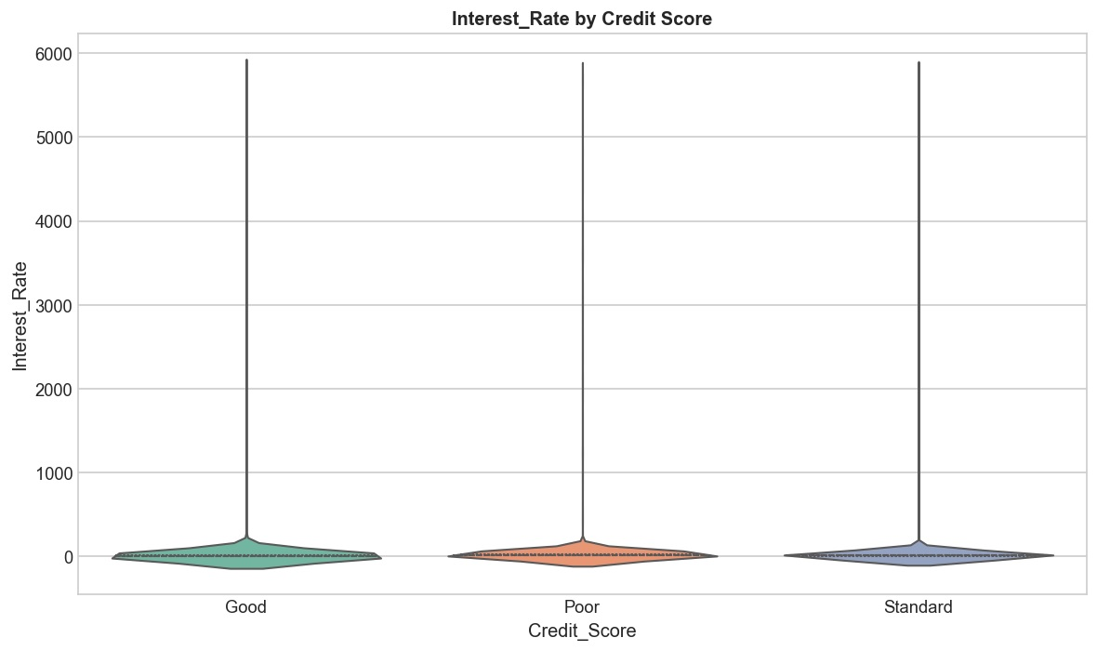
Figure 13: Interest Rate by Credit Score
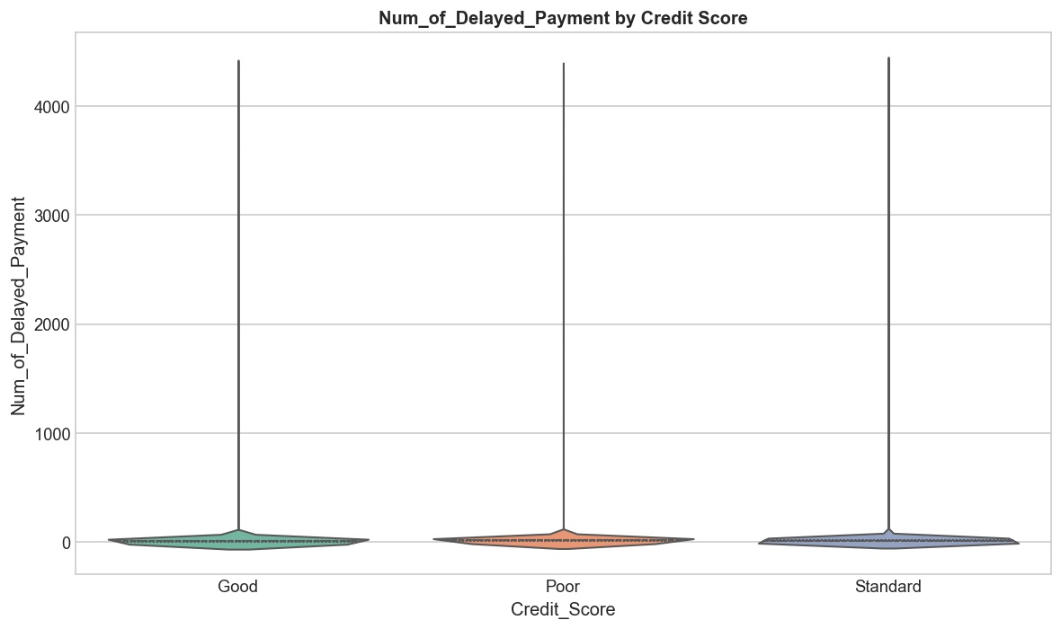
Figure 14: Delayed Payments by Credit Score
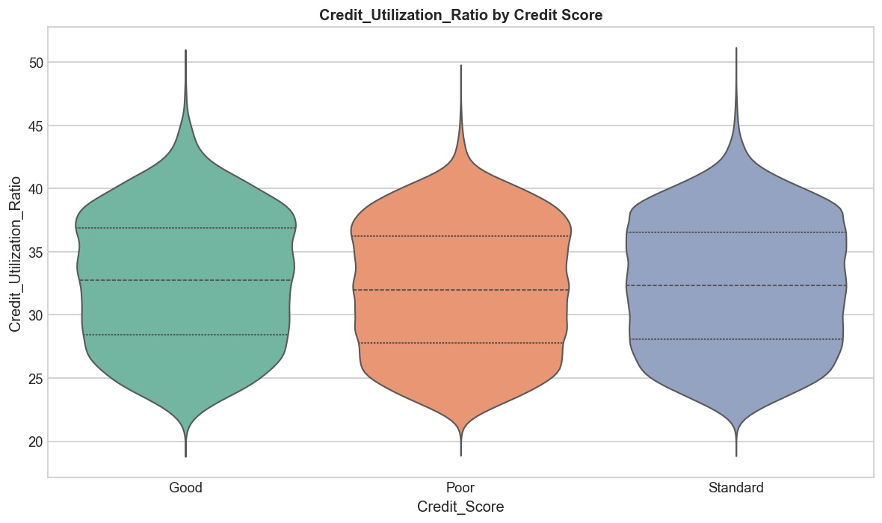
Figure 15: Credit Utilization by Credit Score
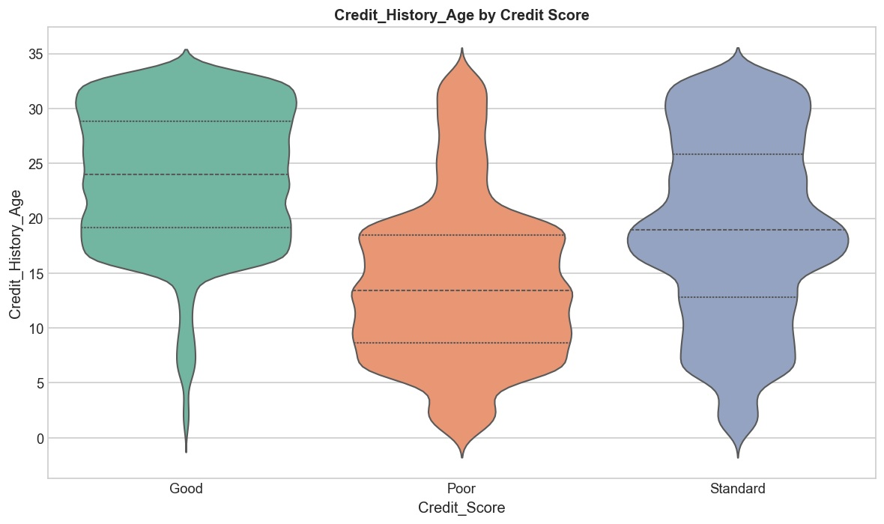
Figure 16: Credit History Age by Credit Score

4.6 Loan Type Analysis
The decomposed Type_of_Loan feature reveals varying associations with credit score classification. Customers with Credit-Builder Loans and Payday Loans show higher proportions of Poor credit scores, consistent with these being higher-risk credit products. Mortgage Loans and Student Loans display more balanced distributions across credit score classes, while Auto Loans and Personal Loans show moderate differentiation. Not Specified Loan entries are relatively evenly distributed, suggesting this category captures customers with minimal loan portfolios.
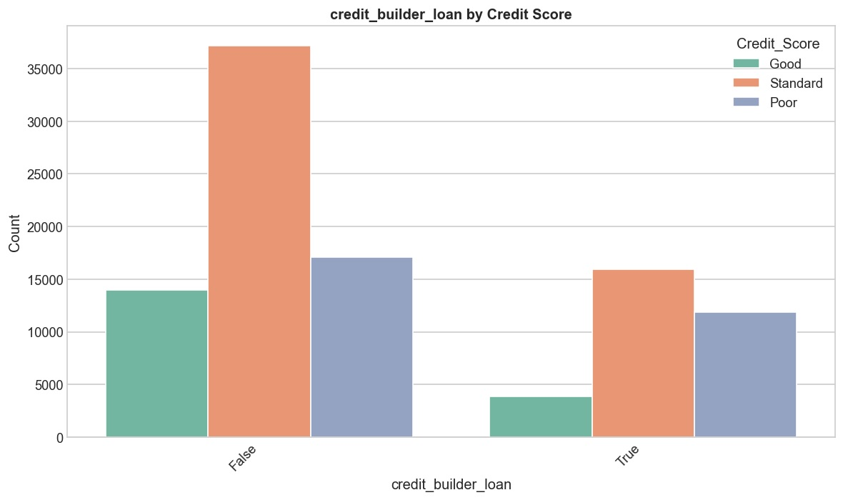
Figure 17: Credit-Builder Loan by Credit Score
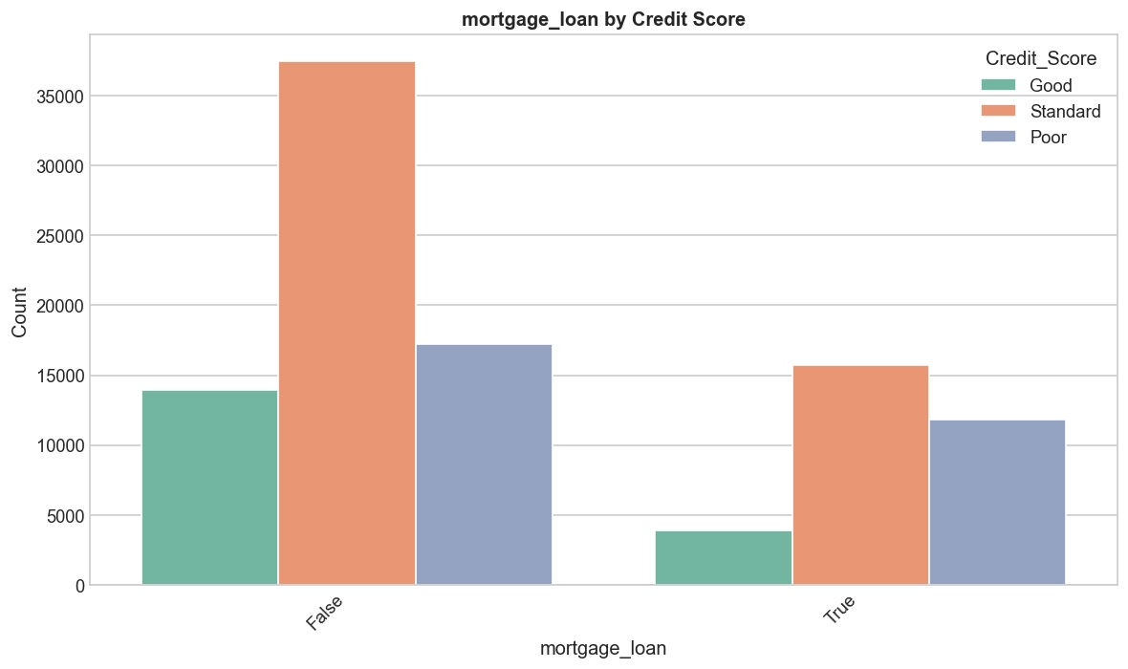
Figure 18: Mortgage Loan by Credit Score

5. Prediction and Modeling

5.1 Feature Encoding and Scaling
A dual-scaler strategy was employed based on feature distribution characteristics. StandardScaler was applied to six features with approximately normal distributions (Age, Delay_from_due_date, Changed_Credit_Limit, Credit_Utilization_Ratio, Credit_History_Age, Monthly_Balance). RobustScaler was used for 20 features with significant skewness and outliers, including all financial metrics and the 9 binary loan type indicators. Four categorical features (Occupation, Credit_Mix, Payment_of_Min_Amount, Payment_Behaviour) were encoded via OneHotEncoder, yielding a total of 52 encoded features.
Method | Features | Rationale
StandardScaler | Age, Delay_from_due_date, Changed_Credit_Limit, Credit_Utilization_Ratio, Credit_History_Age, Monthly_Balance | Approximately normal distributions
RobustScaler | Annual_Income, Monthly_Inhand_Salary, Interest_Rate, Outstanding_Debt, Num_of_Delayed_Payment + 9 loan binary cols + others | Skewed with outliers
OneHotEncoder | Occupation, Credit_Mix, Payment_of_Min_Amount, Payment_Behaviour | Nominal categorical features
Table 2: Feature Encoding and Scaling Strategy

5.2 Train/Test Split
The training data was split 80/20 with stratified sampling, yielding 80,000 training and 20,000 validation samples. Stratification preserves the 53.2% Standard, 29.0% Poor, and 17.8% Good proportions in both subsets, which is critical for reliable performance estimation on imbalanced classes.

5.3 Model Selection
Four diverse classification algorithms were selected for benchmarking, spanning distance-based, bagging, and boosting paradigms. This diversity captures a broad spectrum of modeling approaches for structured tabular data.
Model | Paradigm | Description | Key Hyperparameters
KNN | Distance-based | Instance-based classification using k nearest neighbors | n_neighbors, weights, metric
Random Forest | Ensemble (Bagging) | Aggregates many decision trees via majority voting | n_estimators, max_depth, min_samples_split
XGBoost | Ensemble (Boosting) | Gradient boosting with L1/L2 regularization | n_estimators, learning_rate, max_depth
LightGBM | Ensemble (Boosting) | Leaf-wise gradient boosting, optimized for speed | num_leaves, learning_rate, n_estimators
Table 3: Summary of Selected Classification Models

5.4 Evaluation Methodology
Model performance was evaluated using a comprehensive suite of metrics: Accuracy, Precision, Recall, Specificity, and F1-Score—computed both per-class and as macro averages. Macro-averaging gives equal weight to each class, providing a balanced assessment that accounts for the class imbalance. Hyperparameter optimization was conducted via GridSearchCV with 5-fold stratified cross-validation for each model.

6. Results and Discussion

6.1 Benchmark Comparison
The benchmark comparison reveals a clear hierarchy among the four models. XGBoost achieves the best overall performance with an accuracy of 79.58% and macro F1-score of 78.44%, significantly outperforming the naive 53.2% baseline. KNN ranks second with 76.53% accuracy and 75.23% of F1-score, followed closely by LightGBM (73.00% accuracy, 72.41% of F1-score) and Random Forest (72.82% accuracy, 71.98% of F1-score). All models demonstrate meaningful classification capability, with macro F1-scores ranging from 72% to 78%, representing a substantial improvement over random or majority-class prediction.

Model | Accuracy | Precision | Recall | Specificity | F1-Score
KNN | 0.7653 | 0.7553 | 0.7502 | 0.8650 | 0.7523
Random Forest | 0.7282 | 0.7097 | 0.7666 | 0.8690 | 0.7198
XGBoost | 0.7958 | 0.7818 | 0.7871 | 0.8845 | 0.7844
LightGBM | 0.7300 | 0.7119 | 0.7717 | 0.8687 | 0.7241
Table 4: Benchmark Evaluation Metrics (Macro-Averaged, Test Set)
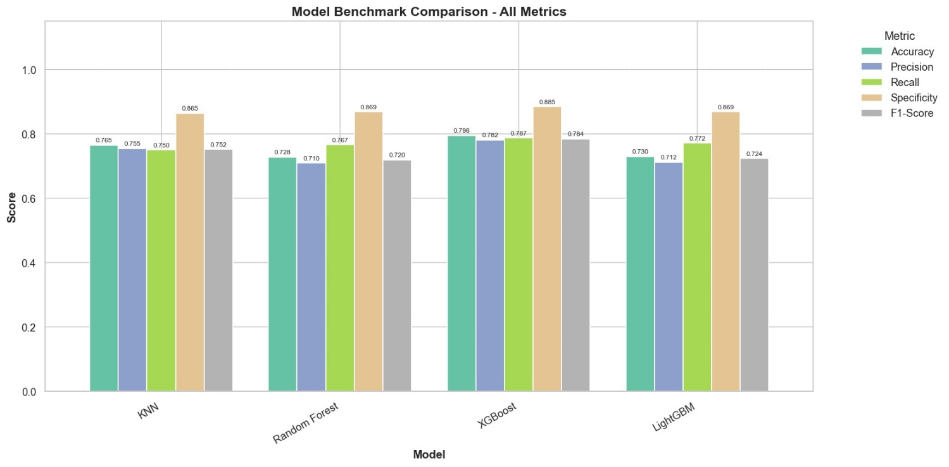
Figure 19: Model Benchmark Comparison — All Metrics

6.2 Per-Class Performance Analysis
Per-class analysis reveals important differences in how each model handles the three credit score categories. The Good class (minority, 17.8%) proves most challenging across all models, while the Standard class (majority, 53.2%) is consistently easiest to predict.

6.2.1 KNN Performance
KNN demonstrates relatively balanced per-class performance, achieving the best F1-scores for the Standard class (0.7850). Its precision-recall tradeoff is more even compared to the ensemble methods, suggesting it captures class boundaries without extreme bias. However, its overall F1-score is limited by the distance-based nature of the algorithm in a high-dimensional feature space.
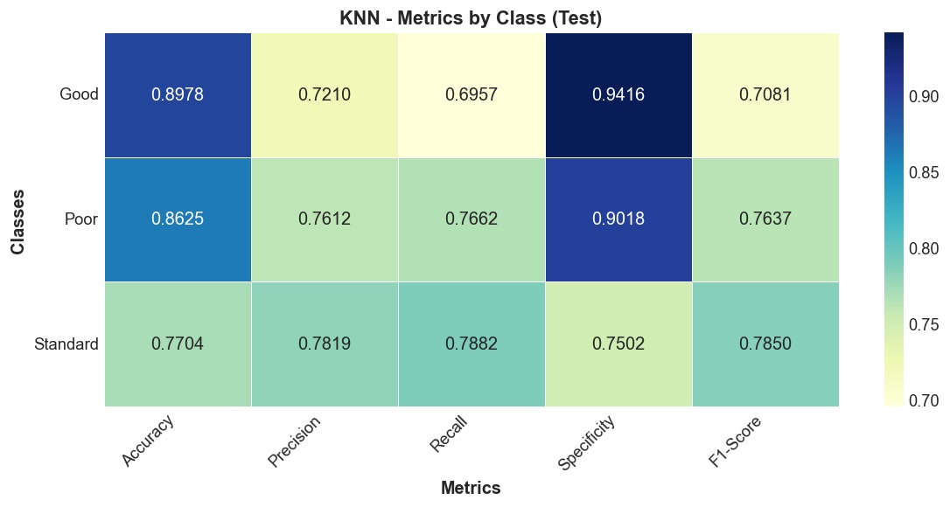
Figure 20: KNN — Per-Class Metrics (Test Set)
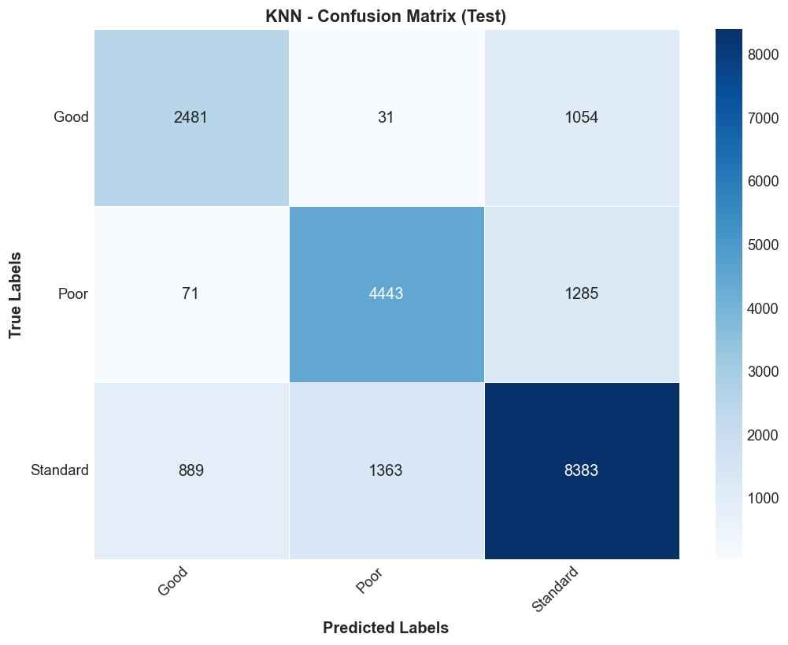
Figure 21: KNN — Confusion Matrix (Test Set)

6.2.2 Random Forest Performance
Random Forest exhibits a distinctive precision-recall asymmetry: very high recall for Good (0.8416) and Poor (0.8158) classes, but notably lower precision for Good (0.5347). This means the model captures most true Good/Poor customers but also misclassifies many Standard customers into these categories—a pattern consistent with the class imbalance biasing the tree splits toward the minority classes.
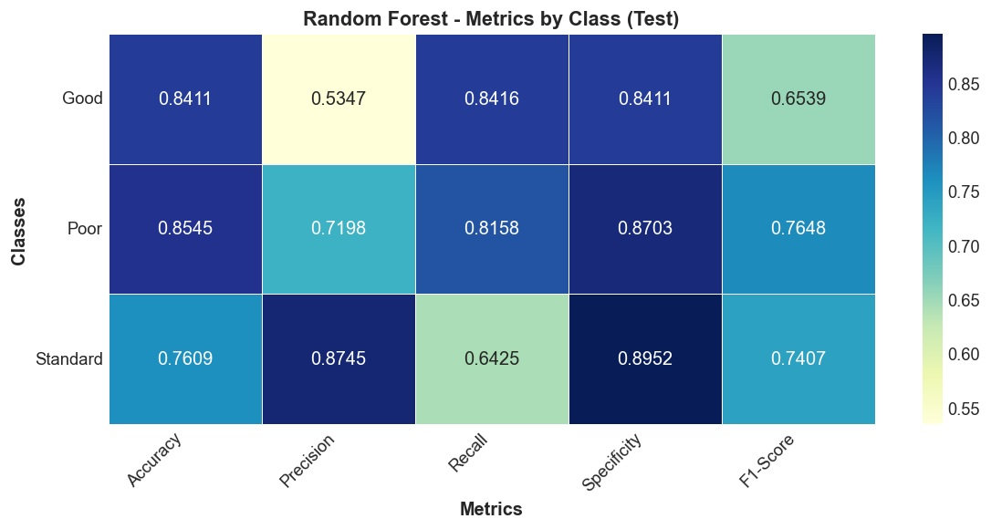
Figure 22: Random Forest — Per-Class Metrics (Test Set)
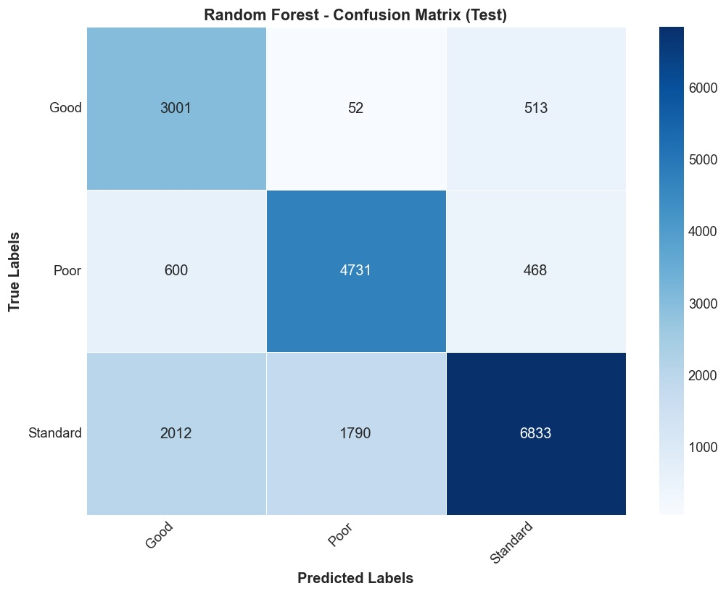
Figure 23: Random Forest — Confusion Matrix (Test Set)

6.2.3 XGBoost Performance
XGBoost achieves the most balanced performance across all three classes. Its per-class F1-scores (Good: 0.7465, Poor: 0.7916, Standard: 0.8150) show the smallest variance among all models, indicating that L1/L2 regularization and sequential error correction effectively mitigate class imbalance effects. The confusion matrix confirms a strong diagonal pattern with the most evenly distributed off-diagonal errors.
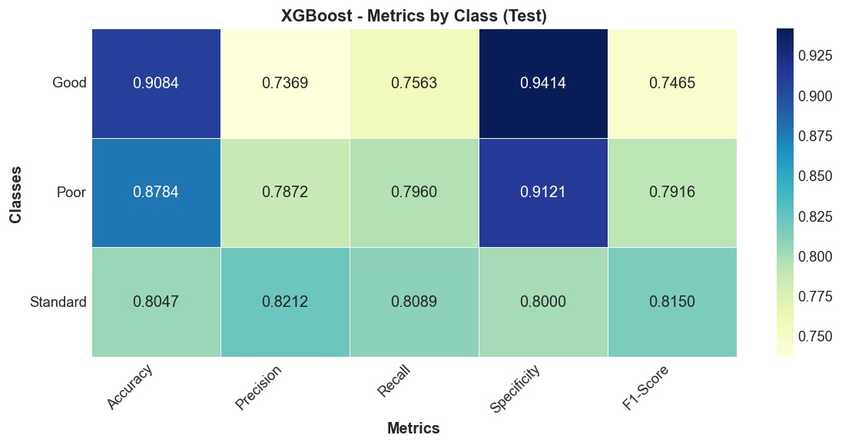
Figure 24: XGBoost — Per-Class Metrics (Test Set)
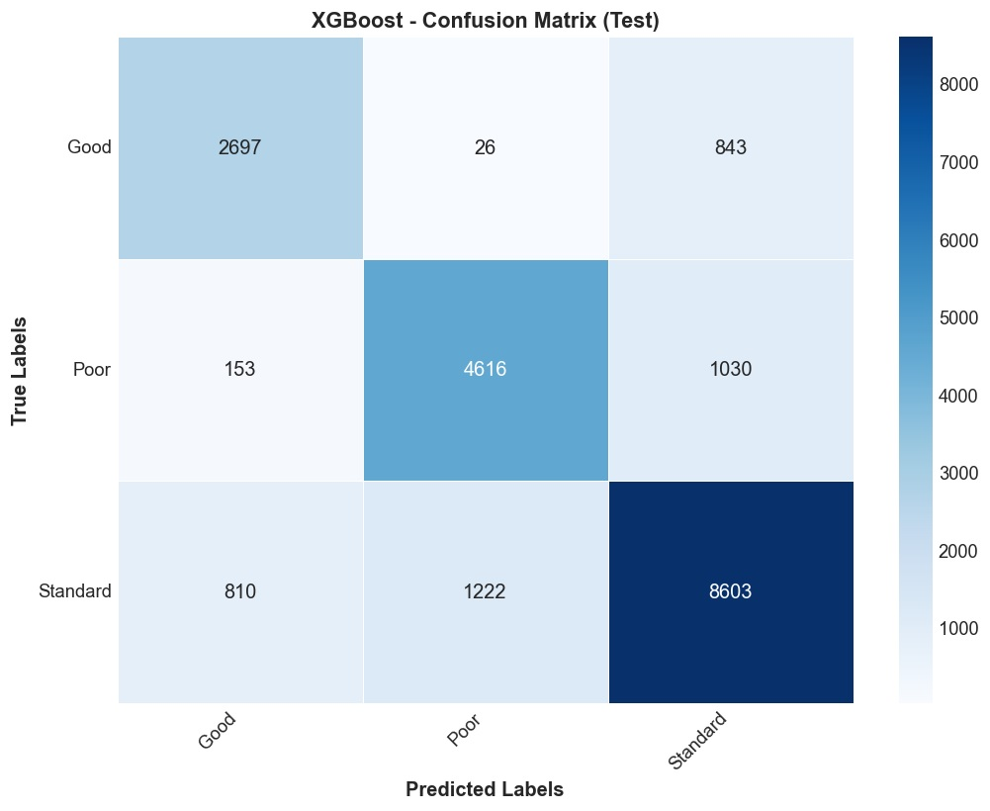
Figure 25: XGBoost — Confusion Matrix (Test Set)

6.2.4 LightGBM Performance
LightGBM shows a pattern similar to Random Forest: high recall for Good (0.8612) and Poor (0.8131) but low precision for Good (0.5587). Its leaf-wise tree growth strategy appears to favor the minority classes, resulting in many false positives for the Good category. Despite this, LightGBM achieves competitive overall metrics, confirming its suitability for large-scale classification tasks.
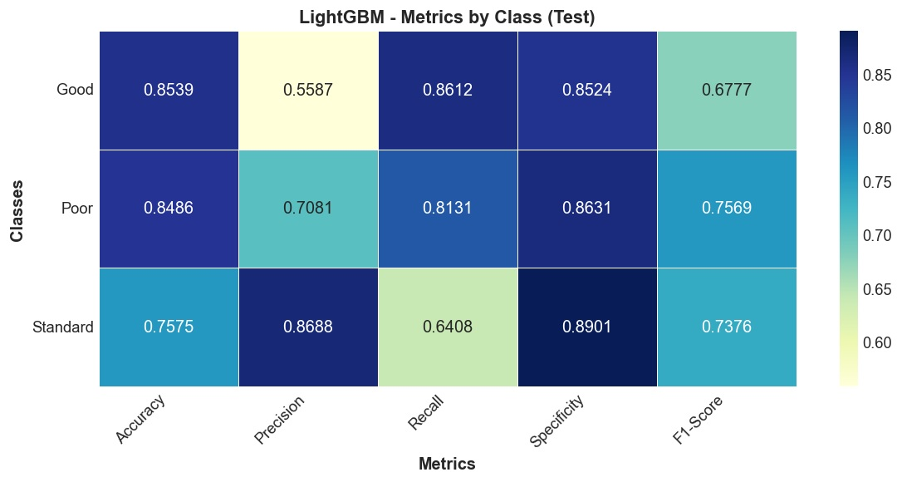
Figure 26: LightGBM — Per-Class Metrics (Test Set)
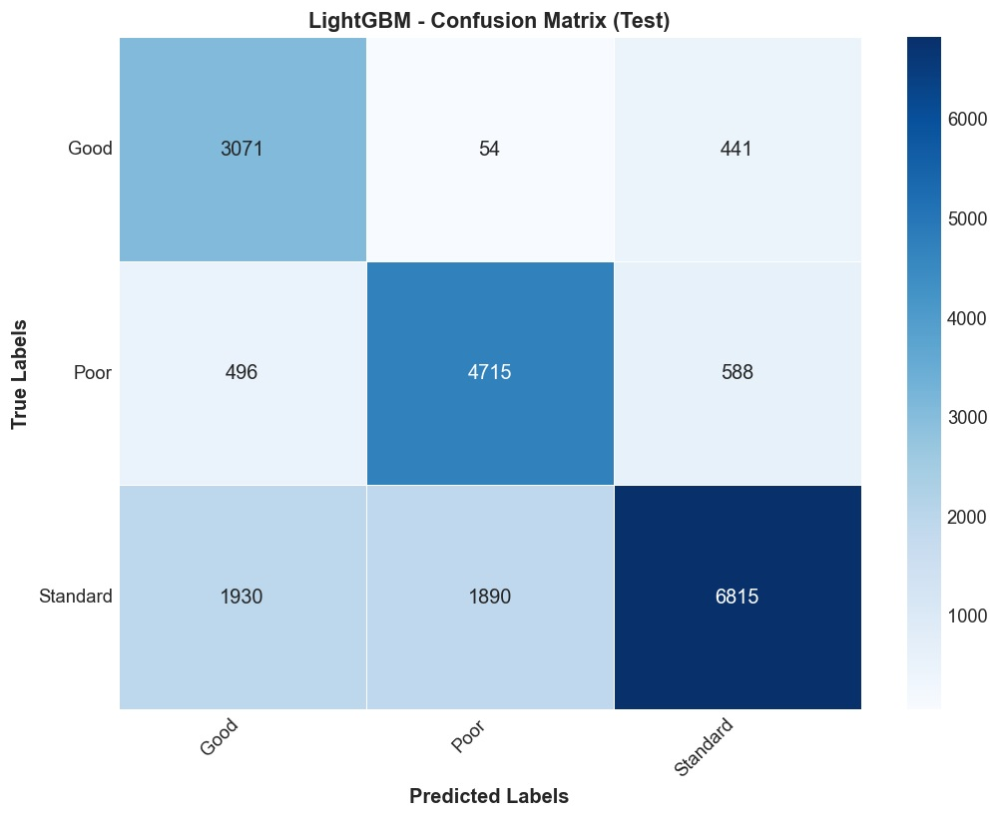
Figure 27: LightGBM — Confusion Matrix (Test Set)

6.3 Confusion Matrix Comparison
The side-by-side confusion matrix comparison reveals distinct error patterns. KNN distributes errors relatively evenly, with some confusion between Poor and Standard classes. Random Forest and LightGBM show a bias toward predicting Good and Poor classes at the expense of Standard, visible as elevated off-diagonal cells in the Standard row. XGBoost demonstrates the most balanced error distribution, with no systematic bias toward any particular class, confirming its superior handling of the multi-class imbalanced setting.
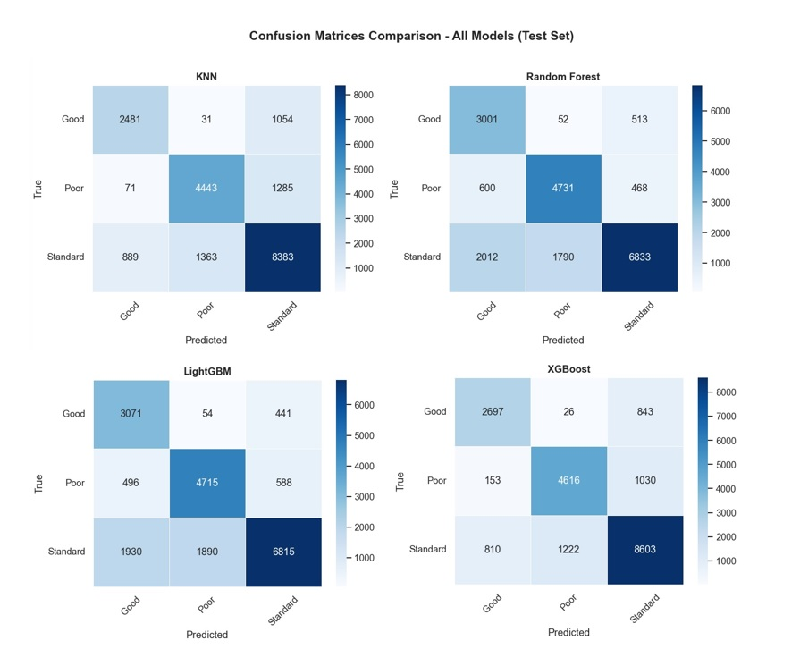
Figure 28: Confusion Matrices Comparison — All Models (Test Set)

6.4 Training Efficiency Analysis
Training time varies dramatically across models. KNN requires 5,419.66 seconds (approximately 90 minutes), making it by far the slowest model due to its lazy-learning nature requiring distance computations at prediction time. LightGBM is the fastest at 645.35 seconds (~11 minutes), followed by Random Forest at 1,126.96 seconds (~19 minutes) and XGBoost at 1,363.15 seconds (~23 minutes). Despite being the fastest to train, LightGBM does not achieve the best accuracy, while XGBoost achieves the top performance with moderate training cost, representing the optimal accuracy-speed tradeoff.
Model | Training Time (s) | F1-Score | Rank
XGBoost | 1,363.15 | 0.7844 | 1st (Best F1)
KNN | 5,419.66 | 0.7523 | 2nd (Slowest)
LightGBM | 645.35 | 0.7241 | 3rd (Fastest)
Random Forest | 1,126.96 | 0.7198 | 4th (Worse)
Table 5: Model Training Efficiency Ranking
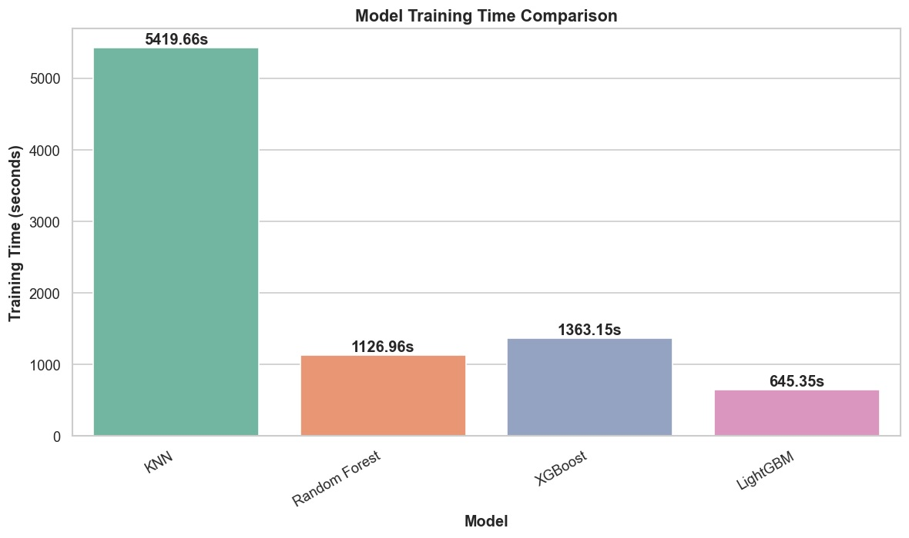
Figure 29: Model Training Time Comparison

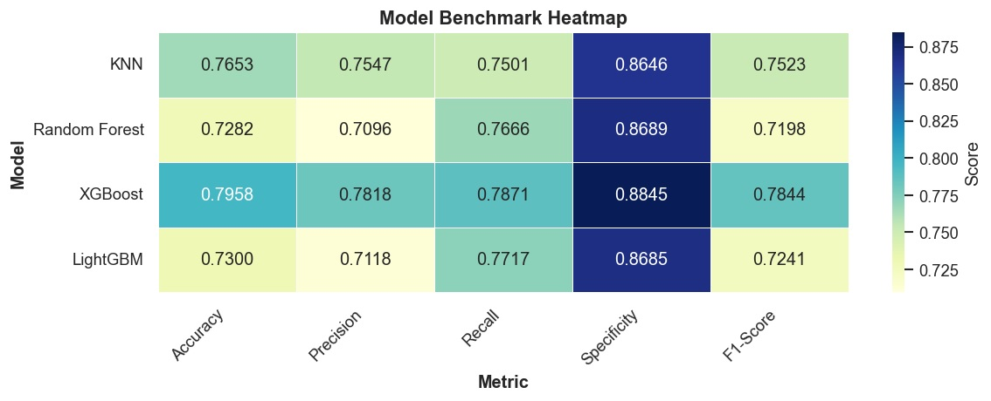
Figure 30: Model Benchmark Heatmap

6.5 Discussion and Interpretation
The benchmark results yield several important insights for credit risk modeling. First, XGBoost consistently emerges as the optimal model, achieving the highest macro F1-score (0.7844) and accuracy (79.58%) with the most balanced per-class performance. Its L1/L2 regularization and sequential boosting mechanism effectively handle the class imbalance without requiring explicit resampling techniques, making it the recommended model for production deployment.
Second, the disparity between KNN's second-place ranking and its prohibitive training time (5,419 seconds) highlights a critical practical consideration: model selection must account for computational cost, especially in production environments requiring frequent retraining. KNN's instance-based nature makes it ill-suited for large-scale deployments despite its reasonable accuracy.
Third, the systematic low precision for the Good class in Random Forest and LightGBM reveals a recurring challenge in imbalanced multi-class classification: tree-based models tend to over-predict minority classes when class weights are not explicitly tuned. This suggests that future iterations should explore cost-sensitive learning or focal loss techniques to improve the precision-recall balance for underrepresented classes.
Finally, all four models achieve macro F1-scores between 0.72 and 0.78, substantially outperforming the naive baseline. This confirms that the selected features—particularly Credit_Mix, Outstanding_Debt, Interest_Rate, Num_of_Delayed_Payment, and Credit_History_Age—capture meaningful predictive signals for credit score classification. The model rankings are consistent with established findings in the ML literature, where gradient boosting methods (particularly XGBoost) tend to dominate structured tabular classification tasks.

7. Conclusions

7.1 Key Findings
- XGBoost achieved the best overall performance (F1 = 0.7844, Accuracy = 79.58%), with the most balanced per-class metrics among all benchmarked models.
- Credit_Mix quality, Outstanding_Debt, Interest_Rate, and Num_of_Delayed_Payment are the strongest predictive features, confirmed by both EDA and model performance.
- The class imbalance (Standard 53.2%, Poor 29.0%, Good 17.8%) affects model precision for minority classes, particularly in tree-based models without explicit class weighting.
- LightGBM offers the best speed-accuracy tradeoff (645s training, F1 = 0.7241), suitable for scenarios requiring rapid model updates.

7.2 Hypotheses Evaluation
ID | Hypothesis | Status | Evidence
H1 | Higher income correlates with better scores | Confirmed | Good class shows higher median income
H2 | Lower debt associated with higher scores | Confirmed | Debt inversely correlates with score quality
H3 | More delayed payments predict poorer scores | Confirmed | Strongest continuous predictor per EDA
H4 | Longer credit history improves score | Confirmed | Positive correlation with Good class
H5 | Higher utilization linked to poor scores | Confirmed | Significant distribution differences across classes
H6 | Bank accounts and credit cards influence classification | Partially Confirmed | Non-linear relationship observed
Table 6: Hypothesis Evaluation Results

7.3 Practical Recommendations
- Deploy XGBoost as the primary credit scoring model, with LightGBM as a fast retraining alternative for scenarios requiring frequent model updates.
- Implement early warning systems monitoring delayed payment counts and credit utilization trends to identify customers at risk of credit deterioration.
- Incorporate SHAP values for model interpretability to comply with regulatory requirements (e.g., Fair Credit Reporting Act).
- Establish quarterly retraining schedules to adapt to evolving economic conditions and customer behavior patterns.
- Explore cost-sensitive learning to improve precision for the Good credit score class without sacrificing overall performance.

7.4 Limitations
- The dataset may contain synthetic or semi-synthetic data, potentially limiting direct applicability to real-world financial systems.
- Significant missing values (up to 15% for Monthly_Inhand_Salary) may introduce imputation bias despite careful strategy selection.
- Cross-sectional data lacks temporal dimension and external macroeconomic factors, limiting the model's ability to capture dynamic credit behavior.

Future Work
- Advanced Feature Engineering: Create interaction features, polynomial features, and domain-specific financial ratios.
- Neural Networks: Explore deep learning approaches (e.g., tabular neural networks, TabNet) for potential performance improvements.
- Cost-Sensitive Learning: Implement asymmetric misclassification costs (false negatives for "Good" credit are costlier than for "Poor").
- Ensemble Methods: Create a stacked ensemble or voting classifier combining the top models.
- Explainable AI (XAI): Implement SHAP and LIME for model interpretability.

8. References

[1] Breiman, L. (2001). Random forests. Machine Learning, 45(1), 5–32. https://doi.org/10.1023/A:1010933404324
[2] Chen, T., & Guestrin, C. (2016). XGBoost: A scalable tree boosting system. Proceedings of the 22nd ACM SIGKDD International Conference on Knowledge Discovery and Data Mining, 785–794. https://doi.org/10.1145/2939672.2939785
[3] Cover, T., & Hart, P. (1967). Nearest neighbor (NN) pattern classification. IEEE Transactions on Information Theory, 13(1), 21–27. https://doi.org/10.1109/TIT.1967.1053964
[4] Hastie, T., Tibshirani, R., & Friedman, J. (2009). The elements of statistical learning: Data mining, inference, and prediction (2nd ed.). Springer.
[5] Hunter, J. D. (2007). Matplotlib: A 2D graphics environment. Computing in Science & Engineering, 9(3), 90–95. https://doi.org/10.1109/MCSE.2007.55
[6] Ke, G., Meng, Q., Finley, T., Wang, T., Chen, W., Ma, W., Ye, Q., & Liu, T.-Y. (2017). LightGBM: A highly efficient gradient boosting decision tree. Advances in Neural Information Processing Systems, 30.
[7] Larose, D. T., & Larose, C. D. (2014). Discovering knowledge in data: An introduction to data mining (2nd ed.). John Wiley & Sons.
[8] Lessmann, S., Baesens, B., Seow, H.-V., & Thomas, L. C. (2015). Benchmarking state-of-the-art classification algorithms for credit scoring: An update of research. European Journal of Operational Research, 247(1), 124–136. https://doi.org/10.1016/j.ejor.2015.05.030
[9] McKinney, W. (2010). Data structures for statistical computing in Python. Proceedings of the 9th Python in Science Conference, 51–56.
[10] Pedregosa, F., Varoquaux, G., Gramfort, A., Michel, V., Thirion, B., Grisel, O., Blondel, M., Prettenhofer, P., Weiss, R., Dubourg, V., Vanderplas, J., Passos, A., Cournapeau, D., Brucher, M., Perrot, M., & Duchesnay, E. (2011). Scikit-learn: Machine learning in Python. Journal of Machine Learning Research, 12, 2825–2830.
[11] Thomas, L. C., Edelman, D. B., & Crook, J. N. (2002). Credit scoring and its applications. SIAM.
[12] Waskom, M. (2021). seaborn: Statistical data visualization. Journal of Open Source Software, 6(60), 3021. https://doi.org/10.21105/joss.03021

