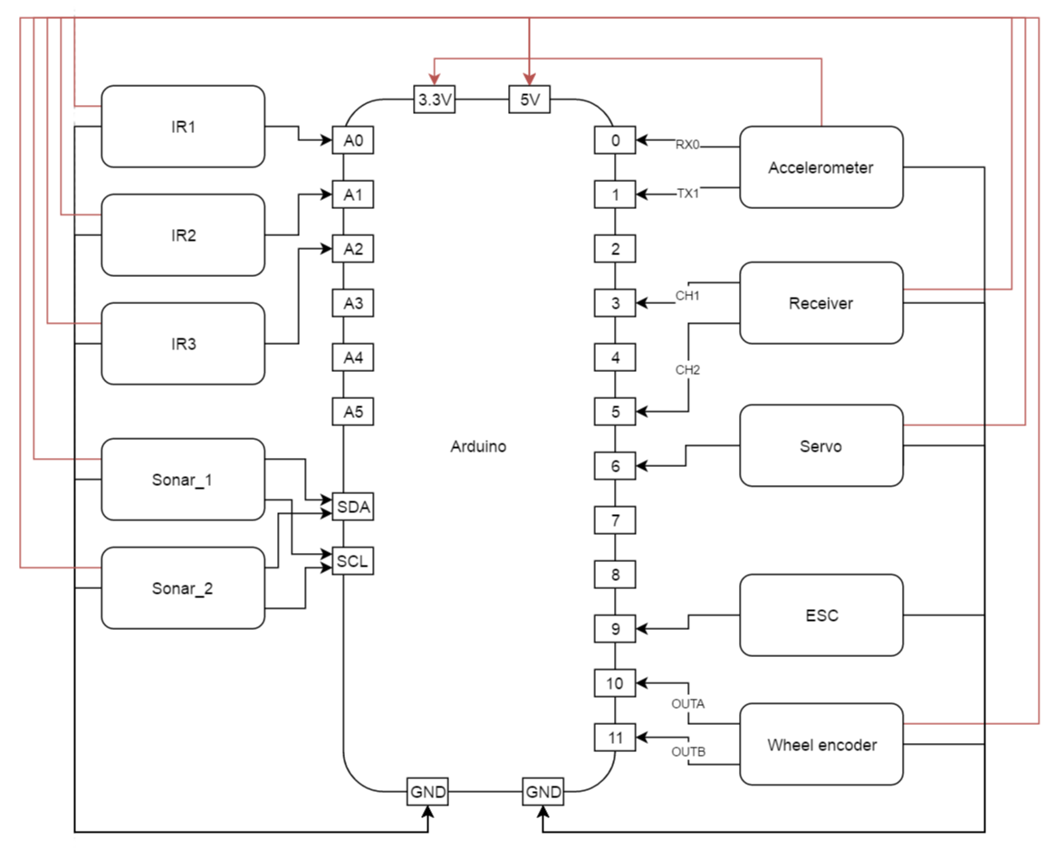

Block diagram describing power, ground, and signal connection on Arduino.

Most of the components are powered with 5 volts through the Arduino. The IMU is powered with 3.3 volts, and the ESC is powered by a battery pack.

For the ultrasonic sensors, the special data line (SDA) and clock line (SCL) pins are used. The IR sensors outputs analogue values.

We use two channels for the receiver, where channel 1 is connected to an interrupt pin (3). When a remote control is switched on, the change in input from channel 1 causes an interrupt which allows us to control the car manually.