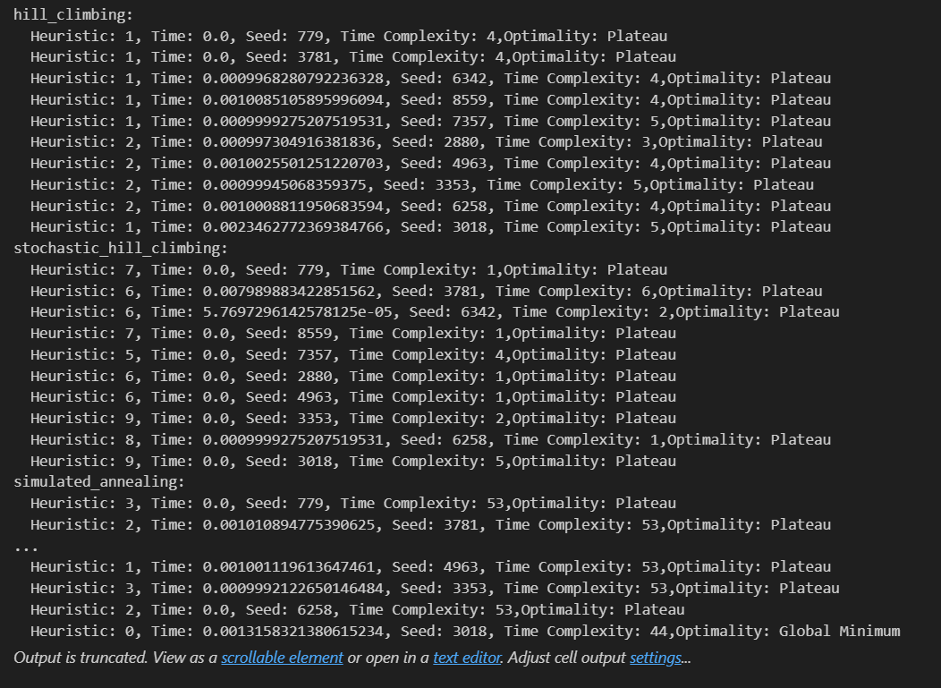

hill_climbing:

Heuristic: 0, Time: 0.0, Seed: 1854, Time Complexity: 5,Optimality: Global Minimum

Heuristic: 1, Time: 0.0, Seed: 8439, Time Complexity: 5,Optimality: Plateau

Heuristic: 1, Time: 0.0, Seed: 1137, Time Complexity: 4,Optimality: Plateau

Heuristic: 1, Time: 0.0, Seed: 2178, Time Complexity: 4,Optimality: Plateau

Heuristic: 2, Time: 0.013508796691894531, Seed: 9452, Time Complexity: 3,Optimality: Plateau

Heuristic: 0, Time: 0.0025119781494140625, Seed: 6739, Time Complexity: 7,Optimality: Global Minimum

Heuristic: 2, Time: 0.0, Seed: 9894, Time Complexity: 3,Optimality: Plateau

Heuristic: 1, Time: 0.0, Seed: 7762, Time Complexity: 3,Optimality: Plateau

Heuristic: 1, Time: 0.0, Seed: 530, Time Complexity: 4,Optimality: Plateau

Heuristic: 1, Time: 0.0, Seed: 5789, Time Complexity: 2,Optimality: Plateau

stochastic_hill_climbing:

Heuristic: 6, Time: 0.0, Seed: 1854, Time Complexity: 3,Optimality: Plateau

Heuristic: 6, Time: 0.0, Seed: 8439, Time Complexity: 4,Optimality: Plateau

Heuristic: 5, Time: 0.0, Seed: 1137, Time Complexity: 4,Optimality: Plateau

Heuristic: 3, Time: 0.0, Seed: 2178, Time Complexity: 3,Optimality: Plateau

Heuristic: 6, Time: 0.0, Seed: 9452, Time Complexity: 1,Optimality: Plateau

Heuristic: 10, Time: 0.0, Seed: 6739, Time Complexity: 1,Optimality: Plateau

Heuristic: 8, Time: 0.0, Seed: 9894, Time Complexity: 3,Optimality: Plateau

Heuristic: 5, Time: 0.0, Seed: 7762, Time Complexity: 1,Optimality: Plateau

Heuristic: 6, Time: 0.0, Seed: 530, Time Complexity: 3,Optimality: Plateau

Heuristic: 3, Time: 0.0, Seed: 5789, Time Complexity: 2,Optimality: Plateau

simulated_annealing:

Heuristic: 1, Time: 0.0, Seed: 1854, Time Complexity: 53,Optimality: Plateau

Heuristic: 1, Time: 0.0, Seed: 8439, Time Complexity: 53,Optimality: Plateau

Heuristic: 2, Time: 0.0, Seed: 1137, Time Complexity: 53,Optimality: Plateau

Heuristic: 2, Time: 0.0, Seed: 2178, Time Complexity: 53,Optimality: Plateau

Heuristic: 2, Time: 0.0, Seed: 9452, Time Complexity: 53,Optimality: Plateau

Heuristic: 2, Time: 0.0, Seed: 6739, Time Complexity: 53,Optimality: Plateau

Heuristic: 2, Time: 0.0, Seed: 9894, Time Complexity: 53,Optimality: Plateau

Heuristic: 2, Time: 0.0, Seed: 7762, Time Complexity: 53,Optimality: Plateau

Heuristic: 3, Time: 0.0, Seed: 530, Time Complexity: 53,Optimality: Plateau

Heuristic: 2, Time: 0.0, Seed: 5789, Time Complexity: 53,Optimality: Plateau