**PROJECT REPORT**

***Project name – Empolyeee Monitoring System***

**What it Does**- It gets the information of employee by tracking his/her MAC address and keeps track on his/her presence within the area of 210 ft.

**Functionalities--**

**Admin:**

admin is the principal user of the system:

He can :

add more employees (users)

can see the data of all the employees

He can also make others admin(groups) and

can alter the data of employees as well

whereas an ordinary employee(other than admin) can only see his own data.

Main working page for admin:

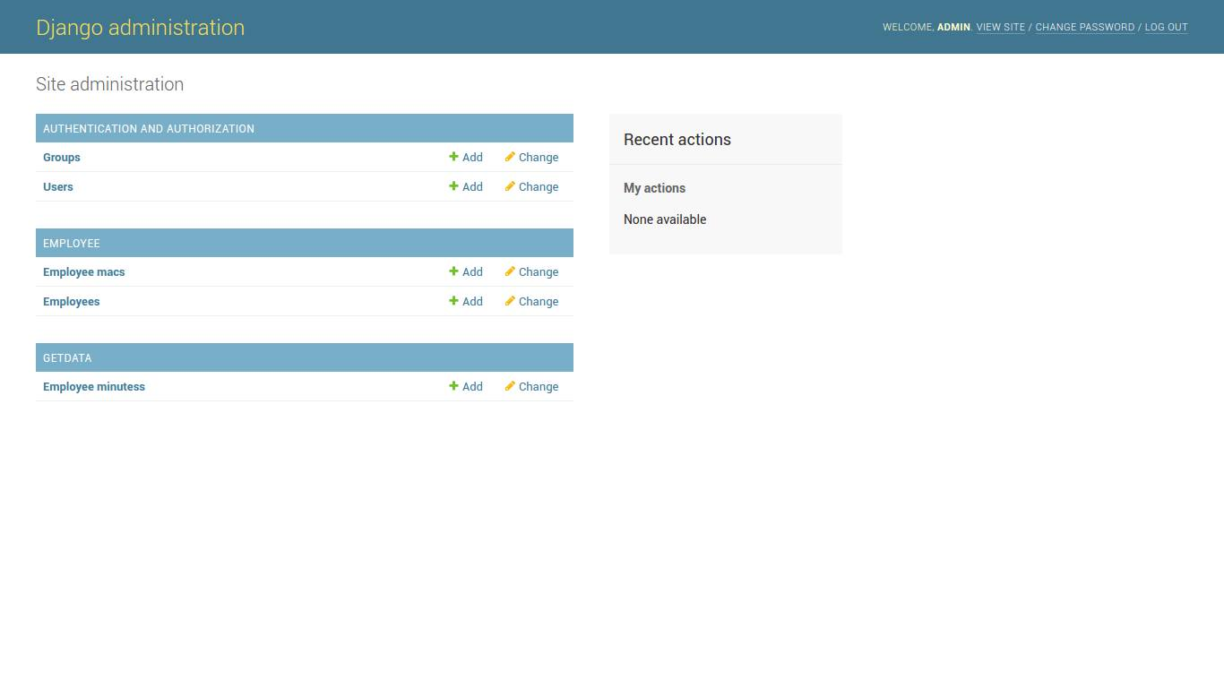Changing data of employees:

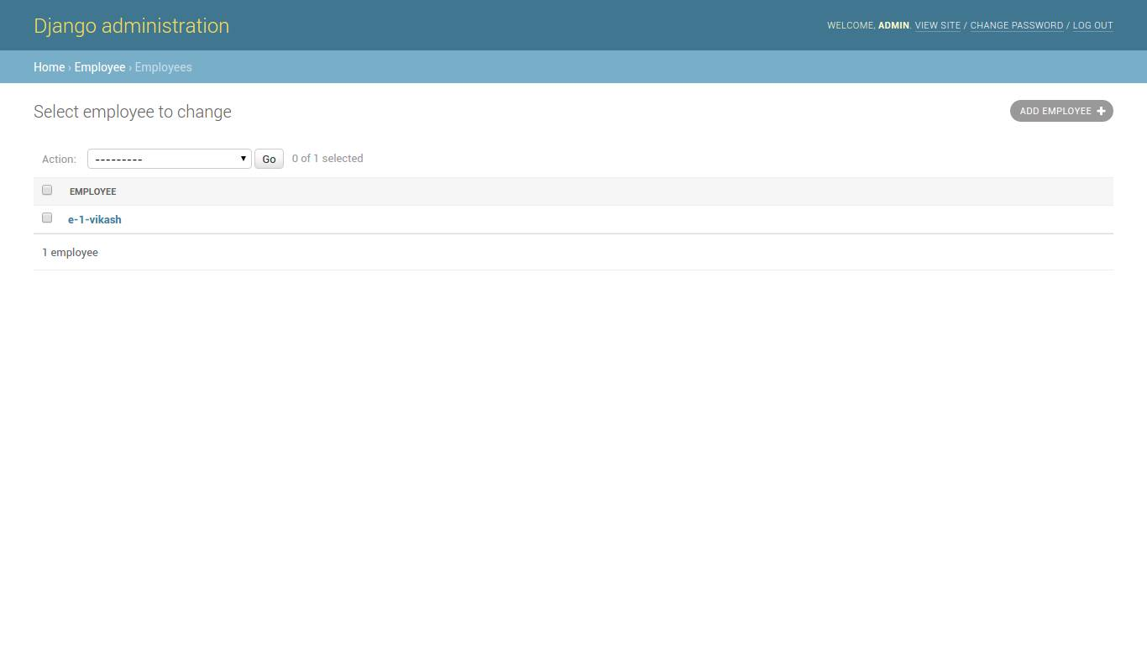

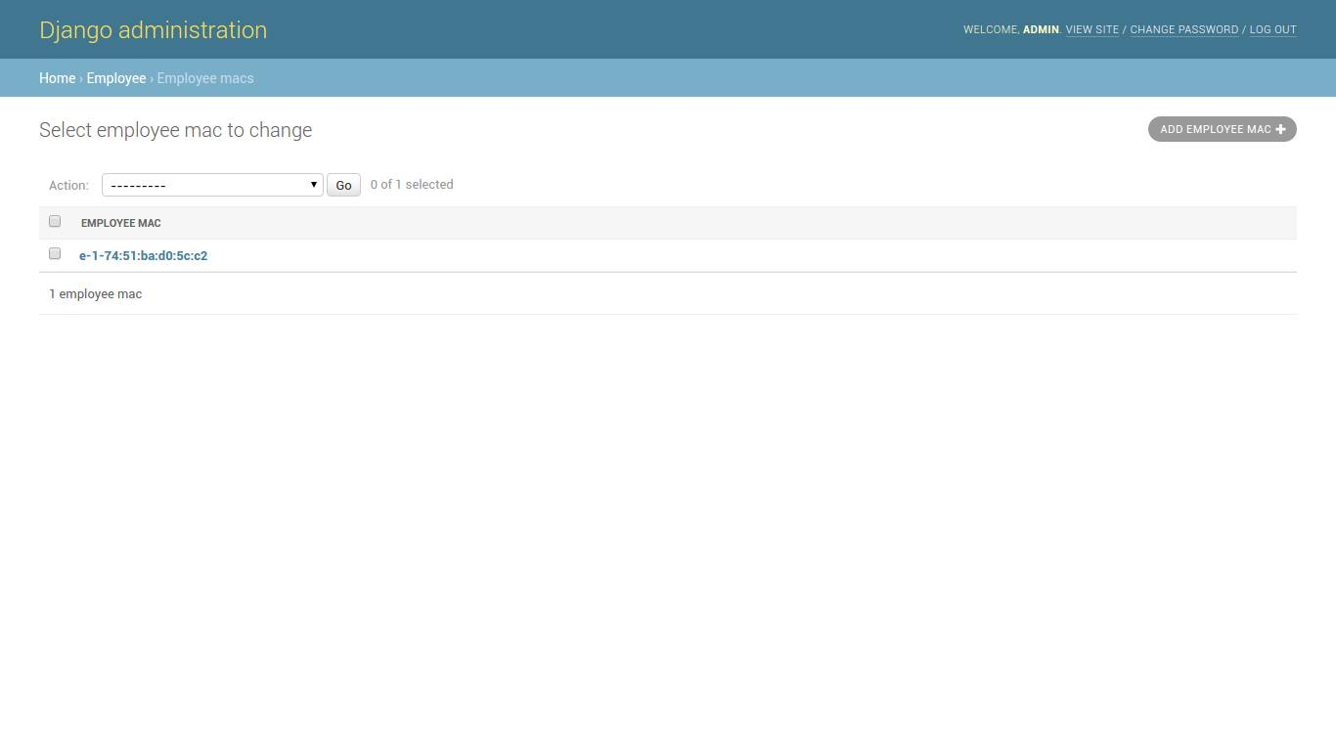Changing MAC address of employees:

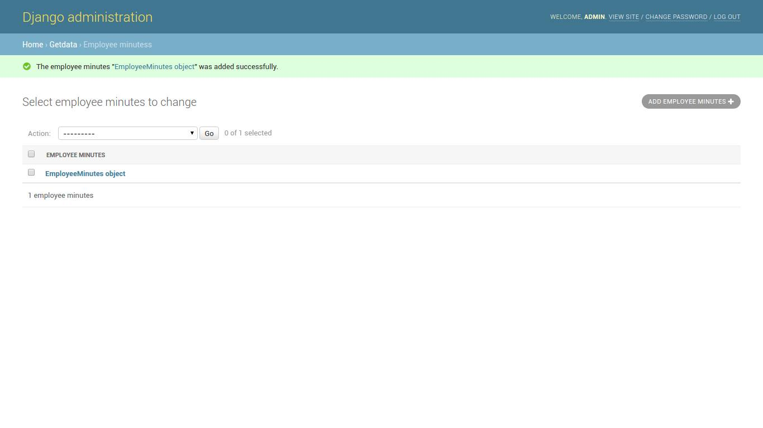

**Login Form:**

For admin- An employee can login as admin by the admin credentials given to him.

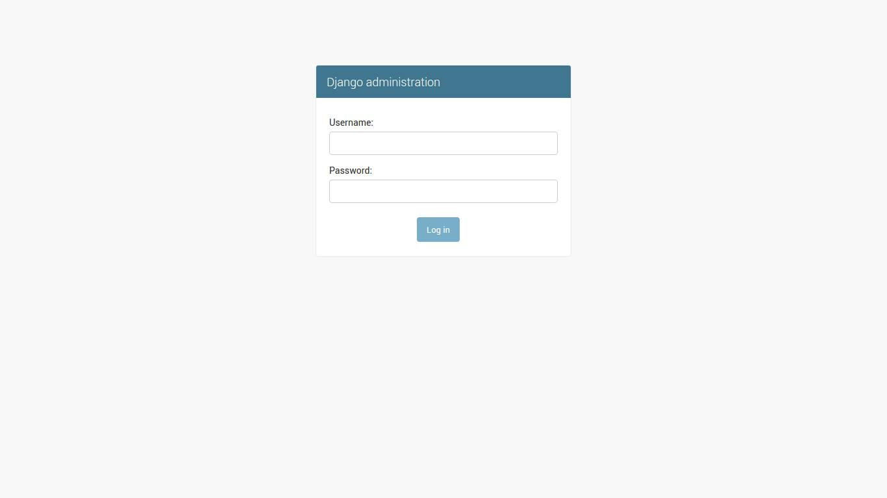

**For users** – First an employee has to register by providing the necessary information such as MAC address , username, password , Email address etc. to admin so that they can create a new user id for employee and respective credentials will be given to user. After that he can enter the portal by giving the valid credentials.

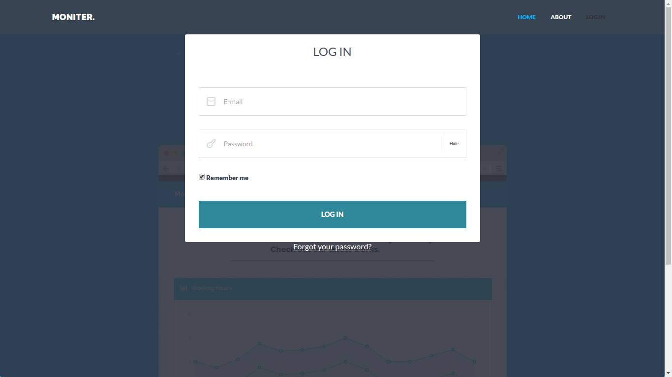

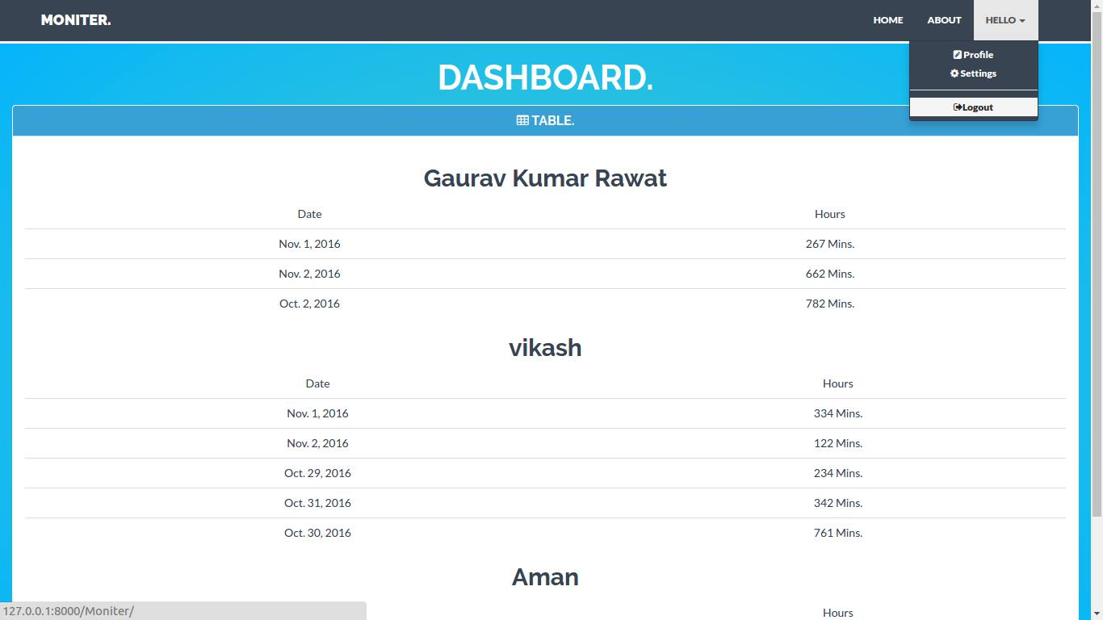

Presence of employees:

presence of an employee for a day (in minutes) will be shown in form of tables

as depicted below:

**Helpfullness of this system:**

This system can be helpful for firms to check for how much time its employees were present in the company campus with the help of devices like laptops, phones of individuals.

Submitted By:

Gaurav Kumar Rawat : 14114025

Vikash Kumar : 14114073

Tarun Jindal : 14114067

Ashish Kumar Prajapati : 14114017

Aman Kumar Singh : 14114007