**096260 - Deep learning course**

**Exercise 3**

Submitted by: Danny Semiat 200068807 Sagitt Efrat 200888386

* **Model architecture description, training procedure:**

**Preprocessing:**

We altered the data according to Sergey's alternations in <https://github.com/szagoruyko/cifar.torch.git>

* + Normalization: normalized the data according to the mean and std of the train data
  + Converted colors data from RGB to YUV

**Our Model’s Architecture:**

Inspired by Elad’s rnn.

We have 2 layers of LSTM :

Data Augmentation:

We used Horizontal Flip on some of the train data.

**Training:**

Optimization: We used optim.sgd

With learning rate that decays every 25 epochs.

Criterion (Loss Function): Cross Entropy.

Number of epochs: 300.

* **Convergence graph of the peprplexity on our model –**

Error: *(Best Epoch: 20, Lowest Perplexity on test set: 116.04)*

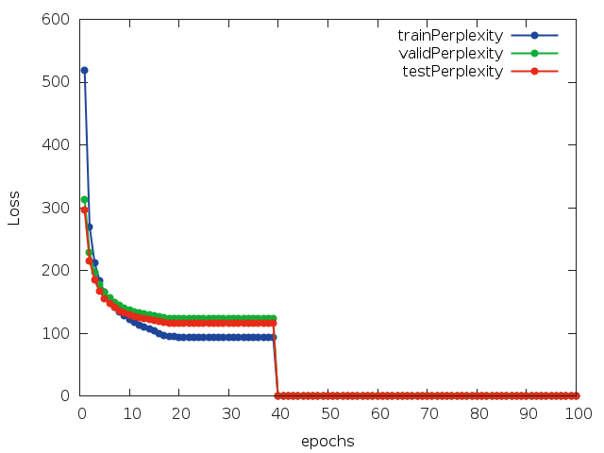

* **A short summary of our attempts and conclusions:**

We tried different kind of variables numbers in the network layers, the number of the layers and also tried different kind of PCA's and then decided on the ones that gave us the lowest loss. The loss function is 'CrossEntropy' after trying also 'MSE' that gave us bigger loss.

The number of epochs was also decided by trial and error.

* **Our code:**

On github repository:

<https://github.com/HolyFalafel/DeepLearning.git>

Under the path:

**ex2\submission\**

train_2_sgd.lua - creates the model.

cifar10_load_model.lua - loads our trained network, normalize the data. function ‘test()’ returns the average error on the test set.