**I**

**FACT OF LIFE #1: We don’t read pages. We scan them.**

One of the very few well-documented facts about Web use is that people tend to spend very little time reading most Web pages. Instead, we scan (or skim) them, looking for words or phrases that catch our eye. The exception, of course, is pages that contain documents like news stories, reports, or product descriptions, where people will revert to reading—but even then, they’re often alternating between reading and scanning.

Why do we scan?

* **We’re usually on a mission.** Most Web use involves trying to get something done, and usually done quickly. As a result, Web users tend to act like sharks: They have to keep moving, or they’ll die. We just don’t have the time to read any more than necessary.
* **We know we don’t need to read everything.** On most pages, we’re really only interested in a fraction of what’s on the page. We’re just looking for the bits that match our interests or the task at hand, and the rest of it is irrelevant. Scanning is how we find the relevant bits.
* **We’re good at it.** It’s a basic skill: When you learn to read, you also learn to scan. We’ve been scanning newspapers, magazines, and books —or if you’re under 25, probably reddit, Tumblr, or Facebook—all our lives to find the parts we’re interested in, and we know that it works.

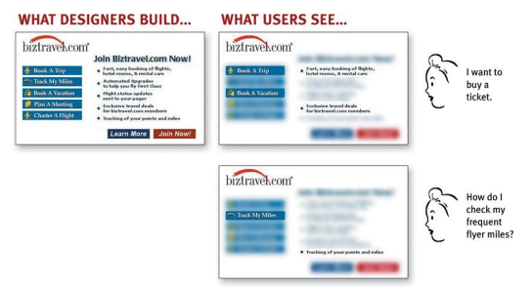

Like Ginger, we tend to focus on words and phrases that seem to match (a) the task at hand or (b) our current or ongoing personal interests. And of course, (c) the trigger words that are hardwired into our nervous systems, like “Free,” “Sale,” and “Sex,” and our own name.

**II**

**FACT OF LIFE #3: We don’t figure out how things work. We muddle through.**

One of the things that becomes obvious as soon as you do any usability testing—whether you’re testing Web sites, software, or household appliances —is the extent to which people use things all the time without understanding how they work, or with completely wrong-headed ideas about how they work.

Faced with any sort of technology, very few people take the time to read instructions. Instead, we forge ahead and muddle through, making up our own vaguely plausible stories about what we’re doing and why it works.

And muddling through is not limited to beginners. Even technically savvy users often have surprising gaps in their understanding of how things work. (I wouldn’t be surprised if even Mark Zuckerberg and Sergey Brin have some bits of technology in their lives that they use by muddling through.)

Why does this happen?

* **It’s not important to us.** For most of us, it doesn’t matter to us whether we understand how things work, as long as we can use them. It’s not for lack of intelligence, but for lack of caring. It’s just not important to us.
* **If we find something that works, we stick to it.** Once we find something that works—no matter how badly—we tend not to look for a better way. We’ll use a better way if we stumble across one, but we seldom look for one.

**III**

**Create effective visual hierarchies**

Pages with a clear visual hierarchy have three traits:

* The more important something is, the more prominent it is. The most important elements are either larger, bolder, in a distinctive color, set off by more white space, or nearer the top of the page—or some combination of the above.

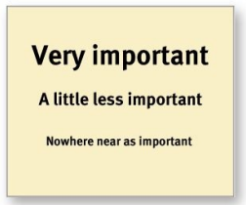

* Things that are related logically are related visually. For instance, you can show that things are similar by grouping them together under a heading, displaying them in the same visual style, or putting them all in a clearly defined area.

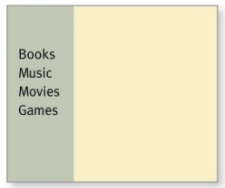

* Things are “nested” visually to show what’s part of what. For instance, a site section name (“Computer Books”) would appear above the titles of the individual books, reflecting the fact that the books are part of the section. And each book title in turn would span all the elements that make up the description of that book.

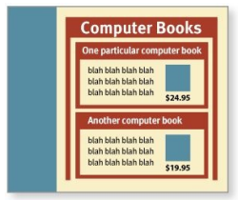

A good visual hierarchy saves us work by preprocessing the page for us, organizing and prioritizing its contents in a way that we can grasp almost instantly.

But when a page doesn’t have a clear visual hierarchy—if everything looks equally important, for instance—we’re reduced to the much slower process of scanning the page for revealing words and phrases and then trying to form our own sense of what’s important and how things are organized. It’s a lot more work.

**IV**

**Keep the noise down to a dull roar**

One of the great enemies of easy-to-grasp pages is visual noise.

Users have varying tolerances for complexity and distractions; some people have no problem with noisy pages, but many find them downright annoying. Users have even been known to put Post-its on their screen to cover up animation that’s distracting them while they’re trying to read.

There are really three different kinds of noise:

* **Shouting**. When everything on the page is clamoring for your attention, the effect can be overwhelming: Lots of invitations to buy! Lots of exclamation points, different typefaces, and bright colors! Automated slideshows, animation, pop-ups, and the never-ending array of new attention-grabbing ad formats! The truth is, everything can’t be important. Shouting is usually the result of a failure to make tough decisions about which elements are really the most important and then create a visual hierarchy that guides users to them first.
* **Disorganization**. Some pages look like a room that’s been ransacked, with things strewn everywhere. This is a sure sign that the designer doesn’t understand the importance of using grids to align the elements on a page.
* **Clutter**. We’ve all seen pages—especially Home pages—that just have too much stuff. The net effect is the same as when your email inbox is flooded with things like newsletters from sites that have decided that your one contact with them has made you lifelong friends: It’s hard to find and focus on the messages you actually care about. You end up with what engineers call a low signal-to-noise ratio: Lots of noise, not much information, and the noise obscures the useful stuff.

**V**

**THE ART OF NOT WRITING FOR THE WEB: Happy talk must die. Instructions must die.**

My Third Law probably sounds excessive, because it’s meant to. Removing half of the words is actually a realistic goal; I find I have no trouble getting rid of half the words on most Web pages without losing anything of value. But the idea of removing half of what’s left is just my way of trying to encourage people to be ruthless about it.

Getting rid of all those words that no one is going to read has several beneficial effects:

* It reduces the noise level of the page.
* It makes the useful content more prominent.
* It makes the pages shorter, allowing users to see more of each page at a glance without scrolling.

We all know happy talk when we see it: It’s the introductory text that’s supposed to welcome us to the site and tell us how great it is or to tell us what we’re about to see in the section we’ve just entered.

Happy talk is like small talk—content-free, basically just a way to be sociable. But most Web users don’t have time for small talk; they want to get right to the point. You can—and should—eliminate as much happy talk as possible.

Another major source of needless words is instructions. The main thing you need to know about instructions is that no one is going to read them—at least not until after repeated attempts at “muddling through” have failed. And even then, if the instructions are wordy, the odds of users finding the information they need are pretty low.

**VI**

**Don’t look now, but I think it’s following us**

Web designers use the term persistent navigation (or global navigation) to describe the set of navigation elements that appear on every page of a site

Just having the navigation appear in the same place on every page with a consistent look gives you instant confirmation that you’re still in the same site —which is more important than you might think. And keeping it the same throughout the site means that (hopefully) you only have to figure out how it works once.

Persistent navigation should include the four elements you most need to have on hand at all times:

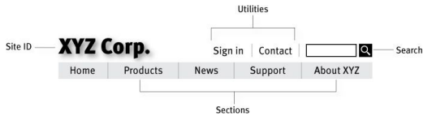

**VII**

**“You are here” & Breadcrumbs**

One of the ways navigation can counteract the Web’s inherent “lost in space” feeling is by showing me where I am in the scheme of things, the same way that a “You are here” indicator does on the map in a shopping mall—or a National Park.

On the Web, this is accomplished by highlighting my current location in whatever navigation bars, lists, or menus appear on the page.

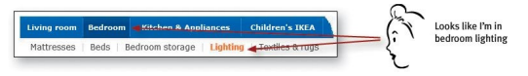

There are a number of ways to make the current location stand out:

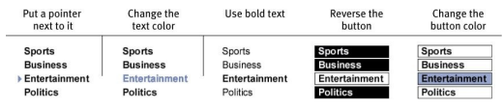

Like “You are here” indicators, Breadcrumbs show you where you are.

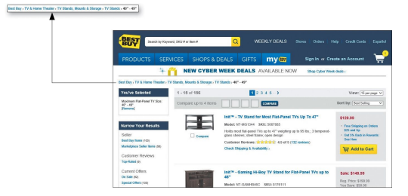

Breadcrumbs show you the path from the Home page to where you are and make it easy to move back up to higher levels in the hierarchy of a site.

Here are a few best practices for implementing them:

* **Put them at the top.** Breadcrumbs seem to work best if they’re at the top of the page. I think this is probably because it literally marginalizes them—making them seem like an accessory, like page numbers in a book or magazine.
* **Use > between levels.** Trial and error seems to have shown that the best separator between levels is the “greater than” character (>), probably because it visually suggests forward motion down through the levels.
* **Boldface the last item.** The last item in the list should be the name of the current page, and making it bold gives it the prominence it deserves. And because it’s the page that you’re on, naturally it’s not a link.

**VII**

**The First Casualty of War**

Given everything the Home page has to accomplish, if a site is at all complex even the best Home page design can’t do it all. Designing a Home page inevitably involves compromise. And as the compromises are worked out and the pressure mounts to squeeze in just one more thing, some things inevitably get lost in the shuffle.

The one thing you can’t afford to lose in the shuffle—and the thing that most often gets lost—is conveying the big picture. Whenever someone hands me a Home page design to look at, there’s one thing I can almost always count on: They haven’t made it clear enough what the site is.

As quickly and clearly as possible, the Home page needs to answer the four questions I have in my head when I enter a new site for the first time:

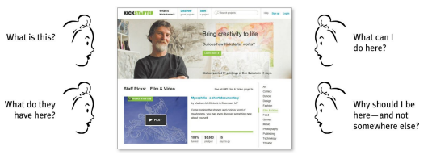

I need to be able to answer these questions at a glance, correctly and unambiguously, with very little effort.

This is what I call the Big Bang Theory of Web Design. Like the Big Bang Theory, it’s based on the idea that the first few seconds you spend on a new Web site or Web page are critical.

**VIII**

**Nothing beats a good tagline!™**

A tagline is a pithy phrase that characterizes the whole enterprise, summing up what it is and what makes it great.

On a Web site, the tagline appears right below, above, or next to the Site ID.

Taglines are a very efficient way to get your message across, because they’re the one place on the page where users most expect to find a concise statement of the site’s purpose.

Some attributes to look for when choosing a tagline:

* Good taglines are **clear** and **informative** and explain exactly what your site or your organization does.

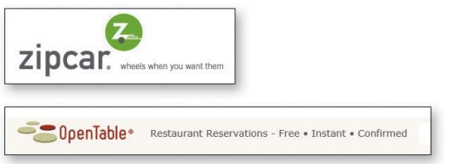

* Good taglines are **just long enough, but not too long**. Six to eight words seem to be long enough to convey a full thought, but short enough to absorb easily



* Good taglines **convey differentiation** and a clear benefit. Jakob Nielsen has suggested that a really good tagline is one that no one else in the world could use except you, and I think it’s an excellent way to look at it.

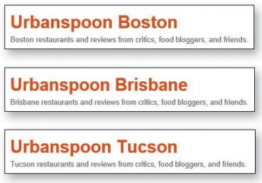

* Bad taglines sound **generic**.



Don’t confuse a tagline with a motto, like “We bring good things to life,” “You’re in good hands,” or “To protect and to serve.”

* Good taglines are **personable, lively**, and **sometimes clever**. Clever is good, but only if the cleverness helps convey—not obscure—the benefit.

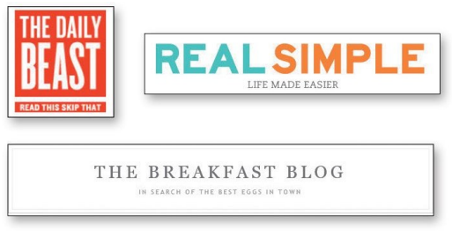

**IX**

**Accessibility and you**

As of right now, these are probably the most important things to do:

* **Add appropriate alt text to every image.** Add an empty (or “null”) alt attribute () for images that screen readers should ignore, and add helpful, descriptive text for the rest
* **Use headings correctly.** The standard HTML heading elements convey useful information about the logical organization of your content to people using screen readers and make it easier for them to navigate via the keyboard. Use <h1> for the page title or main content heading, <h2> for the major section headings, <h3> for subheadings, nad so on, and then use CSS to redefine the visual appearance of each level.
* **Make your forms work with screen readers.** This largely boils down to using the HTML <label> element to associate the fields with their text labels, so people know what they’re supposed to enter.
* **Put a “Skip to Main Content” link at the beginning of each page.** Imagine having to spend 20 seconds (or a minute, or two) listening to the global navigation at the top of every page before you could look at the content, and you’ll understand why this is important.
* **Make all content accessible by keyboard.** Remember, not everyone can use a mouse.
* **Create significant contrast between your text and background.** Don’t ever use light grey text on a dark grey background, for instance.
* **Use an accessible template**. If you’re using WordPress, for example, make sure that the theme you choose has been designed to be accessible.

**X**

**A few definitive answers**

But I know that we all love to have definitive answers, so here’s a tiny collection of things that you should always do or never do.

* **Don’t use small, low-contrast type.** You can use large, low-contrast type, or small (well, smallish) high-contrast type. But never use small, low-contrast type. (And try to stay away from the other two, too.) Unless you’re designing your own design portfolio site, and you really, truly don’t care whether anybody can read the text or not.
* **Don’t put labels inside form fields.** Yes, it can be very tempting, especially on cramped mobile screens. But don’t do it unless all of these are true: The form is exceptionally simple, the labels disappear when you start typing and reappear if you empty the field, the labels can never be confused with answers, and there’s no possibility that you’ll end up submitting the labels along with what you type (“Job TiAssistant Managertle”). And you’ve made sure they’re completely accessible. If you don’t agree, before you send me email please search for “Don’t Put Labels Inside Text Boxes (Unless You’re Luke W)” and read it.
* **Preserve the distinction between visited and unvisited text links.** By default, Web browsers display links to pages that you’ve already opened in a different color so you can see which options you’ve already tried. This turns out to be very useful information, especially since it’s tracked by URL, not by the wording of the link. So if you clicked on Book a trip, when you see Book a flight later you know that it would take you to the same page. You can choose any colors you want, as long as they’re noticeably different.
* **Don’t float headings between paragraphs.** Headings should be closer to the text that follows them than the text that precedes them. (Yes, I know I mentioned this is Chapter 3, but it’s so important it’s worth repeating.)