# A Study on Bearing Creep Mechanism With FEM Simulation Zhan 2007

This paper discusses outer ring creep in rolling bearings under non-rotating load conditions. Traditionally, outer ring creep was attributed to rotating bearing loads, but the paper investigates cases where creep occurs even with a fixed radial load. The study employs Finite Element Method (FEM) simulation and experimental tests to analyze the phenomenon.

The key findings include:

1. Outer ring creep under non-rotating load results from localized strain and rippling deformation caused by rolling elements.

2. FEM simulation indicates that each passage of a rolling element generates a driving force, causing the outer ring to rotate in the same direction as the inner ring.

3. Experimental tests validate the simulation results, showing that **outer ring creep speed increases with bearing load and is not primarily caused by dynamic torque**.

4. Housing stiffness also influences outer ring **creep likelihood**, with t**hinner housings exhibiting greater susceptibility**.

# Intermediate layer as measure against rolling bearing creep Schiemann 2018

This article investigates measures to counteract rolling bearing creep, focusing on tribological, design, and positive-fit approaches. Simulation studies and laboratory tests were conducted on various measures, including elastic intermediate layers, interference-fit intermediate steel rings (ISRs), and other design modifications. The results highlight the effectiveness of ISRs in inhibiting bearing creep, especially with minimal interference between the ISR and the outer ring. Tests on bearings 6205 and NU205 demonstrated successful prevention of creep under various conditions. Additionally, the study emphasizes the **importance** of considering ISR **thickness** **in relation to bearing outer ring diameter**. Calculation models and design rules derived from the research have been implemented in the **"SimWag2.1Z88" software**, aiding designers in detecting and addressing rolling bearing creep early in the development phase. Future research aims to extend these findings to rolling-bearing-supported helical planetary gears, addressing axial creep phenomena.

The key findings include:

1. Elastic Intermediate Layers:** Different materials, including a thermoplastic layer and a glass-reinforced plastic (GRP) layer, were studied for their effectiveness in preventing rolling bearing creep. **The GRP layer demonstrated significant improvement** in the creep threshold for cylindrical roller bearings compared to deep groove ball bearings. Bolj občutljiv na creeping je deep groove ball bearing.

2. Intermediate Steel Rings (ISRs):** Fitting **ISRs** onto the outer ring with an interference fit was found to be **highly effective in inhibiting bearing creep**. Even with small interferences, ISRs successfully prevented bearing creep in tests with bearings 6205, NU205, and 6216.

3. Influence of ISR Thickness:** The thickness of the ISR was crucial in determining its effectiveness. **Thicker ISRs demonstrated better performance** in preventing bearing creep, and even a small interference was sufficient to terminate creep.

4. Application to Larger Bearings:** The study confirmed that **ISRs are applicable to larger bearings** (6216) and emphasized the importance of considering ISR thickness relative to the bearing outer ring diameter.

5. Software Implementation:** The derived calculation models and design rules were implemented in the "SimWag2.1Z88" software, providing a tool for designers to detect and address rolling bearing creep early in the development phase.

6. Future Research:** Ongoing research aims to extend the findings to rolling-bearing-supported helical planetary gears, addressing axial creep phenomena and further enhancing understanding of fundamental creep mechanisms in various bearing systems.

# Steady-state creep in an inclusion bearing material by plastic accommodation

The study investigates stress relaxation in materials containing inclusions at high temperatures under an external load, focusing on steady-state creep with only matrix plastic flow. The analysis uses variational principles and finite element method (FEM). The research challenges previous conclusions and demonstrates that **steady-state creep occurs even with matrix plastic flow**. The study discusses the nonuniform stress distribution causing steady-state creep and explores the **dependence of creep rate on inclusion aspect ratio and volume fraction**. FEM analyses reveal steady-state creep in both two- and three-dimensional cases, correcting earlier false results obtained without certain options. The findings provide insights into the behavior of materials with inclusions under external loads.

Key findings from the study:

1. Steady-State Creep: The research establishes the **existence of steady-state creep** in materials with inclusions, **even when only matrix plastic flow is operational**. This challenges previous conclusions that suggested the eventual stop of creep.

2. Nonuniform Stress Distribution: The study discusses the characteristic of **nonuniform stress distribution**, which is identified as a **key factor contributing to steady-state creep** in materials with inclusions.

3. Dependence on Inclusion Properties: The research explores how the steady-state creep rate is influenced by the **inclusion aspect ratio and volume fractio**n. This provides insights into the factors affecting the creep behavior of materials with inclusions.

4. Finite Element Method (FEM) Analyses: FEM analyses are employed to validate and complement the findings. The study highlights the importance of certain options in FEM calculations, such as the constant dilatation option, in obtaining accurate results and avoiding false conclusions.

5. Correction of Previous Analysis: The research points out errors in a previous analysis that indicated the eventual stop of creep. By using FEM with appropriate options, the study corrects these inaccuracies and presents a more accurate representation of the material's creep behavior.

6. Insights into Material Behavior: The findings contribute to a better understanding of how materials with inclusions respond to external loads, particularly in terms of steady-state creep and the role of various factors in influencing creep rates.

# Study on creep characteristics of oil film bearing Wang 2014

Bolj mesh okoli ne bearinga, ansys!

Babbitt, especially SnSb11Cu6, in oil film bearing were studied through creep tests, mathematical modeling, and finite element numerical simulation. Here are the key findings and conclusions:

Key findings from the study:

2. Mathematical Modeling:

- The Graham creep model and the wheat quarts method, along with a global optimization algorithm, were employed to analyze the creep data.

- **Creep coefficients were determined**, and **relationships between creep coefficients and stress** were established using mathematical models.

3. Finite Element Numerical Simulation (FEM):

- **ANSYS was used for FEM** analysis to simulate the creep behavior of SnSb11Cu6 Babbitt.

- The simulation results were validated against experimental data, showing a maximum relative error of less than 0.25%, confirming the accuracy of the FEM approach.

4. Creep Characteristics: **Utrujanje**

- The **strain hardening phenomenon** was identified as a major cause of Babbitt creep.

- The process of Babbitt creep was described as a competitive process involving alloy reversion and dislocation multiplication due to strain hardening.

- Creep curves exhibited two phases: a decelerating creep stage followed by a steady creep stage.

5. Extrapolation of Creep Data:

- Creep coefficients obtained from tests were used to extrapolate **creep curves under different stress conditions.**

- Stress-relative indices were employed to deduce creep properties under various stress levels, providing a comprehensive understanding of Babbitt creep.

6.*FEM Simulation of Oil Film Bearing:

- The FEM simulation of SnSb11Cu6 Babbitt in an oil film bearing demonstrated that creep **strain mainly concentrated in the central zone with higher load, corresponding to the minimum oil film thickness**.

- **Creep strain increased continuously with time**, and the zone with obvious creep deformation expanded externally.

# FE Simulations of Irreversible Relative 2013

This paper explores the phenomenon of **creeping in rolling bearing seats, which involves continuous rotation of the bearing ring relative to the connection geometry** (housing or shaft). Creeping can lead to wear in bearing seats and eventual bearing failure, making it crucial to avoid. The study focuses on **identifying factors influencing creeping** and proposes methods to mitigate its effects. **An algorithm for analytically determining the critical creeping load** is developed. The research provides valuable insights for optimizing bearing design and selection to prevent creep damage, particularly in the context of renewable energy applications like wind turbines. The work includes **complex 3D finite element simulations**, parameter analyses, and constructive solutions such as flexible thin-film interlayers and form-fitted creeping locks. The developed algorithm aids in calculating the critical creeping load, offering a practical tool for bearing design without relying on extensive and costly experiments.

Key findings from the study:

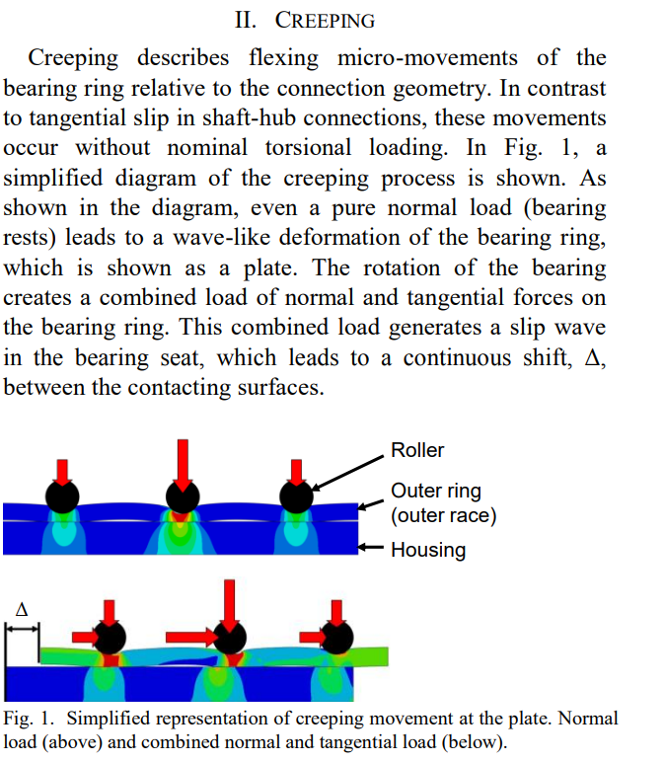

4. Analytical Determination of Creeping Load:

- An **algorithm is developed for the analytical determination** **of the critical creeping load** in the outer ring of roller bearings under radial loads.

5. Finite Element Simulations:

- **Complex 3D finite element kinematic simulations are conducted to analyze the creeping behavior of roller bearings.**

- A detailed analysis of the creeping of the bearing ring is presented for the first time.

6.Influence of Factors on Creeping:

- Factors such **as modulus of elasticity**, **thickness ratio**, and **coefficient of friction** influence creeping behavior.

- **Higher modulus of elasticity in the housing reduces creeping torque.**

**- Higher coefficient of friction in the bearing seat reduces creeping torque.**

7. Effect of Clearance Fit:

- **Increasing clearance fit** between housing and outer ring **reduces creeping torque**.

- Clearance fit modification affects the load zone, leading to a reduction in stress and prevention of creeping.

8. Constructive Solutions to Reduce Creeping:

- **Flexible thin-film interlayers** (FTI) between the housing and bearing ring can **reduce** **creeping torque**, with polyamide showing promising results.

- Form-fitted creeping locks provide a constructive solution for heavily loaded bearings and critical creeping applications.

9. Calculation Model for Critical Creeping Load:

- **An algorithm is presented for the analytical determination of the critical creeping load**, allowing for the estimation of bearing load before the onset of creeping.

- The automated calculation tool, **SimWag, is developed based on this algorithm**.

# Sesti clanek nima kroglicnih ma valje so idk