**Project4:**

**ELECTRICITY PRICES AND PREDICTIONS**

**INTRODUCTION:**

**Electricity prices are a critical component of modern economies,impacting everything from house hold budgets to industrial production costs.Understanding and predicting electricity prices is alike essential for consumers,energy producers,policy makers and investors. Data science with its analytical and predictive capabilities has emerged as a valuable tool for tackling this challenge.**

**1.DATASOURCE:**

* Historical Electricity price data:

**Historical electricity price data is essential for training . predictive models.you can obtain this data from government agencies,utility companies or energy market operators.these data sets typically include price information for different time intervals** **(eg:hourly,daily or monthly)and may span several years.**

* Weather Data:

Weather conditions can significantly affect electricity demand and supply. Collect historical weather data, including temperature, humidity, wind speed, and precipitation.

* Economic Indicators:

Economic factors, such as GDP, inflation rates, and industrial production, can also impact electricity prices.

* Energy Supply Data:

Data on energy production and generation methods, including fossil fuels, renewables, and nuclear, can be crucial.

* Market Data:

Information about market trends, news, and events that may influence energy prices.

**2. Data Preprocessing:**

* Data Cleaning:

Clean and preprocess the data to handle missing values, outliers, and inconsistencies.

* Data Integration:

Merge data from different sources and align timestamps for consistency.

* Feature Engineering:

Create new features or transform existing ones that may capture relevant patterns. For example, you can calculate moving averages, seasonality, or lag features.

* Scaling and Normalization:

Standardize numerical features to ensure they are on the same scale.

**3.Feature Selection:**

Use techniques like feature importance from machine learning models or domain knowledge to select the most relevant features for prediction.

**4.Model Selection:**

Choose appropriate machine learning or time series forecasting models. Common choices include:

* Linear Regression
* Random Forest
* Support Vector Machines
* Time Series Models (e.g., ARIMA, SARIMA)
* Deep Learning (e.g., LSTM, GRU)

**5. Model Training:**

* Split the data into training, validation, and test sets.
* Train the selected models on the training data.
* Tune hyperparameters using cross-validation to optimize model performance.

**6. Model Evaluation:**

* Evaluate model performance using appropriate metrics such as Mean Absolute Error (MAE), Mean Squared Error (MSE), or Root Mean Squared Error (RMSE).
* Compare different models to select the best-performing one.

Example:

[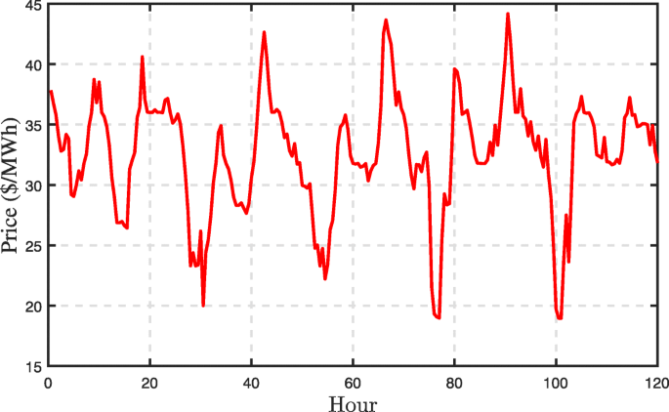](https://bdataanalytics.biomedcentral.com/articles/10.1186/s41044-018-0036-x/figures/1)

**. 4**

[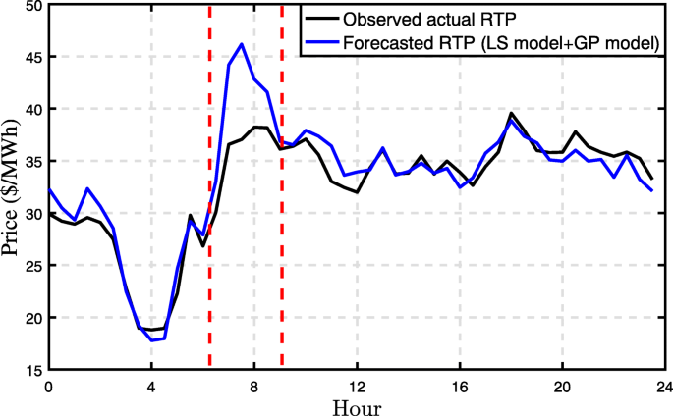](https://bdataanalytics.biomedcentral.com/articles/10.1186/s41044-018-0036-x/figures/4)

**[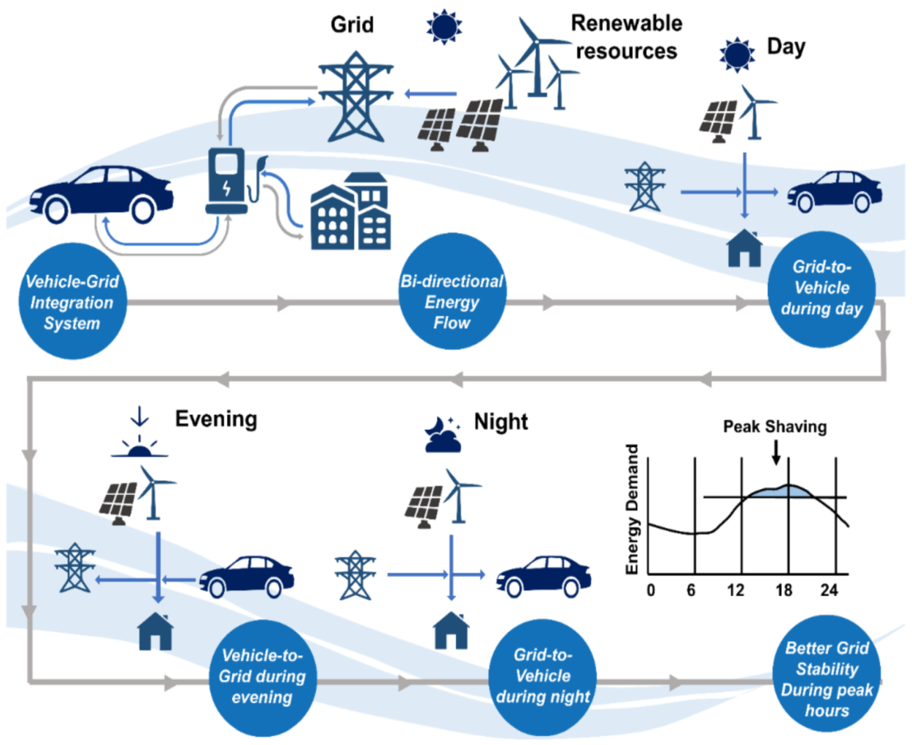](https://www.mdpi.com/energies/energies-15-00589/article_deploy/html/images/energies-15-00589-g001.png)**

**Advantages:**

* **Highlight the advantages of electricity price prediction:**
* **Informed decision-making for businesses and consumers.**
* **Reduced operational costs for utilities.**
* **Improved grid stability and resilience.**

**Disadvantages:**

* **Acknowlage the potential disadvantages and challenges:**
* **Uncertainties due to external factors(eg: weather events).**
* **Ethical concerns regarding data privacy and market manipulation.**
* **Technological limitation and model inaccuracies.**