# PMD installation

URL GITHUB: https://github.com/Homarzx/codeinspection

PMD download from the marketplace.

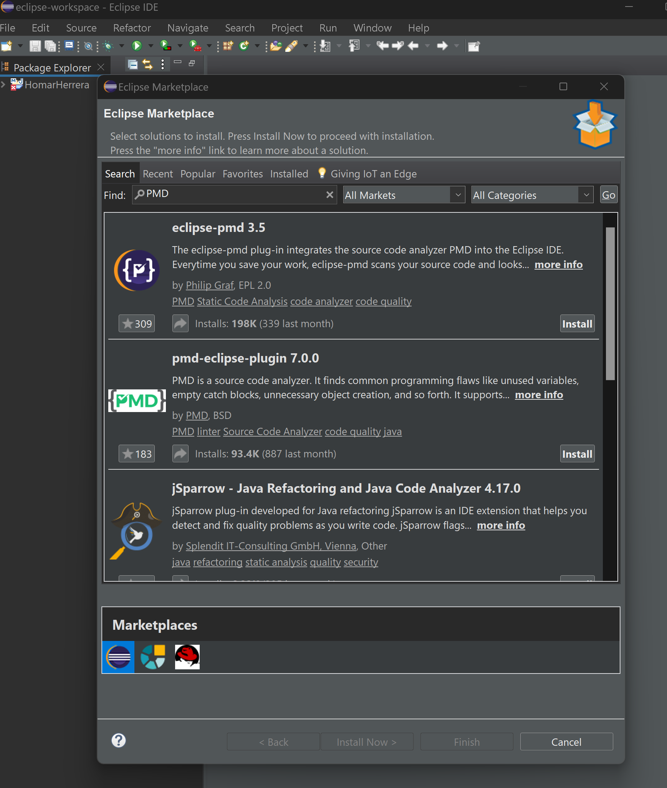

Replacement and deletion of rules and modifications of the reports properties

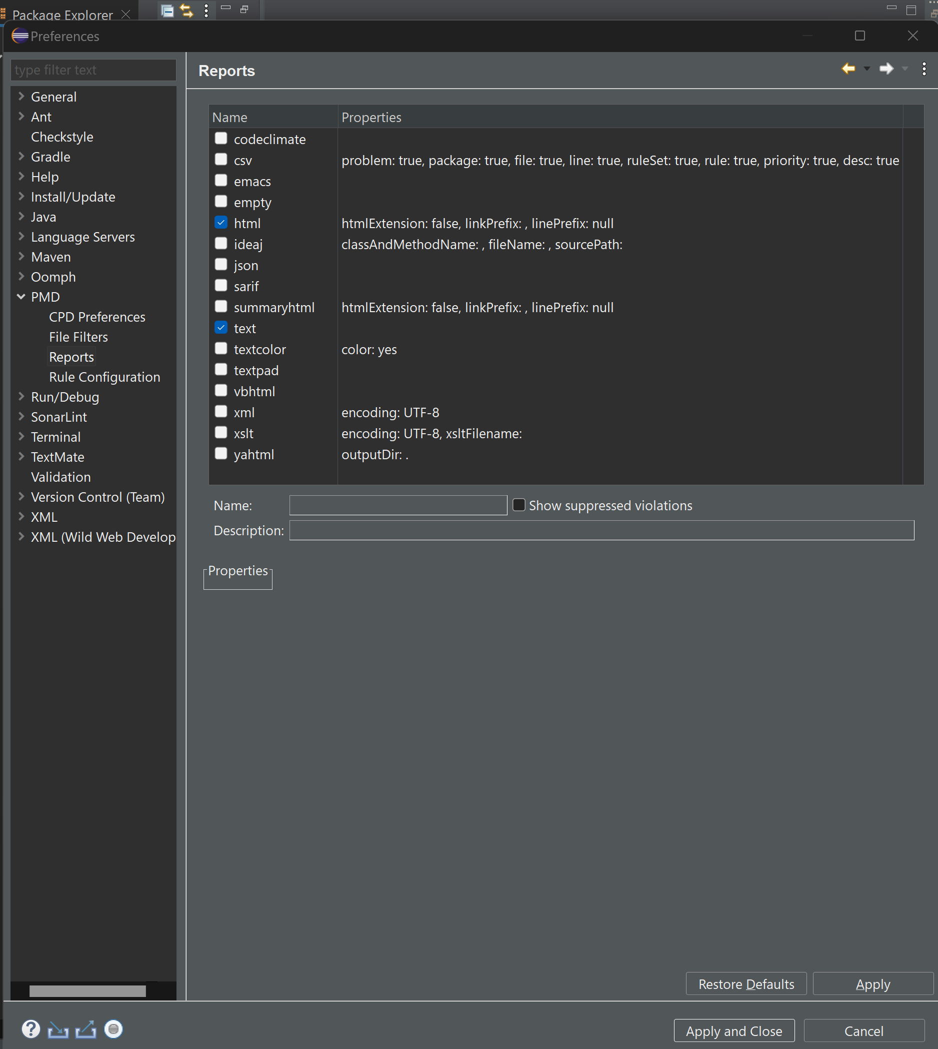

# Development

Report of development before correction

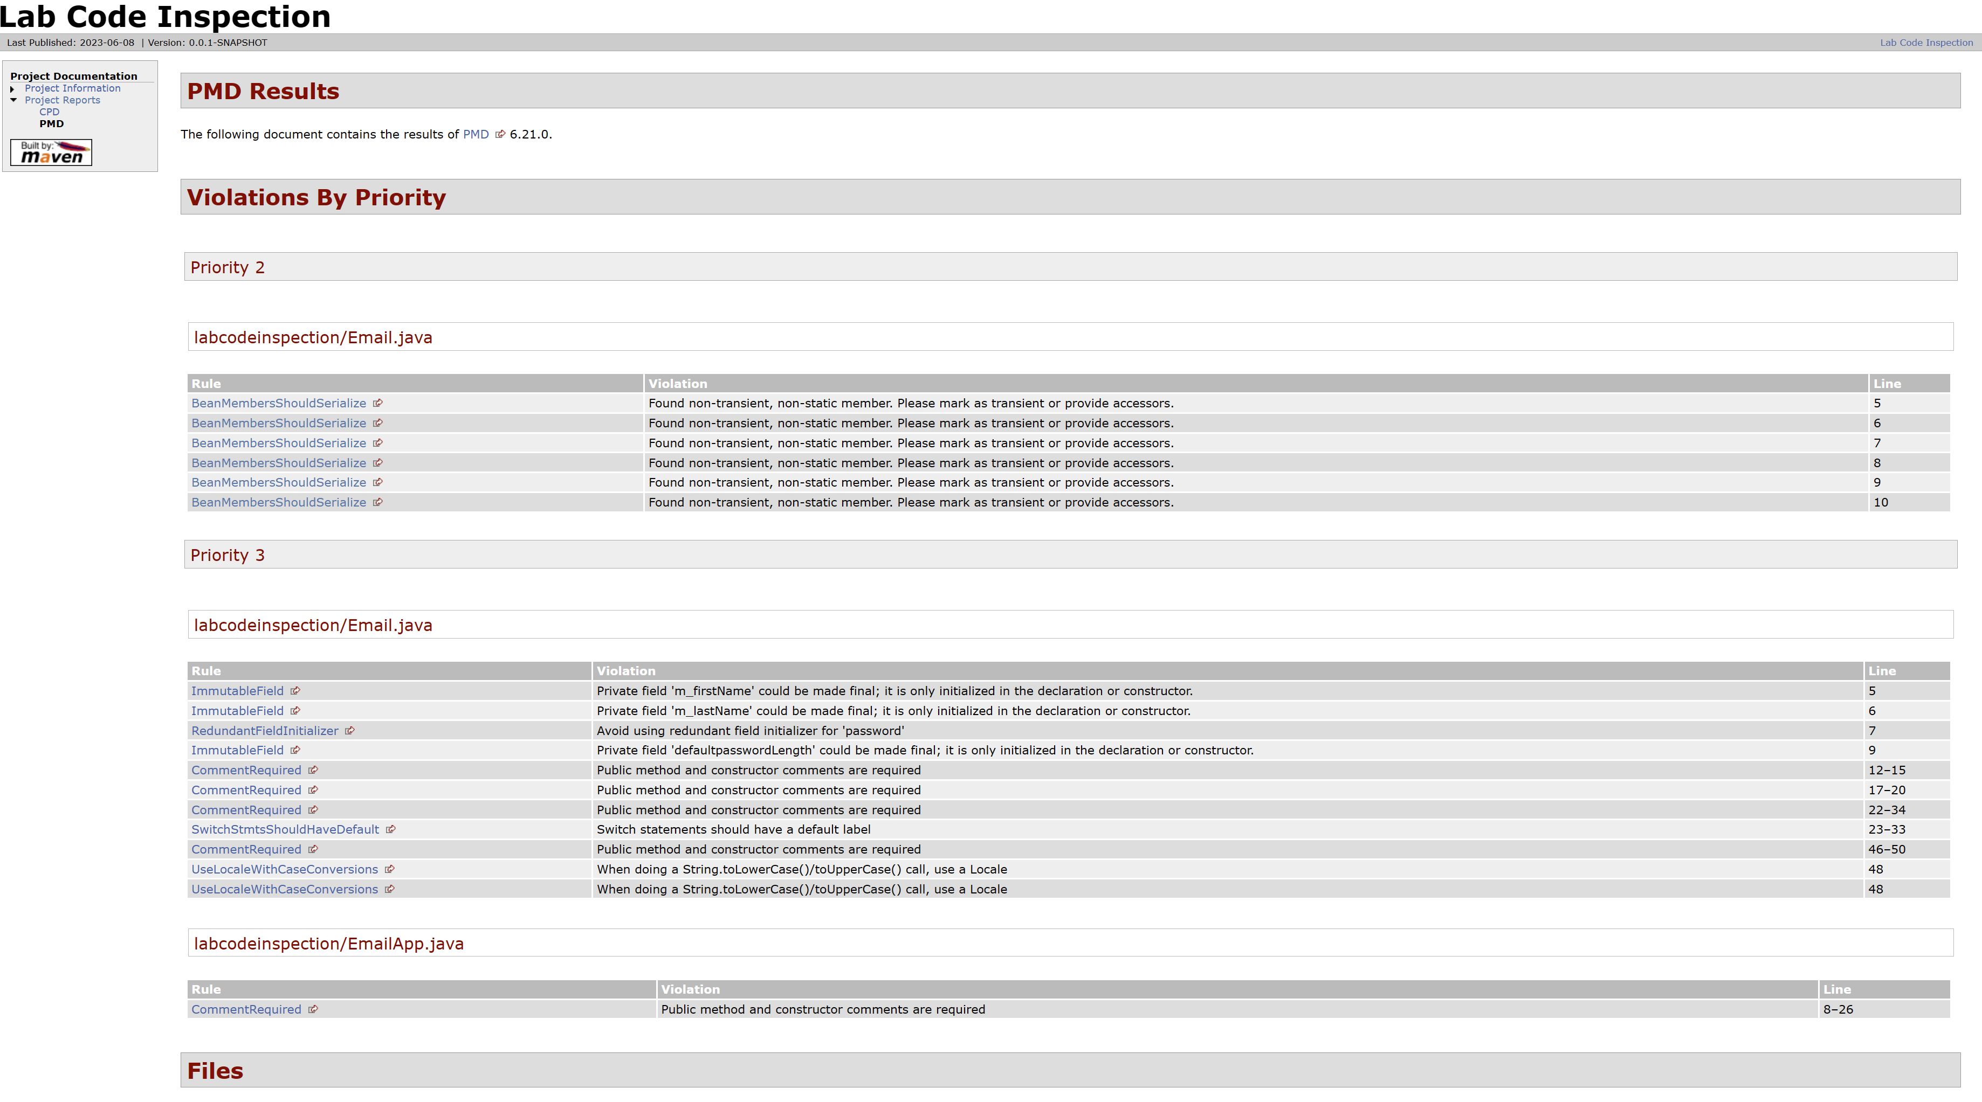

Report of development after correction

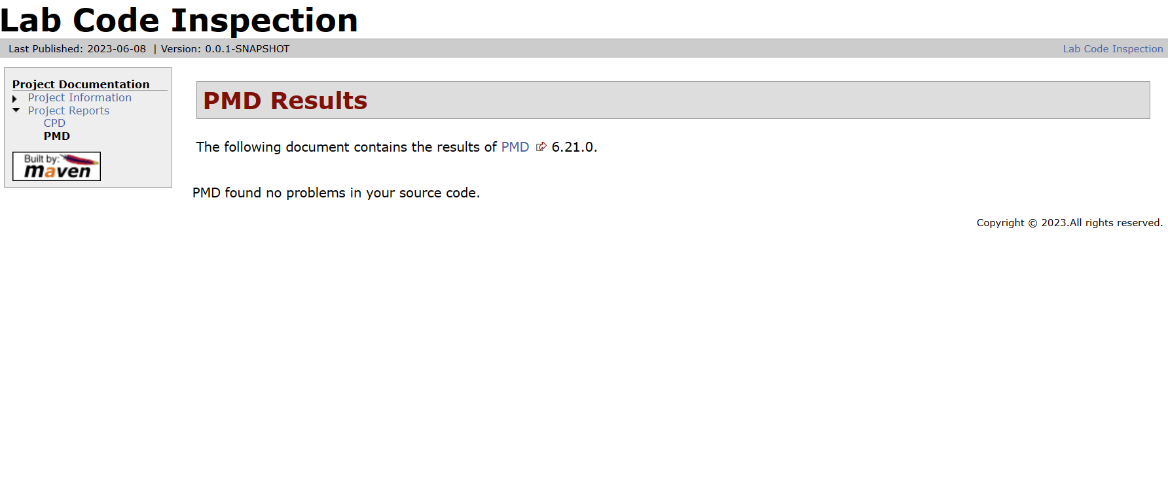

# Challenge

Report of development before correction

