A Change of Heart Clinic

Software Requirements Specification

Version 1.8

12/11/2017

Jeremy Jaeger

Beau Stensgard

Dan Nygard

# 

# Revision History

|  |  |  |  |
| --- | --- | --- | --- |
| **Date** | **Description** | **Author** | **Comments** |
| 11/01/17 | Version 1.0 | Everyone | First Revision |
| 11/02/17 | Version 1.1 | Dan Nygard | Writing of introduction, general description, and UI |
| 11/02/17 | Version 1.2 | Jeremy Jaeger | Revisions, initial requirements creation |
| 11/05/17 | Version 1.3 | Dan Nygard | Added two Use Cases and template for more. Made minor updates to Chapter 2 based on comments. |
| 11/6/17 | Version 1.4 | Beau Stensgard | Documentation of functional requirements. |
| 11/6/17 | Version 1.5 | Dan Nygard | Updated to include only Patients and Doctors. Added Patient and Doctor classes to section 3.4. |
| 11/6/17 | Version 1.6 | Jeremy Jaeger, Dan Nygard | ER diagram, Class diagram and descriptions |
| 12/9/17 | Version 1.7 | Dan Nygard | Final Edits before submission |
| 12/11/17 | Version 1.8 | Jeremy Jaeger,  Dan Nygard | Fixing sections according to feedback, added GUI images |

# Document Approval

The following Software Requirements Specification has been accepted and approved by the following:

|  |  |  |  |
| --- | --- | --- | --- |
| **Signature** | **Printed Name** | **Title** | **Date** |
|  |  |  |  |
|  |  |  |  |
|  |  |  |  |

**Table of Contents**

Revision History ii

Document Approval ii

1. Introduction 1

1.1 Purpose 1

1.2 Scope 1

1.3 Definitions, Acronyms, and Abbreviations 1

1.4 References 1

1.5 Overview 1

2. General Description 1

2.1 Product Perspective 2

2.2 Product Functions 2

2.3 User Characteristics 2

2.4 General Constraints 3

2.5 Assumptions and Dependencies 3

3. Specific Requirements 3

3.1 External Interface Requirements 3

3.1.1 User Interfaces 3

3.2 Functional Requirements 5

3.2.1 FR-1: The software shall store patient medical records and test results. 6

3.2.2 FR-2: The software shall allow patients to retrieve their own medical records and test results. 7

3.2.3 FR-3: The software shall allow doctors to retrieve medical records and test results of their patients. 7

3.2.4 FR-4: The software shall allow doctors to modify medical records and test results of their patients. 8

3.2.5 FR-5: The software shall allow patients to view a calendar of available times to schedule appointments with their doctors. 8

3.2.6 FR-6: The software shall allow doctors to view a calendar of their scheduled and requested appointments. 8

3.2.7 FR-7: The software shall allow patients to request appointment scheduling at available times. 9

3.2.8 FR-8: The software shall allow doctors to confirm appointment requests. 9

3.2.9 FR-9: The software shall allow patients to request prescription renewals. 10

3.2.10 FR-10: The software shall allow doctors to confirm prescription renewals. 10

3.2.11 FR-11: The software shall allow doctors to prescribe new prescriptions to their patients. 11

3.2.12 FR-12: The software shall allow users to view their sent and received messages. 11

3.2.13 FR-13: The software shall allow patients to message their doctor. 11

3.2.14 FR-14: The software shall allow doctors to message their patients. 11

3.2.16 FR-15: The software shall require users to login before performing actions besides requesting an account. 11

3.2.17 FR-16: The software shall allow users to request an account from an administrator. 11

3.2.18 FR-17: The software shall allow an administrator to create an account for a user. 11

3.3 Use Cases 12

3.3.1 UC-1: View Medical Record 12

3.3.2 UC-2: Request Appointment 14

3.3.3 UC-3: Message Doctor 15

3.3.4 UC-4: Request Prescriptions 17

3.3.5 UC-5: Confirm Prescriptions 18

3.4 Classes / Objects 20

3.4.1 Patient 20

3.4.2 Doctor 21

3.4.3 User 21

3.4.4 Email 21

3.4.5 Appointment 21

3.4.6 Department 21

3.4.7 Hospital 22

3.5 Non-Functional Requirements 22

3.5.1 Performance 22

3.5.2 Reliability 22

3.5.3 Availability 22

3.5.4 Security 22

3.5.5 Maintainability 22

3.5.6 Portability 22

3.6 Inverse Requirements 22

3.7 Design Constraints 23

3.8 Logical Database Requirements 23

3.9 Other Requirements 23

4. Analysis Models 24

4.1 Sequence Diagrams 24

4.1.1 SD-1: Request Appointment 24

4.2 Activity Diagrams (Data Flow Diagrams) 25

4.2.1 AD-1: Messaging System 25

4.3 Entity Relationship Diagram 26

4.4 State-Transition Diagrams (STD) 27

5. Change Management Process 27

A. Appendices 27

A.1 Appendix 1 27

A.2 Appendix 2 27

# 

# 1. Introduction

## 1.1 Purpose

## 1.2 Scope

There is a need for the patients and doctors within a hospital system to be able to interact outside of the clinical setting. Our software system, “A Change of Heart Clinic” (ACHC), will allow:

* Patients to access their medical history, schedule appointments, access test results, request prescription renewals, and contact their Doctors via messaging.
* Doctors to renew prescriptions, manage their requested appointments, update patient medical records, and contact their patients via messaging.

ACHC will be a web-based application that allows patients and doctors the interaction described above. To provide this, it will:

* Store patient medical history and test results in an accessible database (read-only for Patients, read-write capable for Doctors).
* Maintain a scheduling calendar allowing patients to request available appointment times and confirmation of appointments by Doctors.
* Maintain a prescription portal for patient renewal requests, which can be confirmed by Doctors.
* Allow for a messaging system between Doctors and Patients.

## 1.3 Definitions, Acronyms, and Abbreviations

* ACHC: A Change of Heart Clinic*.*

## 1.4 References

## 1.5 Overview

# 2. General Description

This section will give an overview of the ACHC system. ACHC will be explained to show how the components of the system will interact with each other and will demonstrate its basic functionality. It will describe the users of the system and what each category of user will be allowed to do. It will also discuss the constraints and assumptions for the system.

## 2.1 Product Perspective

ACHC will be self-contained, and web-based. It will rely on a web portal, which will be the point of interaction for all users. Security for each user account will be provided through a username/password system.

To store patient information and test results, a database will be implemented. Web portals will be added to provide the remaining features: A scheduling calendar, a prescription renewal service, and messaging.

## 2.2 Product Functions

Within the web application, Patients will be able to access their medical records, which will be retrieved from the database. Medical records will include information such as Hypertension Summaries, Weight/BMI Summaries, Care Plans, Test Results, Health Summaries, Current Health Issues, Medications, Allergies, Preventative Care, Medical History, and Immunizations.

Patients also have access to medical tools like questionnaires, research studies, medical record access history, medical record downloads/requests. An eyeglass prescription center is also accessible from the system.

Patients will also be able to request appointments through the scheduling portal (by choosing a hospital, department, doctor, and date/time). Patients can also request video visits or e-visits. Patients can view and cancel upcoming appointments and tests;

Doctors will be able to update medical record information within the database. They will also be able to confirm or deny patient-requested appointments in the scheduling portal, which will notify patients via message of that approval/denial. Doctors will also be able to confirm prescription renewal requests in the prescriptions portal.

Within the messaging portal, Patients and Doctors will be able to send messages back and forth, and all users will be able to view and read the messages sent to or from them. Users can get medical advice or doctors’ letters. Users can also request prescription renewals.

## 2.3 User Characteristics

Three categories of user will exist, with differing permissions granted to each user type: Patients, Doctors, and Administrator. The System Administrator will be responsible for setting up user accounts and managing the website.

Patients may only access their data (and may not modify it). Patients may also request appointments and prescription renewals, and send messages to their Doctors.

Doctors may access and modify patient data, confirm appointments and renew prescriptions, and send messages to patients.

The system administrator may create all types of user accounts, and may access all website-related code in order to make repairs/modifications.

## 2.4 General Constraints

Internet access will be required for patients to access the system.

The application may also be constrained by the amount of server space allotted to the database.

## 2.5 Assumptions and Dependencies

All users will be assumed to be using a modern web browser (such as Mozilla Firefox or Google Chrome).

All users will be assumed to be using a device running Windows 10.

The system will be assumed to be available 24/7.

# 3. Specific Requirements

## 3.1 External Interface Requirements

### 3.1.1 User Interfaces

The initial interface that appears when a user accesses the website will be a login screen. Creation of an account must be done on-site at one of the ACHC affiliated hospitals, and there will be no option for users to register or create an account through the web system.

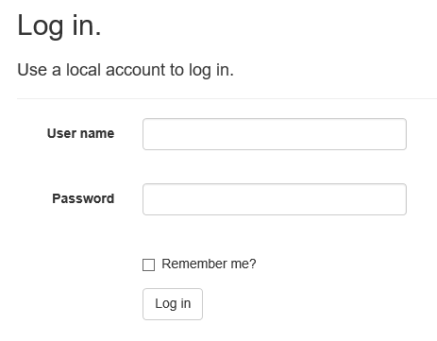

Once an account has been created by an admin and the user has successfully logged in, that user’s account page will appear. Within the account page, separate tabs exist, which contain links to each section: patient medical information and test results, appointment scheduler, prescription renewal, and messaging.

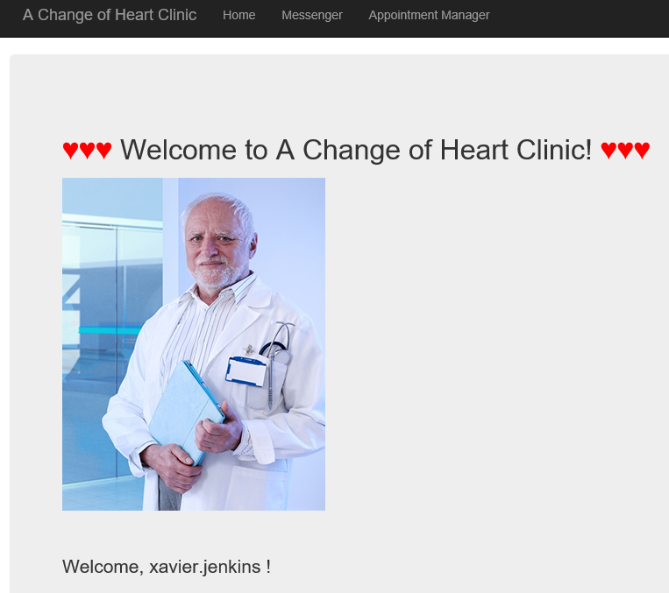

Within the patient medical information view, the most current information for that patient will be displayed from the database. Doctors will be able to choose one of their patients to view medical information and will also be provided an option to add new patient medical information and test results.

Within the appointment scheduler, a calendar will be displayed which will show only the available appointment times with the patient’s doctor. Patients will be able to select one of those available times, then submit the request. Doctors may access the scheduler to confirm any requested appointments.

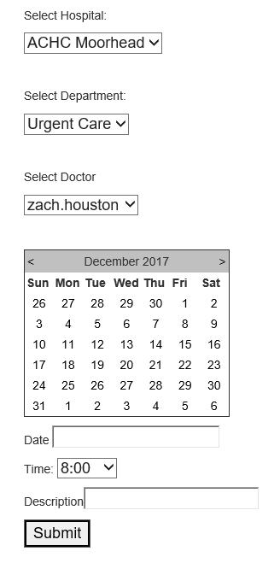 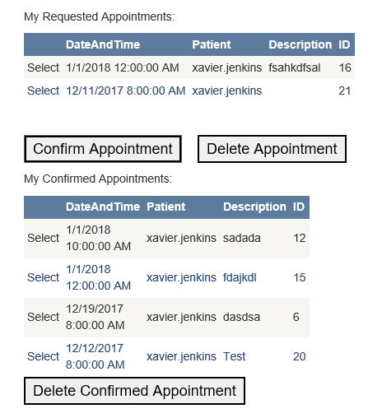

Patient View Doctor View

Within the prescription renewal portal, a list of the patient’s current prescriptions will be displayed from the database. Patients may select a prescription from the list and select “Request Renewal” to submit the request. This can then be confirmed by the Patient’s Doctor.

Within the messaging portal, Patients and Doctors may select a message recipient from a list of relevant recipients, write a message, and click “Submit” to send the message to that recipient.

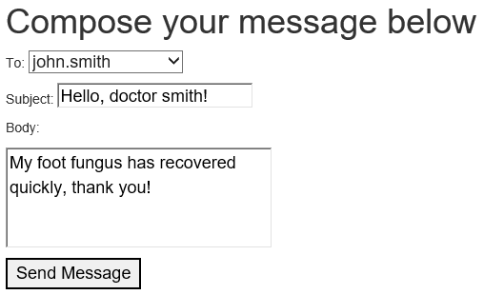

Additionally, Patients and Doctors can view their inbox and outbox to see all messages that they have sent or received.

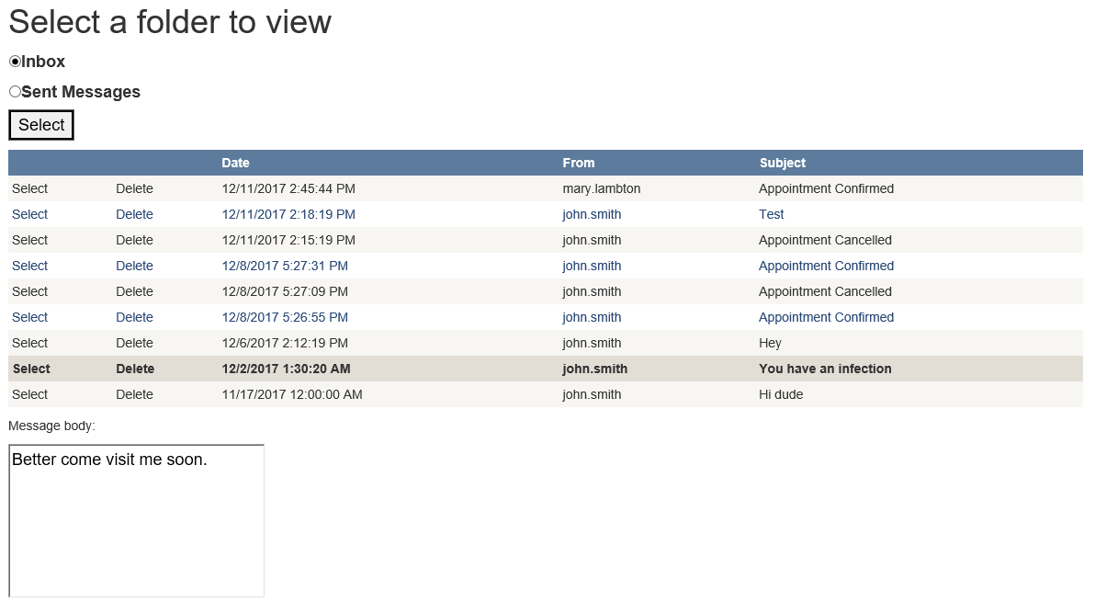

## 3.2 Functional Requirements

This section describes the functional requirements and features of the ACHC software.

|  |  |  |
| --- | --- | --- |
| **Req ID** | **Description** | **Related Use Cases** |
| FR-1 | The software shall store patient medical records and test results | 1 |
| FR-2 | The software shall allow patients to retrieve their own medical records and test results | 1 |
| FR-3 | The software shall allow doctors to retrieve medical records and test results of their patients | 9 |
| FR-4 | The software shall allow doctors to modify medical records and test results of their patients | 9 |
| FR-5 | The software shall allow patients to view a calendar of available times to schedule appointments with their doctors | 2 |
| FR-6 | The software shall allow doctors to view a calendar of their scheduled and requested appointments | 8 |
| FR-7 | The software shall allow patients to request appointment scheduling at available times | 2 |
| FR-8 | The software shall allow doctors to confirm appointment requests | 8 |
| FR-9 | The software shall allow patients to request prescription renewals | 4, 5 |
| FR-10 | The software shall allow doctors to confirm prescription renewals | 5 |
| FR-11 | The software shall allow doctors to prescribe new prescriptions to their patients | 9 |
| FR-12 | The software shall allow users to view their sent and received messages | 3, 4, 5 |
| FR-13 | The software shall allow patients to message their doctor | 3 |
| FR-14 | The software shall allow doctors to message their patients | 7 |
| FR-15 | The software shall require users to login before performing actions besides requesting an account | 11 |
| FR-16 | The software shall allow users to request an account from an administrator | 11 |
| FR-17 | The software shall allow an administrator to create an account for a user | 11 |

### 3.2.1 FR-1: The software shall store patient medical records and test results.

3.2.1.1 Introduction

A database will be integrated in the system to store Patient medical history.

3.2.1.2 Inputs

A Patient entry (with a unique Patient ID key) will be added to the database. Initial medical information (from, for example, the first doctor’s visit) will be added upon account creation. Doctors will have permission to add additional Patient info.

3.2.1.3 Processing

All database access will be run through the web system.

3.2.1.4 Outputs

The database will retrieve and display Patient medical information. For Patients, only their information will be available. For Doctors, only the information for their assigned Patients will be available.

3.2.1.5 Error Handling

Errors identified during testing will be corrected or handled with exceptions.

### 3.2.2 FR-2: The software shall allow patients to retrieve their own medical records and test results.

3.2.2.1 Introduction

Patients will have access to view their medical records.

3.2.2.2 Inputs

None (for Patients - see FR-1 above).

3.2.2.3 Processing

All database access will be run through the web system.

3.2.2.4 Outputs

The database will retrieve and display Patient medical information. For Patients, only their information will be available.

3.2.2.5 Error Handling

Errors identified during testing will be corrected or handled with exceptions.

### 3.2.3 FR-3: The software shall allow doctors to retrieve medical records and test results of their patients.

3.2.3.1 Introduction

Doctors will be able to access medical records and test results of patients.

3.2.3.2 Inputs

Given input to search the records should be by the patient name.

3.2.3.3 Processing

It will search through the database for the patient name by input, accounting for similiar names.

3.2.3.4 Outputs

It will then display in a list the related patients by name, providing the necessary information for each and allowing selection of the desired patient.

3.2.3.5 Error Handling

If the user provides an invalid input, such as not including full name or inappropriate characters, it should prompt the user to provide correct input.

### 3.2.4 FR-4: The software shall allow doctors to modify medical records and test results of their patients.

3.2.4.1 Introduction

Doctors can modify individual records and test results for patients, built on the dependency of FR-3.

3.2.4.3 Processing

The display from FR-3 allows individual selection of a patient’s record or test results.

3.2.4.4 Outputs

This should then prompt the correct medical record/test results, with ability for the user to modify the given page and submit it back through the database.

3.2.4.5 Error Handling

If the changes are illegal to the correct data type/template, such as removing information to blank, it should prompt the user the changes are not allowed.

### 3.2.5 FR-5: The software shall allow patients to view a calendar of available times to schedule appointments with their doctors.

3.2.5.1 Introduction

Displays each day in a calendar format on a separate page, allows selection and shows the individual times of availability.

3.2.5.2 Inputs

Input is operated as a button for selection for each day.

3.2.5.3 Processing

Taking in the input, gathers the current schedule for that day.

3.2.5.4 Outputs

Displays the current times of availability in another window. Allows appointment selection of time and window exit.

3.2.5.5 Error Handling

Given the limited input, specific errors will be handled in testing.

### 3.2.6 FR-6: The software shall allow doctors to view a calendar of their scheduled and requested appointments.

3.2.6.1 Introduction

Built on the functionality of FR-5, but with included permissions for more detailed input

3.2.6.2 Inputs

Selection for each day.

3.2.6.3 Processing

Accounting for permission, gathers current schedule alongside patient information for each time.

3.2.6.4 Outputs

Displays current times of availability in another window, but shows patient name for each time. Allows selection of patient and displays the correct information on that patient

3.2.6.5 Error Handling

Given the limited input, specific errors will be handled in testing.

### 3.2.7 FR-7: The software shall allow patients to request appointment scheduling at available times.

3.2.7.1 Introduction

Built on the functionality of FR-5, selection of appointment time is done through calendar display.

3.2.7.2 Inputs

Takes in current selection through button input.

3.2.7.3 Processing

Processes for input, displaying in a separate window the patient information, then sends it for approval.

3.2.7.4 Outputs

Should then display the updated calendar, showing the patient's time on the current day as now ‘requested’, still subject to approval

3.2.7.5 Error Handling

Given the limited input, specific errors will be handled in testing.

### 3.2.8 FR-8: The software shall allow doctors to confirm appointment requests.

3.2.8.1 Introduction

Given in notification, shows doctors the current times requested by patients.

3.2.8.2 Inputs

Inputs should be given by ‘approve’, ‘deny’, or ‘change time’

3.2.8.3 Processing

This should update the current schedule as such, guaranteeing the removal of ‘requested’ to either a taken schedule slot on that day or cleared for availability. The ‘change’ time selection should allow the functionality of FR-7.

3.2.8.4 Outputs

Updates calendar to correspond to selection, window for ‘change’ time reliant on FR-7.

3.2.8.5 Error Handling

Given the limited input, specific errors will be handled in testing.

### 3.2.9 FR-9: The software shall allow patients to request prescription renewals.

3.2.9.1 Introduction

Offered in a separate page, allows the user to request a prescription renewal which notifies medical faculty.

3.2.9.2 Inputs

Under the assumption that the user has their medical records inside already, allows for the selection of prescription renewals.

3.2.9.3 Processing

Takes the selection, messages the appropriate staff, then confirms request sent.

3.2.9.4 Outputs

Displays in a list the available prescriptions, followed by confirmation of request for the user.

3.2.9.5 Error Handling

Given the limited input, specific errors will be handled in testing.

### 3.2.10 FR-10: The software shall allow doctors to confirm prescription renewals.

3.2.10.1 Introduction

Given the request sent from FR-9, uses it to display on a page ‘current requests’, which allows the appropriate staff to approve or decline renewals.

3.2.10.2 Inputs

Should offer selection of prescription, followed with more info on the prescription itself and the patient record, providing then a button for approval and decline.

3.2.10.3 Processing

This should then process the request and notify the patient as well as update the request page.

3.2.10.4 Outputs

Should display that the request has been handled, and display in the request page confirming or declining said request for the patient to see.

3.2.10.5 Error Handling

Given the limited input, specific errors will be handled in testing.

### 3.2.11 FR-11: The software shall allow doctors to prescribe new prescriptions to their patients.

### 3.2.12 FR-12: The software shall allow users to view their sent and received messages.

### 3.2.13 FR-13: The software shall allow patients to message their doctor.

### 3.2.14 FR-14: The software shall allow doctors to message their patients.

### 3.2.16 FR-15: The software shall require users to login before performing actions besides requesting an account.

### 3.2.17 FR-16: The software shall allow users to request an account from an administrator.

### 3.2.18 FR-17: The software shall allow an administrator to create an account for a user.

## 3.3 Use Cases

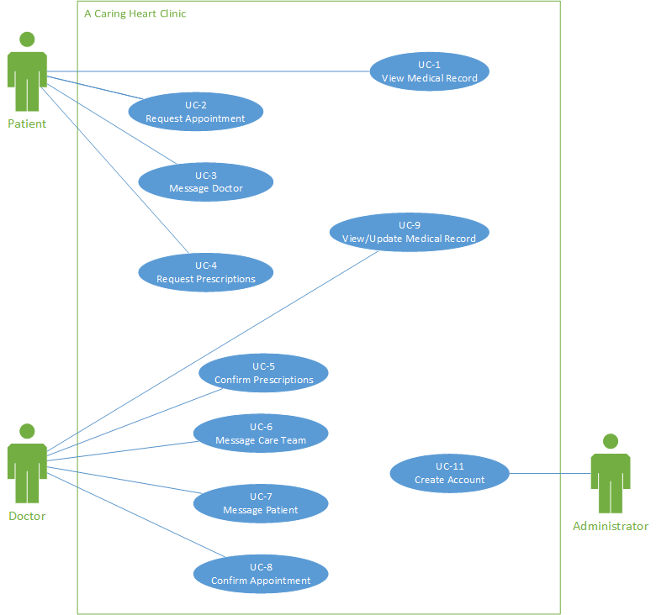

### 3.3.1 UC-1: View Medical Record

|  |  |
| --- | --- |
| **Use Case** | View Medical Record |
| **Id** | UC-1 |
| **Related FRs** | FR-1: The software shall store patient medical records and test results  FR-2: The software shall allow patients to retrieve their own medical records and test results |
| **Description** | ACHC Patient has successfully logged in and is able to access the section of the web system which displays that patient’s medical information from the database. |
| **Primary Actor** | Patient |
| **Supporting Actors** | Doctor |
| **Stakeholders and Interests** | Patient - has a strong interest in medical information pertaining to them  Doctors - want patients to understand their own medical history |
| **Pre-Conditions** | Patient must have successfully logged in to the system. |
| **Post Conditions** | Success end condition  Patient has successfully viewed the medical record containing his or her medical history.    Failure end condition:  Patient is not able to view his or her medical record. |
| **Main Success Scenario** | 1. Patient logs in to the web system. 2. Patient selects the tab “Medical Information and Test Results”. 3. Upon entering the “Medical Information and Test Results” section, the Patient’s medical information is retrieved from the database and displayed along with the Patient’s test results. |
| **Variations/Alternative scenario** | None |
| **Frequency** | Patients will be assumed to check their medical information between 1-2 times per month. |
| **Assumptions** | Patients will have begun a care routine at the hospital and have been assigned at least one doctor. |
| **Special Requirements** | Performance:   1. The information displayed within the web system will be displayed within 5 seconds of accessing the site.   User Interface:   1. The information displayed within the web system will be easy to read and understand.   Security   1. All user passwords will be masked with an asterisk when they are entered. |

### 3.3.2 UC-2: Request Appointment

|  |  |
| --- | --- |
| **Use Case** | Request Appointment |
| **Id** | UC-2 |
| **Related FRs** | FR-5: The software shall allow patients to view a calendar of available times to schedule appointments with their doctors  FR-7: The software shall allow patients to request appointment scheduling at available times |
| **Description** | ACHC Patient has successfully logged in and is able to access the scheduling portal of the web system. This allows that patient to view open appointments with that Patient’s Doctor and to request a new appointment from those available. |
| **Primary Actor** | Patient |
| **Supporting Actors** | Doctor |
| **Stakeholders and Interests** | Patient - wants to be able to view open appointment times and request one of those times.  Doctors - want patients to request appointments, and to not ask for times when the Doctor is not available. |
| **Pre-Conditions** | Patient must have successfully logged in to the system. |
| **Post Conditions** | Success end condition  Patient has successfully viewed the scheduling portal, selected an open appointment time, and requested an appointment.    Failure end condition:  Patient is not able to view the scheduling portal. |
| **Main Success Scenario** | 1. Patient logs in to the web system. 2. Patient selects the tab “Schedule an Appointment”. 3. Patient views all open appointment times with that Patient’s doctor. 4. Patient selects an open appointment time and requests that time for an appointment. |
| **Variations/Alternative scenario** | Patient has not yet confirmed a Doctor for their care. In this case they will receive a message that they need a doctor assigned to them. |
| **Frequency** | Patients will be assumed to request an appointment an average of 1 time per month. |
| **Assumptions** | Patients will have begun a care routine at the hospital and have been assigned at least one doctor. |
| **Special Requirements** | Performance:   1. The information displayed within the web system will be displayed within 5 seconds of accessing the site.   User Interface:   1. The information displayed within the web system will be easy to read and understand.   Security   1. All user passwords will be masked with an asterisk when they are entered. |

### 3.3.3 UC-3: Message Doctor

|  |  |
| --- | --- |
| **Use Case** | Message Doctor |
| **Id** | UC-3 |
| **Related FRs** | FR-12: The software shall allow users to view their sent and received messages.  FR-13: The software shall allow patients to message their doctor. |
| **Description** | Within the messaging portal, patients should be able to send messages to their doctors to inform them of pertinent information. |
| **Primary Actor** | Patient |
| **Supporting Actors** | Doctor |
| **Stakeholders and Interests** | Patient - wants to send a message  Doctor - wants to receive important info from his patients |
| **Pre-Conditions** | Patient must have successfully logged in to the system. |
| **Post Conditions** | Success end condition  The patient was able to compose and send a message to his assigned doctor.  Failure end condition  No message was sent from the patient to his doctor. |
| **Main Success Scenario** | 1. Patient logs in to the web system. 2. Patient selects the tab “Messaging”. 3. Patient selects “Send a message”. 4. Patient selects doctor from possible recipient list. 5. Patient composes a subject and the body text. 6. Patient is satisfied with his message and clicks “Send”. |
| **Variations/Alternative scenario** | Patient has not yet received a doctor assigned to them. In this case, the list to choose a recipient will be empty and they will receive notification that they must first have a doctor. |
| **Frequency** | Patients will be assumed to send messages to their doctors on average 1 time per month. |
| **Assumptions** | Patients will have begun a care routine at the hospital and have been assigned at least one doctor. |
| **Special Requirements** | Performance:   1. The information displayed within the web system will be displayed within 5 seconds of accessing the site. 2. The message will be sent to the doctor within 5 seconds of the patient pressing “Send.”   User Interface:   1. The information displayed within the web system will be easy to read and understand.   Security   1. All user passwords will be masked with an asterisk when they are entered. |

### 3.3.4 UC-4: Request Prescriptions

|  |  |
| --- | --- |
| **Use Case** | Request Prescriptions |
| **Id** | UC-4 |
| **Related FRs** | FR-9: The software shall allow patients to request prescription renewals.  FR-12: The software shall allow users to view their sent and received messages. |
| **Description** | Allows the patient to request renewal of prescriptions as well notifying the appropriate doctor |
| **Primary Actor** | Patient |
| **Supporting Actors** | Doctor |
| **Stakeholders and Interests** | Patient - wishing for their renewal of prescriptions  Doctor - Supplier and maintainer of prescriptions |
| **Pre-Conditions** | Must have successfully logged in  Must have medical records |
| **Post Conditions** | Success end condition  Patient has successfully retrieved their prescription information corresponding to their medical record    Failure end condition:  Patient is not able to view current prescriptions. |
| **Main Success Scenario** | 1. Patient logs in 2. Patient selects ‘Prescription Requests’ 3. Upon entering, selects their desired prescription renewal 4. Notifies doctor for approval |
| **Variations/Alternative scenario** | Patient has no current prescriptions for renewal. |
| **Frequency** | Assumed to renew prescriptions of a bi-yearly basis |
| **Assumptions** | Patient has records in the system. |
| **Special Requirements** | Performance:   1. The information displayed within the web system will be displayed within 5 seconds of accessing the site.   User Interface   1. The information displayed within the web system will be easy to read and understand.   Security   1. All user passwords will be masked with an asterisk when they are entered. |

### 3.3.5 UC-5: Confirm Prescriptions

|  |  |
| --- | --- |
| **Use Case** | Confirm Prescriptions |
| **Id** | UC-5 |
| **Related FRs** | FR-10: The software shall allow doctors to confirm prescription renewals.  FR-9: The software shall allow patients to request prescription renewals.  FR-12: The software shall allow users to view their sent and received messages. |
| **Description** | Allows the doctor to view prescription requests, and provide a meaningful input to approve or deny it. |
| **Primary Actor** | Doctor |
| **Supporting Actors** | Patient |
| **Stakeholders and Interests** | Patient - Interested in renewing a prescription, waiting on doctor’s approval  Doctors - Decision in the matter, needs a comprehensive way to view requests and provide a prompt, satisfactory response |
| **Pre-Conditions** | Doctor must have successfully logged in to the system. |
| **Post Conditions** | Success end condition  The doctor is able to see current requests and respond to them  Failure end condition  The doctor cannot see the current requests |
| **Main Success Scenario** | 1. Doctor logs in to the system 2. Selects the tab “Prescription Requests” 3. Views said request 4. Selects either approve or decline 5. Updates current request and notifies appropriate patient. |
| **Variations/Alternative scenario** | The doctor currently has no sent prescription requests |
| **Frequency** | Depending on the volume of patients, but on average a daily basis. |
| **Assumptions** | Doctor is able to see said prescriptions and corresponding patient. |
| **Special Requirements** | Performance:   1. The information displayed within the web system will be displayed within 5 seconds of accessing the site.   User Interface   1. The information displayed within the web system will be easy to read and understand.   Security   1. All user passwords will be masked with an asterisk when they are entered. |

## 3.4 Classes / Objects

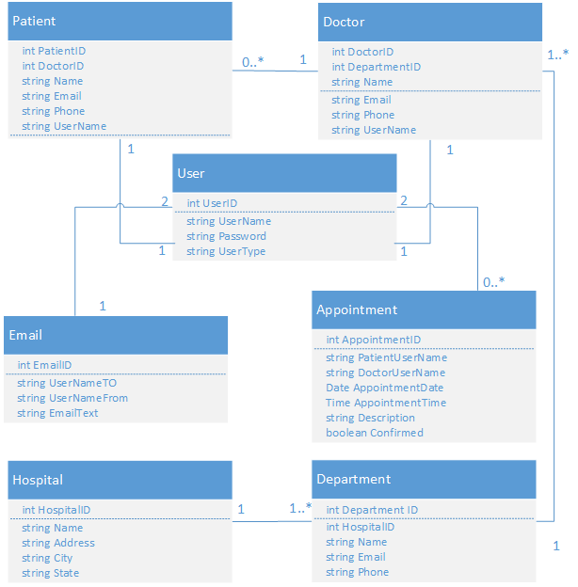

### 3.4.1 Patient

3.4.1.1 Attributes

int PatientID: The unique identifier each Patient object holds.

int DoctorID: The unique identifier of that Patient’s Doctor

string Name: The Patient’s name.

string PatientEmail: The Patient’s e-mail address.

string PatientPhone: The Patient’s phone number.

string UserName: The Patient’s unique user name.

### 3.4.2 Doctor

3.4.2.1 Attributes

int DoctorID: The unique identifier each Doctor object holds.

int DepartmentID: The unique identifier of the Department the Doctor is assigned to.

string Name: The Doctor’s name.

string DoctorEmail: The Doctor’s e-mail address.

string DoctorPhone: The Doctor’s phone number.

string UserName: The Doctor’s unique user name.

### 3.4.3 User

3.4.3.1 Attributes

int UserID: The unique identifier each User object holds.

string UserName: The User name.

string Password: The password associated with the User object.

string UserType: “Doctor” or “Patient.”

### 3.4.4 Email

3.4.4.1 Attributes

int EmailID: The unique identifier each Email object holds.

string UserNameTo: The name of the recipient.

string UserNameFrom: The name of the sender.

string EmailText: The content of the Email.

### 3.4.5 Appointment

3.4.5.1 Attributes

int AppointmentID: The unique identifier each Appointment object holds.

string PatientUserName: The user name of the Patient.

string DoctorUserName: The user name of the Doctor.

Date AppointmentDate: The date of the appointment.

Tiime AppointmentTime: The time of the appointment.

string Description: The appointment description.

boolean Confirmed: Allows the calendar to handle approvals/denials.

### 3.4.6 Department

3.4.6.1 Attributes

int DepartmentID: The unique identifier each Department object holds.

Int HospitalID: The ID of the Hospital associated with the Department.

string Name: The name of the Department.

string Email: The e-mail address of the Department.

String Phone: The phone number of the Department.

### 3.4.7 Hospital

3.4.7.1 Attributes

int HospitalID: The unique identifier each Hospital object holds.

string Name: The name of the Hospital.

string Address: The address of the Hospital.

string City: The city the Hospital is located in.

string State: The state the Hospital is located in.

## 3.5 Non-Functional Requirements

### 3.5.1 Performance

3.5.1.1: PFR-1: The software shall take less than 5 seconds to send a message from a user.

Reason: To allow rapid communication of messages between doctors and patients.

3.5.1.2: PFR-2: The software shall display a notification if there is new activity related to their account (for example, new messages or requests).

Reason: To provide awareness to Users when new information arrives in their account.

### 3.5.2 Reliability

### 3.5.3 Availability

### 3.5.4 Security

3.5.4.1: SR-1: The software shall disable login capabilities of an account for 10 minutes after 5 consecutive failed login attempts.

Reason: To prevent malicious “brute force” attempts to acquire access to a User account.

3.5.4.2: SR-2: The software shall automatically log out of a User account after 10 minutes of inactivity.

Reason: To prevent unauthorized access of an account due to human error (i.e. forgetting to log out of the system on a public computer).

### 3.5.5 Maintainability

### 3.5.6 Portability

## 3.6 Inverse Requirements

3.6.1: IR-1: The software shall **not** allow the patient to request more than one appointment at a time. If the patient already has an appointment request pending when requesting another appointment, the original request will be overridden by the new one.

## 3.7 Design Constraints

* The software shall use no more than 50 MB system memory.
* The software shall be programmed with the language C#, plus supporting web development packages included in Microsoft Visual Studio.

## 3.8 Logical Database Requirements

## 3.9 Other Requirements

# 4. Analysis Models

## 4.1 Sequence Diagrams

### 4.1.1 SD-1: Request Appointment

**Introduction:** A core feature of ACHC is the ability of a Patient to request an appointment, and in turn allow a Doctor to confirm the requested appointment.

**Relevant FR & UC:** UC-2, UC-8, FR-5, FR-7

**Description:** A Patient requiring an appointment accesses the calendar, which displayed the available appointment times for that Patient’s Doctor. The Patient selects an available time and submits it back to the calendar, which then displays that requested appointment in the Doctor’s calendar. If the doctor approves (or denies) the appointment the calendar then holds (or removes) that appointment time and sends an auto-message notifying the Patient of the result.

**Diagram:**



## 4.2 Activity Diagrams (Data Flow Diagrams)

### 4.2.1 AD-1: Messaging System

**Introduction:** One of the core features of ACHC is the messaging system, in which patients can message doctors and doctors can message patients.

**Relevant FR & UC:** FR-12, FR-13, FR-14, UC-3

**Description:** Within the messaging system, users will be able to either view their messages or compose and send a new message. When viewing messages, users can switch between separate tabs for sent messages and received messages (the inbox). When composing messages, the message recipients must be chosen from a given list of valid recipients. For patients, this is just their doctor. For doctors, this is any of their patients.

**Diagram:**

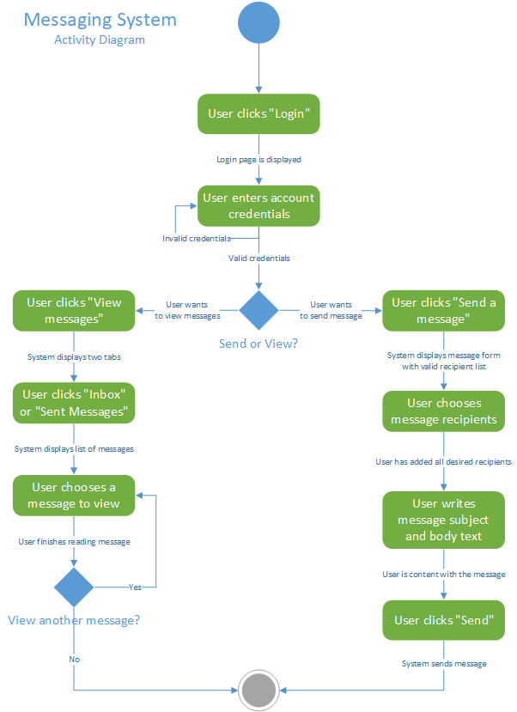

## 4.3 Entity Relationship Diagram

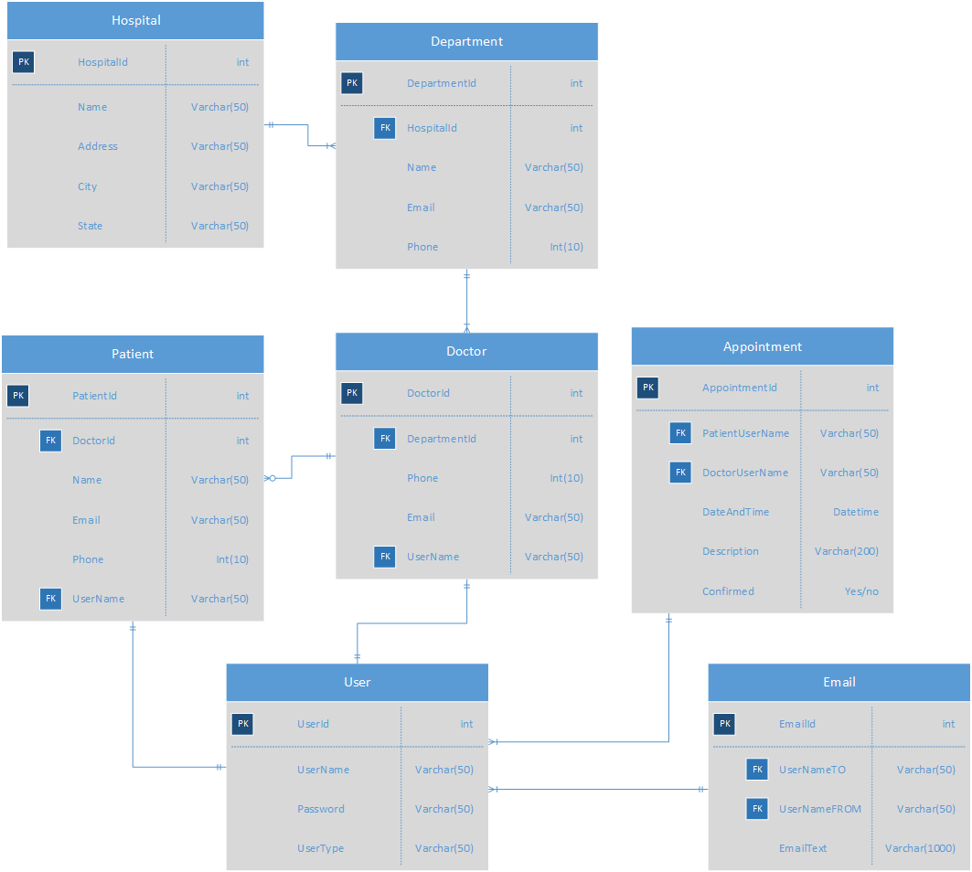

## 4.4 State-Transition Diagrams (STD)

# 5. Change Management Process

# A. Appendices

## A.1 Appendix 1

## A.2 Appendix 2