

**MASENO UNIVERSITY**

**SCHOOL OF COMPUTING AND INFORMATICS**

**DEPARTMENT OF COMPUTER SCIENCE AND TECHNOLOGY**

**BACHELOR OF SCIENCE IN COMPUTER TECHNOLOGY**

**CCT 403**

**GROUP PROJECT**

**ALEX GICHU MWAMBA CI/00029/017**

**JAMES MUHINDI WAWERU CI/00079/017**

**KELVIN KINUTHIA CI/00028/017**

**SUPERVISOR: MR. JOHN ALWALA**

**PROJECT PROPOSAL**

**SMART HOME AUTOMATION WITH MACHINE LEARNING**

**DATE OF SUBMISSION: SEPTEMBER 6, 2021**

### 

SMART HOME AUTOMATION

USING ESP8266, WEB APPLICATION WITH MACHINE LEARNING

A smart home automation project submitted to the Department of Computer Science in the School of computing and information technology. This project is in partial fulfillment of the requirements for the award of the degree of BSc (Computer Technology) Maseno university

### Declaration

we do hereby declare that the work presented in this project proposal is our (Alex, James, Kelvin) own original and independent work and it has not been presented before to the Faculty of Science for the award of Bachelor’s Degree in Computer Technology of Maseno University or any other related department. Thou not shall the report be duplicated without our consent.

Name: Alex Gichu Mwamba

Signature: …………………………………………

Date: …………………………………………….

Name: James Waweru

Signature: …………………………………………

Date: …………………………………………….

Name: Kelvin Kinuthia

Signature: …………………………………………

Date: …………………………………………….

Supervisor: Mr. John Alwala

Signature: ……………………………………………

Date: ………………………………………………….

### Abstract

IOT is nowadays the most preferred technology. A system of interrelated computing devices, mechanical and digital machines, objects, animals or people that are provided with unique identifiers (UIDs) and the ability to transfer data over a network without requiring human-to-human or human-to- computer interaction. One of the major sides of IOT is a smart home. Smart home is very helpful for people to make life easy. Home Automation is the automatic or semi- automatic control and monitoring of household appliances and residential house features like doors, Gate, light, fans and even the windows. The IOT definition has been evolved due to convergence of multiple technologies like, The Real Time Analysis, Machine Learning, Commodities Sensors and Embedded systems. IOT technology is used more for making the home a smart home.

Table of Contents

Declaration 1

Abstract 1

CHAPTER 1: INTRODUCTION 3

1.1 Problem Statement 3

1.2 Proposed Solution 3

1.3 Objectives and Aims 4

1.4 Motivation 4

CHAPTER  2: LITERATURE REVIEW 5

2.1 Introduction 5

2.2 Theoretical review 6

CHAPTER 3: SYSTEM ANALYSIS AND DESIGN 6

3.1 Introduction 6

3.2 Systems Development Methodology 7

3.3 Use case Diagram 7

3.3 Class diagram 8

3.4 Data and System Analysis: 9

3.5 System Specification 9

3.5.1 Node-MCU 9

3.5.2 4-Channel 5V DC relay module. 10

3.5.3 DHT11 temperature sensor. 11

CHAPTER 4: BUDGET, CONCLUSIONS AND REFERENCES 13

4.1 PROPOSED BUDGET 13

4.2 CONCLUSION 13

4.3 References 13

# CHAPTER 1: INTRODUCTION

1. **INTRODUCTION**

The Internet of Things (IoT) is the over networking of the devices, vehicles (also referred to as "connected devices" and "smart devices"), buildings, everything. with electronics, software, sensors, and network connectivity which enable these items to contact among them and exchange data. The IoT provide sense to objects or controlled remotely across existing network infrastructure, but building an IoT application needed the selection and integration of multiple components: sensors, communications issues, and networks as a start. And turning the data that you collect into something useful will typically involve cloud computing, analytics, integration with core systems, and process changes .The integration of other technologies with IoT project makes the project more develop and expanded in the services provided, In this project we also develop a machine learning model that helps in prediction of temperature and humidity and also a chatbot for conversing with the system.

## 1.1 Problem Statement

Home automation is a relatively new phenomenon that’s gaining popularity among homeowners and business people. Home automations solve a wide range of problems that users run into every day. Many homeowners complain of theft in their homes. Statistics show that crime reports estimate that close to 88% of all burglaries are residential in nature, and only 13% of the reported cases get cleared due to lack of physical evidence or witness. With more online stores like Amazon dropping an increasing number of deliveries at thousands of doorsteps, its becoming more tempting to simply walk up, grab the package and freely walk.. But home automation such as video security can simply solve this problem. In addition, smart locks are used to remotely close the door if a homeowner forgets to lock.

It is common to come home and find your house is so cold or your room is still dark and you can't find the switch. Home automation will put on the lights using an automated AI system and increase the temperature levels before getting home. Home automation also is a life saver when it comes to energy saving since it is common for people to leave the lights on or any other machine.

## 1.2 Objectives and Aims

From our project, we ought to achieve several objectives which include:

1. To come up with an intelligent system that is capable of predicting future weather (temperature and humidity) and apply collective measure from its knowledge with accuracy.
2. To develop a system that

**CHAPTER  2: Design implementation**

Keywords

Arduino, ESP8266, Firebase, Android Studio.

**Hardware implementation**

This part contain microcontroller (ESP8266 WiFi Module that can give any microcontroller access to WiFi network) and some peripheral components like relay use to connect all devices to be controlled by the system, also other components require to connect all of among them. In addition there is mobile phone with android OS which contain an application to control and view status of the devices (Figure.1) display whole connecting project:

Fig.1: The project device

**ESP8266 Chip**

The ESP8266 is WiFi Module with full TCP/IP protocol stack that can give any microcontroller access to the WiFi network. ESP8266 is a complete and self-contained Wi-Fi network solution that can carry software applications, or through another application processor uninstall all Wi-Fi networking capabilities. ESP8266 when the device is mounted and as only application of the application processor, the flash memory can be started directly from an external Move. Built in cache memory will help improve system performance and reduce memory requirements. Another case is when wireless Internet access assume the task of Wi-Fi adapter, In addition it can be added to any microcontroller-based design.

Fig. 3: ESP8266 Chips

**SOFTWARE PART**

It’s important part which is the soul of the hardware components and controls the work for each one and data streaming among them, this part consists of three major software: Arduino IDE, Firebase console and Android Studio.

                       ‘                              

**Arduino IDE**

The Arduino Integrated Development Environment is special software running on our computer that we can write sketches for the Arduino board. And then we will upload the sketch to the board, the code that we have written is compiled into low level language that is understood by the microcontroller [5]. This last step is quite important, because it’s where Arduino makes our life simple by hiding away as much as possible of the complexities of programming microcontrollers.

Here should be add;

1. firebase and esp8266 wifi library to enable device to connect to internet and firebase.
2. DHT11 to enable the system to read from humidity and temperature sensor
3. Telegram library for employing telegram chatbot to control the system

**Firebase Console**

Firebase provide power to application backend, including data storage, user authentication, static hosting, notification and more. server and client connection via firebase. Focus on creating extraordinary user experiences, it’s provide tools to develop high-quality web and smart phone applications and also Machine learning tools. Firebase used to send notify to the mobile device application after receive it from ESP8266, in addition it will Recorded temperature and humidity figures in a real time database.

# 

**Android Studio**

This project use android operating system application to receive alert from firebase and control the components (Although it's possible to use cross platform for all OS's), so it’s needed an IDE to create application. The best environment use for this purpose is android studio in general because it’s supported by google company and contains large of libraries and tools that help the programmer in code and design easily, also I can add firebase api to the project easily.

**Visual Studio Code**

We are also using visual studio code in designing a web application, we selected vs code from others like sublime text, pycharm since vs code provide a variety of programming languages and libraries that can be used together without contradictions, Also it is easy to use and install Django virtual environment.

**PROPOSED WORK**

Proposed system diagram implemented in (Figure.8) which describe work of the system and how the data translating form user to Arduino chip and how its exchange between owner smart phone and cloud server.

The following flowchart that shown in shows the structure of system work, which start by inserting user name and password from user to device (Arduino) and it will be check if this user exists in firebase or not.

# CHAPTER 3: SYSTEM ANALYSIS AND DESIGN

**Project Structure**

Our project involves 4 main parts which are:

1. Data collection
2. Machine learning model
3. Application and Web application design
4. Chatbot

**Data collection**

We needed data which include temperature and Humidity that we used to train our model. We have been collecting the data throughout the project time.

After we the data is collected it is saved in an online database where then we download the data in form of csv file and deploy it to our model.

We used a DHT11 sensor and integrated it to ESP8266 which is a micro controller where the micro controller would read the data and send it to firebase Realtime database.

**Configuring DHT11 ESP8266 node mcu v1**

* Installing Arduino IDE in your computer and downloading ESP-boards.
* Adding dht11 libraries (DHT).
* Installing CH340 driver to enable the system recognize the board (ESP8266).
* Running DHT11 test code to check the functionality of the DHT11
* Adding Arduino Json library, firebase client library.

**Configuring firebase console**

* Opening firebase in the browser.
* Create a new Realtime database and obtain firebase authentication code.
* add the authentication code Arduino ide to upload it to esp8266 board.

**Dht11 firebase code**

**#include "FirebaseESP8266.h" // Install Firebase ESP8266 library**

**#include <ESP8266WiFi.h>**

**#include <DHT.h>**

**#define FIREBASE_HOST "homeautomation-7c6bf-default-rtdb.firebaseio.com" // the project name address from firebase id**

**#define FIREBASE_AUTH "5nJ61Vj1joGhvf8XQqkBpdHZ2JpsPGYQlEPrmN1Y" // the secret key generated from firebase**

**#define WIFI_SSID "press"**

**#define WIFI_PASSWORD "Passw0rd"**

**#define DHTPIN D2**

**#define DHTTYPE DHT11**

**DHT dht(DHTPIN, DHTTYPE);//Define FirebaseESP8266 data object**

**FirebaseData firebaseData;**

**FirebaseData ledData;**

**FirebaseJson json;**

**void sensorUpdate(){**

**float h = dht.readHumidity();// Read temperature as Celsius (the default)**

**float t = dht.readTemperature(); // Read temperature as Fahrenheit (isFahrenheit = true)**

**float f = dht.readTemperature(true);// Check if any reads failed**

**if (isnan(h) || isnan(t) || isnan(f)) {**

**Serial.println(F("Failed to read from DHT sensor!"));**

**return; }**

**Serial.print(F("Humidity: "));**

**Serial.print(h);**

**Serial.print(F("% Temperature: "));**

**Serial.print(t);**

**Serial.print(F("C ,"));**

**Serial.print(f);**

**Serial.println(F("F "));**

**if (Firebase.pushFloat(firebaseData, "/Humidity/TEMP", t))**

**{ //Firebase.pushFloat(firebaseData,"/Temperature", t); //setup path and send readings**

**Serial.println("PASSED")}**

**else**

**{**

**Serial.println("FAILED");**

**}**

**if (Firebase.pushFloat(firebaseData, "/Humidity/HUM", h))**

**{**

**//Firebase.pushFloat("/Humidity", h); //setup path and send readings**

**Serial.println("PASSED");**

**}**

**else**

**{**

**Serial.println("FAILED");**

**}**

We have instructed Esp8266 to read data at an interval of 1000ms and record it at firebase

**Reasons for selecting firebase;**

* it can be easily integrated into codes without many problems
* it is accessible both online and offline
* from firebase we can exploit our data to machine learning directly from firebase console.
* The data is secure.
* It is freely accessible.

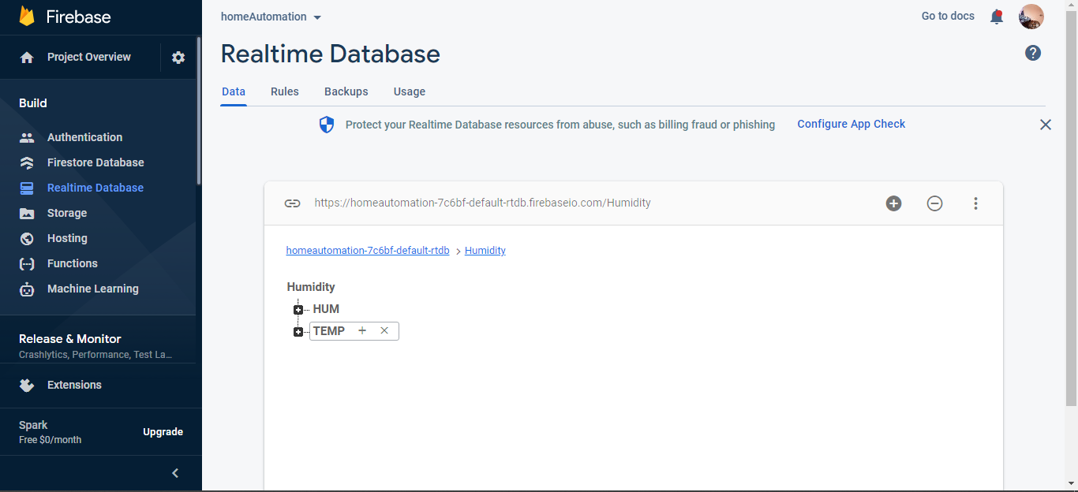

**Machine learning model**

**Mobile application and Web app design**

**Chatbot**

## Requirement analysis

## Methodology

## 

## 

## 

## 

## 

## 

## 

## 

## 

## 

## 

## 

## 

## 

# 

# CHAPTER 4:  CONCLUSIONS AND RECOMMEDATION

## 4.2 CONCLUSION

Home automation based on IoT is one of the promising and essential issues in recent times. It provides a comfortable living. In this paper, we implemented an IoT-based low cost and flexible home automation system framework through a mobile web app. We intend to use ESP8266 as a microcontroller board with the Wi-Fi module. However, in future work, we will develop a smart building and as well as a smart city. The big challenge is to manage all in real-time data in a well-organized pattern. We hope our proposal will be considered and approved so that we can continue with the building of the real system.

## 4.3 References

1.Ginovsky, J. (2017, June 9). [Preparing for AI and IoT’s coming collision.](http://www.bankingexchange.com/retail-banking/customers/item/6886-preparing-for-ai-and-iot-s-coming-collision) *Banking Exchange.*

*2.*Jaffe, M. [IoT Won’t Work Without Artificial Intelligence](https://www.wired.com/insights/2014/11/iot-wont-work-without-artificial-intelligence/). *Wired.*

3.Barzilay, O. (2017, 2 Nov). [Can Blockchain and AI Accelerate the Arrival of the IoT Economy?](https://www.forbes.com/sites/omribarzilay/2017/11/02/can-blockchain-and-ai-accelerate-the-arrival-of-the-iot-economy/#537c90d440d8) Forbes.

4.Bergey, C. (2017, 2 Nov). [Data Context vs. Content in an IoT Environment.](http://internetofthingsagenda.techtarget.com/blog/IoT-Agenda/Data-context-vs-content-in-an-IIoT-environment) IoT Agenda.

**APPENDIX**