**Window 7**

IE: cannot access www.durhamtechbookshare.com

**Window 10**

Edge: cannot access [www.durhamtechbookshare.com](http://www.durhamtechbookshare.com)

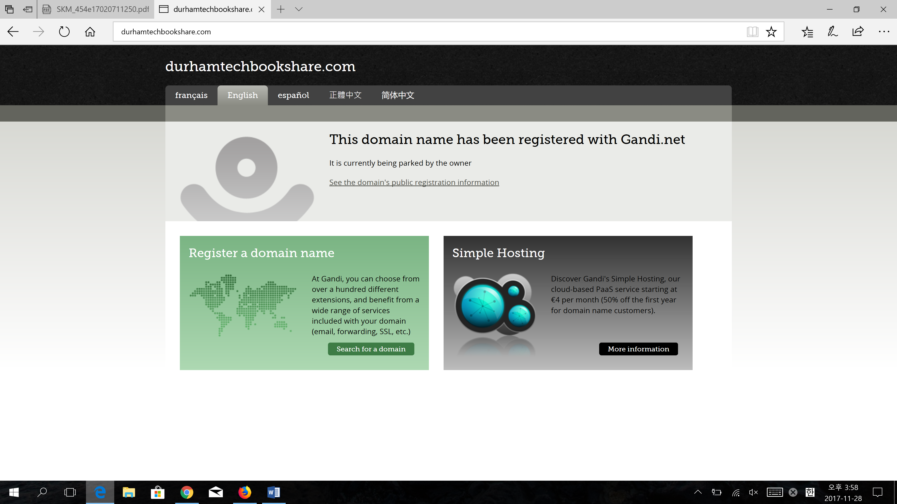

Chrome:



-At homepage: Link show up twice

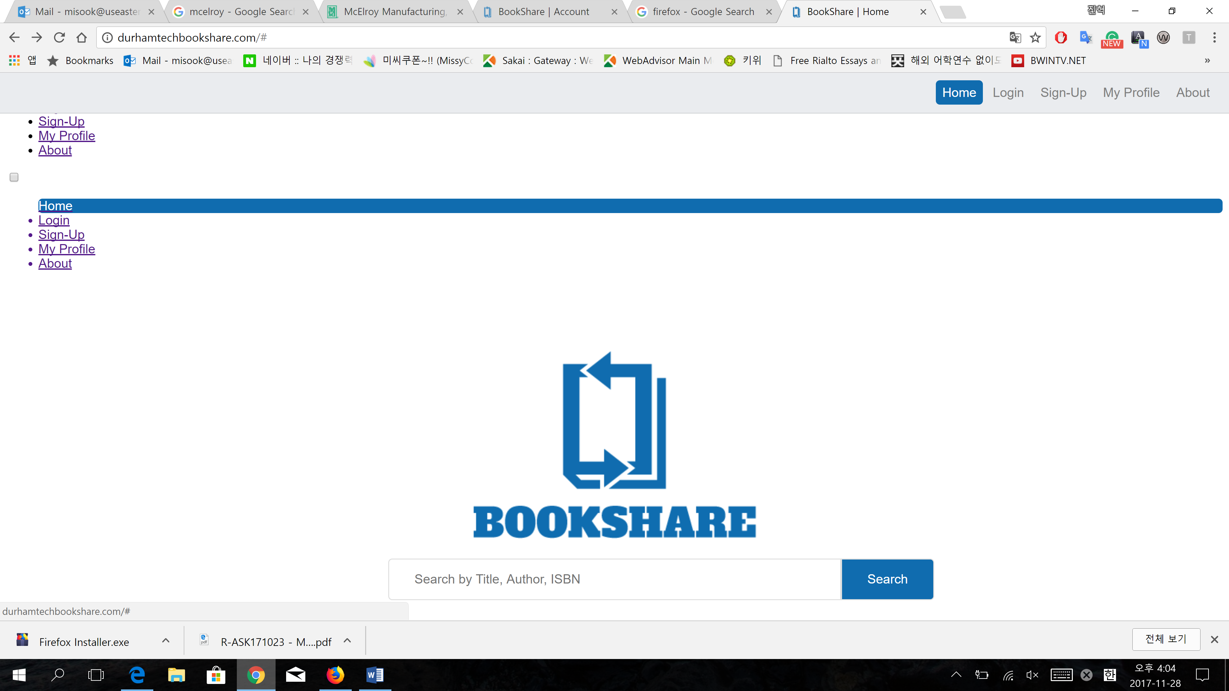

-At login page: Right up side does not have link for home,login,signup, my profile, and about

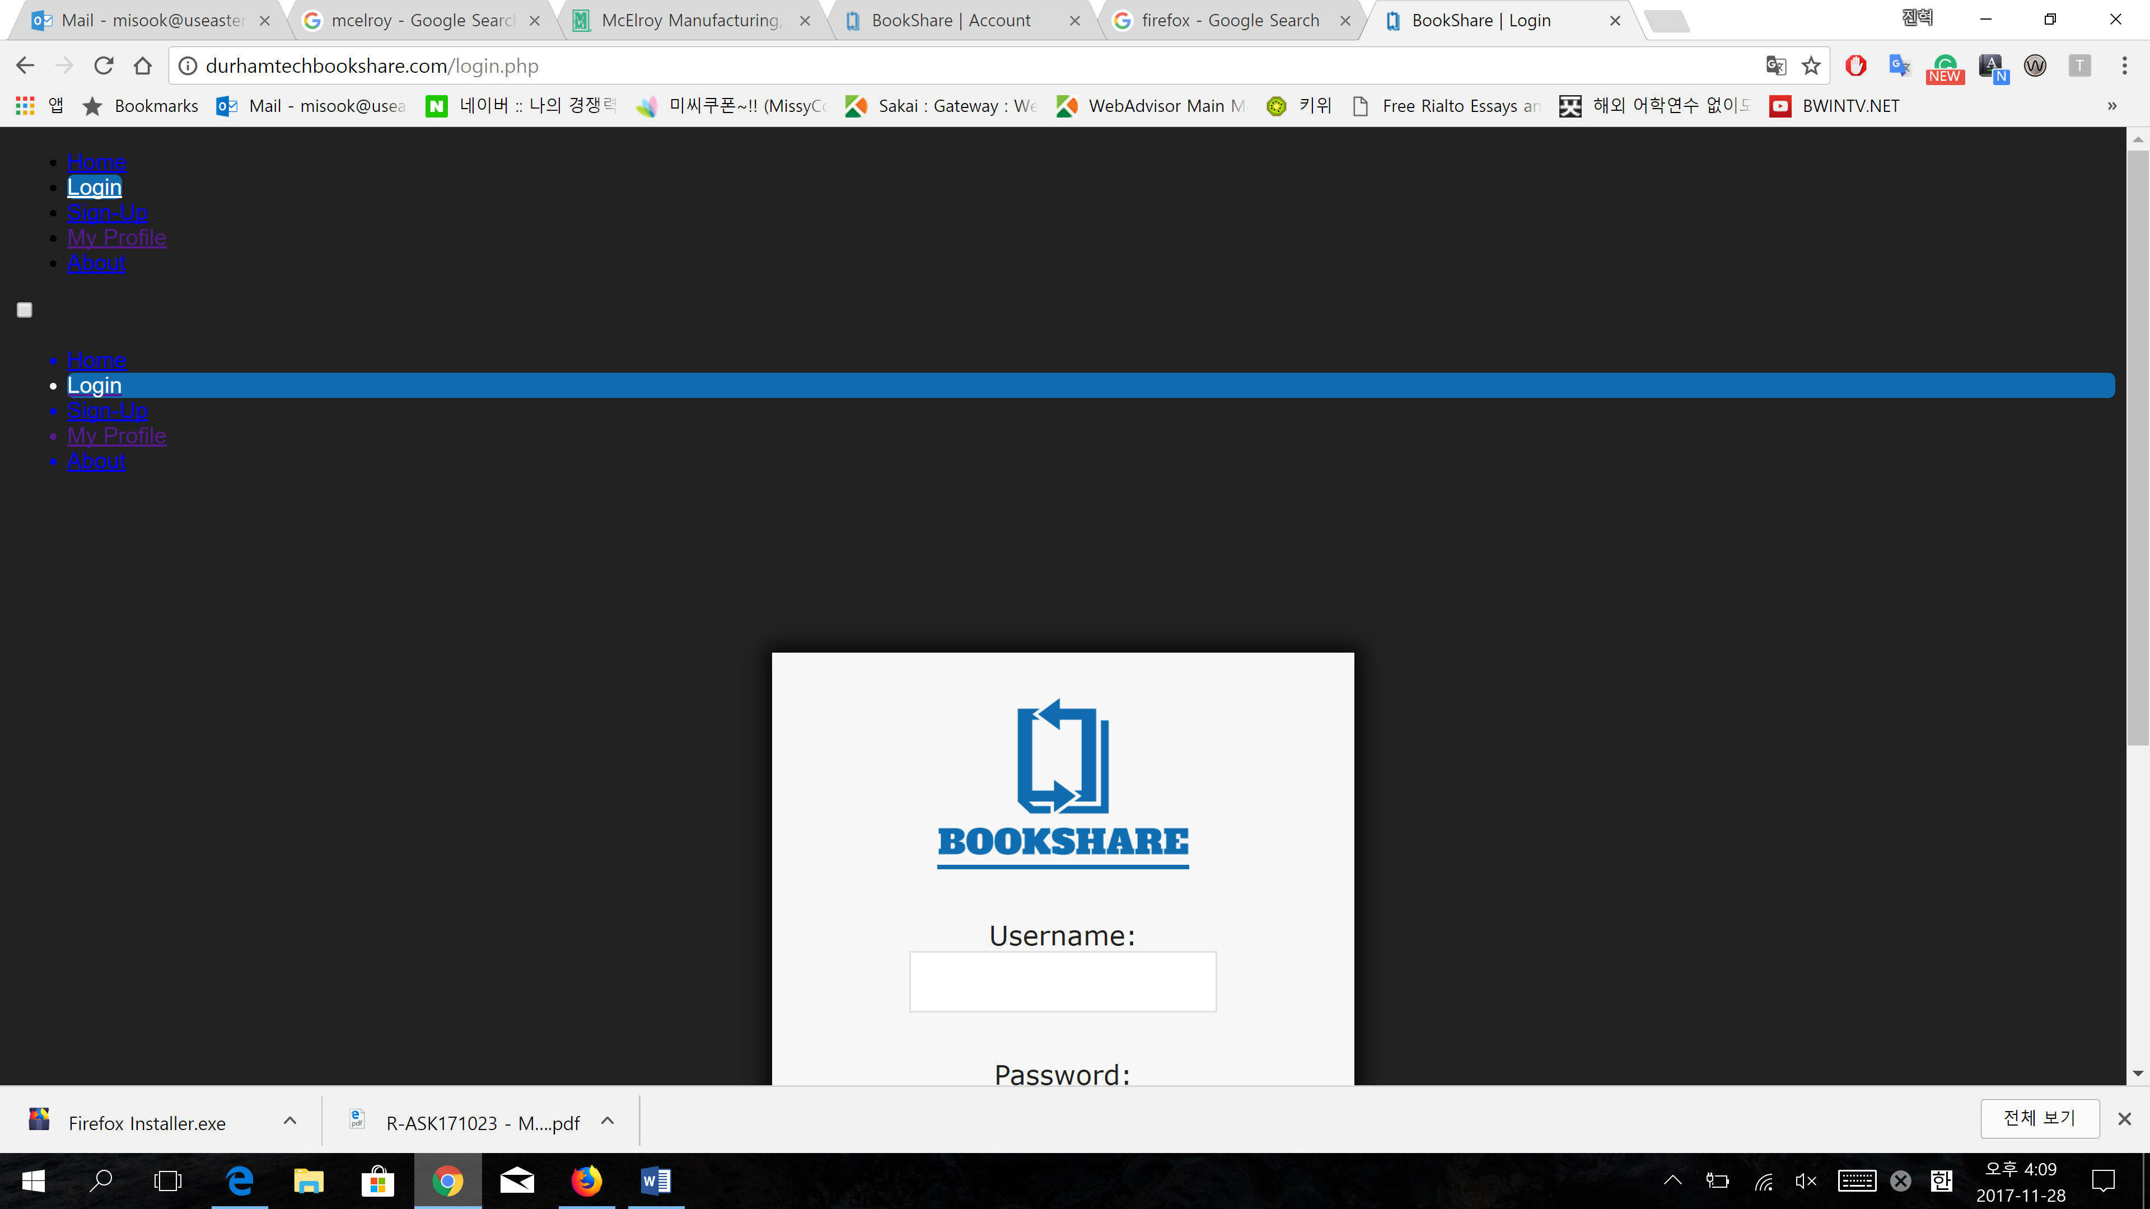



-Cannot Access to My profile (with right up side link) and About page

-My profile page: Does not have link on Right up side

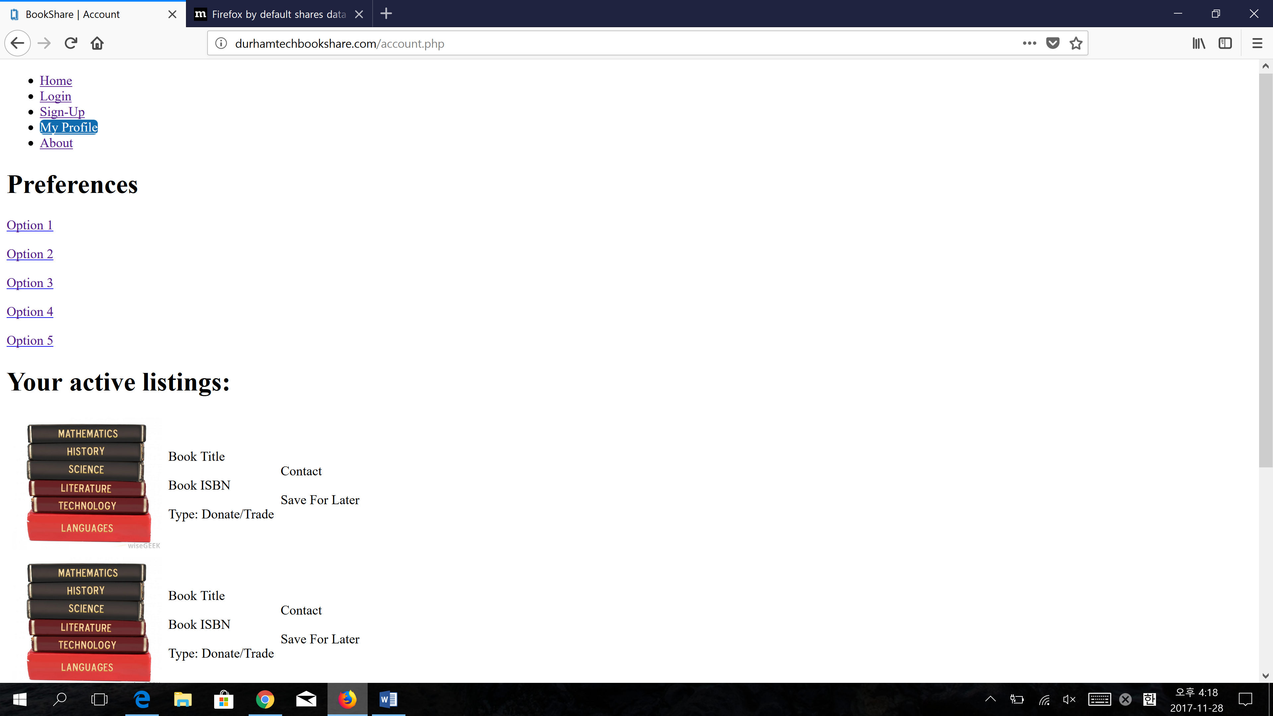



Firefox:

Same as Chrome.

**Android**

Chrome, firefox : Same as Chrome on Window 10

**Ipad, Iphone**

Chome, firefox, safari: Same as Chrome on Window 10