**Locally-informed proposals in**

**Metropolis-Hastings algorithm with**

**applications**

**Bartosz Chmiela**[1]

1 *Mathematical Institute, University of Wrocław, pl. Grunwaldzki 2/4, 50-384 Wrocław, Poland*

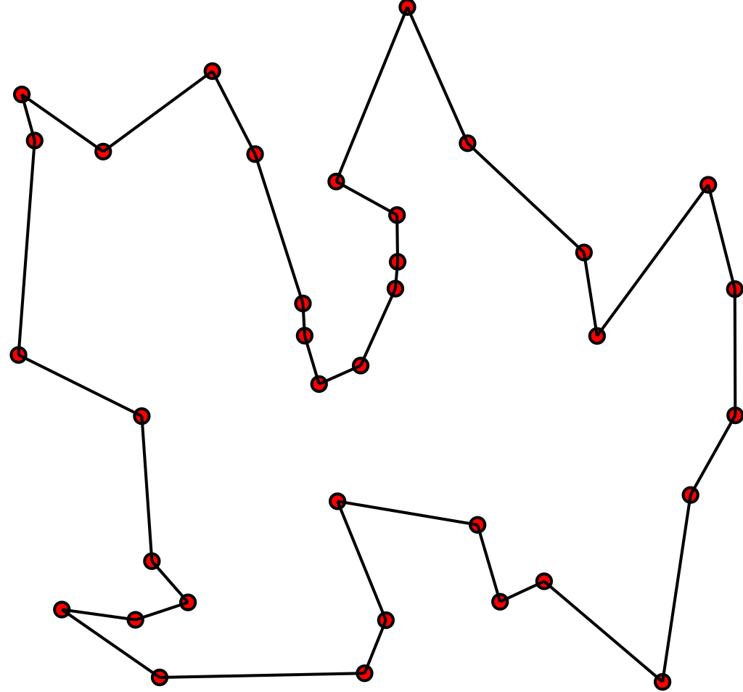Figure 1: Traveling salesman problem, source: wiki.

The Markov chain Monte Carlo methods (abbrv. MCMC) are a family of algorithms used for approximate sampling from a given probability distribution. They prove very efective when the state space is large. This fact can be used to solve many hard deterministic problems - one of them being traveling salesmen problem, which asks for the shortest route that visits all of the cities exactly once. We will present an application of a relatively new modification of a well known Metropolis-Hasting algorithm (called locally informed proposals) to the aforementioned traveling salesman problem. This approach uses a locally computed distribution, that changes depending on a candidate, at each step of the Metropolis-Hastings algorithm. We will present the implementation of the modified algorithm, experiments based on it, results and a comparison with previous MCMC methods.

Talk based on a master's thesis written under supervision of Paweł Lorek

1. Email: chmiela.bartosz@gmail.com