Teach Yourself the .MAD File Spec in 20 Minutes
By Orof Da Ludicrous

Before we get started, you’ll need the following tools:
- Mad_editor by Delphy (most recent version, 1.01 d).
- Some sort of 3d modeling program
- Text editor (notepad is best).
- 3d Explorer (version 1.4.10 BETA tends to work perfectly)

And I will assume you have the following in this tutorial:
- 3D Studio Max (or any 3d editor really)
- Rhino 3d
- Mad_Editor
- Notepad
- Peomatrix by Ratbag
- Peoinfo by Ratbag
- Peochain by Ratbag
- A copy of Homeworld
- 3d Explorer (version 1.4.10 BETA tends to work perfectly)

I couldn’t really tell you where to get all this, because I don’t know. You can get a demo of Rhino 3d from http://www.rhino3d/com, and you can search the relic message boards (editing section) to try and locate a copy of Delphy’s and Ratbag’s tools.

Note: go to the end of this guide to learn about just how to trigger mad files and how to add the important line into a .shp file.

STEP 1: Making a Model
When you’re making an animated model, it usually helps to have a model in the first place. So, logically, step 1 is to make a model and decide what it will replace in Homeworld (HW). I won’t go over how to replace a unit in HW, because there are already plenty of places to learn about this process. If all else fails, go to the Relic’s message boards in the editing section. You’ll almost always get help there from competent people within a couple days at most.

For my unit, I decided to replace the r1 attackbomber with my ETA transformable mobile frame from my upcoming Relic 9 mod (shameless plug). I already had the model all made up, so I just threw a holdover texture on it and started getting it ready for HW.

The first thing to know is that every individual piece that you are going to want to animate has to be its own object. The point that you’re going to want to rotate about also has to be its origin; you can’t rotate around an arbitrary point. Also, the pieces have to have the correct orientation so that when they are imported into HW they will fly forward and not sideways or some stupid direction. The best, and fastest, way to do this is to fire up Rhino and then import every object you plan on having in your model one by one and orienting it in Rhino (see figure 1). Figure 1 shows how you should orient objects in Rhino to get them to fly straight in HW.
I’ve found that Rhino tends to save orientations and axis data much better that 3d Studio MAX, which tends to just assume that an objects axis has the same orientation and position as the global axis.

Figure 1 – Rhino object orientations
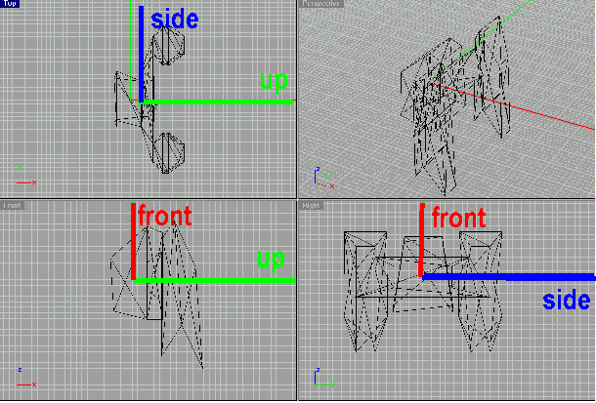
After you have all the objects oriented in Rhino, you can go back into 3d Studio MAX (or stay in Rhino) and create a new file. Then, import all of the objects you’ve oriented in rhino one at a time. IMPORTANT: don’t move them off the origin. Each object’s origin point should be in the same place as the global origin (0,0,0). This is necessary for later. After you have all your objects imported in the same work space, export the file again as a .3ds file.

STEP 2: Getting your model into HW file Formats
Now that you have a model, its time to import it into 3d explorer so that you can export it as a .peo file. This is a really easy step, but since different versions of 3d Explorer seem to work with varying levels of success, it can also be the most frustrating. Just start 3d Explorer and import the .3ds file for your model. It should look something like mine does in Figure 2.

Figure 2 – 3d explorer model orientations
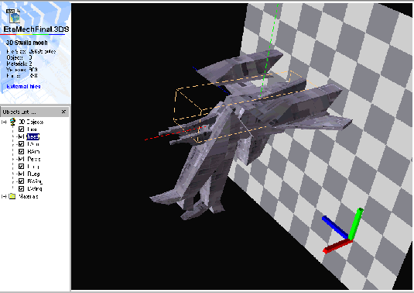
This is a good time to check the axis data that we fixed in step 1. Check every one of your objects by clicking on their name on the left. Each one should have the same axis data (the three colored lines) in the same direction as is shown in Figure 2. Green is up/down, Blue is Left/right, Red is forward/back. If everything looks correct, export your model to the same directory as your copy of the RatBag tools and Mad_Editor and go on to the next step. You can also export an .x file for the mex process, but I won’t go over that.

STEP 3: The happy fun peomatrix comedy hour (or 2, or 3)
Here comes another one of those easy, yet time consuming steps. Fire up your copy of peomatrix (the readme that came with it will tell you how) and start tweaking the position values. This will take awhile, as after each change you have to put the new file through peochain and then replace it into HW and test it. Just keep trying until you get the placements correct. Just change the values of the transformation matrix in peomatrix, link the object with peochain, and then take the .peo file that it outputs and put it into every lod folder in your replacement folder (for the ETA, this was homeworld\r1\attackbomber\rl0\lod0 – lod4).

STEP 4: Finally, actual MAD editing! Wait no, more .peo stuff.
Ok, lets go over what you should have by now. You should have a .peo file with the objects each in their proper places. You should also have an r1 folder in your HW directory with a .shp, .lod, and graphics folder all ready for your use (Mine was “homeworld\r1\attackbomber.shp“,“homeworld\r1\attackbomber.lod“, and the “homeworld\r1\attackbomber” folder full of the “rl0\lod0 – 4” folders).
Step 4 is only vital if you have a object with multiple levels of hierarchy. Don’t know what I mean? OK, as an example, the ETA’s legs were linked to its pelvis, so that when the pelvis rotated, it brought the legs with it. This is done in Delphy’s handy Mad_editor, which doubles as a .peo linker. Note: you can also use this to make turrets with barrels. Cool, huh? Just click “file → open → peo geometry” to load the file into Mad_Editor.
Figure 3 – peo heirarchy
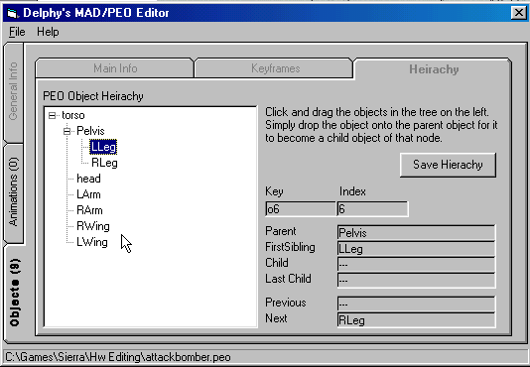
As you can see in Figure 3, I’ve linked the Lleg and RLeg on the second level, with Pelvis as their parent object. This makes it so that rotating the Pelvis will rotate the Legs about the Pelvis’s base point. The use of this editor is really easy, but there’s one trick. To move an object, you first have to click on it to select it. After you click on it you can drag it onto any other object and it will become that object’s child. After you have the hierarchy all settled you just click “save hierarchy”. It should say something along the lines of “Save Completed”. Just click OK. Now you have to quit Mad_Editor and move the .peo file that you edited back into every “rl0\lod0 – 4” folder again. This should be the last time, though, so it’s OK.

STEP 5: Now comes the MAD editing.
Ok, we got our finalized .peo file. Now here comes my “wisdom” regarding .mad editing using Delphy’s mad editor. This is a step that can be really daunting, but its not really that bad. Just like the placement of objects with Peomatrix, its mostly trial and error. Tweak a value, save the mad editor, check it in HW, repeat until satisfied. There are several little quirks in the Mad_editor that can complicate this process, though.
First, start Mad_Editor and load a .peo data file. To do this click “file -> new -> from .peo file”. This will load a new .mad file with all of the objects from your .peo file ready for you to make key frames for. Before you jump right in, though, you have to rename the animations or change the times that they cover. Figure 4 shows this process. Then you have to make sure that every object has every animation included for it. Figure 5 shows a screen shot of this process.

Figure 4 – Naming Animations
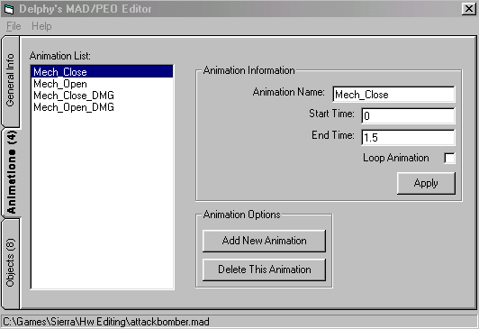
You can add new animation using the two buttons at the bottom, and change their data at the text fields at the right. Just be sure that the start time and end time is unique for each animation, as is the name. Unusually, each animation from top to bottom should cover the same amount of time and should be separated by a short time. For example, the ETA has its Mech_Close animation from time 0 to 1.5, and its Mech_Open animation from time 1.53 to 3. be sure to click apply after each change, or it will disregard changes.

Figure 5 – including animations for objects
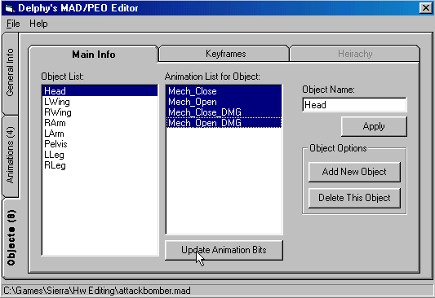
For each object, just click every one of the animations
from the list in the middle so that they are blue, and click “Update Animation Bits.” They should then stay blue, and the object will be included in that animation. You shouldn’t have to mess with the “Add New Object” because you loaded your complete peo file earlier. You can use “Delete This Object” (I deleted torso for example) because not all objects in your file may be animated.

Now on to the subject of key frames!
MAD files are based on key frame animation. Basically, this means that the animations are mostly handled mostly by the HW engine, but you supply certain points that it has to move or animation the objects to. This makes it much easier on the animators, and little harder on the original programmer (like we care, they did a good job).
At this point, I have to say this: look at examples from the HW .big file to judge what you want to do. If I went through every little point of key frame animation, this tutorial would be 30 pages long. What I am going to do is tell about some of the more conceptual points. The first is translation.

Figure 6 shows a sample output file for the peoinfo program

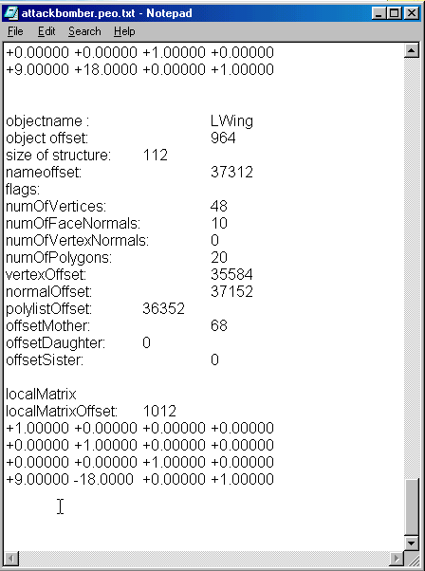
If you’ve moved any of your objects off the very center origin of the base object (this is nearly unavoidable, my base object for ETA was “torso”), you’ll have to set the same offsets in every key frame of the .mad file. To help this process, try using peoinfo to spit out a file that show you all of the offsets for every object in the file. Figure 6 shows a sample file for the peoinfo output. The important part to look at is the matrix at the bottom of the screen shot there. The first three entries of the last line there are the coordinate offsets. The first entry controls the uo/down offset. The second entry is the left/right offset. The third entry is the front/back offset. In this case, the Left wing is off set 9 units up, 18 units to the left, and 0 units to the front or back. This is the only really important entry in this file unless you rotated the objects at all (which you shouldn’t have because we set them up right in the beginning.

.

Figure 7 show a screenshot of a key frame in the ETA’s animation.
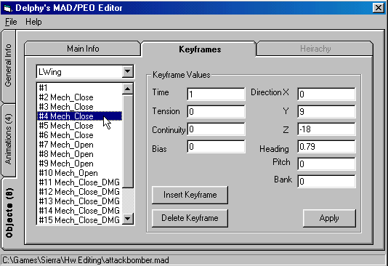
Ok, here’s the key frame window. This is where you’ll be spending many, many hours tweaking values. Right now I’d like to concentrate on the right upper part of the window, in the Direction X Y Z area. This is pretty standard, just set the XYZ values to exactly the same offsets as in your peoinfo file, unless you want the object to move during an animation. When using mad files, the objects tend to disregard the offsets in the peo file, so you have to set them in the mad animation. The coordinate system of this editor is slightly different than the peoinfo file, however. X is the third entry in the peoinfo file, Y is the first entry, and Z is the second entry. This is pretty important, and it gave me some trouble initially. As you can see, I’ve offset my Left Wing 0 in the X direction, 9 in the Y direction, and –18 in the Z direction. You have to do this for EVERY key frame.
Adding and deleting key frames is easy due to the two buttons labeled, shockingly, “Insert Keyframe” and “Delete Keyframe.” You should usually do about 4 frame for each animation, and the closed animations should have one extra to hold the position between the two animations. Also Note that Mech_Close has the same offsets and rotations as Mech_Close_DMG, just different time intervals.

Here’s a brief explanation of each of the text fields:

Time: The time that this key frame occurs
Tension: This is the “snappiness” of the animaton. No real effect in game, just for tweaking.
Continuity: I haven’t discerned any real effect of this parameter. It is set as 0 or near 0 in almost every one of the original Homeworld mad animations.
Bias: Set this when you are moving or rotating an object. It helps the frames adjust to different keyframes more smoothly. No real major effect for in game though.
X: Front/Back offset.
Y: Up/Down offset.
Z: Left/Right offset.
Heading: Rotation about the up/down axis (turning left and right).
Pitch: Rotation about the Front/Back axis (rolling left and right).
Bank: Rotation about the left/right axis (turning up or down).
**///** NOTE: Heading, Ppitch and Bank is based upon radians. 2 * pi radius is one circle **///**

Remember to hit apply after each change, or it will go back to its original settings.

Here’s an example of the timing for my ETA Left wing Mech_Close and Mech_Open:

Keyframe | Time | Tension | Cont | Bias | X | Y | Z | Head | Pitch | Bank
1 | -1 | 0 | 0 | 0 | 0 | 9 | -18 | 0 | 0 | 0
2 | 0 | 1 | 0 | 0 | 0 | 9 | -18 | 0 | 0 | 0
3 | 0.1 | 1 | 0 | 0 | 0 | 9 | -18 | 0 | 0 | 0
4 | 1.0 | 0 | 0 | 1 | 0 | 9 | -18 | 0.79 | 0 | 0
5 | 1.45 | 1 | 0 | 1 | 0 | 9 | -18 | 0.79 | 0 | 0
6 | 1.5 | 0 | 0 | 0 | 0 | 9 | -18 | 0.79 | 0 | 0
7 | 1.53 | 1 | 0 | 0 | 0 | 9 | -18 | 0.79 | 0 | 0
8 | 1.55 | 1 | 0 | 0 | 0 | 9 | -18 | 0.79 | 0 | 0
9 | 2.5 | 0 | 0 | 1 | 0 | 9 | -18 | 0 | 0 | 0
10 | 3 | 1 | 0 | 0 | 0 | 9 | -18 | 0 | 0 | 0

In this animation, Mech_Close goes from time 0 to time 1.5, and Mech_Open goes from 1.53 to 3. The time –1 at the beginning is just a placeholder, basically, found in most HW mad files. So, in this animation, the wing goes through the close animation, turning to 0.79 to extend into fighter mode. After its done closing, or when the open event is met, it closes again to retract into the body of the ETA. Check out the ETA itself to see this animation in action.

After you’re done animating your fighter, just save the mad file and put it in the same directory as your .shp file.

STEP 6: Adding things to the .shp file
Ok, now you’ve got your great mad animation, but no way to call it in game. This is where changes in the mad animation come in. The following are several cases in which I execute my animation for the ETA file, according to different event. It also shows what is needed inside the .shp file for these to work.

CASE 1: I Want My ship to animate after it leaves a carrier, or when it enters a carrier.

Put the following into your ship file in the bottom, replacing my animation names with yours.

DESIGN NOTES: model your fighter so that it is in the pose you want it to be when it is normally flying around. Set the beginning of the open files in the retracted position. By this I mean the altered positions, say you want a wing to fold out. Set the open animation so that the beginning of the animation shifts the rotations and positions of the wing so that it is retracted. The example of the Eta is the Left wing being rotated by 0.79 radians. The end of the close animation should be retracted.

BindAnimations 1

MadStartInfo 0 , Mech_Open , 1 , Mech_Open

MadDockAnims 1, Mech Open, 1 Mech Close, 0, Mech Open_DMG,0,Mech_Close_DMG

madGunOpenDamagedHealthThreshold 0.70 ;<= 1.0f

You can tweak the 0.70 decimal in the last line to anything between 1.0 and 0.0. 1.0 means 100% health will sue the damaged animations, 0.0 means it has to be dead to use the animations. In this case it will never use it.

CASE 2: I Want my ship to animate right before it fires.

DESIGN NOTES: You have to model you fighter so that it is in its attack pose. For the ETA’s case, this meant that I had to model it in mech mode. Found that out AFTER I made it…
Once again, the end of the closed animation should be the retracted position, and the beginning of the open animations is the retracted position. The ship will fly around normally in is closed, retracted position and only go to its open natural state when firing.

BindAnimations 1

MadStartInfo 1 , Mech_OPEN , 1 , Mech _OPEN

MadGunAnims 1, Mech OPEN, 1, Mech CLOSE, 1, Mech_ Open_DMG, 1, Mech_Close_DMG

madGunOpenDamagedHealthThreshold 0.70 ;<= 1.0f

//You can tweak the decimal here too.

Something of interest to note is that you can use animated objects as turrets. Just do the normal bind nomenclature in this case. When the ship is done animating, it will change the animated object into a turret and use it normally, changing it back to a static animated object again before closing.

CASE 3: I Want my ship to animate while moving.

DESIGN NOTES: You’ll want to model your fighter so that is in the open, moving position in this case. It is about the same as the combat animation in this case. If you want something to spin permanently in ANY animation case, just make the very base object rotate about its Pitch and click on the Loop animation check box. This will make it spin permanently, like the probe. This would be one way to make a spinning portion of capital ships as well. You could just set it so that the spinning section rotates 2 * pi radians about pitch and then loop that animation. As soon as it was done coming out of the ship, it would spin until it docked again (never). NOTE: I haven’t tested this, it’s just a thought. Anyway, here’s the .shp data.

BindAnimations 1

MadStartInfo 1 , Mech_Open , 1 , Mech_Open

MadSpecialCaseAnims 1, Mech_Open, 1, Mech_Close, 1, Mech_Open_DMG, 1, Mech_Close_DMG

madGunOpenDamagedHealthThreshold 0.70 ;<= 1.0f
//you can tweak this decimal

CASE 4: I Want my Mothership to animate while undocking large ships.

DESIGN NOTES: Model this in the closed position, and then animate it so the end of the open animation is in the open position.

BindAnimations 1

MadMothershipDockingAnims 1,HangarDoor_OPEN,1,HangarDoor_CLOSE
//The open and close animation names are these two names here

specialDoorOffset[R1][Carrier] 0.0,-237.0,305.0
specialDoorOffset[R1][CloakGenerator] 0.0,0.0,69.0
specialDoorOffset[R1][DDDFrigate] 0.0,0.0,141.0
specialDoorOffset[R1][GravWellGenerator] 0.0,0.0,125.0
specialDoorOffset[R1][HeavyCruiser] 0.0,-180,248.0
specialDoorOffset[R1][IonCannonFrigate] 0.0,0.0,145.0
specialDoorOffset[R1][MissileDestroyer] -2.5,0.0,127.5
specialDoorOffset[R1][ResourceController] 0.0,0.0,198.0
specialDoorOffset[R1][StandardDestroyer] -2.5,0.0,127.5
specialDoorOffset[R1][StandardFrigate] 0.0,0.0,145.0
specialDoorOffset[R1][CryoTray] 3.0,0.0,113.0

specialDoorOffset[R2][AdvanceSupportFrigate] 7.5,0.0,101.0
specialDoorOffset[R2][Carrier] -6.0,-300.0,275.0
specialDoorOffset[R2][CloakGenerator] 0.0,0.0,124.0
specialDoorOffset[R2][DFGFrigate] 0.0,0.0,125.0
specialDoorOffset[R2][GravWellGenerator] 0.0,0.0,158.0
specialDoorOffset[R2][HeavyCruiser] 0.0,0.0,285.0
specialDoorOffset[R2][IonCannonFrigate] 0.0,0.0,97.0
specialDoorOffset[R2][MissileDestroyer] 0.0,0.0,191.0
specialDoorOffset[R2][ResourceController] 0.0,0.0,257.0
specialDoorOffset[R2][StandardDestroyer] 0.0,0.0,185.0
specialDoorOffset[R2][StandardFrigate] 0.0,0.0,101.0
specialDoorOffset[R2][CryoTray] 3.0,0.0,113.0
//These offsets are the distance the door opens for specific ships. Important for it to look perfect

;specialDoorOffset race ship LW_X,LW_Y,LW_Z,Heading,Up (heading is based on (0=up,1=right,2=forward,4=down,5=left,6=back) of the door's coordinate system
;make sure spaces are correct race<space>ship<space>LW_X<space>...
specialDoorOffset R1 AdvanceSupportFrigate 7.5 0.0 166.0 -1 -1
specialDoorOffset P1 P1IonArrayFrigate 0.0 0.0 200.0 6 0
specialDoorOffset R2 Carrier 71.75 262.5 300.0 4 1
specialDoorOffset R2 ResourceController 0.0 0.0 250.0 1 0
specialDoorOffset R1 CloakGenerator 0.0 0.0 70.0 0 6

specialDoorInterpolationPerSecond 50.0
//This is just a tweaking variable to make the door look a little smoother when it opens Feel free to change this value until you find something nice

