|  |
| --- |
| Argand Plotter |
| User Manual: A-Level Edition |
|  |

Sam Hubbard



## Contents

**Introduction 3**

**System Requirements 3**

**Installation Instructions 4**

**User Interface 5**

**Entering Equations 7**

**Saving and Loading .arg Files 8**

**Troubleshooting 9**

**Glossary 11**

Words featured in the glossary are set in **Bold**

## Introduction

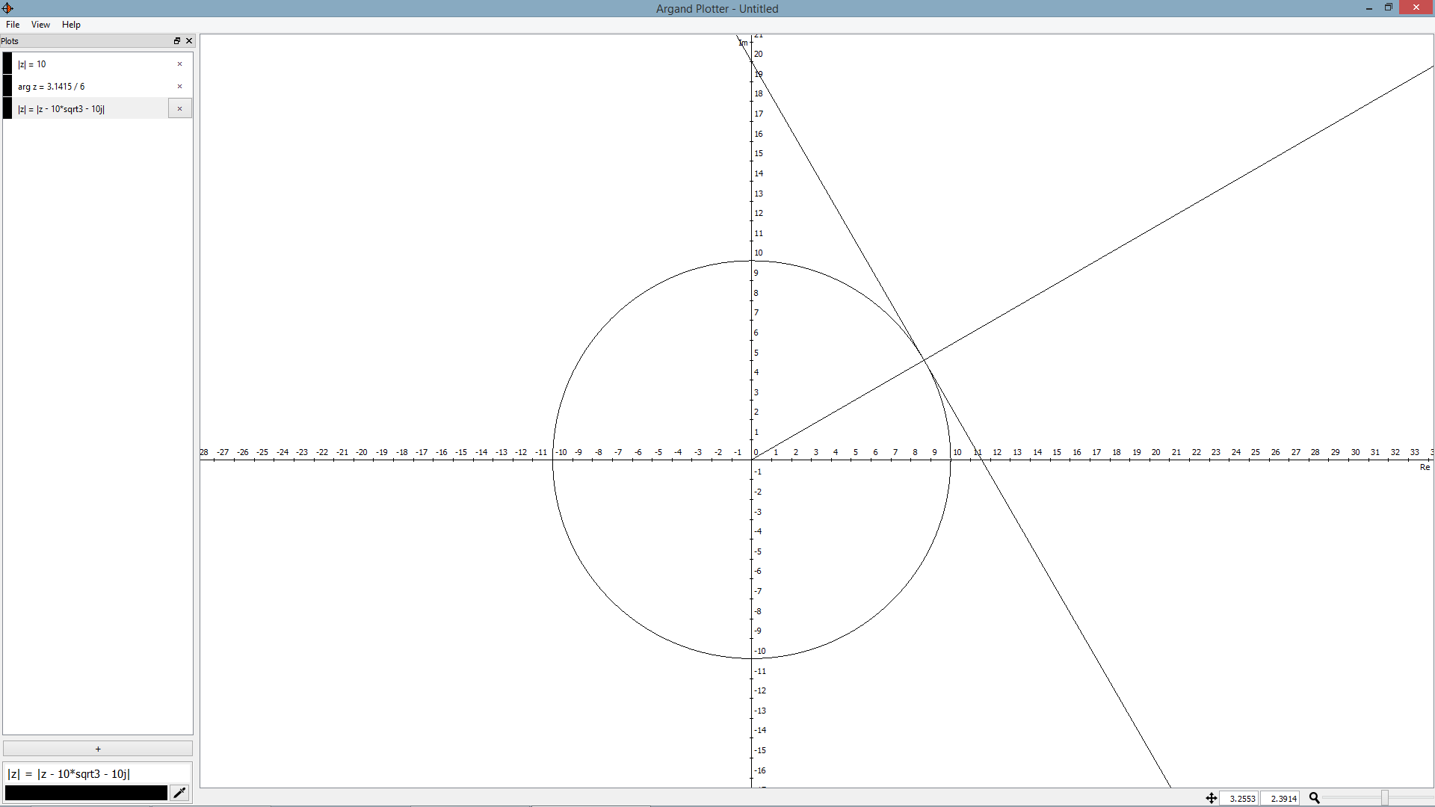

*Thank you for using Argand Plotter!*

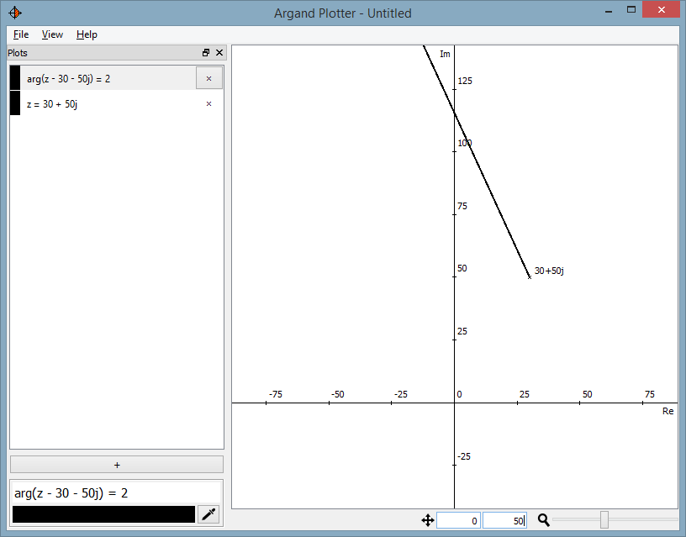

Argand Plotter is a graphing package specifically designed to plot **Argand diagrams.** While many software packages exist for plotting **Cartesian equations**, very few solutions exist for drawing **loci** involving complex numbers, and those that do are limited. Argand Plotter – originally created as an A-Level Computing coursework project for a student’s maths department – aims to fill this niche.

Argand Plotter is designed for teachers and students, to aid learning of the UK GCE Further Maths syllabus; however, anyone learning about complex numbers and Argand diagrams can find use in it.

This guide explains how to install and use the program, as well as how to avoid some known bugs and caveats.

## System Requirements

|  |  |
| --- | --- |
| Operating system: | * Windows 7 * Windows 8 / 8.1 * Mac OS X * Ubuntu 14.04.2 LTS   This list is not exhaustive, and the program may work on other OSs. |
| Display resolution: | 1024 x 768 or greater recommended. |
| Python (source only): | Python 3 or later (3.4 recommended). |
| PyQT (source only): | PyQT 4 or later (4.11.2 recommended). |

## Installation Instructions

### Windows

There are three options for installation on Windows:

1. *Installer:*The installer is by far the easiest option. It creates start menu entries and file associations for the program, and includes an uninstaller. To install the program, simply run the installer and follow the on-screen instructions.

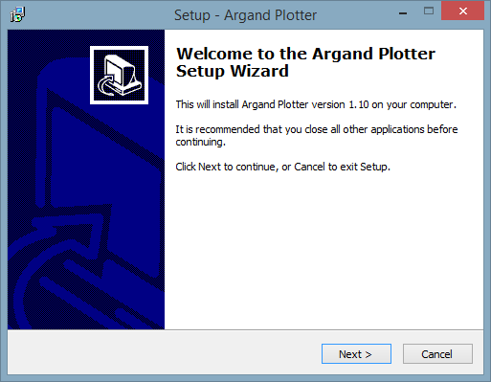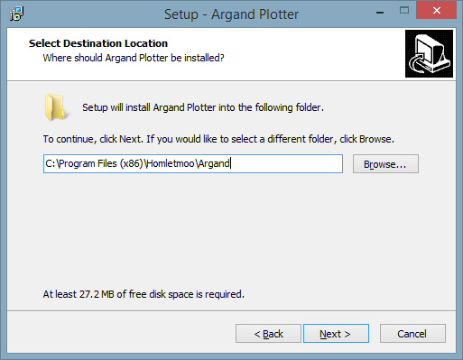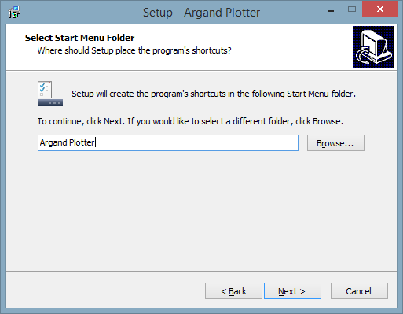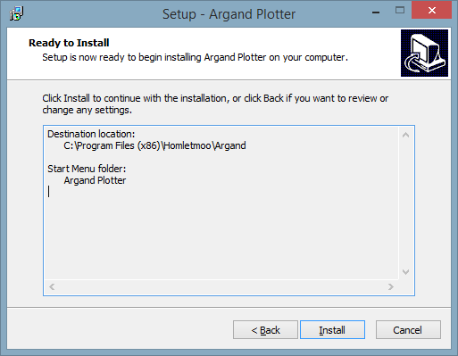

1. *Zip:*A zip containing precompiled Windows binaries is also supplied. Since the program doesn’t create any configuration files on the computer, the zip may be unpacked on a memory stick to create a portable installation.
2. *Source (advanced):*As Python is an interpreted language, it may be run directly from source. This option is best for those interested in how the program works, or who want to modify it. Python 3 and PyQT 4 are required.

### Mac OS and Linux

Unfortunately, the only current option for installation on these operating systems is source. Therefore, Python 3 and PyQT 4 are required.

## User Interface

## Entering Equations

## Saving and Loading .arg Files

## Troubleshooting

## Glossary