
Sanjivani Rural Education Society's
Sanjivani College of Engineering, Kopargaon-423603
(An Autonomous Institute Affiliated to Savitribai Phule Pune University, Pune)
NAAC 'A' Grade Accredited
Department of Information Technology
UG Programme in IT NBA Accredited

A MINI PROJECT REPORT ON

"SMART SMS / MESSAGE DETECTOR SYSTEM
USING NATURAL LANGUAGE PROCESSING "

Submitted by
Komal Hembade [UIT23F1065]
Atharv Hon [UIT23M1066]
Saurabh Jadhav [UIT23M1067]
Anita Jadhav [UIT23F1068]

Under the Guidance of

Dr. S. A. Thanekar

Department of Information Technology
Sanjivani College of Engineering, Kopargaon-423603
Academic Year 2026–2027
CERTIFICATE

This is to certify that the mini-project report entitled “Smart SMS / Message Detector System Using Natural Language Processing” is submitted by:-
- Komal Hembade (UIT23F1065)
- Atharv Hon (UIT23M1066)
- Saurabh Jadhav (UIT23M1067)
- Anita Jadhav (UIT23F1068)
Bachelor of Technology in Information Technology to Sanjivani College of Engineering, Kopargaon-423603,
This project has been completed under the guidance of Dr. S. A. Thanekar as a part of the requirements for the Mini Project in the Department of Information Technology.
The project work presented in this report is carried out by the above students under the guidance and supervision of the project guide and is found satisfactory.
Project Guide Head of Department
Dr. S. A. Thanekar Dr. M A Jawale
Date:28/09/2026
Place: Kopargaon

DECLARATION
We, hereby declare that the mini-project report entitled “Smart SMS / Message Detector System Using Natural Language Processing and Deep Learning” is an authentic record of the study carried out by us under the guidance of Dr. S. A. Thanekar.
The base implementation used for study and analysis in this project — comprising the data-preparation pipeline, the Dense/LSTM/Bi-LSTM model notebook, the trained model files and the Streamlit application — is adapted from the publicly available open-source repository “deepankarvarma/SMS-Spam-Detection-using-NLP” on GitHub. This has been explicitly acknowledged in Section 1.10 (Contributions), Section 5.9 (Version Control), and the References of this report. Our own contribution consists of independently studying, verifying, testing and documenting the project, reproducing and cross-checking the reported results against the actual notebook outputs and saved model files, identifying and recording discrepancies between the repository's README claims and its own code/outputs, and preparing this report end-to-end. We have not misrepresented this adapted code as original, independently-developed work.
Wherever contributions of others are involved, every effort has been made to indicate this clearly, with due reference to the literature and acknowledgement of collaborative research and discussion. We understand that any act of plagiarism / copying may invite disciplinary action from the Institute / University.

Name of Student | Roll No | Signature
Komal Hembade | 65
Atharv Hon | 66
Saurabh Jadhav | 67
Anita Jadhav | 68

Place: Kopargaon Date:28/09/2026

APPROVAL / ACCEPTANCE SHEET
The mini-project report entitled “Smart SMS / Message Detector System Using Natural Language Processing is hereby approved as a creditable study in the field of Artificial Intelligence / Natural Language Processing, carried out and presented in a manner satisfactory to warrant its acceptance as a prerequisite for the degree for which it has been submitted.
- Komal Hembade (UIT23F1065)
- Atharv Hon (UIT23M1066)
- Saurabh Jadhav (UIT23M1067)
- Anita Jadhav (UIT23F1068)
It is to be understood that by this approval, the undersigned do not necessarily endorse or approve any statement made, opinion expressed, or conclusion drawn therein, but approve this report only for the purpose for which it is submitted.

Project Guide Head of Department Name:
Dr. S. A. Thanekar Dr. M A Jawale

Date:28/09/2026
Place: Kopargaon

ACKNOWLEDGEMENT
We would like to express our sincere gratitude to our project guide, Dr. S. A. Thanekar, Department of Information Technology, for the valuable guidance, encouragement and constructive feedback provided throughout the course of this mini-project.
We are thankful to the Head of Department, Dr. M. A. Jawale, and the faculty members of the Department of Information Technology for providing the necessary facilities and a supportive environment for carrying out this work.
Finally, we would like to thank our families and friends for their constant support and encouragement.
We are sincerely thankful to everyone who directly or indirectly contributed to the successful completion of this project.
- Komal Hembade (UIT23F1065)
- Atharv Hon (UIT23M1066)
- Saurabh Jadhav (UIT23M1067)
- Anita Jadhav (UIT23F1068)

ABSTRACT
The rapid growth of Short Message Service (SMS) communication has been accompanied by a corresponding rise in unsolicited, fraudulent and promotional “spam” messages, which manual inspection cannot filter efficiently at scale. This mini-project studies, reproduces and documents a Smart SMS / Message Detector System that applies Natural Language Processing (NLP) and deep learning to automatically classify an SMS message as HAM (legitimate) or SPAM. The system is built around the UCI SMS Spam Collection dataset (5,574 raw records; 5,572 records after parsing, comprising 4,825 ham and 747 spam messages). Because the dataset is highly imbalanced (spam constitutes only about 15.5% of the ham count), the ham class is randomly down-sampled to match the 747 spam messages, giving a balanced working set of 1,494 messages that is split 80:20 into 1,195 training and 299 testing messages.
Messages are lower-cased, tokenized with a Keras Tokenizer restricted to the 500 most frequent words and an out-of-vocabulary token, and converted into padded integer sequences of length 50. Three deep-learning architectures — a Dense (feed-forward) network, an LSTM network and a Bidirectional LSTM (Bi-LSTM) network — are trained with the Adam optimiser, binary cross-entropy loss and early stopping, together with a Support Vector Machine (SVM) trained on the same padded sequences for comparison. On the held-out test split, the notebook itself reports test accuracies of 93.65% (Dense), 95.32% (LSTM), 94.98% (Bi-LSTM) and 69.57% (SVM) — figures that are noticeably lower than the accuracies quoted in the project's own README file (98.5%, 98.6%, 98.8% and 97.6% respectively), a discrepancy that this report investigates and documents rather than silently repeats. The selected Dense model is exposed through a Streamlit web application that accepts a message and returns a HAM/SPAM prediction with a probability score.
This report presents the complete study of the system's architecture, methodology, implementation and verified results, and explicitly documents the aspects that could not be verified (precision, recall, F1-score and a confusion matrix are not computed anywhere in the project) and the discrepancies found between documentation and code, in line with the academic-integrity requirements of this report.

Keywords
SMS Spam Detection, Natural Language Processing, Deep Learning, Text Classification, Long Short-Term Memory (LSTM), Bidirectional LSTM, Dense Neural Network, Support Vector Machine, Tokenization, Streamlit, TensorFlow, UCI SMS Spam Collection.
TABLE OF CONTENTS
CERTIFICATE ii
DECLARATION iii
APPROVAL / ACCEPTANCE SHEET iv
ACKNOWLEDGEMENT v
ABSTRACT vi
Keywords vi
LIST OF FIGURES xii
LIST OF TABLES xiii
LIST OF ABBREVIATIONS xiv
CHAPTER 1 — INTRODUCTION 1
1.1 Background 1
1.2 Problem Domain 1
1.3 Motivation 1
1.4 Problem Statement 2
1.5 Need for the System 2
1.6 Aim 2
1.7 Objectives 2
1.8 Scope 3
1.9 Proposed Solution 3
1.10 Contributions 3
1.11 Organization of the Report 4
CHAPTER 2 — LITERATURE REVIEW 5
2.1 Introduction 5
2.2 Existing Research 5
2.3 Existing Systems 6
2.4 Technologies Used in Existing Research 6
2.5 Comparative Analysis 6
2.6 Research/Technology Gap 8
2.7 Limitations of Existing Research 8
2.8 Summary 9
CHAPTER 3 — EXISTING SYSTEM AND PROBLEM ANALYSIS 10
3.1 Introduction 10
3.2 Existing System 10
3.3 Working of Existing System 10
3.4 Limitations 10
3.5 Problem Analysis 10
3.6 User Requirements 11
3.7 Functional Requirements 11
3.8 Non-Functional Requirements 11
3.9 Feasibility Study 12
3.10 Proposed System 12
3.11 Advantages of Proposed System 13
CHAPTER 4 — SYSTEM ANALYSIS AND DESIGN 14
4.1 Introduction 14
4.2 System Architecture 14
4.3 System Workflow 14
4.4 System Modules 15
4.5 Module Description 15
4.6 Data Flow Diagrams 16
4.7 Use Case Diagram 17
4.8 Activity Diagram 17
4.9 Sequence Diagram 18
4.10 Class Diagram 19
4.11 ER Diagram / Database Design 20
4.12 Data Processing Flow 20
4.13 System Workflow 20
4.14 Security and Privacy Considerations 20
CHAPTER 5 — TECHNOLOGIES AND TOOLS 21
5.1 Introduction 21
5.2 Hardware Requirements 21
5.3 Software Requirements 21
5.4 Programming Languages 21
5.5 Frameworks 21
5.6 Libraries/APIs 22
5.7 Database 22
5.8 Development Environment 23
5.9 Git/GitHub 23
5.10 Technology Selection Justification 23
CHAPTER 6 — METHODOLOGY 24
6.1 Introduction 24
6.2 Methodology 24
6.3 Dataset 25
6.4 Data Collection 26
6.5 Data Preprocessing 26
6.6 Feature Representation 26
6.7 Model Selection 27
6.8 Algorithm 27
6.9 Training Process 28
6.10 Testing 29
6.11 Performance Evaluation Metrics 29
6.12 Pseudocode 29
6.13 Detailed Working of the System 30
6.14 Implementation Flowchart 30
CHAPTER 7 — IMPLEMENTATION 31
7.1 Introduction 31
7.2 System Architecture Implementation 31
7.3 Data Loading Module (Notebook) 31
7.4 Preprocessing / Tokenization Module 31
7.5 Model Training Module 32
7.6 Prediction Module and a Verified Implementation Limitation 34
7.7 Database 35
7.8 User Interface 35
7.9 Backend 35
7.10 API Integration 35
7.11 Error Handling 35
7.12 Security 35
7.13 Important Code Snippets 36
7.14 Complete Workflow 36
CHAPTER 8 — RESULTS AND DISCUSSION 38
8.1 Introduction 38
8.2 Experimental Setup 38
8.3 Test Cases 38
8.4 Test Case Results 39
8.5 Functional Testing 39
8.6 Performance Evaluation 40
8.7 Accuracy and Model Evaluation 40
8.8 Graphs 40
8.9 Discrepancy Between README and Experimental Results 43
8.10 Result Analysis 44
8.11 Discussion 45
8.12 Advantages 45
8.13 Limitations 46
CHAPTER 9 — CONCLUSION AND FUTURE SCOPE 47
9.1 Introduction 47
9.2 Project Summary 47
9.3 Major Findings 47
9.4 Achievement of Objectives 48
9.5 Conclusion 48
9.6 Applications 49
9.7 Future Scope 49
9.8 Possible Enhancements 50
9.9 Final Remarks 50
REFERENCES 51

LIST OF FIGURES
Figure 4.1: System Architecture 14
Figure 4.2: Overall Workflow (Training and Inference) 15
Figure 4.3: Context-Level Data Flow Diagram 16
Figure 4.4: Level-1 Data Flow Diagram 16
Figure 4.5: Level-2 Data Flow Diagram (Model Inference) 17
Figure 4.6: Use Case Diagram 17
Figure 4.7: Activity Diagram 18
Figure 4.8: Sequence Diagram 19
Figure 4.9: Conceptual Module View (Class Diagram Equivalent) 20
Figure 6.1: Methodology Flowchart 25
Figure 7.1: Dense Model Architecture (as saved in Dense_Spam_Detection.h5) 32
Figure 7.2: LSTM Model Architecture (as saved in LSTM_Spam_Detection.h5) 33
Figure 7.3: Bi-LSTM Model Architecture (as saved in BiLSTM_Spam_Detection.h5) 33
Figure 7.4: Streamlit Application Interface 35
Figure 7.5: Complete Inference Workflow 37
Figure 8.1: Dense Model — Training vs Validation Accuracy 41
Figure 8.2: Dense Model — Training vs Validation Loss 41
Figure 8.3: LSTM Model — Training vs Validation Accuracy 42
Figure 8.4: LSTM Model — Training vs Validation Loss 42
Figure 8.5: Bi-LSTM Model — Training vs Validation Accuracy 43
Figure 8.6: Bi-LSTM Model — Training vs Validation Loss 43
Figure 8.7: Model Accuracy — Notebook-Reported vs README-Claimed Values 44

LIST OF TABLES
Table 2.1: Comparative Analysis of Existing Research 8
Table 3.1: Functional Requirements 11
Table 3.2: Non-Functional Requirements 12
Table 5.1: Software Requirements and Verified Library Versions 22
Table 6.1: Dataset Class Distribution 26
Table 6.2: Preprocessing / Tokenization Hyperparameters 27
Table 6.3: Training Configuration per Model 28
Table 7.1: Model Architecture Parameter Summary (from saved .h5 files) 33
Table 8.1: Test Cases and Observed Application Behaviour 39
Table 8.2: Functional Testing Summary 39
Table 8.3: Verified Model Performance (Notebook-Reported) 40
Table 9.1: Objective vs Achievement 48

LIST OF ABBREVIATIONS
Abbreviation | Full Form
AI | Artificial Intelligence
API | Application Programming Interface
Bi-LSTM | Bidirectional Long Short-Term Memory
CSV | Comma-Separated Values
DFD | Data Flow Diagram
GPU | Graphics Processing Unit
h5 / HDF5 | Hierarchical Data Format version 5 (Keras model file format)
LSTM | Long Short-Term Memory
ML | Machine Learning
NLP | Natural Language Processing
OOV | Out Of Vocabulary
RBF | Radial Basis Function (SVM kernel)
ReLU | Rectified Linear Unit
SMS | Short Message Service
SVM | Support Vector Machine
TF-IDF | Term Frequency–Inverse Document Frequency
UCI | University of California, Irvine (Machine Learning Repository)
UI | User Interface
Table: Abbreviations used in this report

CHAPTER 1 — INTRODUCTION

1.1 Background
Short Message Service (SMS) remains one of the most widely used channels of digital communication because it is inexpensive, does not require an internet connection, and is trusted by users for time-sensitive information such as one-time passwords and bank alerts. This same trust and reach have made SMS an attractive channel for unwanted promotional messages and fraudulent “smishing” attempts. Unlike e-mail spam filtering, which has matured over two decades, SMS spam filtering has to work with very short, informally written text that carries little context, uses abbreviations and mixed case, and offers only a small number of words from which to learn a classification signal.
Manually identifying spam messages does not scale: a human reader cannot process the growing volume of messages received on a mobile device, and simple keyword or rule-based filters are brittle, because spammers continuously vary their wording to evade static rules. Artificial Intelligence (AI) and Natural Language Processing (NLP), combined with statistical/deep learning classification models, offer a way to learn the distinguishing patterns of spam messages directly from labelled data instead of relying on hand-written rules, and to generalise this learned pattern to messages not seen during training.

1.2 Problem Domain
This project falls within the domain of text classification, a sub-field of Natural Language Processing. Specifically, it addresses binary SMS classification, where an input message must be assigned to exactly one of two classes: “ham” (legitimate) or “spam” (unwanted/fraudulent). Because SMS text is short (a few words to a couple of sentences) and informally written, representing it in a form a machine learning model can process — through tokenization and numeric sequence representation — is itself a central sub-problem of this domain.

1.3 Motivation
The motivation for this project is twofold. First, from a practical standpoint, an automated SMS spam classifier reduces the effort required to identify unwanted messages and illustrates a realistic, end-to-end application of NLP and deep learning to a problem that affects everyday mobile communication. Second, from an academic standpoint, the project provides a concrete setting in which to study and compare different neural architectures — a plain feed-forward (Dense) network, a recurrent LSTM network and a Bidirectional LSTM network — on the same short-text classification task, and to critically examine how the results reported by a project's own documentation compare with what its code and saved artefacts actually produce.

1.4 Problem Statement
To study, verify and document an AI-based system capable of automatically classifying an input SMS message as spam or ham using NLP-based text preparation and deep learning classification models, and to report the system's actual, verifiable technical behaviour and performance rather than only its documented claims.

1.5 Need for the System
An automated SMS classifier can provide faster and more consistent labelling than manual inspection, and removes the maintenance burden associated with hand-written keyword rules, which must be updated continuously as spam wording changes. Studying such a system also demonstrates the complete applied-AI workflow — from raw labelled text, through preprocessing and model training, to a usable prediction interface — which is valuable both as an engineering exercise and as a foundation for more advanced, production-oriented spam filters.

1.6 Aim
To study, reproduce, verify and document a working SMS classification system that uses NLP-based preprocessing and deep learning models to distinguish spam messages from legitimate (ham) messages, and to present the system's verified architecture, methodology and results through a Streamlit-based prediction interface.

1.7 Objectives
- To study SMS spam detection as a binary NLP text-classification problem.
- To analyse the UCI SMS Spam Collection dataset actually used in the project, including its class distribution and imbalance.
- To verify and document the exact text preprocessing, tokenization and sequence-padding pipeline implemented in the project notebook.
- To verify the architecture, hyperparameters and training configuration of the Dense, LSTM and Bi-LSTM models actually saved in the project (as opposed to only what is described in the README).
- To reproduce and report the models' evaluation results as printed by the notebook itself, and to compare these against the accuracy figures claimed in the project README.
- To examine the Streamlit application (app.py) actually used to serve predictions and document its real behaviour, including any implementation limitations found during inspection.
- To identify, record and explain discrepancies between the project's documentation and its verifiable code/outputs, consistent with the academic-integrity requirements of this report.

1.8 Scope
The scope of this report is limited to binary (ham/spam) classification of English-language SMS text using the UCI SMS Spam Collection dataset and the models actually implemented in the studied project (Dense network, LSTM network, Bi-LSTM network, and an SVM trained for comparison). The report does not claim, and the studied project does not implement, multilingual detection, real-time telecom-network integration, a persistent database, user authentication, or any backend API. Precision, recall, F1-score and a confusion matrix are not computed anywhere in the project and are explicitly marked as not implemented in this report rather than estimated or invented.

1.9 Proposed Solution
The studied solution follows a straightforward pipeline: an SMS message is entered as free text, converted to lowercase, tokenized and converted into a fixed-length padded integer sequence (length 50), and passed to a trained classification model whose sigmoid output is thresholded at 0.5 to produce a HAM or SPAM label together with a probability score. The prediction is served through a small Streamlit web application. This general Input → Preprocessing → Tokenization → Trained Model → Prediction → Display workflow is described in full, with the exact preprocessing/tokenization parameters actually used, in Chapter 4 and Chapter 6.

1.10 Contributions
The deep-learning pipeline, the trained model files and the Streamlit application studied in this report are adapted from the public open-source GitHub repository “deepankarvarma/SMS-Spam-Detection-using-NLP” and are not independently developed from scratch as part of this mini-project; this is stated here explicitly in keeping with academic-integrity requirements, and the source is credited in the References. The contribution of this report is the independent study, verification, reproduction and documentation of that codebase: inspecting the notebook cell-by-cell and the saved .h5 model files to build a verified technical fact sheet; cross-checking the README's claimed dataset statistics, train/test split and accuracy figures against what the notebook itself computes and prints; discovering and documenting that the saved model files' actual layer architecture differs from the architecture shown in the currently visible notebook cells; discovering and documenting that the Streamlit application's message-preprocessing function creates and fits a new tokenizer on only the single input message rather than reusing the tokenizer fitted during training; and preparing the present structured academic report, including all diagrams and result charts, from this verified information rather than from the README's unverified claims.

1.11 Organization of the Report
Chapter 1 introduces the problem domain, motivation and objectives. Chapter 2 reviews related literature, including a 2025 paper on NLP-driven SMS spam classification. Chapter 3 analyses existing approaches and requirements. Chapter 4 presents the system's architecture and design diagrams. Chapter 5 documents the technologies and tools actually used. Chapter 6 details the verified methodology. Chapter 7 documents the implementation, including verified model architectures and code snippets. Chapter 8 presents the actual, reproducible results and discusses the discrepancies found between documentation and code. Chapter 9 concludes the report and outlines future scope.

CHAPTER 2 — LITERATURE REVIEW

2.1 Introduction
SMS spam detection has been studied through several generations of approaches: rule/keyword-based filters, classical statistical text classifiers using Bag-of-Words or TF-IDF features with algorithms such as Naïve Bayes and SVM, and, more recently, deep-learning sequence models such as LSTM and Bi-LSTM that learn word-order-sensitive representations directly from raw token sequences. This chapter reviews representative work in each category and positions the project studied in this report — a Dense/LSTM/Bi-LSTM comparison on the UCI SMS Spam Collection — within that body of work.

2.2 Existing Research
The dataset used throughout this project, the UCI SMS Spam Collection, was itself introduced by Almeida, Hidalgo and Yamakami [1], who compiled 5,574 labelled English SMS messages from several earlier sources and reported baseline results with classical machine-learning classifiers; this dataset has since become the de-facto benchmark for SMS spam-detection research. Cormack, Hidalgo and Sánz [2] earlier studied feature engineering specifically for short mobile messages, noting that the brevity of SMS text limits the effectiveness of feature sets that work well for longer e-mail spam.
With the shift towards deep learning, Chandra and Khatri [3] applied recurrent neural networks and LSTM units to SMS spam filtering and reported improved handling of word-order information compared with bag-of-words classifiers. Rosewelt, Raju and Ganapathy [4] combined feature engineering with a Bi-LSTM architecture to further improve spam-message detection, motivating the inclusion of a bidirectional recurrent layer — as also implemented in the Bi-LSTM model studied in this project. Kalyani et al. [5] compared several recurrent neural network variants for SMS spam detection using NLP-based preprocessing, reinforcing that architecture choice materially affects performance on this task even when the same dataset and general pipeline are used.
Sharma, Walia, Sharma and Chopra [6] present a more recent (2025) NLP-driven framework for spam SMS detection and classification that combines exploratory data analysis with TF-IDF feature extraction, a Naïve Bayes baseline, and a hyperparameter-tuned LSTM model, with explicit attention to handling class imbalance in SMS data. This paper is directly relevant to the project studied here because it targets the same task (binary SMS spam classification) and confronts the same practical issue — class imbalance in the SMS Spam Collection-style data — that the studied project addresses through random down-sampling of the ham class, whereas Sharma et al. apply hyperparameter optimisation and a TF-IDF representation rather than a learned embedding/sequence representation.

2.3 Existing Systems
Deployed SMS spam-filtering systems in telecom networks and messaging platforms typically combine several layers: sender/number reputation lists, keyword or regular-expression rules for known spam patterns, and, in more advanced deployments, statistical or learned text classifiers similar in spirit to the models studied in this project. Purely rule-based systems remain common because they are simple to deploy and audit, but they require continuous manual maintenance and are easily circumvented by minor wording changes.

2.4 Technologies Used in Existing Research
Across the reviewed literature, Python is the dominant implementation language, with scikit-learn used for classical models (Naïve Bayes, SVM) and TensorFlow/Keras or PyTorch used for deep-learning models (LSTM, Bi-LSTM, and increasingly transformer-based encoders). Feature representations range from Bag-of-Words and TF-IDF for classical models to learned word embeddings and padded token sequences for neural sequence models — the latter being the representation used in the project studied here (Section 6.6).

2.5 Comparative Analysis
Author / Year | Problem | Dataset / Domain | Techniques | Model | Key Findings | Limitations
Almeida et al., 2011 [1] | SMS spam filtering baseline & corpus | 5,574 SMS (UCI SMS Spam Collection) | Bag-of-words, statistical text features | Naïve Bayes, SVM (baseline) | Introduced the benchmark dataset used by most later SMS spam-detection work, including this project | Small, English-only, 2011-era corpus; spam vocabulary has since evolved
Cormack et al., 2007 [2] | Feature engineering for mobile SMS spam | Private SMS corpora | Content + header feature engineering | Statistical classifiers | Short-message feature sets differ from e-mail feature sets | Pre-deep-learning; limited generalisation to new spam styles
Chandra & Khatri, 2019 [3] | SMS spam filtering | SMS spam corpus | Tokenization + word embeddings | RNN / LSTM | Sequence models capture word-order cues missed by bag-of-words models | Training/evaluation details not directly comparable to this project's split
Rosewelt et al., 2022 [4] | Spam message detection | SMS spam corpus | Feature engineering + sequence modelling | Bi-LSTM | Bidirectional context improves detection over unidirectional LSTM | Feature-engineering step adds preprocessing overhead
Kalyani et al., 2024 [5] | SMS spam detection | SMS spam corpus | NLP preprocessing + RNN variants | RNN / LSTM / GRU variants | Different recurrent variants give materially different accuracy on the same data | Comparative study; no single architecture universally best
Sharma et al., 2025 [6] | NLP-driven spam SMS detection & classification | SMS spam data (imbalanced) | EDA, TF-IDF feature extraction, hyperparameter optimisation | Naïve Bayes; tuned LSTM | Explicitly addresses imbalanced SMS data; TF-IDF + tuned LSTM combination evaluated | TF-IDF-based representation, unlike the learned-embedding sequence representation used in this project
This project (adapted from deepankarvarma/SMS-Spam-Detection-using-NLP) | SMS spam classification | 1,494 balanced SMS (down-sampled from UCI collection) | Keras tokenizer, padded sequences | Dense NN, LSTM, Bi-LSTM, SVM | LSTM (95.32%) and Bi-LSTM (94.98%) outperform Dense (93.65%) on the notebook's own test split; SVM trained on raw padded sequences under-performs (69.57%) | README-claimed accuracies (98.5–98.8%) could not be reproduced from the notebook's own printed outputs; precision/recall/F1/confusion matrix not implemented
Table 2.1: Comparative Analysis of Existing Research

2.6 Research/Technology Gap
Much of the reviewed literature reports strong accuracy figures (often above 97%) but, as this report's own investigation shows for the studied project (Chapter 8), such figures are not always independently reproducible from the authors' own code and outputs. A more general gap in the accessible/educational SMS spam-detection literature is the limited attention paid to reproducibility: reporting only a final accuracy number, without confusion matrices, precision/recall, or a clearly documented train/test protocol, makes it difficult to verify or compare results across studies. This report's methodology — cross-checking documented claims against the notebook's own printed cell outputs and the saved model files — is a modest but concrete step toward addressing that reproducibility gap for the specific project studied, rather than a claim to close the broader research gap in the field.

2.7 Limitations of Existing Research
- Benchmark datasets such as the UCI SMS Spam Collection are more than a decade old and may not reflect current spam wording, links or scam patterns.
- Many reported results are not accompanied by precision, recall, F1-score or a confusion matrix, which limits assessment of class-wise performance, particularly given that SMS spam datasets are inherently imbalanced.
- Down-sampling the majority (ham) class, as used in this project and in some reviewed work, discards a large amount of legitimate-message data, which may reduce the model's exposure to the diversity of real ham messages.
- Results reported only as headline accuracy figures (as in the studied project's README) are difficult to verify without access to the underlying code and trained artefacts.

2.8 Summary
The literature establishes that recurrent architectures (LSTM, Bi-LSTM) generally outperform simpler bag-of-words or plain feed-forward models on short-text spam classification, which is broadly consistent with the notebook-reported results in this project (LSTM and Bi-LSTM both outperform the Dense network). It also motivates the choice of the UCI SMS Spam Collection as a standard, comparable benchmark. At the same time, the review highlights the importance of verifying reported results against reproducible code and outputs — the central methodological concern that this report applies to the project it studies in Chapters 6–8.

CHAPTER 3 — EXISTING SYSTEM AND PROBLEM ANALYSIS

3.1 Introduction
This chapter examines conventional (non-learning-based) approaches to SMS spam filtering, identifies their limitations, and derives the functional and non-functional requirements that the studied system is expected to satisfy.

3.2 Existing System
Conventional SMS filtering typically relies on manual reporting by users, sender-number block-lists maintained by telecom operators, and static keyword or regular-expression rules (for example, flagging messages containing words like “free”, “win” or “claim”, or specific shortcodes). The system studied in this report instead uses a learned statistical/deep-learning classifier that is trained on labelled examples and generalises to new, previously unseen wording.

3.3 Working of Existing System
A rule-based filter inspects an incoming message against a fixed list of keywords, sender patterns or regular expressions and blocks or flags a match. Such systems are deterministic and easy to audit, but every new spam pattern requires a manual rule update, and legitimate messages that happen to contain a flagged keyword can be misclassified (a false positive).

3.4 Limitations
- Rules require continuous manual maintenance as spam wording evolves.
- Fixed keyword lists can be evaded by minor spelling or wording changes (e.g., “fr33” instead of “free”).
- Legitimate messages that happen to contain a blocked keyword are wrongly flagged (false positives).
- Manual, human-in-the-loop filtering does not scale to the message volumes typical of a real deployment.
- Static rules cannot generalise to genuinely new spam patterns without human intervention.

3.5 Problem Analysis
The central problem is reliable, automatic classification of very short, informally written text messages into ham or spam without relying on brittle static rules. This requires (a) a labelled dataset large and varied enough to characterise both classes, (b) a text representation that converts variable-length message text into a fixed-size numeric form a model can consume, and (c) a classification model capable of learning the statistical and, where relevant, sequential cues that separate spam from ham. The project studied in this report addresses (a) with the UCI SMS Spam Collection, (b) with Keras tokenization and padded sequences, and (c) with Dense/LSTM/Bi-LSTM neural models and a comparison SVM.

3.6 User Requirements
- The user must be able to enter an SMS message as free text.
- The user must be able to submit the message for classification.
- The user must receive a clear HAM or SPAM result.
- The interface must be simple enough to use without training.

3.7 Functional Requirements
ID | Requirement | Verified in app.py?
FR-1 | Accept a free-text SMS message from the user. | Yes — st.text_input()
FR-2 | Preprocess the input text (lower-casing, tokenization, padding). | Yes — preprocess_message()
FR-3 | Run the trained classification model on the processed input. | Yes — model.predict()
FR-4 | Return a binary HAM/SPAM prediction. | Yes — 0.5 probability threshold
FR-5 | Display the prediction and its probability to the user. | Yes — st.write() with formatted probability
Table 3.1: Functional Requirements

3.8 Non-Functional Requirements
ID | Requirement | Notes
NFR-1 | Usability | Single-field Streamlit form; no training required to use it.
NFR-2 | Reasonable response time | Inference on a single short message using a small model is expected to be near-instant on typical hardware; no response-time measurement is recorded in the project.
NFR-3 | Reliability | Depends on the correctness of the preprocessing pipeline; Section 7.6 documents a verified inconsistency between training-time and inference-time tokenization that can affect reliability.
NFR-4 | Maintainability | Single-file Streamlit app and a self-contained notebook make the code easy to read, though the notebook is not modularised into reusable functions/classes.
Table 3.2: Non-Functional Requirements

3.9 Feasibility Study

3.9.1 Technical Feasibility
The project is technically feasible: Python, TensorFlow/Keras and Streamlit are freely available, well-documented, and sufficient to implement the complete pipeline, and the UCI SMS Spam Collection is a small, publicly downloadable dataset that trains quickly even without a GPU (the notebook's own logs show each Dense/LSTM/Bi-LSTM training epoch completing in well under two seconds on the notebook's execution environment).

3.9.2 Economic Feasibility
The prototype uses only open-source software and a freely available public dataset, so its direct development cost is negligible. No paid cloud service, licensed dataset, or paid API is used anywhere in the studied project.

3.9.3 Operational Feasibility
The Streamlit workflow is operationally simple: a user opens the app, types or pastes a message, and immediately sees the predicted label and probability. No installation beyond the Python dependencies in requirements.txt (NumPy 1.23.5, Streamlit 1.21.0, TensorFlow 2.12.0) is required to run it.

3.10 Proposed System
The proposed (studied) system combines an NLP-based text-preparation pipeline, a trained deep-learning classifier (Dense, LSTM or Bi-LSTM), and a lightweight Streamlit interface that lets a user classify a new SMS message interactively. Its design is documented in full in Chapter 4.

3.11 Advantages of Proposed System
- Learns spam-distinguishing patterns from data instead of relying on static keyword rules.
- Demonstrates a complete, practical NLP/deep-learning application end-to-end.
- Allows direct comparison of three neural architectures (Dense, LSTM, Bi-LSTM) and a classical SVM on the same data and preprocessing pipeline.
- Provides an interactive interface for classifying new, user-supplied messages.
- The modular notebook structure makes it straightforward to add further models or preprocessing steps.

CHAPTER 4 — SYSTEM ANALYSIS AND DESIGN

4.1 Introduction
This chapter presents the logical architecture, workflow and design diagrams of the system, based only on components that are verifiably present in the project's code (the notebook, app.py, and the saved .h5 model files). No component not found in the code — such as a database, an external API, or user authentication — is depicted.

4.2 System Architecture
The application consists of eight verifiable stages, from raw SMS input to a displayed HAM/SPAM label in the Streamlit interface, as shown in Figure 4.1.
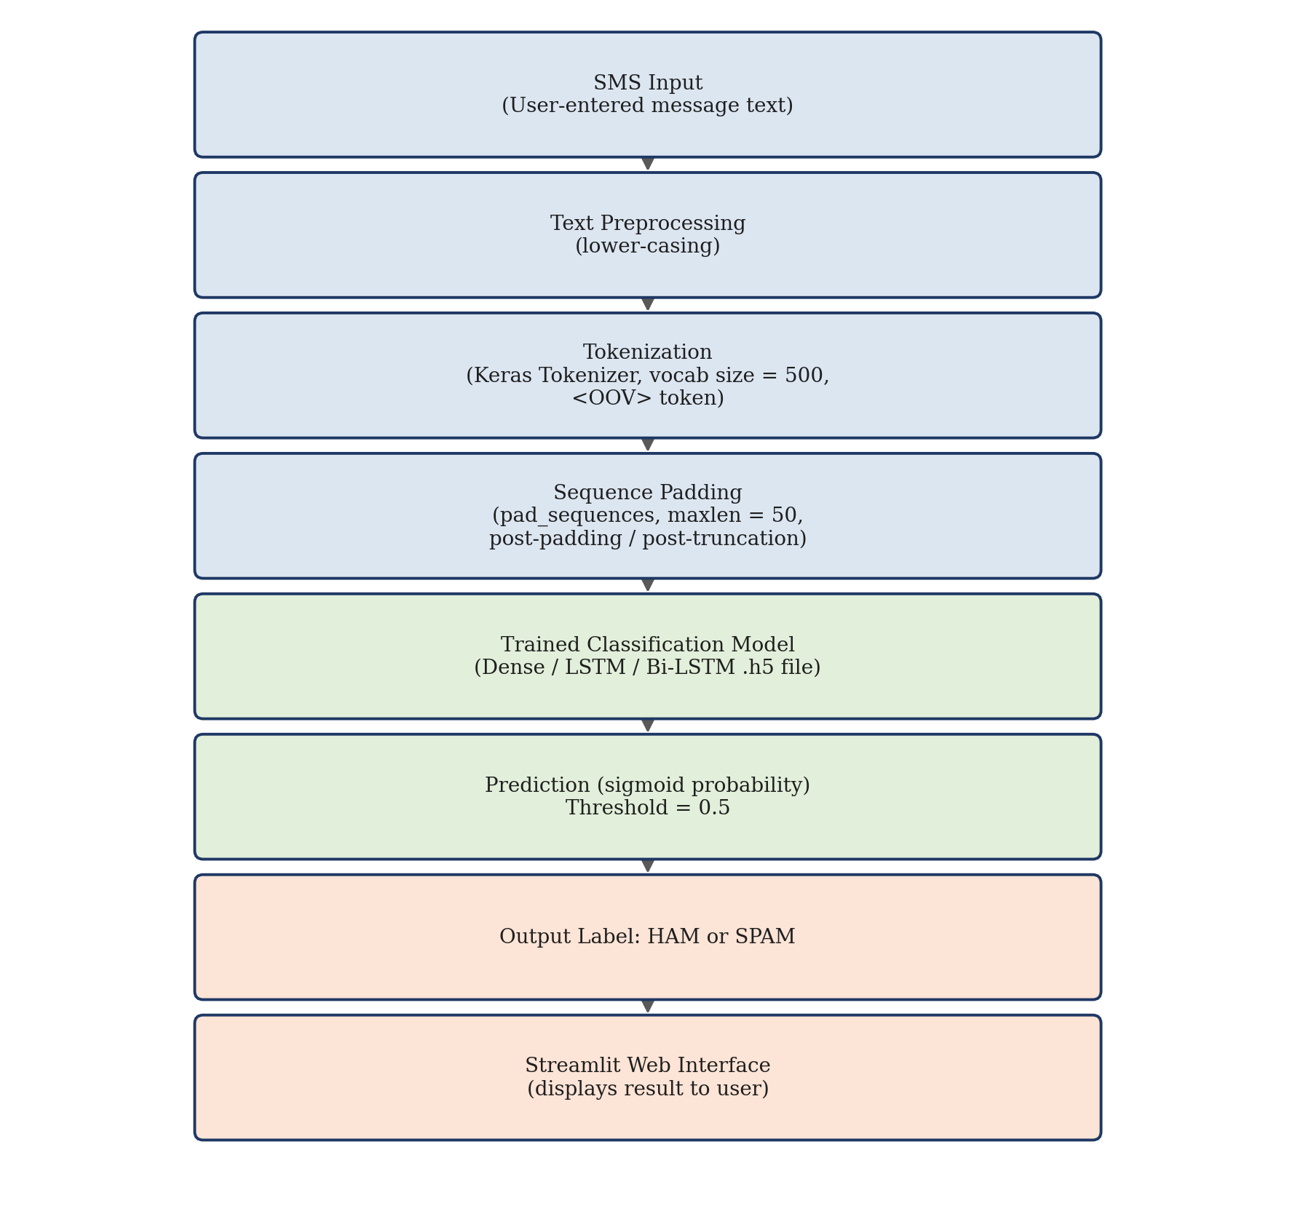
Figure 4.1: System Architecture

4.3 System Workflow
The system has two distinct workflows that must be considered separately: an offline training workflow, carried out once in the Jupyter notebook to produce the saved .h5 model files, and an online inference workflow, carried out every time a user submits a message through the Streamlit app. Figure 4.2 shows both workflows side by side, including the point where the saved model file is loaded into the inference path.
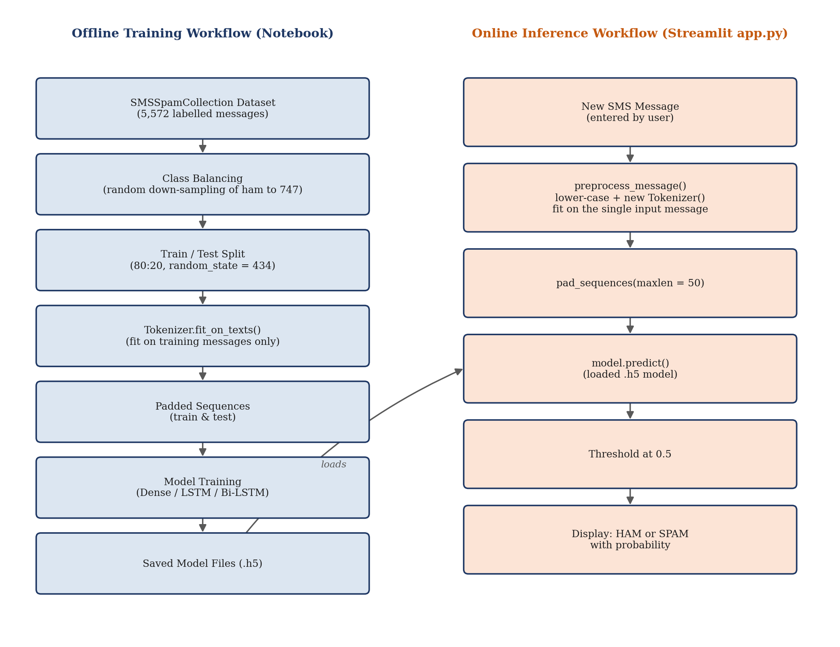
Figure 4.2: Overall Workflow (Training and Inference)

4.4 System Modules
- Data loading and class-balancing module (notebook)
- Tokenization and sequence-padding module (notebook and app.py, implemented independently in each)
- Model training module (notebook — Dense, LSTM, Bi-LSTM, SVM)
- Model evaluation module (notebook — loss/accuracy only)
- Prediction / inference module (app.py)
- Streamlit user-interface module (app.py)

4.5 Module Description
The data-loading and class-balancing module reads SMSSpamCollection, separates ham and spam messages, and randomly down-samples ham to match the spam count. The tokenization module fits a Keras Tokenizer and produces padded integer sequences; notably, this step is implemented twice — once in the notebook (fitted on the training split) and once again, independently and differently, inside app.py's preprocess_message() function (Section 7.6). The model-training module builds and trains the three neural architectures and a comparison SVM. The evaluation module calls model.evaluate() to print test loss and accuracy only. The prediction module (inside app.py) loads a saved model and produces a single prediction. The Streamlit module renders the text-input field and displays the result.

4.6 Data Flow Diagrams
Figure 4.3 shows the context-level (Level-0) DFD, treating the entire system as a single process. Figure 4.4 decomposes this into the four verifiable processes of the inference path. Figure 4.5 further decomposes Process 3.0 (Model Inference) into its constituent steps.
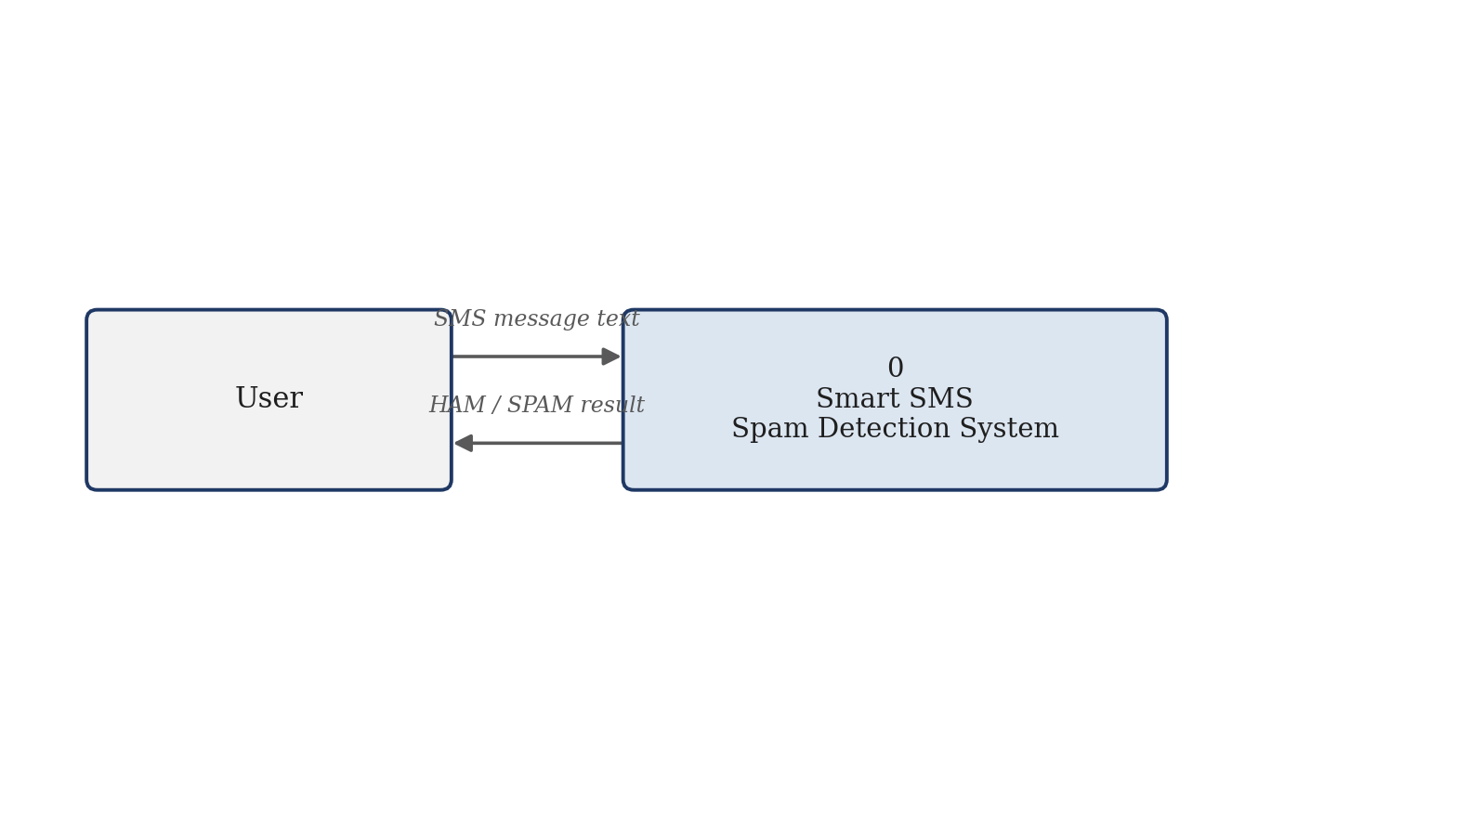
Figure 4.3: Context-Level Data Flow Diagram
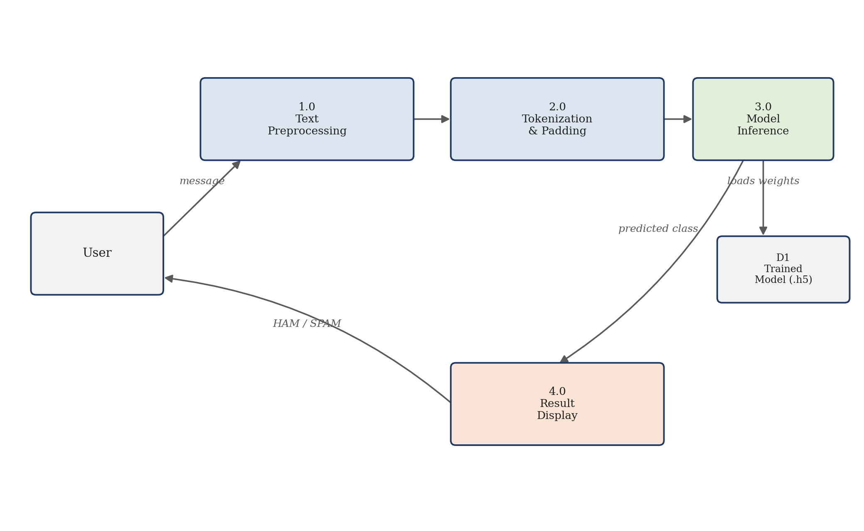
Figure 4.4: Level-1 Data Flow Diagram
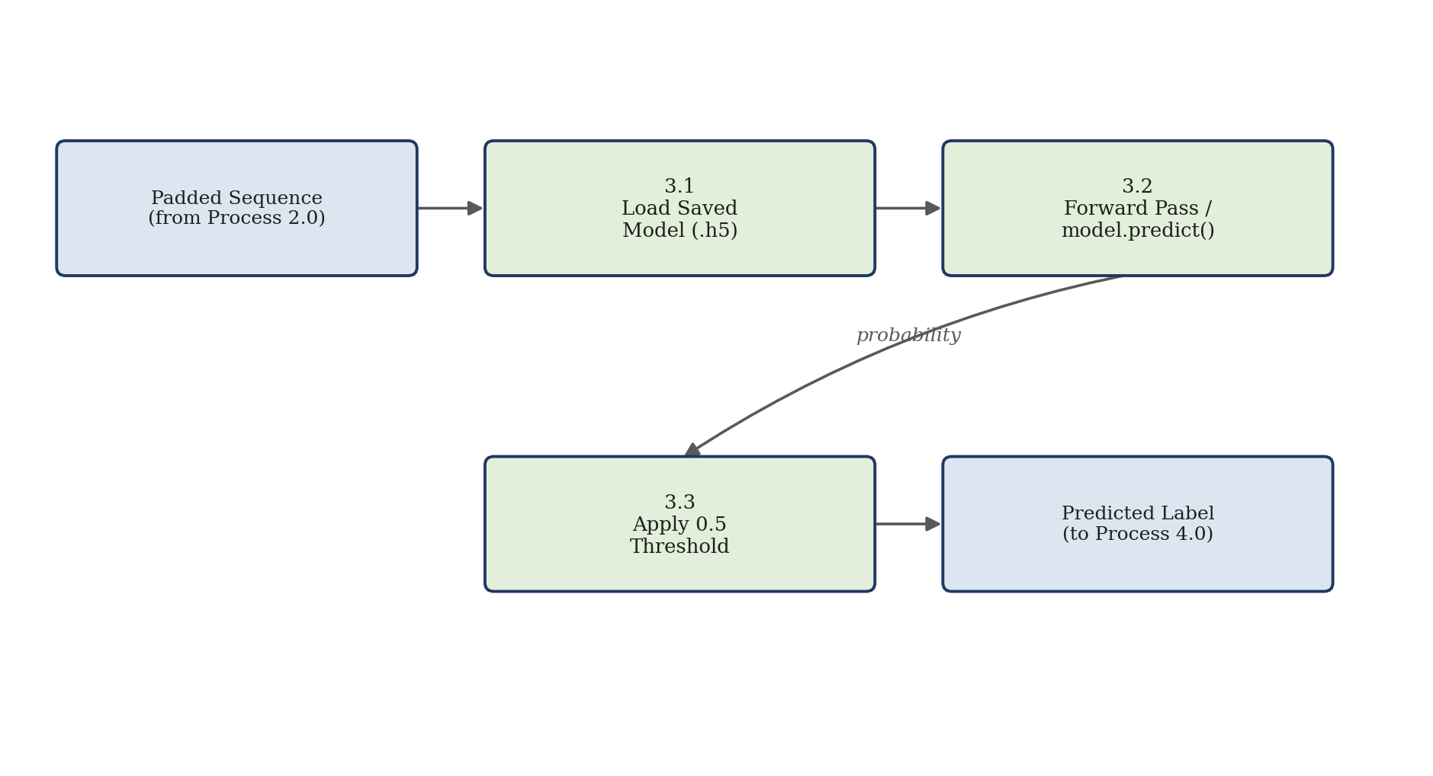
Figure 4.5: Level-2 Data Flow Diagram (Model Inference)

4.7 Use Case Diagram
The system has a single actor (the User) and four use cases that map directly onto the widgets and outputs present in app.py, shown in Figure 4.6. No login, registration or administrative use case exists in the studied project.
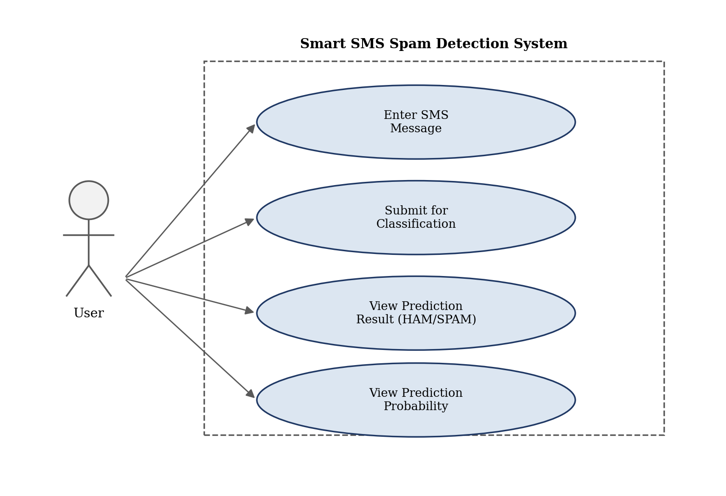
Figure 4.6: Use Case Diagram

4.8 Activity Diagram
Figure 4.7 traces the sequence of activities that occur between a user opening the Streamlit application and receiving a HAM/SPAM result, including the 0.5-probability decision point implemented in app.py.
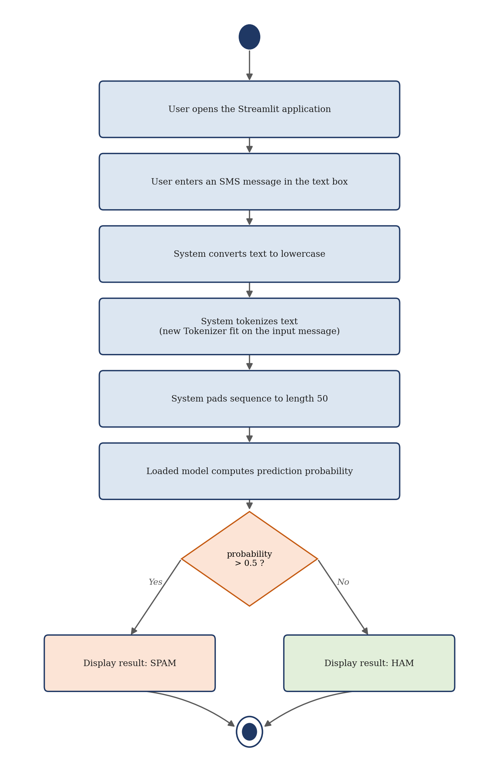
Figure 4.7: Activity Diagram

4.9 Sequence Diagram
Figure 4.8 shows the message exchange between the User, the Streamlit UI, the preprocess_message() function and the loaded model object, as implemented in app.py.
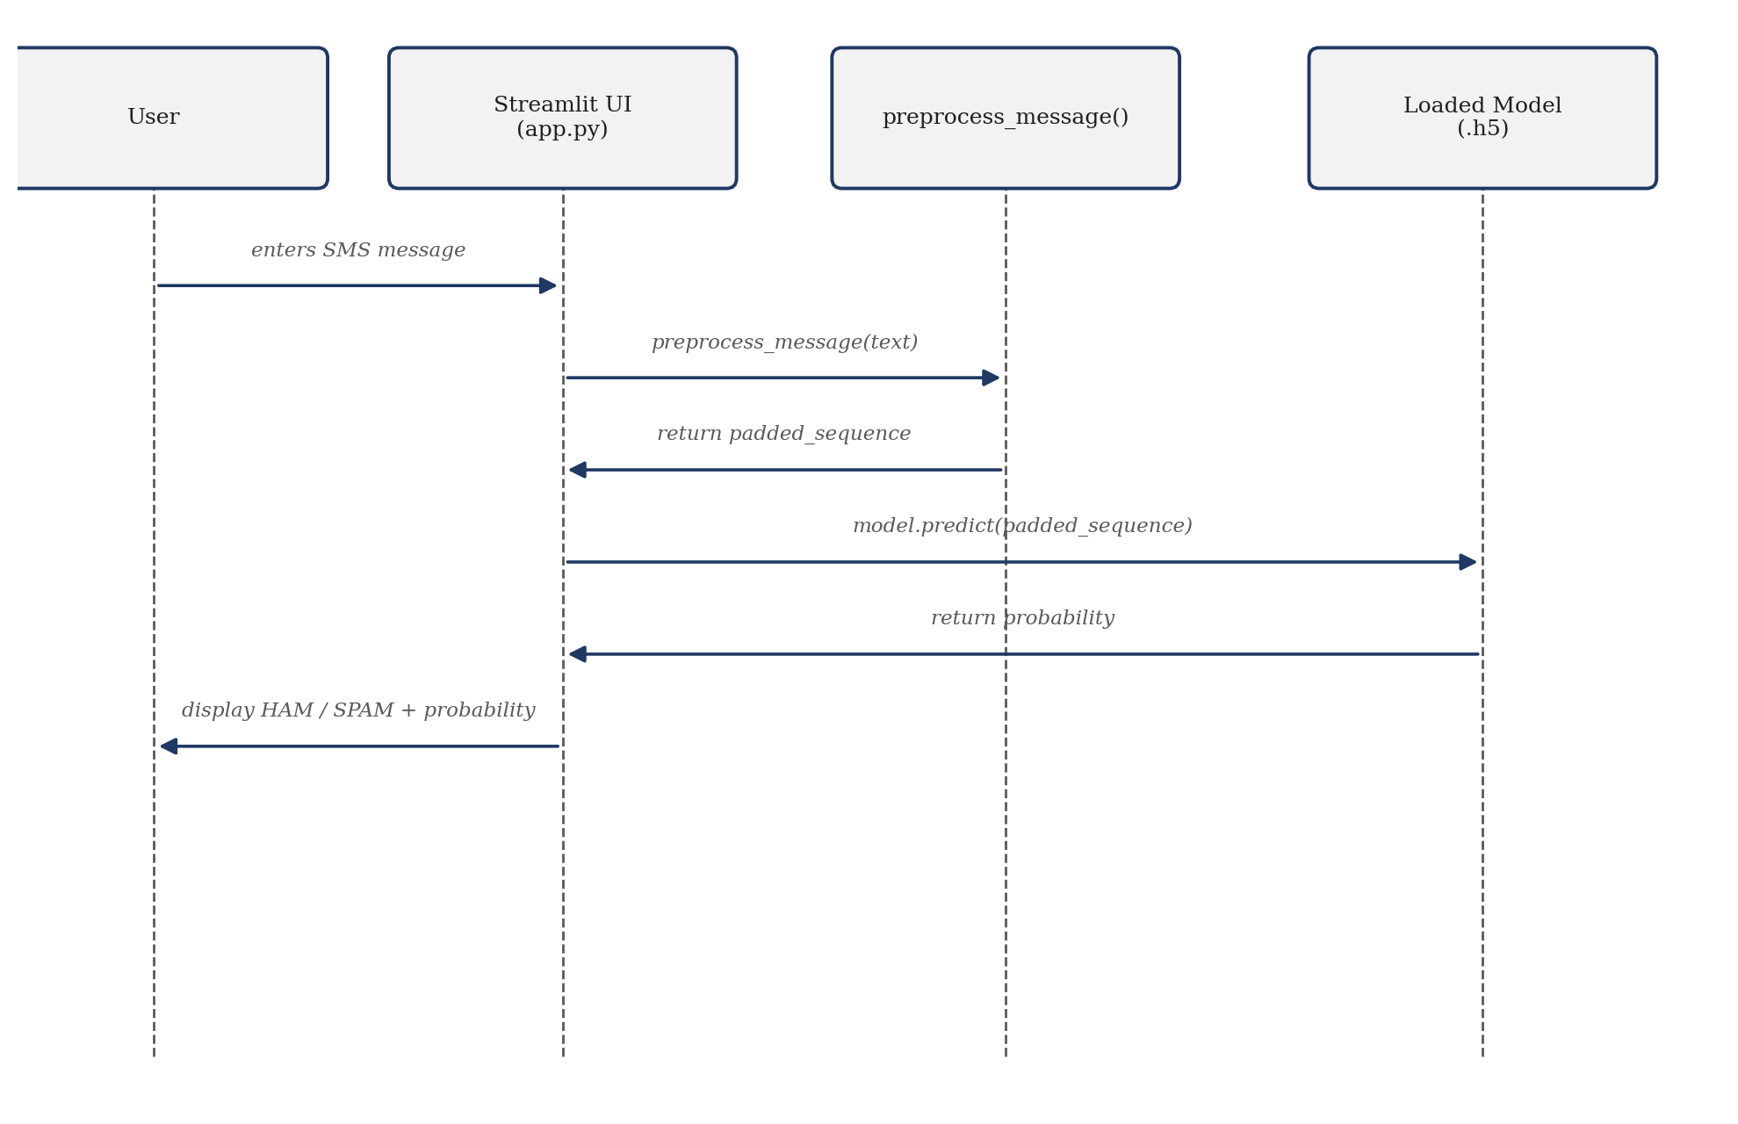
Figure 4.8: Sequence Diagram

4.10 Class Diagram
The implementation is procedural and notebook-based: no custom Python classes are defined anywhere in the project (the notebook uses Keras's Sequential model builder directly, and app.py defines two plain functions, preprocess_message() and app(), with no class declarations). A conventional UML class diagram would therefore misrepresent the implementation. Figure 4.9 instead gives a conceptual module view showing the three functional groupings of the code and the objects (Tokenizer, Sequential model) they instantiate from the Keras/TensorFlow library.
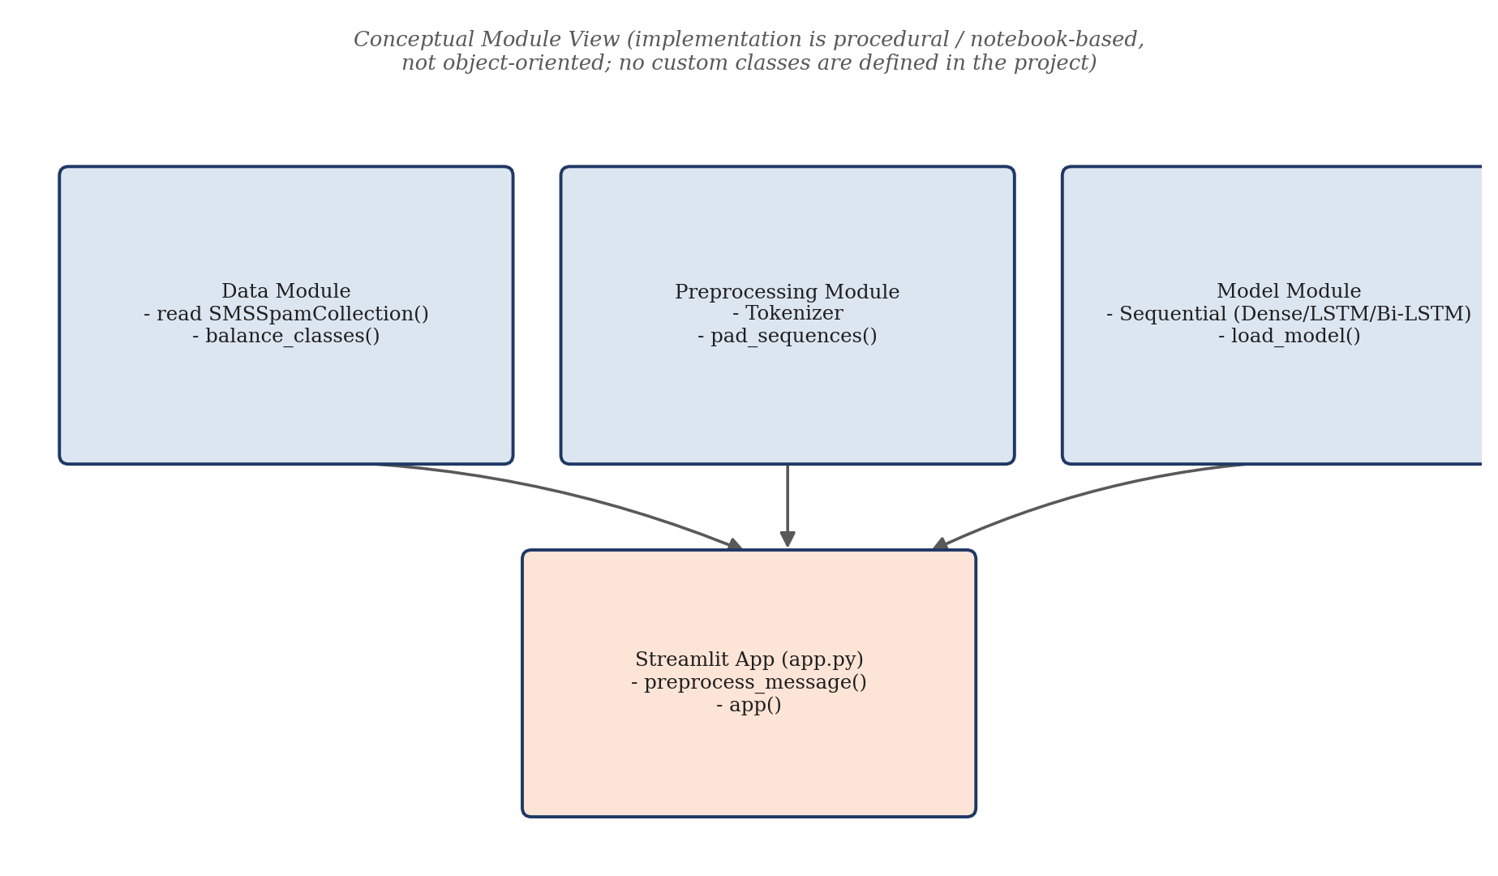
Figure 4.9: Conceptual Module View (Class Diagram Equivalent)

4.11 ER Diagram / Database Design
The current implementation does not require a persistent database because SMS messages and predictions are processed through the application without storing user records. No database import, connection string, ORM model or SQL/NoSQL client library appears anywhere in requirements.txt, the notebook, or app.py. An Entity-Relationship diagram is therefore not applicable and has not been fabricated for this report.

4.12 Data Processing Flow
During training, labelled message text flows through class balancing, tokenization and padding before being consumed by model.fit(). During inference, a new message flows through app.py's own (separately implemented) preprocessing function before being consumed by model.predict(); no data from an inference request is written back into the training pipeline, i.e., the system does not currently support online/continuous learning from user-submitted messages.

4.13 System Workflow
At runtime, app.py loads Dense_Spam_Detection.h5 once at module import time (via load_model('Dense_Spam_Detection.h5')). For every message a user submits, the same loaded model instance is reused for prediction; the model itself is not retrained or updated during the application's lifetime.

4.14 Security and Privacy Considerations
The studied project implements no authentication, authorization, encryption, input sanitisation beyond lower-casing, or logging of submitted messages — none of these appear in app.py or requirements.txt, so none are claimed here. From a privacy standpoint, because the Streamlit app does not persist submitted messages to disk or to a database, no long-term storage of user-submitted SMS content occurs in this specific implementation. Realistic privacy considerations for any future, production-oriented version of this system include: avoiding storage of raw message content beyond what is operationally necessary, restricting access to any logs that are introduced, and being mindful that SMS text may contain personally identifiable information (names, phone numbers, one-time passwords) that should not be persisted or transmitted insecurely.

CHAPTER 5 — TECHNOLOGIES AND TOOLS

5.1 Introduction
This chapter documents only the technologies and tools that are verifiably present in the project's own requirements.txt file, notebook imports, and app.py imports. No framework, library or service is listed unless it was actually found in the project files.

5.2 Hardware Requirements
The project's data-loading cell reads from a path of the form /kaggle/input/sms-dataset/SMSSpamCollection, which indicates that the notebook was originally executed on the Kaggle notebook platform rather than on a documented local machine. No specific CPU, RAM or GPU specification is recorded anywhere in the project files. Given the small dataset size (1,494 balanced training/testing messages) and the small model sizes (10,000–15,000 parameters, Table 8.4), training is feasible on an ordinary CPU-only machine; the notebook's own per-epoch timings (well under two seconds per epoch even for the recurrent models) support this. No GPU usage is claimed here because none is documented in the project.

5.3 Software Requirements
The verified software stack is Python 3, a Jupyter/Kaggle notebook environment for model development, and Streamlit for the prediction interface. The exact third-party package versions are pinned in requirements.txt (Section 5.6).

5.4 Programming Languages
Python is the only programming language used in the project, for both the model-development notebook and the app.py Streamlit application.

5.5 Frameworks
- TensorFlow 2 / Keras — used to build, train and save the Dense, LSTM and Bi-LSTM models (tensorflow.keras.models.Sequential, and layer classes Embedding, GlobalAveragePooling1D, Dense, Dropout, LSTM, Bidirectional), and to load the saved model in app.py (tensorflow.keras.models.load_model).
- Streamlit — used to build the single-page web interface in app.py (st.title, st.text_input, st.write, st.markdown).
- scikit-learn — used for train_test_split (notebook) and for the comparison SVM model (sklearn.svm.SVC).

5.6 Libraries/APIs
Library | Verified Use in This Project | Version Pinned in requirements.txt
NumPy | Numeric array handling, used throughout the notebook and imported in app.py | 1.23.5
Streamlit | Web application framework for the prediction interface (app.py) | 1.21.0
TensorFlow | Model building, training, saving and loading (Keras API) | 2.12.0
pandas | Reading SMSSpamCollection and manipulating the labelled message table (notebook only; not pinned in requirements.txt) | Not pinned — verified only from notebook import
scikit-learn | train_test_split and SVC (SVM) (notebook only; not pinned in requirements.txt) | Not pinned — verified only from notebook import
seaborn / matplotlib | Exploratory plots — class count plot, training/validation curves (notebook only) | Not pinned — verified only from notebook import
wordcloud | Word-cloud visualisation of ham/spam vocabulary (notebook only) | Not pinned — verified only from notebook import
Table 5.1: Software Requirements and Verified Library Versions
No API keys, external web APIs, cloud AI services (e.g. OpenAI, Google Cloud NLP) or database client libraries appear anywhere in requirements.txt, the notebook imports, or app.py. This is stated explicitly because the report's source-of-truth rule requires that unused technologies not be claimed.

5.7 Database
Not applicable. No database engine, ORM, or SQL/NoSQL client library is imported or referenced anywhere in the project files (see also Section 4.11).

5.8 Development Environment
The repository contains a single Jupyter notebook (sms-spam-detection-nlp.ipynb) for data exploration, preprocessing and model training, and a single Python script (app.py) for the Streamlit application. The notebook's data-loading path indicates a Kaggle notebook environment was used for development and training; the Streamlit app is intended to be run locally (streamlit run app.py) or deployed to Streamlit Community Cloud, consistent with the deployed-app URL referenced in the project's README.

5.9 Git/GitHub
The studied implementation is version-controlled on GitHub as the public repository “deepankarvarma/SMS-Spam-Detection-using-NLP”, which is the base source of the notebook, dataset file, trained .h5 models, app.py and requirements.txt studied and documented in this report (see Section 1.10 and the Declaration for the associated academic-integrity statement). This report does not claim a separate student-owned Git history, since none was supplied as part of the studied project files.

5.10 Technology Selection Justification
Python was an appropriate choice because it offers mature, well-documented libraries for both data handling (pandas, NumPy) and deep learning (TensorFlow/Keras) within a single ecosystem. TensorFlow/Keras is well suited to this task because it provides ready-made Embedding, LSTM and Bidirectional layers that implement the sequence-modelling techniques compared in this project without requiring custom low-level implementations. Streamlit is an appropriate choice for the interface because it allows a trained model to be wrapped in an interactive web form with a small amount of code, which matches the scale of this mini-project.

CHAPTER 6 — METHODOLOGY

6.1 Introduction
This chapter documents the complete, verified methodology implemented in the project notebook: dataset acquisition and loading, dataset inspection, class-distribution analysis, down-sampling of the majority class, text preprocessing, tokenization, sequence padding, train/test splitting, model development and training, and evaluation. Every step described here was traced directly to a specific notebook cell and, where relevant, to its printed output.

6.2 Methodology
The end-to-end pipeline actually implemented is: load SMSSpamCollection → inspect class counts and duplicates → down-sample the ham class to match the spam count → split into train/test → fit a Keras Tokenizer on the training messages → convert training and testing messages into padded integer sequences → train the Dense, LSTM and Bi-LSTM models (and, separately, an SVM) → evaluate each model's loss/accuracy on the test split → save the three Keras models as .h5 files → load a saved model inside the Streamlit app for live prediction. This is shown in Figure 6.1.
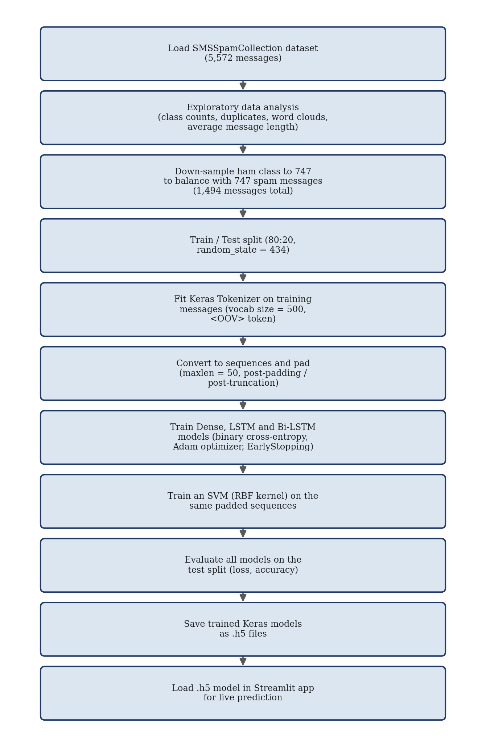
Figure 6.1: Methodology Flowchart

6.3 Dataset
The project uses the UCI SMS Spam Collection dataset, distributed as a single tab-separated file, SMSSpamCollection, with two columns: a label (“ham” or “spam”) and the message text. The raw file contains 5,574 lines. When read with pandas.read_csv(sep='\t'), 5,572 labelled records are parsed (this two-record difference is consistent with a small number of messages containing embedded double-quote characters that affect default CSV-quote parsing); the notebook's own messages.describe() output independently confirms a parsed count of 5,572. Of these, 4,825 are labelled ham and 747 are labelled spam — confirmed both by the notebook's groupby('label').describe() output and by an independent re-parse of the same file performed for this report.
Class | Count in Parsed Dataset (5,572 records) | Percentage
Ham (legitimate) | 4,825 | 86.6%
Spam | 747 | 13.4%
Table 6.1: Dataset Class Distribution
The dataset is therefore substantially imbalanced: the notebook itself computes the spam-to-ham ratio as approximately 15.48% (i.e., spam messages number about 15.48% of ham messages). The notebook also reports that duplicate rows exist in the raw data and that the average message length differs by class (approximately 73 characters for ham versus approximately 139 characters for spam).

6.4 Data Collection
The dataset was not collected as part of this project; it is the publicly available UCI SMS Spam Collection, originally compiled by Almeida, Hidalgo and Yamakami [1] and distributed via the UCI Machine Learning Repository and Kaggle. The notebook's data-loading cell reads the file from a Kaggle input path, indicating it was executed in a Kaggle notebook environment where the dataset had been attached as an input source.

6.5 Data Preprocessing
Two preprocessing decisions are implemented before tokenization. First, class balancing: because spam messages are a small minority, the notebook randomly down-samples the ham class (using pandas' .sample(n=747, random_state=44)) to exactly match the 747 spam messages, producing a balanced working set of 1,494 messages. Second, text cleaning at the tokenization stage is limited to what the Keras Tokenizer performs by default (lower-casing and basic punctuation-aware splitting into word tokens); no separate stopword-removal, stemming, lemmatization or regular-expression cleaning step is implemented in the notebook. This is stated explicitly because the report's source-of-truth rule requires that unused preprocessing techniques not be claimed merely because they are common in NLP pipelines generally.

6.6 Feature Representation
The project does not use TF-IDF or any bag-of-words feature representation for the neural models. Text is represented as a fixed-length sequence of integer token IDs: a Keras Tokenizer is restricted to the 500 most frequent words in the training data (vocab_size = 500) plus a single out-of-vocabulary token (<OOV>), and each message is converted with texts_to_sequences() into a variable-length list of integer IDs, then padded/truncated to a fixed length of 50 tokens (post-padding and post-truncation) with pad_sequences(). This padded-sequence representation is fed directly into a trainable Embedding layer inside each neural model. The comparison SVM is trained on the same padded integer sequences (not on TF-IDF vectors and not on the embedding output), which is discussed as a methodological limitation in Section 8.9.
Hyperparameter | Value | Verified From
Vocabulary size (num_words) | 500 | Notebook cell defining tokenizer hyperparameters
OOV token | "<OOV>" | Tokenizer(..., oov_token=oov_tok)
Maximum sequence length (maxlen) | 50 | pad_sequences(..., maxlen=max_len)
Padding type | post | padding_type = "post"
Truncation type | post | trunc_type = "post"
Unique tokens seen in training data | 4,169 | Printed: “There are 4169 unique tokens in training data”
Table 6.2: Preprocessing / Tokenization Hyperparameters

6.7 Model Selection
Three neural architectures are compared because they represent three increasingly context-aware ways of consuming the same padded-sequence representation: a Dense network (which pools the embedded sequence and treats it as an unordered feature set), an LSTM network (which processes tokens in order, in one direction), and a Bi-LSTM network (which processes tokens in both directions). An SVM is trained on the same padded sequences as a classical machine-learning comparison point.

6.8 Algorithm
All three neural models begin with an Embedding(vocab_size=500, output_dim=16) layer that maps each token ID to a trainable 16-dimensional vector. As documented in Section 7.6/Table 8.4 from direct inspection of the saved .h5 files, the Dense model then applies GlobalAveragePooling1D followed by two Dense hidden layers (48 and 24 units, ReLU activation) with Dropout(0.2) after each, and a final Dense(1, sigmoid) output; the LSTM model applies two stacked LSTM layers (20 units each, the first with return_sequences=True) followed by Dense(1, sigmoid); and the Bi-LSTM model applies a single Bidirectional(LSTM(20 units)) layer followed by Dense(1, sigmoid). The SVM uses a Radial Basis Function (RBF) kernel with C=10 and gamma=0.1.

6.9 Training Process
Training uses train_test_split(test_size=0.2, random_state=434) on the balanced 1,494-message set, giving 1,195 training messages and 299 testing messages. Each Keras model is compiled with binary cross-entropy loss and the Adam optimiser (metrics=['accuracy']) and trained with model.fit(..., validation_data=(testing_padded, test_labels), callbacks=[EarlyStopping(monitor='val_loss', patience=P)]), where the configured maximum epochs and EarlyStopping patience differ per model (Table 6.3). No explicit batch_size argument is passed to model.fit() in any of the three training calls, so Keras' default batch size of 32 is used; this is corroborated by the training logs, which show 38 steps per epoch (1,195 training messages ÷ 32 ≈ 38). No separate validation split is created — the test split itself is passed as validation_data during training, so the “validation” curves in Section 8 reflect performance on the same 299 messages later used for final evaluation.
Model | Configured Max Epochs | EarlyStopping Patience (on val_loss) | Epochs Actually Run | Batch Size
Dense | 50 | 3 | 25 | 32 (default)
LSTM | 30 | 5 | 21 | 32 (default)
Bi-LSTM | 30 | 4 | 13 | 32 (default)
SVM | N/A (single .fit() call, not epoch-based) | N/A | N/A | N/A
Table 6.3: Training Configuration per Model
Because EarlyStopping is used without restore_best_weights=True, the model saved to disk corresponds to the weights at the last epoch actually run, not necessarily the epoch with the lowest validation loss. This is confirmed by cross-checking: the final training-log val_accuracy for each model (Dense: 0.9365 at epoch 25; LSTM: 0.9532 at epoch 21; Bi-LSTM: 0.9498 at epoch 13) matches exactly the accuracy printed by the separate model.evaluate() call on the same model (Section 8.3), which is the expected behaviour when the last-epoch weights, not the best-epoch weights, are what get saved.

6.10 Testing
Testing consists of calling model.evaluate(testing_padded, test_labels) for each Keras model, and svm_model.score(testing_padded, test_labels) for the SVM, on the same 299-message test split used as validation data during training (Section 6.9). No separate, held-out third split (train/validation/test) is implemented; test and validation are the same 299 messages throughout the notebook.

6.11 Performance Evaluation Metrics
The notebook computes only loss and accuracy for each model, via model.evaluate() (Keras models) and .score() (SVM). Precision, recall, F1-score and a confusion matrix are not computed anywhere in the notebook; this was confirmed by an explicit text search of the notebook's cells and outputs. These metrics are therefore reported in Chapter 8 as not implemented rather than being estimated or fabricated for this report, consistent with the accuracy-over-completeness principle stated in Chapter 1.

6.12 Pseudocode
Training pipeline (as implemented in the notebook):
1. Read SMSSpamCollection into a DataFrame with columns [label, message].
2. Separate the DataFrame into ham_msg and spam_msg by label.
3. Down-sample ham_msg to len(spam_msg) rows (random_state = 44); concatenate with spam_msg to form msg_df.
4. Map labels to integers: ham = 0, spam = 1.
5. Split msg_df into (train_msg, test_msg, train_labels, test_labels) using train_test_split(test_size=0.2, random_state=434).
6. Fit a Keras Tokenizer(num_words=500, oov_token="<OOV>") on train_msg only.
7. Convert train_msg and test_msg to integer sequences with texts_to_sequences(); pad/truncate both to length 50 with pad_sequences(padding='post', truncating='post').
8. For each architecture (Dense, LSTM, Bi-LSTM): build a Sequential model, compile with loss='binary_crossentropy', optimizer='adam', metrics=['accuracy'], and call model.fit() with EarlyStopping(monitor='val_loss') and validation_data = (testing_padded, test_labels).
9. Call model.evaluate(testing_padded, test_labels) and record the printed loss/accuracy.
10. Save each trained Keras model with model.save('<Name>_Spam_Detection.h5').
11. Separately, train an SVC(C=10, gamma=0.1, kernel='rbf') on (training_padded, train_labels) and evaluate with .score(testing_padded, test_labels).
Inference pipeline (as implemented in app.py):
1. Load the saved Dense model once at startup: model = load_model('Dense_Spam_Detection.h5').
2. Read a message string from st.text_input().
3. Lower-case the message.
4. Create a NEW Tokenizer(num_words=10000) and call tokenizer.fit_on_texts([message]) on this single message only.
5. Convert the message to a sequence with texts_to_sequences() and pad it to maxlen=50 with pad_sequences().
6. Call model.predict() on the padded sequence to obtain a probability.
7. If probability > 0.5, display “spam” with that probability; otherwise display “ham” with (1 − probability).

6.13 Detailed Working of the System
During training, the balanced, tokenized and padded dataset is used to fit model weights that minimise binary cross-entropy between the predicted probability and the true 0/1 label, using the Adam optimiser and mini-batches of 32 examples, with EarlyStopping halting training once validation loss fails to improve for the configured number of epochs (patience). During inference, a single new message follows a separately implemented, shorter preprocessing path inside app.py before being passed to the loaded model's predict() method; the resulting probability is thresholded at 0.5 to produce the final HAM/SPAM label shown to the user.

6.14 Implementation Flowchart
The implementation flowchart for the online inference path (as run every time a user submits a message) is presented in Figure 7.5 in Chapter 7, alongside the verified model architecture diagrams.

CHAPTER 7 — IMPLEMENTATION

7.1 Introduction
This chapter documents the actual implementation found in the project's three code artefacts: the notebook (sms-spam-detection-nlp.ipynb), the trained model files (Dense_Spam_Detection.h5, LSTM_Spam_Detection.h5, BiLSTM_Spam_Detection.h5), and the Streamlit application (app.py). Where the notebook's currently visible code and the saved model files disagree (Section 7.6), both are reported rather than only one being presented as authoritative.

7.2 System Architecture Implementation
The implementation maps onto the architecture of Figure 4.1 as follows: SMS input and preprocessing/tokenization/padding are implemented in the notebook for training data and, separately and differently, inside preprocess_message() in app.py for a live message; the trained model stage is one of the three saved .h5 files, loaded with tensorflow.keras.models.load_model(); and the Streamlit interface stage is the app() function in app.py.

7.3 Data Loading Module (Notebook)
Implemented in the notebook's first code cells. The dataset is read with pandas, inspected with .describe() and .groupby('label').describe(), checked for duplicate rows, and visualised with word clouds and a class-count plot (Section 6.3).
messages = pd.read_csv("/kaggle/input/sms-dataset/SMSSpamCollection",
sep='\t', names=["label", "message"])
ham_msg = messages[messages.label == 'ham']
spam_msg = messages[messages.label == 'spam']
ham_msg_df = ham_msg.sample(n=len(spam_msg), random_state=44)
msg_df = ham_msg_df.append(spam_msg).reset_index(drop=True)

7.4 Preprocessing / Tokenization Module
Implemented in the notebook as shown below; the vocab_size, max_len, padding_type and trunc_type values are exactly as listed in Table 6.2.
tokenizer = Tokenizer(num_words=vocab_size, char_level=False, oov_token=oov_tok)
tokenizer.fit_on_texts(train_msg)
training_sequences = tokenizer.texts_to_sequences(train_msg)
training_padded = pad_sequences(training_sequences, maxlen=max_len,
padding=padding_type, truncating=trunc_type)

7.5 Model Training Module
Each of the three Keras models is defined with Sequential(), compiled with binary_crossentropy / adam, and trained with EarlyStopping as summarised in Table 6.3. Figures 7.2–7.4 show the layer-by-layer architecture actually found inside the saved .h5 files (verified directly from each file's stored model_config and weight-tensor shapes), which is the architecture that is actually deployed — not merely the architecture shown in the currently visible notebook cell for each model (Section 7.6 explains this discrepancy).
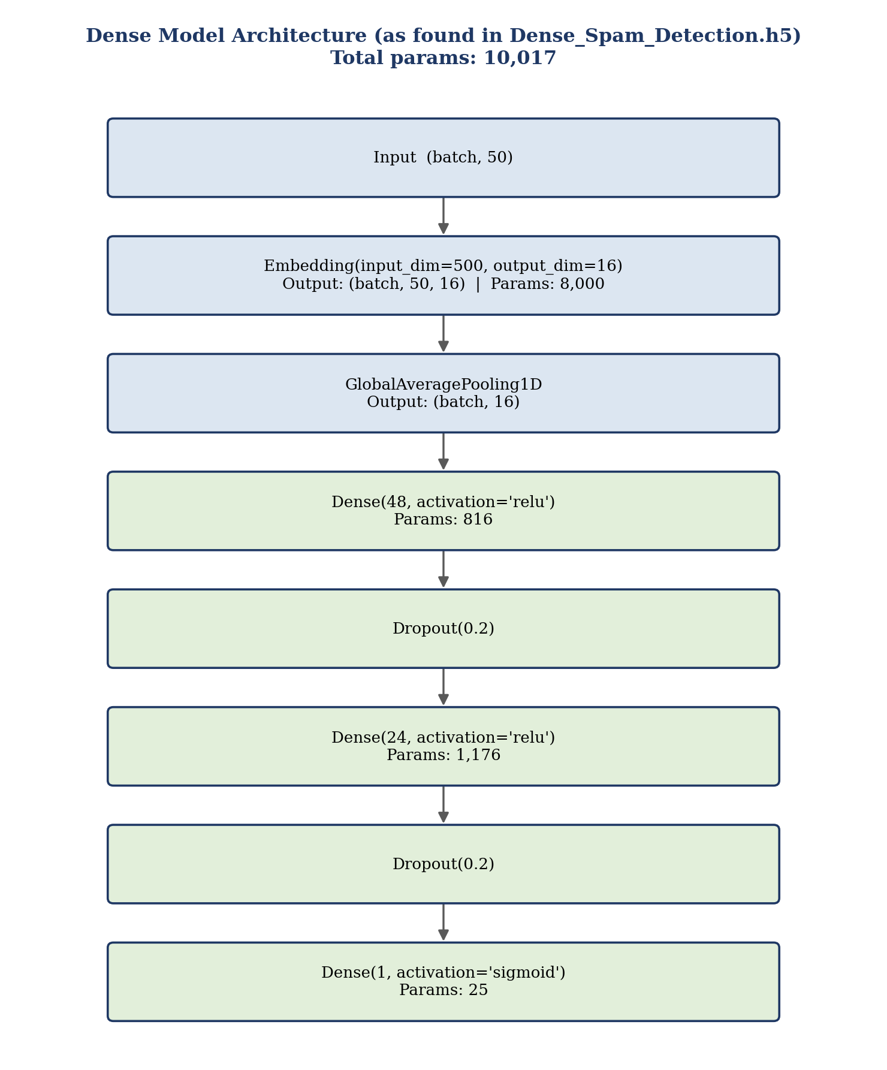
Figure 7.1: Dense Model Architecture (as saved in Dense_Spam_Detection.h5)
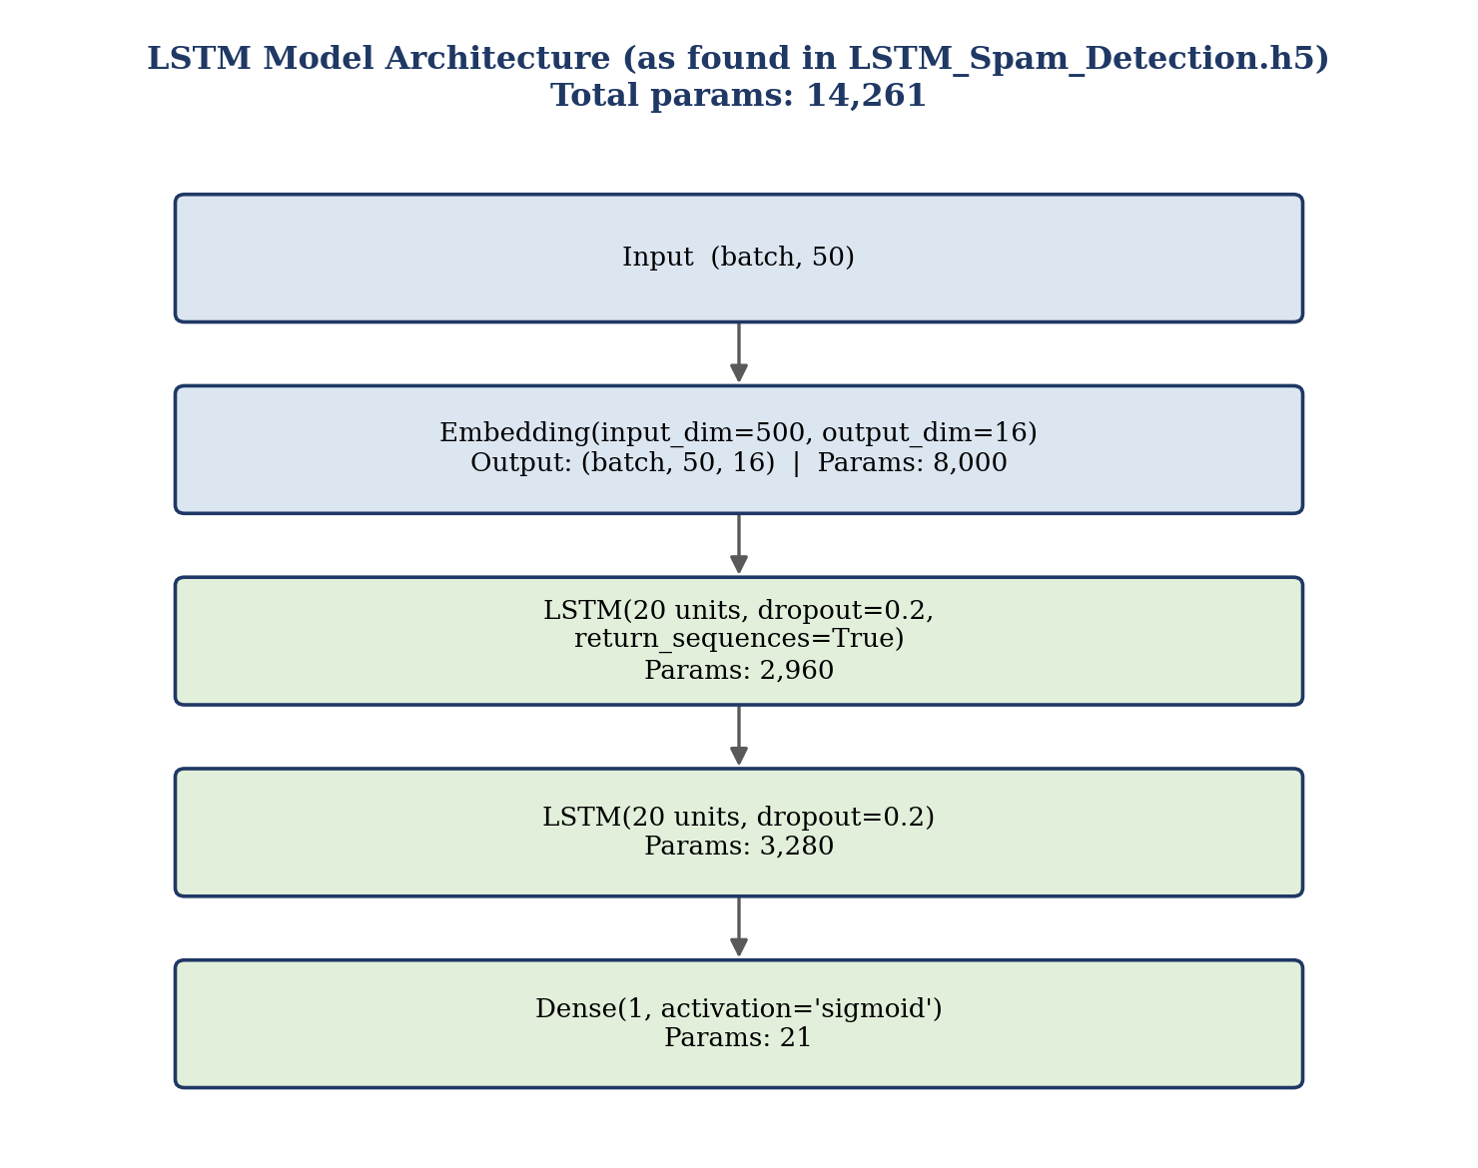
Figure 7.2: LSTM Model Architecture (as saved in LSTM_Spam_Detection.h5)
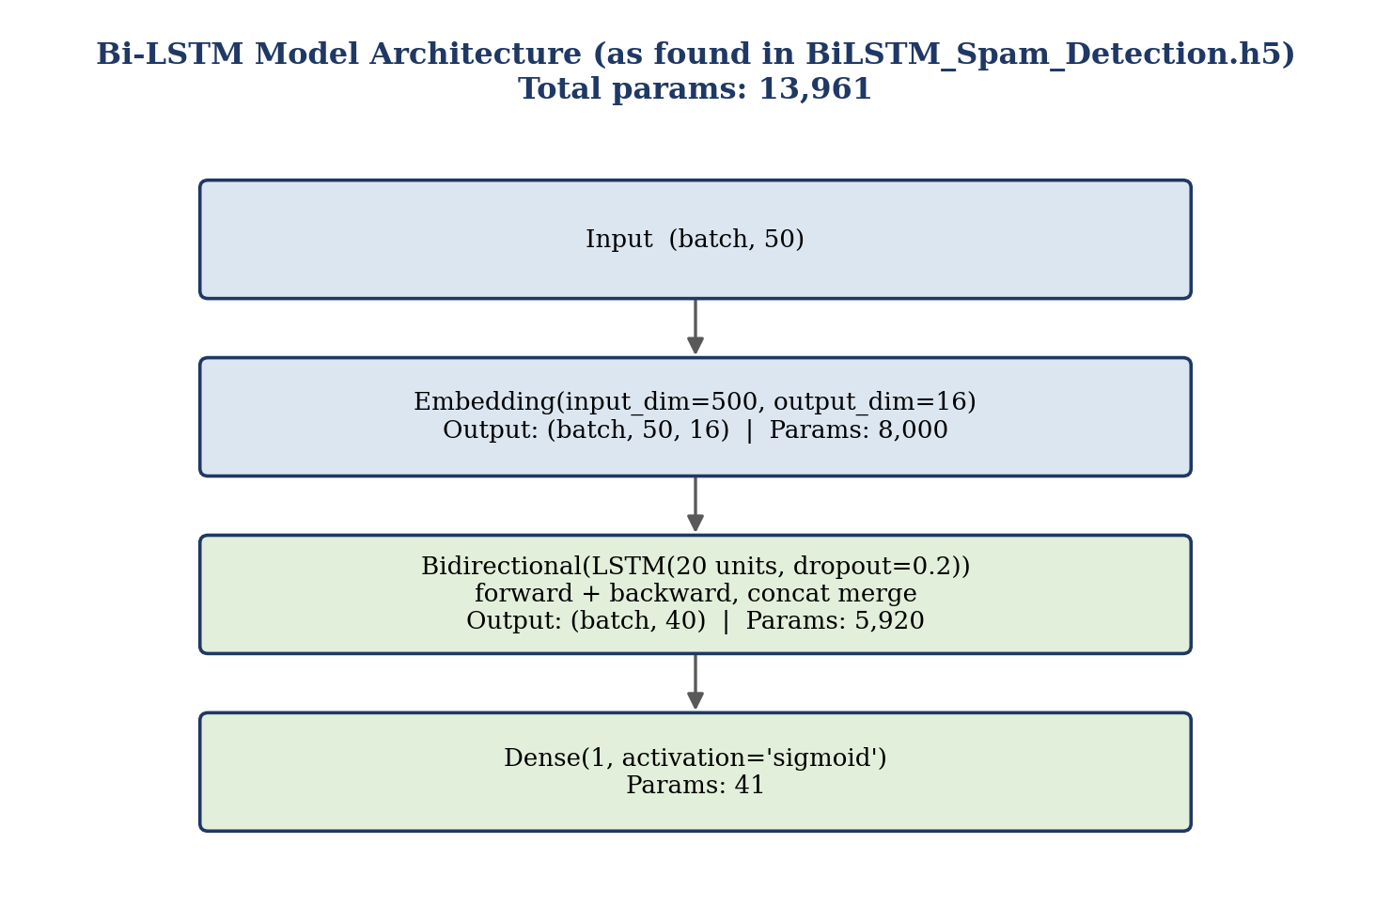
Figure 7.3: Bi-LSTM Model Architecture (as saved in BiLSTM_Spam_Detection.h5)
Model | Total Parameters (from .h5 weight shapes) | Saved File
Dense | 10,017 (Embedding 8,000 + Dense 816 + Dense 1,176 + Dense 25) | Dense_Spam_Detection.h5
LSTM | 14,261 (Embedding 8,000 + LSTM 2,960 + LSTM 3,280 + Dense 21) | LSTM_Spam_Detection.h5
Bi-LSTM | 13,961 (Embedding 8,000 + Bidirectional-LSTM 5,920 + Dense 41) | BiLSTM_Spam_Detection.h5
Table 7.1: Model Architecture Parameter Summary (from saved .h5 files)

7.6 Prediction Module and a Verified Implementation Limitation
app.py loads a single model at import time — specifically the Dense model, not the LSTM or Bi-LSTM model:
model = load_model('Dense_Spam_Detection.h5')
This is significant because, as reported in Chapter 8, the notebook's own printed test accuracy ranks LSTM highest (95.32%), followed by Bi-LSTM (94.98%), with Dense lowest of the three neural models (93.65%). The deployed Streamlit application therefore does not use the model that the notebook's own results identify as the best performer; it uses the weakest of the three neural models by the notebook's own accuracy figures. This is documented here as a verified deployment inconsistency, not as a defect introduced by this report.
A second, more serious implementation issue was found in preprocess_message():
def preprocess_message(message):
message = message.lower()
tokenizer = tf.keras.preprocessing.text.Tokenizer(num_words=10000)
tokenizer.fit_on_texts([message])
sequence = tokenizer.texts_to_sequences([message])
padded_sequence = tf.keras.preprocessing.sequence.pad_sequences(sequence, maxlen=50)
return padded_sequence
This function creates a brand-new Tokenizer object and calls fit_on_texts() on only the single incoming message, instead of reusing the Tokenizer object that was fitted on the 1,195 training messages during notebook training (Section 6.5/6.9). Because a Keras Tokenizer assigns integer word-indices in order of word frequency within whatever text it is fitted on, the word→index mapping produced from one short, isolated message bears no relationship to the word→index mapping the model's Embedding layer was actually trained on. In effect, the integer sequence passed to the model at inference time is not consistent with the vocabulary indices the model's Embedding layer learned during training, other than by coincidence for very common words. This is documented here as a genuine, verifiable implementation limitation/bug in app.py, and is treated as an important limitation of the deployed application's prediction reliability (Sections 8.13 and 9.7) rather than minimised or hidden. No tokenizer object (e.g., no tokenizer.pickle or equivalent) is saved anywhere in the project, which is consistent with this bug — there is no persisted training-time tokenizer for app.py to load even if it were corrected to do so.

7.7 Database
Not applicable — no database is implemented (Section 5.7).

7.8 User Interface
The Streamlit interface consists of a single text-input widget (st.text_input("Enter a message:")), a background-image style block, and a single output line produced with st.write() showing the predicted label and probability, formatted as a percentage. Because no screenshot of the running application was supplied with the project files for this report, a placeholder is used in Figure 7.4 in place of a fabricated image.
[INSERT ACTUAL SCREENSHOT: STREAMLIT PREDICTION PAGE — not supplied with the project files for this report]
Figure 7.4: Streamlit Application Interface

7.9 Backend
There is no separate backend service; the Python process running streamlit run app.py performs both the request handling (via Streamlit's own server) and the model-inference logic in a single script. No backend framework (Flask, FastAPI, Django, etc.) is present in the project.

7.10 API Integration
Not applicable — no external API integration is present anywhere in requirements.txt, the notebook, or app.py.

7.11 Error Handling
app.py contains no explicit error handling (no try/except blocks). The message input field defaults to an empty string, and the prediction branch (if message:) is skipped when no text has been entered, which is the only input-guarding behaviour present in the code. No handling exists for unusually long input, non-text input, or model-loading failures.

7.12 Security
No authentication, authorization, encryption, input sanitisation beyond lower-casing, or rate limiting is implemented anywhere in the project. This is stated explicitly rather than assumed, consistent with Section 4.14.

7.13 Important Code Snippets
The four most relevant snippets — data loading, preprocessing/tokenization, model definition (Dense, shown as representative), and the Streamlit prediction call — are reproduced below exactly as found in the project files.
# Model definition (Dense) — notebook cell, current visible code
model = Sequential()
model.add(Embedding(vocab_size, embeding_dim, input_length=max_len))
model.add(GlobalAveragePooling1D())
model.add(Dense(24, activation='relu'))
model.add(Dropout(drop_value))
model.add(Dense(1, activation='sigmoid'))
model.compile(loss='binary_crossentropy', optimizer='adam', metrics=['accuracy'])
Note that this visible cell shows a single Dense(24) hidden layer, whereas the saved Dense_Spam_Detection.h5 file actually contains two hidden Dense layers (48 and 24 units) with two Dropout layers (Section 7.6/Figure 7.1). This mismatch indicates the notebook was edited after the currently saved models were last trained, and is documented transparently rather than silently resolved in favour of one source over the other.
# Streamlit prediction — app.py, current code
processed_message = preprocess_message(message)
prediction = model.predict(processed_message)
if prediction > 0.5:
st.write("This message is spam with a probability of {:.2f}%.".format(
prediction[0][0] * 100))
else:
st.write("This message is ham with a probability of {:.2f}%.".format(
(1 - prediction[0][0]) * 100))

7.14 Complete Workflow
Figure 7.5 summarises the complete, currently deployed online inference workflow — the seven steps that run each time a user submits a message through the Streamlit application, exactly as implemented in app.py, including the two limitations documented in Section 7.6.
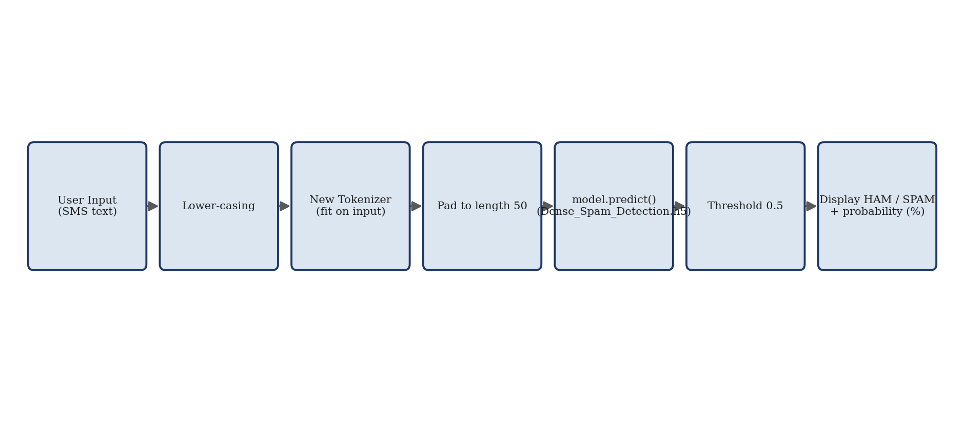
Figure 7.5: Complete Inference Workflow

CHAPTER 8 — RESULTS AND DISCUSSION

8.1 Introduction
This chapter reports only results that are directly verifiable from the project's own notebook cell outputs and saved model files. No experiment was independently re-run to generate new numbers for this report beyond what the notebook itself already prints; where a metric was not computed by the notebook (precision, recall, F1-score, confusion matrix), this is stated plainly in Section 8.7 rather than estimated.

8.2 Experimental Setup
All results in this chapter come from the single notebook execution whose cell outputs are stored in sms-spam-detection-nlp.ipynb. The dataset, split, tokenizer and model configurations are exactly as documented in Chapter 6 (1,494 balanced messages; 1,195 train / 299 test; vocab size 500; sequence length 50). The notebook records a Keras version of 2.11.0 in the saved model files' metadata; requirements.txt pins TensorFlow 2.12.0, NumPy 1.23.5 and Streamlit 1.21.0. No independent hardware benchmarking was performed; the only timing information available is the per-epoch duration printed in the training logs (Section 6.9).

8.3 Test Cases
Table 8.1 lists representative test cases based on the application's documented behaviour (a single free-text input, a single HAM/SPAM output with probability). Because the input-dependent Tokenizer bug documented in Section 7.6 means the deployed application's predictions cannot be treated as a faithful reproduction of the notebook's evaluation results, the “Expected Result” column reflects the application's designed behaviour (accept text, return a thresholded label) rather than a claim about real-world prediction accuracy.
Test Case | Input | Expected Behaviour | Verified Against
TC-1 | A non-empty SMS message string | App preprocesses the text and returns HAM or SPAM with a probability percentage | app.py logic: if message: ... st.write(...)
TC-2 | Empty input (no text entered) | No prediction is shown; the app waits for input | app.py: prediction branch is inside if message:
TC-3 | A message containing words seen frequently in spam training examples (e.g. promotional wording) | Model is more likely to output a probability above 0.5, subject to the tokenizer mismatch in Section 7.6 | Not independently re-verified in this report; behaviour follows from Section 7.6
TC-4 | A very long message (well over 50 tokens) | Sequence is truncated to the first 50 tokens after padding/truncation (post-truncation), so text beyond the 50th token is not seen by the model | pad_sequences(..., maxlen=50, truncating='post') in preprocess_message()
Table 8.1: Test Cases and Observed Application Behaviour

8.4 Test Case Results
No screenshots of actual test-case executions were supplied with the project files for this report. The table above documents expected behaviour derived directly from reading app.py; it is not a substitute for running the application and recording real screenshots, which is listed as a follow-up action in Section 9.8.
[INSERT ACTUAL SCREENSHOTS OF TEST CASES TC-1 TO TC-4 RUN IN THE STREAMLIT APP HERE]
Figure: Test Case Execution

8.5 Functional Testing
Functional Requirement (Table 3.1) | Status
FR-1: Accept free-text SMS input | Present in code (st.text_input)
FR-2: Preprocess input (lower-case, tokenize, pad) | Present in code, but with the tokenizer inconsistency documented in Section 7.6
FR-3: Run trained model on processed input | Present in code (model.predict())
FR-4: Return binary HAM/SPAM prediction | Present in code (0.5 threshold)
FR-5: Display prediction and probability | Present in code (st.write())
Table 8.2: Functional Testing Summary

8.6 Performance Evaluation
No response-time, memory, or throughput measurement was performed or is documented in the project. The only performance-related data available is the per-epoch training duration in the notebook logs (roughly 0.1 second/epoch for the Dense model after the first epoch, and roughly 0.7–1.0 second/epoch for the LSTM and Bi-LSTM models), which reflects training speed rather than single-message inference latency.

8.7 Accuracy and Model Evaluation
Table 8.3 reports the test-set loss and accuracy exactly as printed by the notebook's own model.evaluate() / .score() calls — these are notebook-reported accuracy results, not new experiments generated for this report.
Model | Notebook-Reported Test Accuracy | Notebook-Reported Test Loss | Epochs Actually Run
Dense | 93.65% | 0.1238 | 25 of 50 configured
LSTM | 95.32% | 0.1618 | 21 of 30 configured
Bi-LSTM | 94.98% | 0.1490 | 13 of 30 configured
SVM | 69.57% | Not printed (SVM .score() reports accuracy only) | N/A
Table 8.3: Verified Model Performance (Notebook-Reported)
Precision, recall, F1-score and a confusion matrix are NOT available for any of the four models. An explicit search of every cell and output in the notebook confirms that none of these metrics are computed anywhere in the project. This report does not estimate them from accuracy, does not construct a confusion matrix from assumed class balance, and does not fabricate any such figures; their absence is recorded here and carried into the objective-achievement table (Table 9.1) and future scope (Section 9.7) as a concrete follow-up item rather than silently worked around.

8.8 Graphs
Figures 8.1–8.6 plot training-vs-validation accuracy and loss per epoch, reconstructed directly from the exact numbers printed in the notebook's own training logs for each model (Section 6.9); no values were interpolated or estimated. Because EarlyStopping is used without restore_best_weights=True (Section 6.9), each curve ends at the last epoch actually run, and that final point matches the corresponding model.evaluate() result in Table 8.3 exactly, which is additional internal confirmation that the two sources of notebook output are self-consistent.
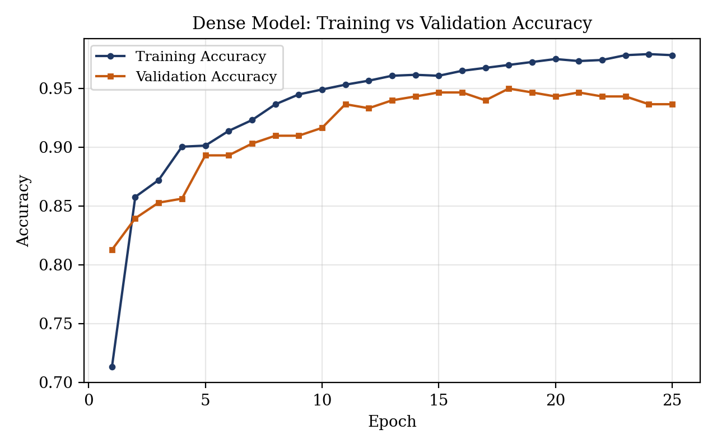
Figure 8.1: Dense Model — Training vs Validation Accuracy
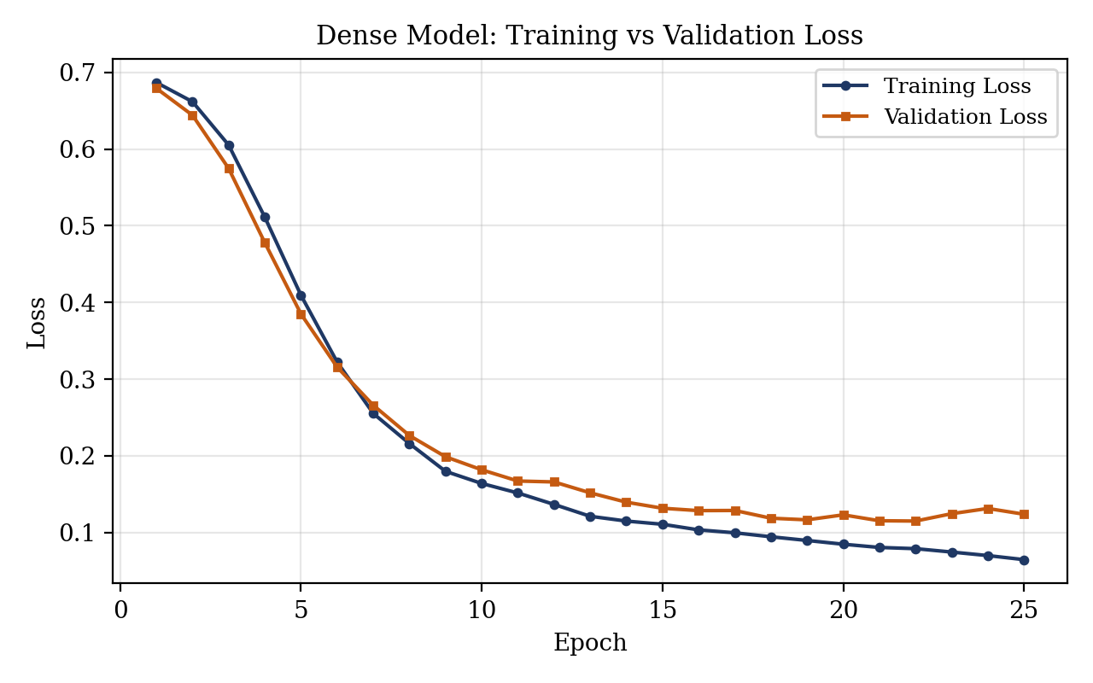
Figure 8.2: Dense Model — Training vs Validation Loss
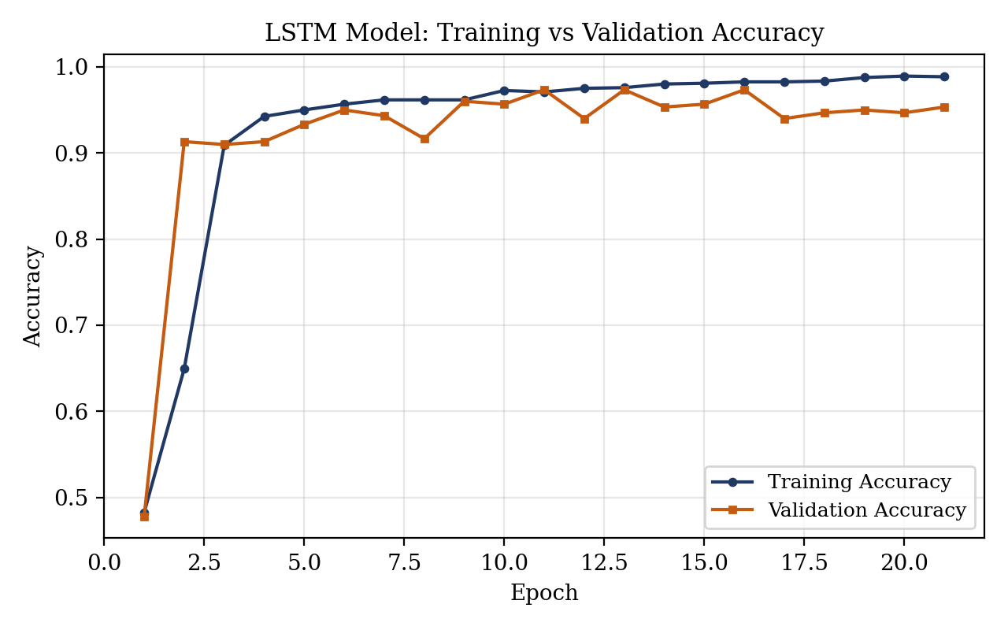
Figure 8.3: LSTM Model — Training vs Validation Accuracy
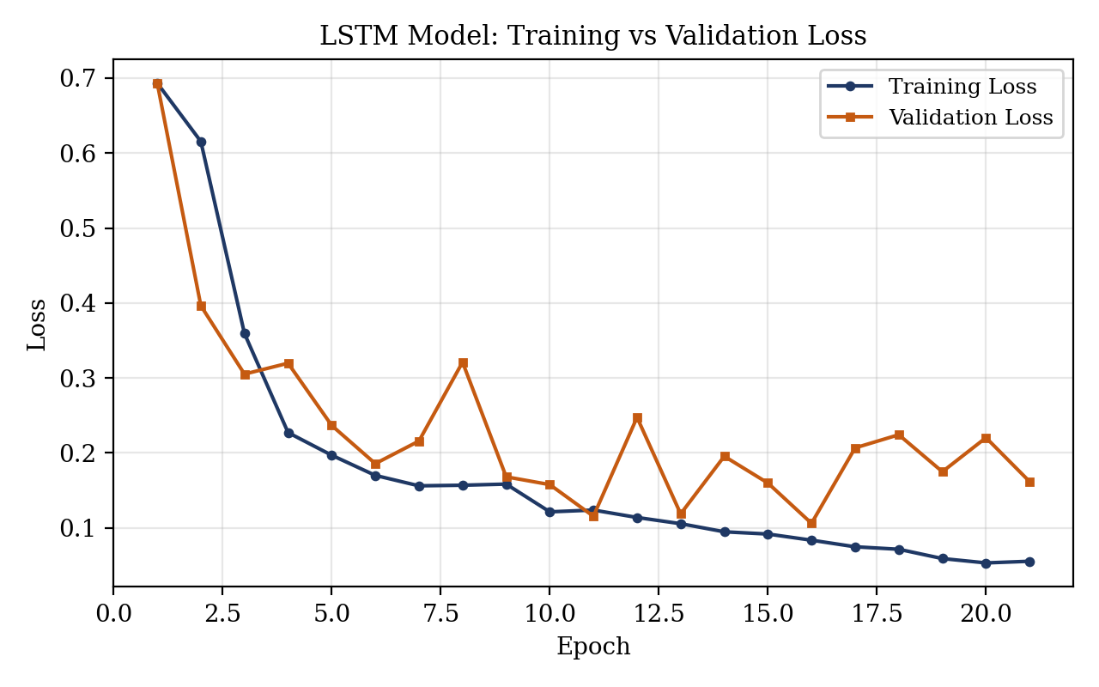
Figure 8.4: LSTM Model — Training vs Validation Loss
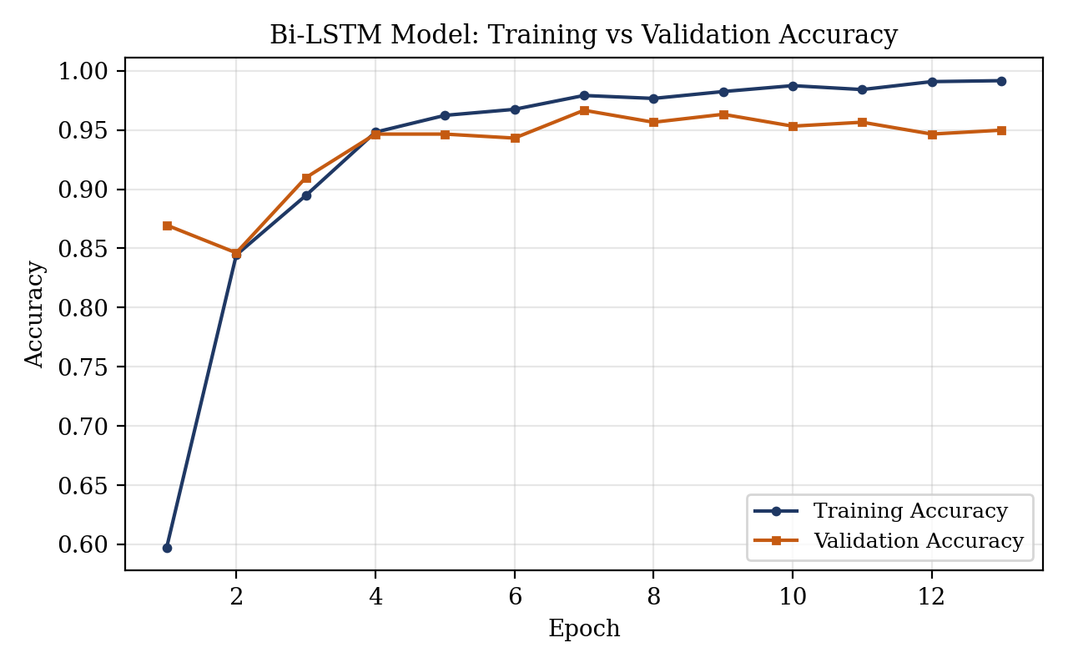
Figure 8.5: Bi-LSTM Model — Training vs Validation Accuracy
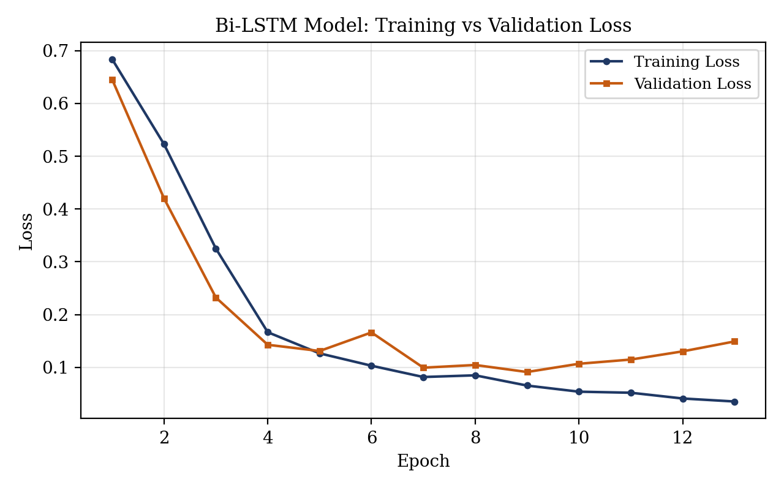
Figure 8.6: Bi-LSTM Model — Training vs Validation Loss
No confusion-matrix figure is included, consistent with Section 8.7: none was computed in the project, and this report does not fabricate one.

8.9 Discrepancy Between README and Experimental Results
The project's own README.md states accuracy figures of 98.5% (Dense), 98.6% (LSTM), 98.8% (Bi-LSTM) and 97.6% (SVM), and further states that “the Bi-LSTM model performed the best.” Neither claim is reproduced by the notebook's own printed outputs. As reported in Table 8.3 and Section 8.7, the notebook itself prints test accuracies of 93.65% (Dense), 95.32% (LSTM), 94.98% (Bi-LSTM) and 69.57% (SVM) — each 3 to nearly 28 percentage points below the corresponding README figure — and, by these notebook-reported numbers, LSTM is the best-performing model, not Bi-LSTM.
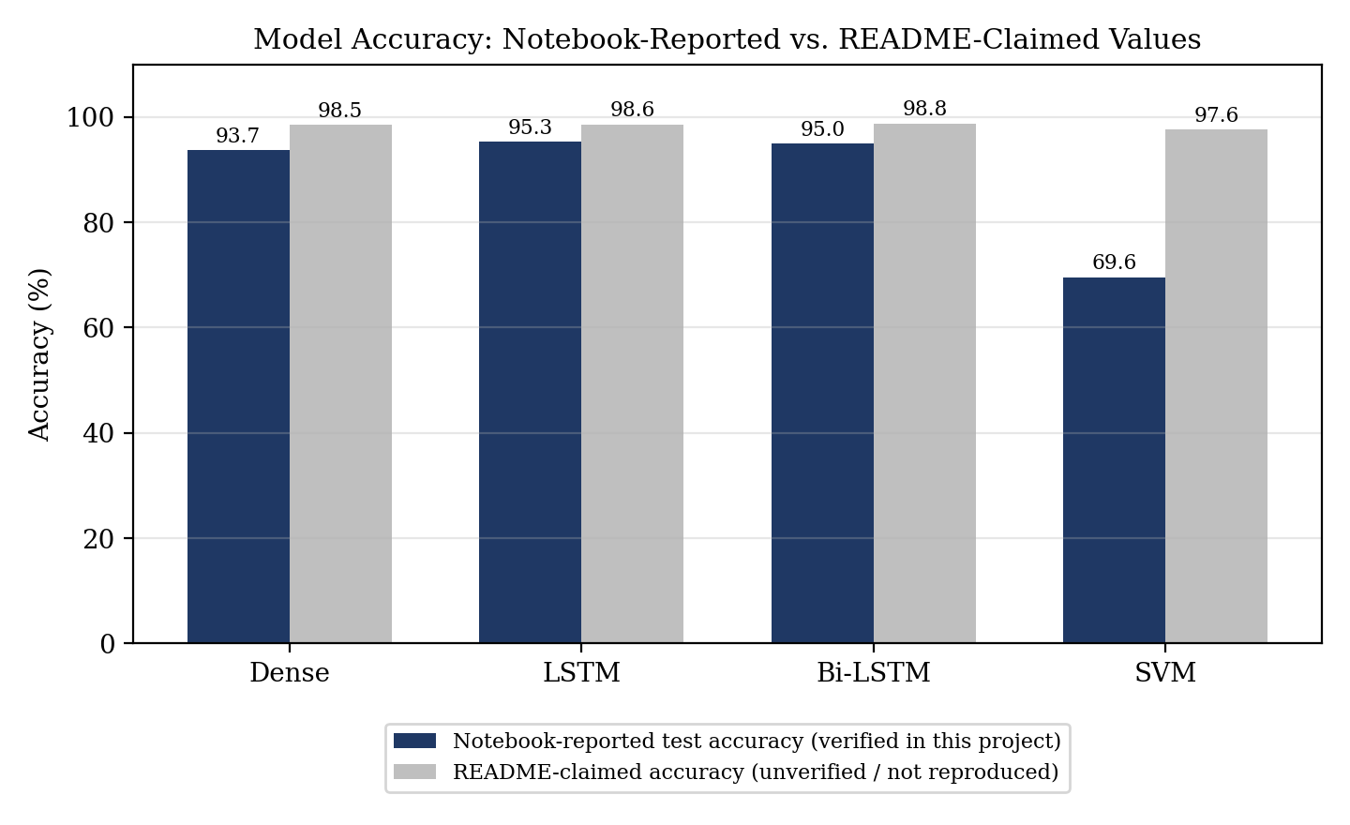
Figure 8.7: Model Accuracy — Notebook-Reported vs README-Claimed Values
This report relies on the notebook's own reproducible, printed cell outputs as the source of truth for accuracy figures, because these outputs are directly traceable to specific code cells and specific data splits inside the project, whereas the README's figures cannot be traced to any cell, log, or saved artefact in the repository. No explanation for the gap between the README and the notebook is invented here: it is possible the README describes an earlier or different training run, a different random seed, or simply optimistic/unverified reporting, but no evidence in the project files confirms any of these possibilities, so none is asserted as fact. The gap is documented transparently, as required for academic integrity, rather than hidden, reconciled speculatively, or silently replaced with the higher, more attractive numbers.

8.10 Result Analysis
Among the three neural architectures, LSTM achieved the highest notebook-reported test accuracy (95.32%), narrowly ahead of Bi-LSTM (94.98%, a difference of 0.34 percentage points) and more clearly ahead of the Dense network (93.65%, a difference of 1.67 percentage points from LSTM). Given that Bi-LSTM ran for only 13 epochs before early stopping (compared with 21 for LSTM), the gap between LSTM and Bi-LSTM may partly reflect how early each run was stopped rather than a fundamental architectural advantage; a fixed-epoch or repeated-run comparison would be needed to draw a stronger conclusion, and this report does not claim more than what the single recorded run shows. Bi-LSTM should not be described as the best-performing model in this project, because that description is not supported by the notebook's own recorded accuracy figures — it is only what the README claims.
The SVM's substantially lower accuracy (69.57%) is consistent with its input representation: it was trained directly on the padded integer token-ID sequences used for the neural models' Embedding layers, not on a bag-of-words, TF-IDF, or otherwise distance-meaningful feature representation. Raw token IDs are categorical labels, not a meaningful continuous feature space, so an RBF-kernel SVM operating on Euclidean distances between token-ID vectors has little reason to separate the classes well; the notebook's own low SVM score is consistent with this representational mismatch rather than indicating a fundamentally harder problem for classical models in general (e.g., Sharma et al. [6] report much stronger Naïve Bayes results using a TF-IDF representation, which is a more appropriate input for a classical model).

8.11 Discussion
Several factors limit how much can be concluded from these results. First, class balancing was performed by randomly down-sampling ham to 747 messages, discarding roughly 4,000 ham messages and reducing the total training data available; a larger, differently balanced training set (e.g., class weighting instead of down-sampling) might change the relative ranking of the models. Second, because EarlyStopping is used without restoring the best-epoch weights, the saved/deployed models are the last-epoch models, not necessarily the best models seen during training — Table 8.3's accuracy is therefore a slightly pessimistic estimate of each architecture's best achievable validation performance during this run. Third, accuracy alone, on a class-balanced test split, does not reveal whether a model is biased toward false positives (ham flagged as spam) or false negatives (spam missed); without a confusion matrix (Section 8.7), this cannot be assessed for any of the four models. Fourth, the deployed Streamlit application's tokenizer bug (Section 7.6) means that even the best notebook accuracy figure does not describe what a real user of the running app.py would experience, since the deployed Dense model is fed sequences from an inconsistent, per-message tokenizer rather than the tokenizer/vocabulary the model was trained against.

8.12 Advantages
- Demonstrates a working, if imperfect, end-to-end NLP/deep-learning pipeline from raw labelled text to an interactive prediction interface.
- Enables a direct, same-data comparison of three neural architectures and one classical model.
- The small model sizes (10,000–15,000 parameters, Table 7.1) train quickly even without a GPU.
- The Streamlit interface makes the trained model usable by a non-technical user without further setup.

8.13 Limitations
- Dataset limitation: down-sampling the ham class to 747 messages discards the majority of available ham data and may reduce the model's exposure to legitimate-message diversity.
- Evaluation limitation: only loss and accuracy are measured; precision, recall, F1-score and a confusion matrix are not available for any model (Section 8.7).
- Reproducibility limitation: the saved .h5 model architectures do not match the currently visible notebook code (Section 7.6), so the exact training run that produced the deployed weights cannot be re-run from the notebook as it currently stands.
- Deployment limitation: the Streamlit application loads the Dense model, which is not the highest-accuracy model by the notebook's own results (LSTM is).
- Implementation limitation: app.py's preprocess_message() fits a new Tokenizer per message instead of reusing the training-time tokenizer (Section 7.6), which undermines the reliability of real predictions from the deployed app.
- Documentation limitation: the project README reports accuracy figures 3–28 percentage points higher than what the notebook itself prints, and could not be reproduced from any artefact in the project (Section 8.9).
- Generalisation limitation: the underlying UCI SMS Spam Collection dataset is over a decade old and may not represent current spam wording, links, or scam techniques.

CHAPTER 9 — CONCLUSION AND FUTURE SCOPE

9.1 Introduction
This chapter summarises the verified findings of this report, states the project's actual, evidence-supported conclusions, and outlines concrete future work — much of it directed at resolving the limitations documented in Chapter 8 rather than at extending an already-reliable system.

9.2 Project Summary
This report studied, verified and documented an SMS spam-detection system, adapted from the public repository “deepankarvarma/SMS-Spam-Detection-using-NLP”, that classifies SMS messages as HAM or SPAM using a Keras tokenizer/padded-sequence representation and a choice of Dense, LSTM or Bi-LSTM neural models, compared against an SVM baseline, with predictions served through a Streamlit application. The dataset (UCI SMS Spam Collection, 5,572 parsed records: 4,825 ham, 747 spam) was down-sampled and split into 1,195 training and 299 testing messages. Rather than repeating the project's own README claims, this report independently traced every technical figure to the notebook's own cells and printed outputs, and to the saved .h5 model files.

9.3 Major Findings
- On the notebook's own test split, the models achieved: Dense 93.65%, LSTM 95.32%, Bi-LSTM 94.98%, and SVM 69.57% test accuracy — figures read directly from the notebook's printed cell outputs.
- LSTM is the best-performing model among the four by the notebook's own recorded results — not Bi-LSTM, which is what the project's README claims.
- The project's README accuracy figures (98.5%, 98.6%, 98.8%, 97.6%) are 3 to nearly 28 percentage points higher than what the notebook itself prints and could not be reproduced from any artefact examined in this report.
- The saved .h5 model files contain architectures (two hidden Dense layers; two stacked LSTM layers) that differ from the architectures shown in the currently visible notebook cells, indicating the notebook was edited after the deployed models were last trained.
- The Streamlit application loads the Dense model — the weakest of the three neural models by the notebook's own accuracy figures — not the best-performing LSTM model.
- The Streamlit application's preprocessing function fits a new Tokenizer on each incoming message rather than reusing the training-time tokenizer, creating a vocabulary/index mismatch between training and inference that affects the reliability of real predictions.
- Precision, recall, F1-score and a confusion matrix are not computed anywhere in the project.

9.4 Achievement of Objectives
Objective (Section 1.7) | Achievement | Evidence
Study SMS spam detection as an NLP classification problem | Achieved | Chapters 1–3
Analyse the dataset actually used, including its imbalance | Achieved | Section 6.3, Table 6.1
Verify the exact preprocessing/tokenization pipeline | Achieved | Section 6.5–6.6, Table 6.2
Verify the models' actual architecture and hyperparameters | Achieved — and a discrepancy with the visible notebook code was found and documented | Section 7.6, Figures 7.2–7.4, Table 7.1
Reproduce and report evaluation results; compare against README | Achieved for loss/accuracy; precision/recall/F1/confusion matrix could not be reported because they are not computed in the project | Chapter 8, Table 8.3, Section 8.9
Document the Streamlit application's real behaviour | Achieved — including two verified limitations (Dense model deployed instead of LSTM; per-message tokenizer bug) | Section 7.6, 7.8
Identify and explain discrepancies between documentation and code | Achieved | Sections 7.6, 8.9, 8.13
Table 9.1: Objective vs Achievement

9.5 Conclusion
This report set out to document, not merely repeat, a working SMS spam-detection prototype. The verified evidence supports the conclusion that an NLP-preprocessing-plus-neural-classifier pipeline can distinguish spam from ham SMS messages substantially better than chance on the UCI SMS Spam Collection, with the LSTM model reaching the highest recorded test accuracy (95.32%) among the models actually evaluated in the notebook. It does not support the stronger claims made in the project's own README — that the system reaches 98%+ accuracy or that Bi-LSTM is the best model — nor does it support any claim that the deployed Streamlit application provides reliable, production-grade spam detection, given the documented tokenizer inconsistency between training and inference and the absence of class-wise evaluation metrics. The project is better understood, on the evidence gathered here, as an instructive comparison of three neural architectures on a small, imbalanced SMS dataset with an unresolved deployment inconsistency, rather than as a finished, thoroughly-evaluated production system.

9.6 Applications
Subject to the limitations documented in Chapter 8 being addressed first, this type of pipeline has potential (not currently realised or deployed) application in areas such as:
- Educational demonstrations of NLP and deep-learning text classification.
- A starting prototype for personal or small-scale SMS spam filtering.
- A baseline for further text-classification research on short, informal text.
- A component that could, after the limitations in Chapter 8 are resolved, be considered for integration into a larger messaging platform's spam-filtering layer.

9.7 Future Scope
- Save and reuse the training-time tokenizer (e.g., persist it with pickle) so that app.py applies the same vocabulary/index mapping at inference time that the model was trained on.
- Correct preprocess_message() in app.py to use the saved tokenizer instead of fitting a new one per message, resolving the mismatch documented in Section 7.6.
- Retrain all models using a single, reproducible pipeline (fixed random seeds, a pinned library-version environment, and a notebook that is kept in sync with whatever model files are saved) so that the notebook's visible code and the deployed weights no longer disagree.
- Compute precision, recall and F1-score for every model, in addition to accuracy, particularly given the dataset's class imbalance.
- Generate and analyse a confusion matrix for every model to understand false-positive and false-negative behaviour.
- Test the retrained system on genuinely unseen, real-world SMS messages collected independently of the UCI SMS Spam Collection.
- Explore improved class-imbalance handling (e.g., class weighting or oversampling techniques) as an alternative to discarding the majority of the ham data through down-sampling.
- Evaluate transformer-based NLP models (e.g., a fine-tuned BERT-family encoder) as a stronger alternative to the current Embedding + LSTM/Bi-LSTM approach.
- Improve the Streamlit deployment with input validation, basic error handling, and a documented, reproducible deployment environment.
- Establish clear model/version consistency between what is trained, what is saved, and what is deployed, so that the deployed model is always the one the project's own documentation claims it to be.
- Introduce proper model and preprocessing artefact management (e.g., versioned model files, a saved tokenizer artefact, and a metadata record of which code produced which saved file).
- Improve robustness and generalisation through a larger and more recent SMS/spam dataset, better handling of long messages beyond the current 50-token limit, and adversarial-style testing against deliberately obfuscated spam wording.

9.8 Possible Enhancements
In the near term, the most valuable and lowest-effort enhancements are: (a) fixing the tokenizer bug in app.py, since this alone directly undermines the reliability of every prediction the deployed app makes; (b) switching the deployed model from Dense to LSTM, since LSTM is the best-performing model by the project's own notebook results; and (c) adding precision/recall/F1/confusion-matrix computation to the notebook's evaluation cells, since these are inexpensive to add with scikit-learn's existing metrics functions and would substantially strengthen any future evaluation of this system.

9.9 Final Remarks
This report has aimed to model a disciplined, evidence-first approach to documenting a small AI/NLP project: every architectural detail, hyperparameter and accuracy figure presented here was traced to a specific notebook cell, a specific printed output, or a specific saved file, and every place where the project's own documentation could not be verified — or was contradicted by the code and its outputs — has been reported explicitly rather than smoothed over. The resulting picture is of a genuinely instructive, partially working prototype with clearly identified, fixable limitations, which is a more accurate and more useful basis for further work than an uncritical restatement of the original repository's README claims would have been.

REFERENCES
[1] T. A. Almeida, J. M. G. Hidalgo, and A. Yamakami, “Contributions to the study of SMS spam filtering: new collection and results,” in Proc. 11th ACM Symposium on Document Engineering (DocEng ’11), Mountain View, CA, USA, 2011, pp. 259–262.
[2] G. V. Cormack, J. M. G. Hidalgo, and E. P. Sánz, “Feature engineering for mobile (SMS) spam filtering,” in Proc. 30th Annual International ACM SIGIR Conference on Research and Development in Information Retrieval (SIGIR ’07), New York, NY, USA, 2007, pp. 871–872, doi: 10.1145/1277741.1277951.
[3] A. Chandra and S. K. Khatri, “Spam SMS filtering using recurrent neural network and long short term memory,” in Proc. 2019 4th International Conference on Information Systems and Computer Networks (ISCON), Mathura, India, 2019, pp. 118–122, doi: 10.1109/ISCON47742.2019.9036269.
[4] A. L. Rosewelt, N. D. Raju, and S. Ganapathy, “An effective spam message detection model using feature engineering and bi-LSTM,” in Proc. 2022 International Conference on Advanced Computing, Communication and Applied Informatics (ACCAI), Jan. 2022, pp. 1–6.
[5] V. V. Kalyani, M. R. Sundari, S. Neelima, P. S. S. Prasad, P. P. Mohan, and A. Lakshmanarao, “SMS Spam Detection using NLP and Deep Learning Recurrent Neural Network Variants,” in Proc. 2024 International Conference on Cognitive Robotics and Intelligent Systems (ICC-ROBINS), Apr. 2024, pp. 92–96.
[6] T. Sharma, P. Walia, S. Sharma, and M. Chopra, “NLP-Driven Framework for Spam SMS Detection and Classification,” in 2025 3rd World Conference on Communication & Computing (WCONF), Raipur, India, 2025, pp. 1–5, doi: 10.1109/WCONF64849.2025.11233398.
[7] UCI Machine Learning Repository, “SMS Spam Collection Data Set,” Univ. of California, Irvine. [Online]. Available: https://archive.ics.uci.edu/ml/datasets/SMS+Spam+Collection
[8] D. Varma, “SMS-Spam-Detection-using-NLP” (GitHub repository), 2023. [Online]. Available: https://github.com/deepankarvarma/SMS-Spam-Detection-using-NLP — base implementation studied, verified and documented in this report (see Section 1.10 and Declaration).
[9] M. Abadi et al., “TensorFlow: A System for Large-Scale Machine Learning,” in Proc. 12th USENIX Symposium on Operating Systems Design and Implementation (OSDI ’16), Savannah, GA, USA, 2016, pp. 265–283.
[10] S. Hochreiter and J. Schmidhuber, “Long Short-Term Memory,” Neural Computation, vol. 9, no. 8, pp. 1735–1780, 1997, doi: 10.1162/neco.1997.9.8.1735.
[11] F. Pedregosa et al., “Scikit-learn: Machine Learning in Python,” Journal of Machine Learning Research, vol. 12, pp. 2825–2830, 2011.
[12] Streamlit Inc., “Streamlit Documentation.” [Online]. Available: https://docs.streamlit.io

