Alphaの値と学習精度と収束速度の関係を調べる．Alphaは0.001から0.01まで変化する．300 point

hidden layer 1 の場合：
Eta=1; Beta1=0.9; Beta2=0.999; Eps=1e-08; Weight_Decay_Rate=0
hidden neural number : 800; epoch : 10000; stop error : 0.01,100回
The best alpha when error got minimum is 0.00479, and have epoch number is 7767
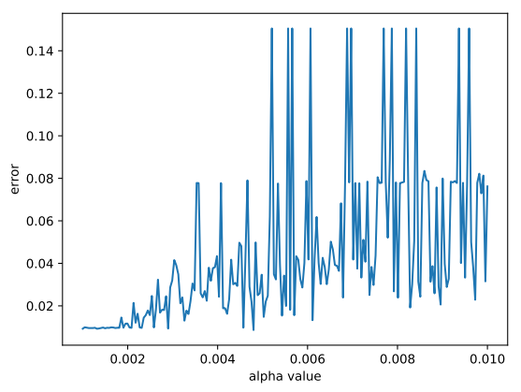
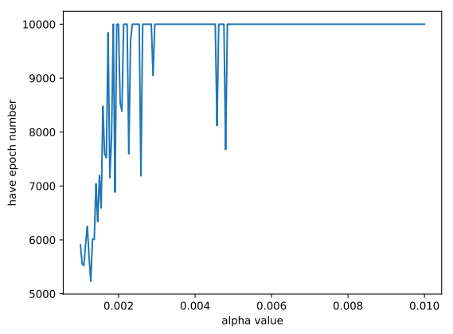

hidden layer 2 の場合：
Eta=1; Beta1=0.9; Beta2=0.999; Eps=1e-08; Weight_Decay_Rate=0
hidden neural number : 700,800; epoch : 10000; stop error : 0.01,100回
The best alpha when error got minimum is 0.0014, and have epoch number is 1903
