@&Hisoblang: $$122\cdot 13-105\cdot 12+21\cdot 12$$

@#578

@587

@678

@687

@&Hisoblang: $$2080 : (1222 - 26\cdot27) + 120$$

@#124

@128

@126

@122

@&Hisoblang: $$\frac{2021^{2}}{2022^{2}+2020^{2}-2}$$

@#$$\frac{1}{2}$$

@$$1$$

@$$\frac{1}{4}$$

@$$\frac{2021}{4039}$$

@&Hisoblang: $$81^{0,75}\cdot 32^{0,4}-8^{-\frac{2}{3}}\cdot 27^{\frac{1}{3}}$$

@#6

@4

@3

@2

@&Hisoblang: $$\sqrt{2021^{2}-2020\cdot 2022}$$

@#1

@2

@4

@3

@&O‘qituvchisining oyligi 3200000 so‘m bo‘lib, undan 12 foiz daromad solig‘i olinadi. O‘qituvchi oyligidan necha so‘m pul daromad solig‘iga olinadi?

@#384000

@348000

@340000

@380000

@&6 ga bo‘lganda 5 qoldiq qoladigan barcha uch xonali sonlar yig‘indisini toping.

@#82200

@82194

@82188

@82182

@&Soddalashtiring: $$\left( \frac{1}{a+1}+b \right):\left( \frac{2b+1}{1-a}-b \right)$$

@#$$\frac{1-a}{1+a}$$

@$$\frac{a-1}{1+a}$$

@$$\frac{1-ab}{1+a}$$

@$$\frac{ab-1}{1+a}$$

@&Agar $$\frac{1}{a}+\frac{1}{b}+\frac{1}{c}=6$$ bo‘lsa, $$\frac{2a+1}{a}+\frac{4b+2}{b}-\frac{5c-3}{c}$$ ifodaning qiymatini toping.

@#7

@6

@8

@17

@&Soddalashtiring: $$\frac{sin^{3}\alpha+cos^{3}\alpha}{sin\alpha+cos\alpha}+\frac{1}{2}sin2\alpha$$

@#1

@$$\left( sin\alpha+cos\alpha \right)^{2}$$

@$$\left( sin\alpha-cos\alpha \right)^{2}$$

@$$sin2\alpha$$

@&Agar $$sin\alpha=-\frac{12}{13}$$ va $$\pi\lt \alpha\lt \frac{3\pi}{2}$$ bo‘lsa, $$tg(2\alpha+\frac{\pi}{4}))$$ ni hisoblang.

@#$$-\frac{1}{239}$$

@$$\frac{1}{239}$$

@$$\frac{120}{119}$$

@$$-\frac{120}{119}$$

@&$$2.8^{\frac{28}{\sqrt{x}}-32} = (\frac{5}{14})^{\frac{5}{\sqrt{x}}-100}$$ tenglamani yeching.

@#0,0625

@0,625

@0,125

@0,0125

@&$$\frac{log_{2}^{2}10+log_{2}10\cdot log_{2}5-2log_{2}^{2}5}{2log_{2}10+4log_{2}5}$$ ni soddalashtiring.

@#$$\frac{1}{2}$$

@$$-\frac{1}{2}$$

@$$\frac{3}{2}$$

@1

@&| x<sup>2</sup>+4x-3 |=15 tenglamaning haqiqiy yechimlari yig‘indisini toping.

@#-4

@-2

@-8

@4

@&$$\sqrt{x^2-4x+5}+\sqrt{x^2-4x+13}=4$$ tenglama nechta haqiqiy ildizga ega?

@#1

@3

@2

@0

@&$$\left| \frac{x^2-5x+4}{x^2-4} \right|\le 1$$ tengsizlikni yeching.

@#$$\left[ 0;1,6 \right]\cup \left[ 2,5;+\infty \right)$$

@$$\left[ 0;1,6 \right]$$

@$$\left[ 2,5;+\infty \right)$$

@$$\left[ 1,6;2 \right)\cup \left[ 2,5;+\infty \right)$$

@&$$y=\sqrt{2x-1}-1$$ funksiyalarning qiymatlar sohasini toping.

@#$$\left[ -1;+\infty \right)$$

@$$\left[ 0,5;+\infty \right)$$

@$$\left[ 0;+\infty \right)$$

@$$\left(-\infty;+\infty \right)$$

@&$$y=f(x)$$ funksiyaning qiymatlar sohasi (-2;12) bo‘lsa, $$y=2f(x) - 4$$ funksiyaning qiymatlar sohasini toping.

@#(-8;20)

@(1;8)

@(-8;8)

@(1;20)

@&$$f(x)=x^{4} \cdot ln3x+2$$ funksiya hosilasini toping.

@#$$ 4x^{3} \cdot ln3x+x^{3}$$

@$$ 4x^{3} \cdot ln3x+3x^{3}$$

@$$ 4x^{3} \cdot ln3x+\frac{x^{3}}{3}$$

@$$ 4x^{3} \cdot ln3x-x^{3}$$

@&Chizmada y=f(x) funksiyaning grafigi va unga abssissasi x<sub>o</sub>=2 bo‘lgan nuqtada o‘tkazilgan d–urinmasi tasvirlangan. Agar $$g(x)=(x+1)^{2}\cdot f(x)$$ bo‘lsa, g‘(2) ni hisoblang.  
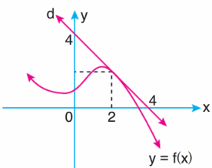  
@#3

@12

@9

@21

@&$$\int_{0}^{1}(x^{3}+x+1)^{2}\cdot(3x^{2}+1)dx$$ integralni hisoblang.

@#$$8\frac{2}{3}$$

@$$8\frac{1}{3}$$

@$$9\frac{2}{3}$$

@$$9\frac{1}{3}$$

@&ABC uchburchakda $$AB=8$$, $$BC=6$$ va $$\angle ABC=150$$ bo‘lsa, uning yuzini toping.

@#12

@24

@14

@20

@&Rasmda berilganlarga koʻra ABC uchburchakning yuzini toping.  
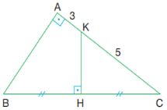  
$$KH \bot BC; BH=HC, AK=3, KC=5$$

@#16

@32

@$$10\sqrt{5}$$

@20

@&Chizmada ABCD to‘rtburchak tasvirlangan. Agar $$BD \bot AC; b=6, c=5, d=4$$ bo‘lsa, to‘rtburchakning BC tomoni uzunligini toping.  
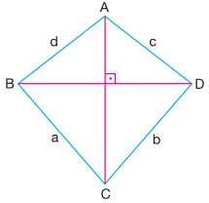

@#$$3\sqrt{3}$$

@$$2\sqrt{6}$$

@$$2\sqrt{7}$$

@$$\sqrt{37}$$

@&Chizmada tasvirlangan prizmaning hajmini toping.  
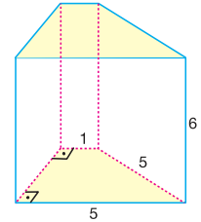

@#54

@42

@108

@72

@&3 piramida ustma-ust joylashtirilgan. Agar ularning yon qirralari teng bo‘lsa, hajmlari nisbatini toping.  
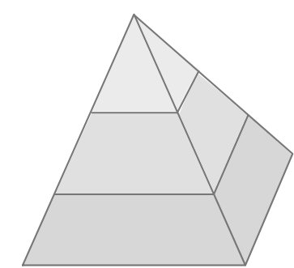

@#1:7:19

@1:8:27

@1:8:26

@1:2:3

@&Fazoda xy tekisligiga nisbatan A(4;-5;6)nuqtaga simmetrik bo‘lgan nuqtani toping.

@#(4;-5;-6)

@(4;5;6)

@(-4;5;-6)

@(-4;-5;-6)

@&Aylanada 8 nuqta belgilangan. Uchlari shu nuqtalarda joylashgan ko‘pi bilan nechta to‘rtburchak yasash mumkin?

@#70

@56

@336

@32

@&A to‘plam 10 ta elementdan tashkil topgan. A to‘plamning qism to‘plamlari sonini aniqlang.

@#1024

@1020

@512

@520

@&Uy maydonining o‘lchamlari chizmada berilgan. I va III xonalarning yuzlari teng. Agar II xonaning yuzi I xonaning yuzidan 9 kvadrat metrga kichik bo‘lsa, III xonaning yuzi necha kvadrat metrga teng?  
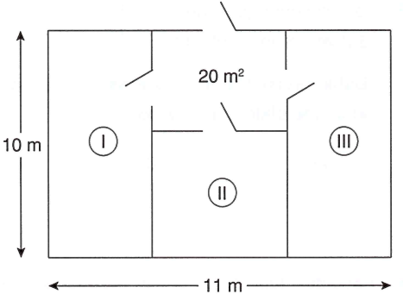

@#33

@32

@24

@42